

REPORT OF INDUSTRIAL TALK 2

SEMESTER 1

SESSION 2018/2019

NAME: 1. AHMAD AZHAR ADILAN BIN INDRA (A18CS0012)
2. CHAN JUN YAO (A18CS0043)
3. ANIS HUMAIRA BINTI MOHAMMAD HAIZAM (A18CS0034)
REPORT’S TITLE: NALI SYMPOSIUM
LECTURER’S NAME: DR ARYATI BINTI BAKRI
SUBJECT: TECHNOLOGY AND INFORMATION SYSTEMS (SCSP1513)
SECTION: 02

NALI, which stands for New Academia Learning Innovation, is an education framework introduced in 2013. With the goal of culturing an entrepreneurial academia, NALI emphasis on student-centred learning, via blended learning philosophy, multiple learning modes and material. Centre for Teaching and Learning (CTL), UTMLead are given great responsibility in order to carry out the NALI initiative, with the objectives:

- To align UTM teaching and learning models, activities, materials, environments and systems with Malaysian National Higher Education Strategic Plan, needs of employers and requirements of accreditation bodies.
- To emulate best teaching and learning practices from the World’s best universities.
- To develop UTM own identity related to teaching and learning models, activities, materials, environments and systems.
- To create meaningful and interactive learning activities, materials, environments and systems appropriate to UTM Graduate Student Attributes.

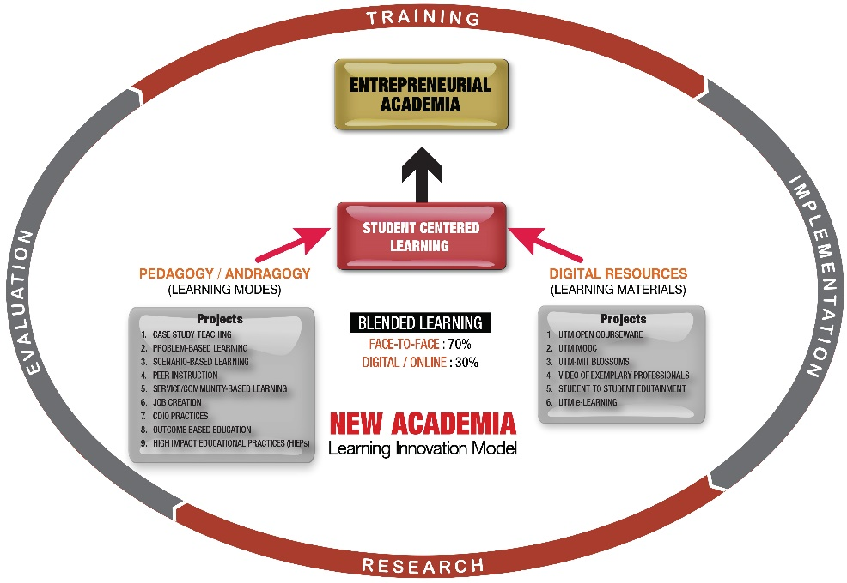

With the support of Dasar e-Pembelajaran Negara (DePAN), the NALI objectives are being achieved through courses with implementation of blended learning: a practice of learning using 2 modes, namely Learning Mode (Pedagogy/Andragogy) and , Learning Materials (Digital Resources), according to a weightage of 70% of face-to-face learning and 30% of digital or online based learning.
For Pedagogy or Andragogy learning mode, includes Case study, Problem Based Learning, Scenario Based Learning, Peer Instruction, Service Learning, Job Creation, CDIO and OBE. While Digital or Online based learning involves the application of technology in learning practice: to deliver learning materials in digital forms such as video material. Efforts in this context are Open Courseware, MOOC, BLOSSOMS, Video of Exemplary Professionals, Student to Student Edutainment, OBE Analysis System, and UTM e-Learning.
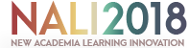

Align with the objectives of NALI, there comes the exhibition and competition, NALI 2018. The exhibition of NALI 2018 aims to recognize NALI research and innovation products in teaching and learning through exhibition and competition, to be the platform for sharing of research and innovation products in teaching and learning. Furthermore, to improve educator’s competency in practicing teaching and learning in the 21st Century through NALI talk series and workshops, and to improve STEM awareness among educators in practicing NALI.
For the symposium of NALI 2018, which held on 25th and 26th September at Dewan Sultan Iskandar, UTM Johor Bahru, hosted a total of 101 booth. Our group of 3 visited the exhibition on the 25th September, in the hope to gain further and better understanding of the NALI framework.
Each booth was equipped not only with attractive poster designs and decoration but also innovative learning materials, which successfully gain attention without any effort. Innovative and unique ideas displayed by each booth is inspiring and had suggested a new point of view of how education can be carried out with the help of technology. The exhibition not only benefited the visitors in which provide a platform to learn new approach in education but also played its role as a platform to encourage collaboration and exchange of ideas and efforts between educators.
Thus, we were assigned by our lecturer to look into 6 booth in groups of three to produce a report based on what we had learned and observed. For our group, the booths that were assigned to us was booth number 7 until booth number 12 out of 86 booths that had registered for NALI 2018. Out of the 6 booths that were designated to us, only 2 booths were available complete with posters, brochures and at least a representative to explain and help us understand more about the project they represent. Booth number 11 however only includes a poster which we will discuss in the following pages.
The first booth that we visited is The Toy Bricks which is booth number 8. This booth is owned by Mrs. Siti Saleha Omain, Mrs. Norhalimah Idris, Mrs. Norhayati Zakwan, Mrs. Zuraidah Sulaiman and Mrs. Nor Zafir Md Salleh. These beautiful women is from Azmin Hashim International Business School (AHIBS), Universiti Teknologi Malaysia. The toy bricks is introduced as an innovative teachings technique for Operation Management course in AHIBS. It has been introduced because based on survey that they have conducted, it shows that the majority of the students agreed that this technique increases their interests and understanding of the subjects and this technique is regarded as a valuable tool in the business curriculum and should be included in the future. It was introduced in this class starting in semester 1 2017/2018 to groups of students majoring in Management of Technology in AHIBS, UTM.
The primary purpose of this technique to be introduced is to improve students’ understanding of Operation Management topics such as Material Requirement Planning (MRP), Inventory Management, Layout Strategy and Qualify Control which are considered relatively challenging among students. Secondly, to introduced scenario-based learning among students by incorporating toy bricks in a production scenario. Next, to enhance students’ learning via team-working and applying operation management theories such as MRP theory. Lastly, to emphasize the “reflection-on-action” learning techniques among students.
The NALI implementation approach in this technique is an original teaching method using toy bricks as a medium in executing the manufacturing process as per MRP concept. Embedding toy bricks and challenging students’ ability to execute given tasks within a given frame is the creativeness of this technique. Next, this method of teaching integrated students’ learning process in assembling the toy bricks in a production scenario along with producing “part request form” using computers.
The innovative teaching technique has a high potential for commercialization. This technique is in the process of IP registration. This technique can be marketed to all public and private institutions that offer Operation Management courses. It can also be targeted to Secondary schools and colleges that offer Commerce subject.
At booth number 9, we get exposed about teaching evaluation system which name is ACCOUNTING EDUCATORS 4.0 READINESS IDENTIFICATION SYSTEM (AERIS 4.0). We have been introduced about this system by Mr. Mohamad Ridhuan Mat Dangi. Basically, AERIS 4.0 is innovated to measure educators’ readiness and willingness to adopt and integrate educational technology and digital tools for the teaching-learning process in the classroom. The variables generated in this system is based on several well-established theories that were used to comprehend the educator’s behaviour, educator’s technology acceptance, educator’s constructivist role, educator’s discovery ability, and competencies. At the faculty level, AERIS 4.0 helps to identify educators requiring more attention. Hence, further action can be formulated to find a resolution to improve their approach in adopting technology.
The main objective for the invention of AERIS 4.0 is to measure the accounting educators’ readiness level of integrating and adopting the educational technology. Secondly, the measurement system could assist the top management, the faculty and education institution in identifying educators who require more attention in the process of embracing educational technology. Finally, to ease the process of formulating the necessary action, which not only increases the readiness level but also encourages educators to adopt technology in their classroom activities.
The innovative feature of the AERIS 4.0 system greatly depends on its systematic database that is different from the traditional format of measurement, which is typically performed on paper. In the other words, the innovation in the form of a database system is not just paperless, fast and easy, but the interactive design combined with creativity allow the result to be presentable and can be illustrated in real time. The scoring system used for the measurement is gauge through a scale ranging from 0 to 5 with distinguish colours. For instance, green colour represent “Very High”, blue colour represent “High”, yellow colour represent “Moderate”, orange colour represent “Low”, purple colour represent “Very Low” and red colour represent “No Integration”.
AERIS 4.0 is designed in the form of computerized database assessment system that can be accepted electronically. Hence, it is creativity-wise because the assessment made is paperless, fast and easy. Besides that, AERIS 4.0 has self-assessment feature which allows educators to evaluate their readiness level themselves. The result of the assessment will be sent to the top management o of the faculty for further action preparation to improve the readiness level of the educators. The product novelty is the assessment and information of this system can be stored and retrieved for future reference. Furthermore, this system also can generate three tiers of scoring such as the first tier yields the score of the individual item of the criteria, the second tier yields the total score of each theme, and the third tier yields the total score of the overall of adoption and integration.
AERIS 4.0 is highly potential to be commercialized since it functions as a measurement tool to evaluate the accounting educators’ readiness level of integrating educational technology into their teaching and learning activities. The potential target users of AERIS 4.0 are the accounting educators at all level of education such as universities, colleges, and schools.
Lastly, AERIS 4.0 also has the potential to be used by other background and field of education because the criteria can be modified and generalized to suit a given context. Since the measurement used is based on universities theories, it can be generalized to other fields of education, different faculties, schools teacher and administration staff. This is because educational technology does not only effects the higher education institution but also to all level of education system. Besides, there are many schools and education institution in Malaysia as well as educators. Thus, it is practical to commercialize and to employ the system.
The last booth that we visited is booth number 11 which is MRMD DIGITAL BOARD. This booth was owned by Dr. Shukriah Saad with his associates whom are Mohammad Ridhuan Mat Dangi, Dr. Aida Hazlin Ismail and Associate Prof. Dr. Norli Ali from the Faculty of Accountancy, Universiti Teknologi MARA (UiTM) Selangor Branch. The purpose of this project is to offer a digital platform with the objective of enriching and enhancing students classroom experiences because with this platform, it will help the students to learn better and the lecturers to teach through better engagement.
This MRMD Digital Board provides lecturers with the opportunity to shift from traditional teaching methodology to a more interactive methodology of teaching and learning which represents an entirely new way of engaging with students. This project represent a new era of teaching and learning technology for the lecturers by using digital platform which enables lecturers and their students to convey and share information by using Quick Response (QR) Code. There is no limit to how or even how much lecturers can share their course materials with their students by using this platform and therefore the potential for this project is limitless.
The innovativeness of this project has made the teaching materials easier to access just by uploading it once on the PADLET application and any new materials or updates for existing materials will be automatically updated to PADLET application without the need to create a new QR code. All QR codes for each element is placed together on a piece of paper called MRMD Digital Classroom Catalogue to demonstrates the extent of innovativeness where MRMD Digital Board enables lecturers to convey and share information with students more effectively by sharing this catalogue.
With the emerging of industrial revolution 4.0, it has inspired the education sector to re-examine the way of doing business. With that in mind, universities must play their role as test beds for educating the future generation and spur innovation throughout its entirety. Thus MRMD Digital Board was initiated to make that possible. Before the use of this platform, some documents or materials were tacked on the boards outside of lecture's rooms in which they were not neatly placed, resulting to over capacity of space to put more materials and documents, making the boards look more untidy and unorganized. After the use of this product however, the situation had improved whereby QR codes for each course material is tacked neatly on the boards instead of documents and materials. Students will have immediate access on to what is relevant to their courses and lecturers can use this platform to create and manage the information on the PADLET application instead of the traditional way of using papers.
The impact of this project is huge whereby the use of QR code for all teaching materials on the MRMD Digital Board provides more venues for the lecturers to be more creative in providing knowledge to their students. The interaction with MRMD Digital Board should also be seen as a way of preparing students for the workplace as they were made familiar with emerging technologies with the use of this platform as part of their learning process.
This project also supports the concept of green learning and saves the earth in which this platform will require less paper handouts. The use of MRMD Digital Board empowers students by getting them to be more interested in learning and allows them to better connect with learning materials. Recently, there have been 9 training sessions conducted for academicians and administrators on the digital platforms including MRMD Digital Board. These trainings are registered with an i-expert system under Consultancy Unit of UiTM.
Next, there are several observable and significant trends throughout the NALI 2018 symposium. First and foremost, the most significant trend in NALI 2018, is the application of digital technology. The usage of digital devices such as VR headset, mobile applications ease the process of learning, promote a more immersive learning experience in the classroom. The concept of virtual classroom, allows a higher degree of participation from the students via interactive activities. Digital technology doesn’t even promote innovative learning experience, but also give support on administrative work. One of the project on the exhibition make use of digital technology to gain insights on implementation and integration of digital learning in the classroom. The application give automatic data storage, data analyzation, which give simple, fast, yet accurate results in order to give reflection on the actual situation, hence yielding a effective grading system.
On the other hand, the trend of play-and-learn is also significant throughout NALI 2018. The Toy Brick booth make use of Lego to let the students simulate the actual process of industrial process. The industrial process which involves inventory management, assembly point, logistics support is being scaled down and carried out using Lego bricks. Students which participates in the process gain first-hand experience, and also retain a better understanding for the whole process. Meanwhile, the play-and-learn trends can also be seen in some other booth which utilize simple tools or toys, to create an immersive and practical experience for the students. By using this effective method, learning experience is being brought to a higher level, one which is innovative, effective, yet fun and interesting.
Furthermore, the trend of tools development is also one of the major trends in NALI 2018. Instead of development in learning experience, a several group of educators focus on development of tools. In this context, tools such as grading systems, personality test are useful to in which to identify student performance, analyse classroom’s performance. These tools might help to provide a better picture, and assist in identifying patterns and problems, and in return helps in decision making.
Overall, what we can learn from this exhibition is that the teaching methods in Malaysia had evolved corresponding to the ever growing of technologies. Researchers and educators had innovate new ways of teaching and interacting with students more efficiently and more effectively to ensure a huge amount of educated students were born. This also shows that Malaysia is taking its baby steps in producing a more intellectual citizens that are capable of thinking rationally and critically about something with hard evidence and not judge the situation based on their own opinions. In previous years, students are only taught through textbooks and had to do lots of exercises in a daily basis until they had exhausted themselves while educators only follows the guidelines given by the Ministry of Education or by their course coordinators in their respective universities. From blackboards to whiteboards to papers to books, all this traditional means of education has long been taught in our lives throughout an entire generation but now with advance technologies we can change that. Students can be more proactive in classrooms, enhance their soft skills through learning and observations by doing presentations or projects and they can also do more hands-on activities to further nurture their knowledge and their personality as a person. Not only that but students can start exploring more in-depth about those new knowledge and information that they had learn in their classes by using the Internet. Technologies had made education and learning process so much more time efficient and energy efficient that no one is needed to go from places to places just to obtain a particular information. Classrooms are more fun to be in for both the students and teachers alike. Other than that, the qualities of education in Malaysia will increase due to a more rigid guidelines and evaluations for educators and effective exposure of knowledge to the nation. With that Malaysia can be well-known for its high achievement in the education sector with more high achievers graduated from Malaysia's schools and universities.
In the nut shells, three of us have done our own job starting from go to the exhibition hall and take a tour on each booth to make sure our report have all the points in the rubric. Azhar have done his work by writing on exhibition contains for booth 8 and booth 9 while Chan also have done his great work by writing the introduction and trends for this report and also Anis the very single lady in our group also doing a great job with writing on exhibition contain for booth 11 and reflection on this industrial talk 2 report. Lastly, we wrote this report based on the information that we got during the exhibition and we also make some references using the poster and brochure that we got from each booth during the exhibition in order to make sure that our report is written by following to the rubric.

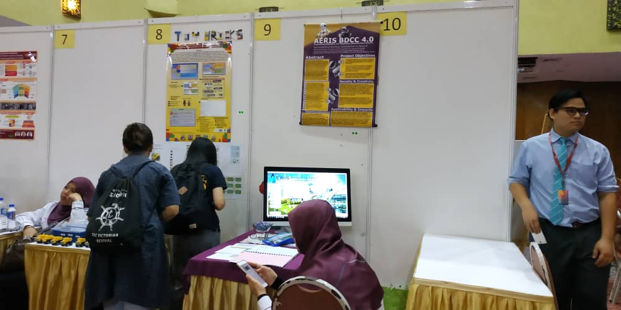
As you can see booth number 7 and 10 there is no poster and there is also no people standing there.

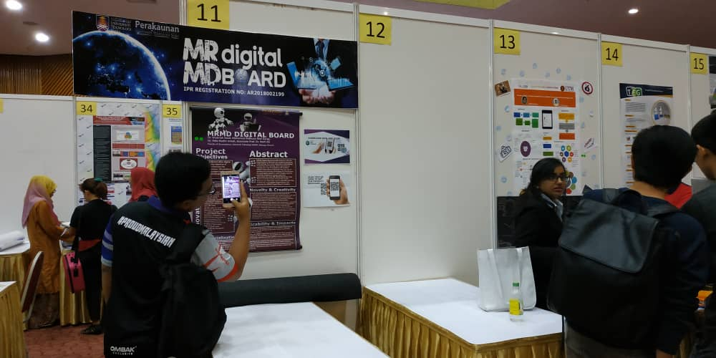
Also at booth 12 there is no poster and no one there but booth 11 there is poster about their project but there is no representative from the booth to give us explanation about their project.

