

REPORT OF INDUSTRIAL TALK 1

SEMESTER 1

SESSION 2018/2019

NAME: AHMAD AZHAR ADILAN BIN INDRA
STUDENT ID: A18CS0012
REPORT’S TITLE: MDEC – eRezeki
LECTURER’S NAME: DR ARYATI BINTI BAKRI
SUBJECT: TECHNOLOGY AND INFORMATION SYSTEMS (SCSP1513)
SECTION: 02

On 24 September 2018 the representative from Malaysia Digital Economic Corporation (MDEC) has come to my university which is Universiti Teknologi Malaysia (UTM) to give a talk about Global Online Workforce (GLOW). The talk have been given by Mr. Mohd Ihsanuddin Bin Jamhari at Seminar Hall level 1 building N28A on 11:00 am in the morning. From the talk I learned something new about the job opportunity out there. It’s doesn’t mean that if we doesn’t have higher education certificate, we cannot have a job. There is because mostly of the participant that join this programme only have SPM certificate and Diploma certificate. With only SPM certificate you can have thousands ringgit if you follow the instruction that the mentor gave to you. Next, from this talk also they explain to us how to be a successful freelancer. Freelancer is the one who make their own many by selling their skills to others. MDEC have open a platform to all freelancer by participating GLOW. This programme will provide a local platform and international platform so that all freelancer can get their job easily. Last but not least, they also explain to us the skill in computing such as programming, translation, web developer, digital assistant, and many more. They said the basic thing that all the computing must have is programming skill. It doesn’t care if you have skills in JAVA or C++, the important thing is you must have programming skill.
Basically, what I want to share in this report is what is e-Rezeki all about, the benefit of e-Rezeki, how MDEC get people to join e-Rezeki and who can join the program, what is the impact of this program to Malaysia, my point of view about e-Rezeki, my reflection towards this program and lastly, a little conclusion about my report.
The e-Rezeki program enables citizens, especially low-income groups, generate additional income by doing digital assignments via online crowdsourcing platform. The e-Rezeki participants will be matched with digital work in line with their respective skills. Crowdsourcing is the practise of obtaining information or input into a task or project by enlisting the services of a large number of people, either paid or unpaid, typically via the internet.
Basically, people that join this program is from B40 people. They want to get extra pocket money and increase their income. We don’t have to be an ICT expert to join this program because there are lot of job in this program such as Digital Micro Task, Digital Works and Digital-Enabled Task. By joining this activities we can have a job in line with our respective skills.
The benefits of this program is it help a lot of B40 peoples to get job and increase their income. Based on BERNAMA news on 23 October 2015, it said that 100,000 people from B40 get benefit from joining eRezeki and eUsahawan. It has been said by Chief Executive Officer of MDEC, Datuk Yasmeen Mahmood. Next, based on The Sun Daily news that posted on 5 November 2015, it said that e-Rezeki participants can get additional income of up to RM550 a month. It has been said by the Deputy Communications and Multimedia Minister Datuk Jailani Johari in parliament during that time.
Besides that, by joining this program we can have opportunity to open a digital work-based business agency. It’s mean we can have our own company and our own business. Therefore, we can created job for others and more job vacancy will be open to the people out there.
Lastly, if we join this program, we can do our job anytime and anywhere. Once we have a job so it doesn’t mean that we must have to go to the office. But if you join this program you can do your job in your house for instance. It also mean that we can be a flexible worker. We can have our quality time with family while doing our job.
GLOW is the program that rebranding from e-Rezeki that guide people who want to be a freelancer. It is one of the strategy from MDEC to get people to join their program. GLOW also will encourage us how to earn income digitally by using crowdsourcing. GLOW is the alternative program to all Malaysian that have skills in business. This program also will teach us how to sell our skills to local and international client and provide platform to people who participate to develop their skills to others such as Freelance, Up Work, Shutterstock and 123RF. The category that can join this program is students, housewives, retirees and senior citizens. It also offer three interesting program which is GLOW@HLI’s, fast track program and “HRDF” program.
The impact of this program to Malaysia is it decrease the number of unemployment people of this country. Based on the chart below, since eRezeki has been introduced in 2015, the rate of employed people become increase. This also effect in the rate of unemployed which in the middle of 2017, the rate of unemployed people decrease until today. The job vacancy also increase by the time eRezeki has been introduced.

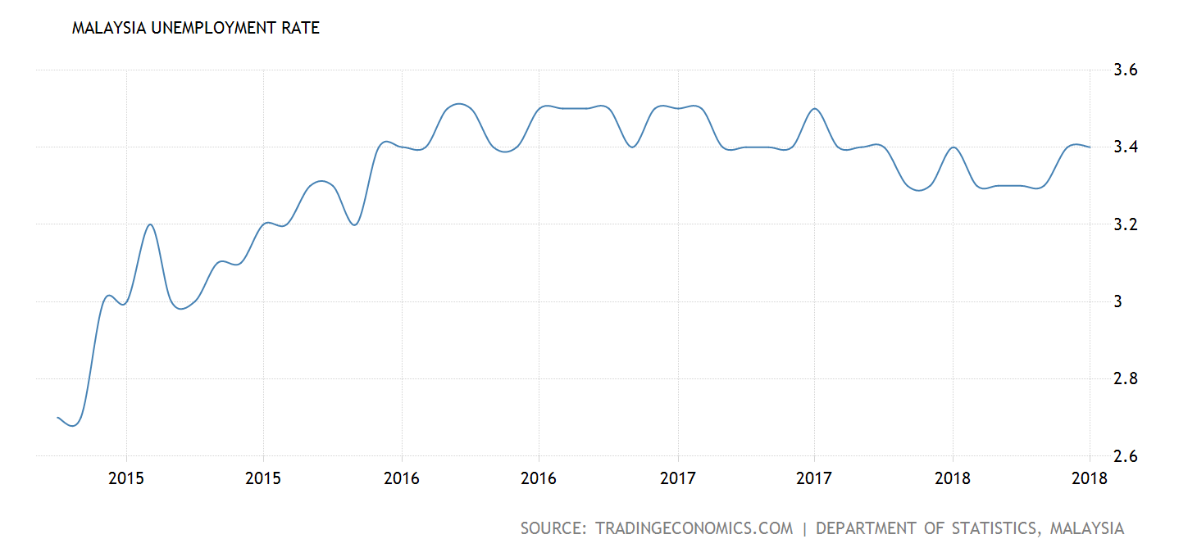

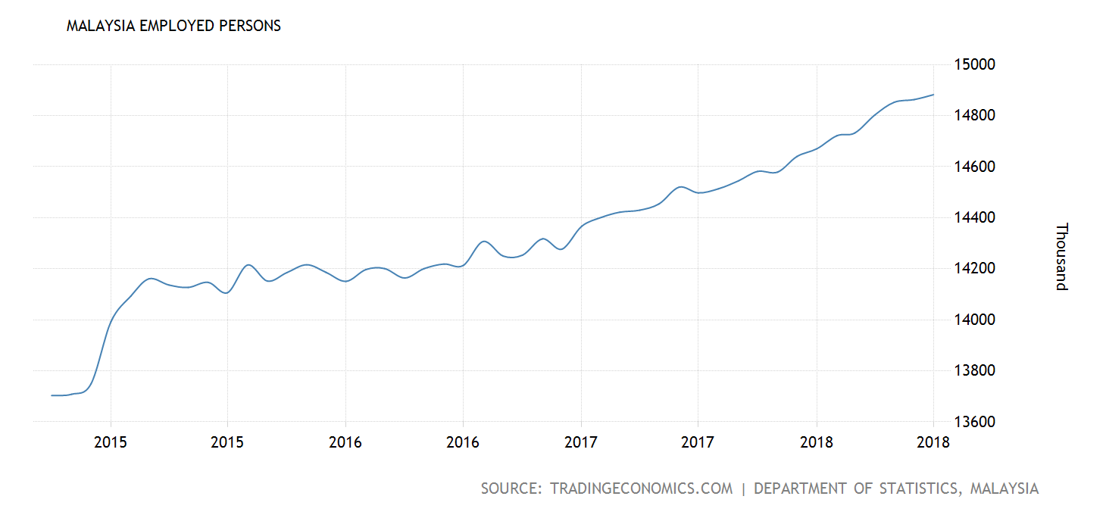

In my point of view, I believe this program can help me to increase my income and I can get extra pocket money if I join this program. It is different from other program out there because first, it is program that collaborate with Malaysia Communication and Multimedia Commission (MCMC) which is government agency and of course they have license to conduct this program. Second, because it is under government agency thus it is free. If I join the program out there, I must pay at least RM100 to participate that program. So, why must we spend a lot of money there, when we can find the free one here? Next, I don’t have to worry about where I want to go after this because the mentor will guide me until I can open my own business. Hence, I can survive in the future. Lastly, MDEC provided an experienced mentor to teach, encourage, and guide us to be a successful businessman. From the experienced that they have faced will make me more careful to start my journey as a businessman.
My reflection towards this industrial talk is not all people that have higher education certificate cannot success in their life. From what I have read about eRezeki, I found that all the participant in this program only have SPM as their higher education certificate and they earned a lot of money from what have they done. Actually, there is a lot of people have succeed after they joining the program under MDEC especially GLOW. Many of them can make hundred thousand ringgit per year and it is not impossible if we work harder like them.
Next, I think all fresh graduate must become more open minded in term of looking for a job. They think it is hard to find a job nowadays. Thus, after they have failed to find they will stop and never try to get another job. This is because the number of unemployment among fresh graduate increase. At the same time they don’t know there is many initiative that government have done to help them to get a job. They also never think that MDEC have prepared many platform if they don’t get a job that they want. They can use the skills that they have to become more successful person. I think all graduate to-be must participate the program under eRezeki as a backup plan if they doesn’t get the job that they want.
Lastly, I think computing skills is very important among Malaysians because many of us is lack of computing skills. I think in 10 years to go each of us must have knowledge about this skills although we doesn’t get involve in ICT field. It is because in the future anything can happen. It will make us lost if we doesn’t have this skills. At least we must have basic knowledge about C++ because in the future we must interact with computer. Thus, I think all Malaysian must get to know all the computing skill start from primary school with the basic programming of C++. Then, 10 years to come it will easy to them to get a job that they want.
In the nut shells, this world is becoming a world of economic digital because many technology has been created by the intelligence people that open many job opportunity. It is become easier nowadays because we can created our own job right on our fingertips. This modern technology lifestyle have make some changes on a personal individual lifestyle. But there is many people that don’t know how to make this technology become a benefit in our daily life. Therefore in Malaysia, there is many initiative that have been planned by government and non-government institution to be a guideline to those who want to change their lifestyle. One of the organisation that very concerned on this issues is MDEC. MDEC preparing a platform to Malaysian people who want to improve their business skills, to develop their business, and looking for job. They provide a class for the people to learn more how to make many online, they also will provide a mentoring session individually and they also will online monitoring us through the semester. For those who joining these program will have experience working with international company that the criteria that many company in Malaysia looking for their employee. MDEC also will provide a local platform to those who want to join this program. With the mission to help build a sustainable digital ecosystem that will drive Malaysia’s digital economy forward and benefit all Malaysians, MDEC will ensure that the people who joining program under MDEC will not regret because many of the people that participated in this program are able to have a job and create a job for others.

REFERENCE

- https://mdec.my/about-mdec/corporate-profile
- https://erezeki.my/about#
- https://tradingeconomics.com/malaysia/employed-persons
- https://tradingeconomics.com/malaysia/unemployed-rate
- https://www.kkmm.gov.my/index.php?option=com_content&view=article&id=9478:2015-10-26-00-49-57&catid=233:kpkk-news&Itemid=541&lang=en
- http://www.thesundaily.my/news/1604124

