

Industrial Visit Report 3

CIMB Bank

Course/ Section: SCSP/ Section 03
Lecturer’s Name: Dr. Sharin Hazlin Huspi
Group Members: Ng Jing Jie (A18CS0172)
Rachel Lim Jia Chyi (A18CS0236)
Tan Rouxuen (A18CS0257)
Yoo Kah Hoo (A18CS0281)

Contents

No | Title | Page
1. | Details of journey | 2
2. | Introduction | 3- 4
3. | Organization structure | 5 - 8
4. | Services | 9 - 10
5 | Achievements | 11 - 12
6. | Career @ CIMB Bank | 12 - 18
7. | Reflection | 19
8. | Conclusion | 20
9. | Reference | 21

Details of Journey
On 26th October 2018, students of Data Engineering course were arranged to visit Commerce International Merchant Bankers (CIMB) in Kuala Lumpur. We were required to gather at the foyer of the building by 2.45pm. Then, we were divided into three groups of 15 students and moved into the office (level 17) to have a short tour which leaded by Miss Tamilarasy and Miss Magdalene. The design of the office is very modern and systematic while the working environment is very comfortable and the views from the building is very nice. Before entering the meeting room which is located at level 15, there are some pastries and drinks were provided by CIMB. We were given some introduction on CIMB by some speakers who are Mr Qasmal, Mr Ahmad Affzan and Mdm Mariani. The duration of this talk is about 1 hour and a short Q&A session was held for 15 minutes. The question proposed by the students were answered patiently by the speakers. After that, we were having a photo session at the level 17 and the lobby of CIMB building. The visitation to the CIMB ended at 4.00 pm.

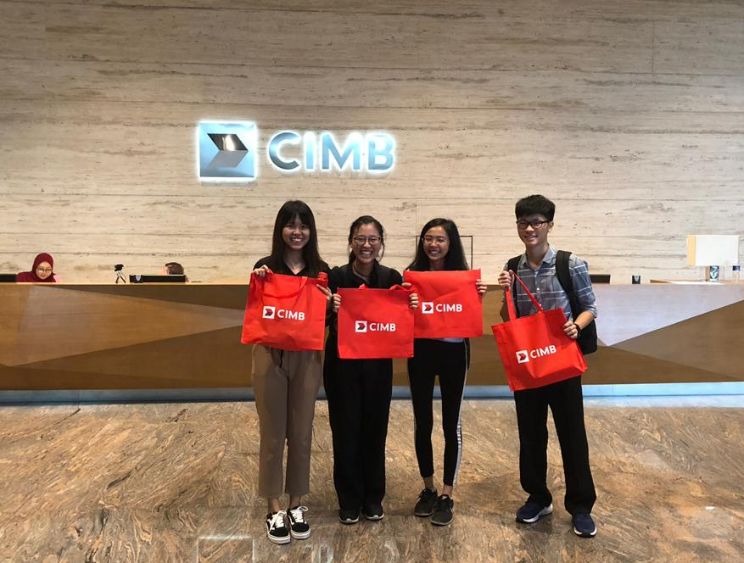
( Figure 1 )

Introduction
Commerce International Merchant Bankers (CIMB) is a group of commercial bank in Malaysia which is leading the ASEAN universal bank. CIMB Bank was established in Malaysia since 1974 and the headquartered was located in Kuala Lumpur. The vision of CIMB is to be the leading ASEAN Company. The mission of CIMB is to provide universal banking services as a high performing, institutionalized and integrated company located in ASEAN and key markets beyond, and to champion the acceleration of ASEAN integration and the region’s links to the rest of the world. The values of CIMB is customer-centric as they exist to serve the customers and sell products and services that customers understand and value. Another values are high performance as they work hard and strategically for customers, staff and other stakeholders and enabling people by empowering their people to innovate and deliver value in their workplace as well as for the community they serve. Besides, strength in diversity and Integrity are also parts of the values of CIMB.
CIMB Bank is the second largest commercial bank in Malaysia. Today, CIMB Bank which is a leading regional universal bank that offering consumer banking, investment banking and Islamic banking, has over 12 million of customers nationwide with 900 branches and above over 16 countries namely Singapore, Thailand, Hong Kong and so on.
The brand architecture of CIMB reflects how they deliver value in different ways to enable the customers to move forward to their goals:

Our leading regional corporate and investment banking franchise.
Consumer and commercial banking in Malaysia, Singapore and Cambodia.
Consumer and commercial banking in Indonesia.
Consumer and commercial banking in Thailand.
Islamic products and services globally

(Table 1 : CIMB’s Brands)
(Source: https://www.cimb.com/en/who-we-are/overview/our-brands.html#read )


( Figure 2 : Commerce International Merchant Bankers (CIMB) )

Organization Structure
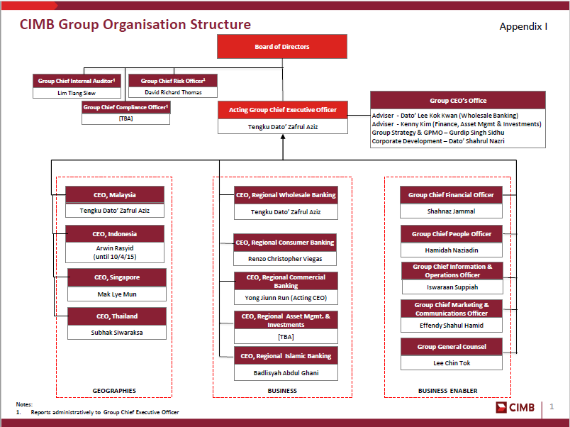
( Figure 3 : CIMB Bank organization structure chart )

The table below shows the board of directors of CIMB Bank in CIMB group.
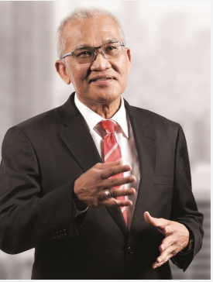  Datuk Mohd Nasir Ahmad | He is appointed as as chairman of CIMB Group Holdings Berhad. He also is a fellow of the Association of Chartered Certified Accountants (ACCA), United Kingdom and Chartered Accountant, Malaysian Institute of Accountants (MIA). He had a master in Business Administration (Finance) in Universiti Kebangsaan Malaysia, Malaysia.
  Tengku Dato’ Sri Zafrul Tengku AbdulAziz | He is the executive director of CIMB Group Holdings Berhad. He is also the executive director of CIMB Bank Berhad and Commissioner of P.T. Bank CIMB Niaga Tbk. He is the fellow of Asian Institute of Chartered Bankers. He completed his Master of Arts in Finance and Management in University of Exeter, United Kingdom, also Investment Management Certificate in Institute of Investment and Research, United Kingdom and Bachelor of Science (Hons) in Economics and Accounting in University of Bristol, United Kingdom.
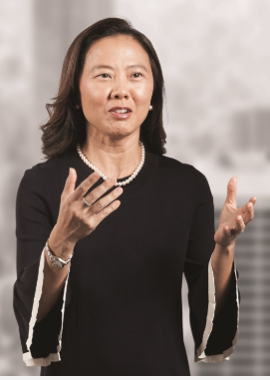  Teoh Su Yin | She is the senior Independent Director of CIMB Group Holdings Berhad. She studied Bachelor of Arts (Hons) in Business Studies, Sheffield Hallam University, United Kingdom, also Business and Technology Education (BTEC) Higher National Diploma (HND) Business Studies in Sheffield Hallam University, United Kingdom and Diploma in Professional Marketing, Chartered Institute of Marketing at United Kingdom.
  Glenn Muhammad Surya Yusuf | He has served on CIMB’s International Advisory Panel since 2006 and he was Deputy Chairman of the Bank Niaga – Bank Lippo Integration Steering Committee in 2008. He also has been a Commissioner of PT Bank CIMB Niaga Tbk since April 2010 and assumed his current position as Vice President Commissioner in June 2012. He pursued in Master in Business Management, Asian Institute of Management in Manila, Philippines and Bachelor of Arts in Economics at University of Philippines in Philippines.
  Watanan Petersik | She is the independent director in CIMB Group and she also is currently the Chairperson of the Nomination, Remuneration and Corporate Governance Committee of CIMB Thai Bank PCL. She had finished her Bachelor of Arts from Bryn Mawr College in USA.
  Robert Neil Coombe | He is the independent director in CIMB Group and also is the Executive Chairman of the ASX listed Austock Group which is a financial services business focused on generational financial solutions. He also the chairman of Craveable Brands which is the largest Australian owned Quick Service Restaurant business. He completed his Bachelor of Laws (LLB) at University of Technology in Sydney, Australia.
  Dato’ Lee Kok Kwan | He was the Deputy Chief Executive Officer (CEO) of CIMB Group.He had a Masters in Business Administration and Bachelor of Business Administration (First Class) in Simon Fraser University, Canada.
  Ahmad Zulqarnain Che On | He is a non-independent director in CIMB Group and also the Deputy Managing Director of Khazanah Nasional Berhad. He had completed his Bachelor of Arts in Economics in Harvard and Radcliffe College in Harvard University, USA.
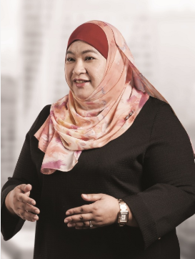  Datin Rossaya Mohd Nashir | She is the secretary of CIMB Group Company. she has more than 20 years of experience in CIMB since 2002, when she joined the Corporate Legal Services Unit in 2004. She had Bachelor of Laws (majoring in Business Law) in Coventry University, United Kingdom.

( Table 2 : Board of director of CIMB Group )

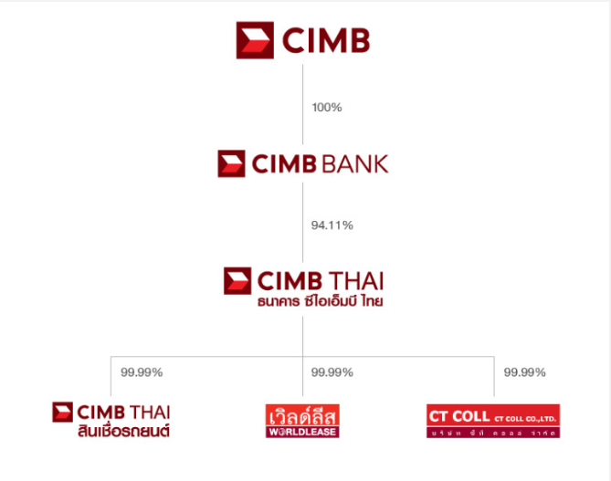
( Figure 4 : CIMB Bank group structure)

Services
CIMB Bank had provides a lot of services such as accounts, cards, loans, investments and insurance to the citizen.
Accounts | - Saving accounts  - Current accounts  - Fixed deposit accounts
Cards | - Debit cards  - Credit cards  - Samsung pay  - Lazada prepaid Mastercard
Loans | - Property loans  - Personal loans  - Car loans
Investments | - Dual currency investment  - Gold investment  - Structured investment
Insurance | - Personal insurance  - Property insurance  - Life insurance  - Car insurance

(Table 3 : Examples of products that provided by CIMB Bank )

Besides, CIMB Bank also provides a lot of products and services for us such as wholesale banking, treasury, asset management, retail and commercial banking and islamic banking. For wholesale banking, it will divides into few categories which are corporate finance, equity capital markets, trade finance, cash management and etc. While debt capital markets and syndicate, cross markets trading and derivatives and government band market making are groups as treasury. Furthermore, asset management can divide into few groups for example, retail and institutional funds, private equity funds and real estate funds. On the other hand, deposit, private banking, loan and financing and etc are categories in retail and commercial banking, while wadiah, mudharabah and sukuk are grouped in islamic banking.
Nowadays, CIMB Bank is a leading regional universal bank that offering consumer banking, investment banking and islamic banking over 16 countries. CIMB Bank is the 5th largest ASEAN bank that have over 900 branches and almost 12 million customers. Their ASEAN operated countries which are Malaysia, Myanmar, Thailand, Singapore, Laos, Cambodia, Vietnam, Brunei, Philippines and Indonesia.
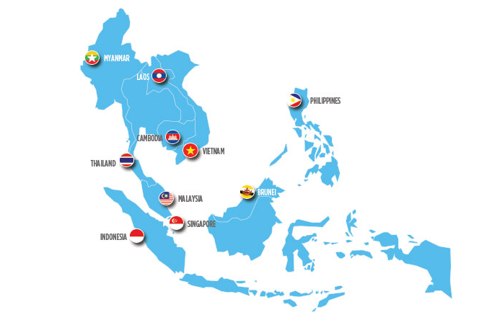
( Figure 5 : CIMB Bank’s ASEAN operated countries )

Achievements
CIMB Bank get a lot of awards since 2008 such as Best Bank in Asia, Best Islamic Bank in Malaysia, 2008 Country Deals of the Year and etc. This is the summarize of the achievement the CIMB Bank got.

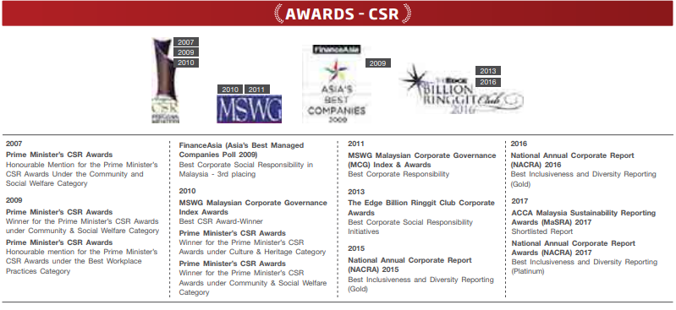
( Figure 6 : Awards that CIMB Bank honored )

CIMB Bank have been awarded 24 awards in 2018, they are awarded by Alpha Southeast Asia 12th Annual Best Financial Institution Awards 2018, Asiamoney Best Bank Awards 2018 and The Asset Triple A Islamic Finance Awards 2018.These are the some awards that had been promulgate to CIMB Bank in 2018.

Award | Awarded By
Best Islamic Finance Retail Bank - Malaysia | Alpha Southeast Asia 12th Annual Best Financial Institution Awards 2018
Best Islamic Finance Commercial Bank - Malaysia | Alpha Southeast Asia 12th Annual Best Financial Institution Awards 2018
Best Corporate and Investment Bank - Malaysia | Asiamoney Best Bank Awards 2018
Best Bank for SMEs - Malaysia | Asiamoney Best Bank Awards 2018
Most Innovative Investment Bank for Islamic Finance | The Banker Investment Banking Awards 2018
Overall Winner – CIPS Procurement and Supply Team of the Year | CIPS Supply Management Awards 2018 Asia
Best Process Improvement Initiative | CIPS Supply Management Awards 2018 Asia
Best Islamic Investment Bank – Malaysia | The Asset Triple A Islamic Finance Awards 2018
Best Retail Sukuk | The Asset Triple A Islamic Finance Awards 2018

( Table 4 : Awards that CIMB Bank received in 2018 )

Careers @ CIMB Bank
The speaker, Qasmal Noor who is currently an assistant manager of Graduate & Campus Engagement under Group Human Resource introduced us the details of CIMB Graduate Programme. Basically, there is three main graduate opportunities included:
- Internship (Undergraduates)
- The Complete Banker
- CIMB FUSION

Internship Programme
CIMB offers internship to undergraduates, to allow students to gain exposure on job training, and to develop practical skills in real life perspective of an occupation. Interns will have opportunities to network with top-level managers and interns from other departments, and have chances to start their career in CIMB if their performed well during their internship period. Moreover, this program also allows interns to consider their career path in their future. Students who have positive attitudes and have good performance in both academic and extracurricular activities will have higher opportunity to join this program.

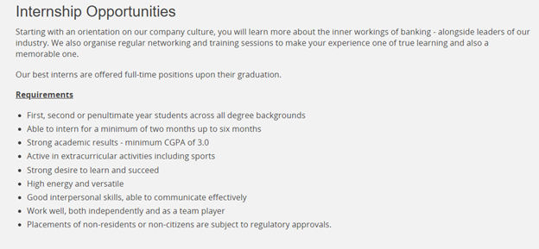
(Figure 7: Introduction and criteria required for an undergraduate to apply for CIMB internship program) (Snapshot taken from https://www.cimb.com/en/careers/graduates-interns/malaysia/internship-oppportunities.html)

Besides, CIMB is also one of a partners of MY ASEAN Internship program. This program is a collaboration between the Ministry of Industry and Trade (MITI) and Talent Corporation Malaysia (TalentCorp), aimed to let more Malaysia youth to aware on ASEAN. This program allows high-achieving penultimate or final year students from Malaysia and ASEAN countries of public and private universities in Malaysia to have internship with Malaysia companies with regional operation in ASEAN countries, and CIMB is one of the companies available in this program.

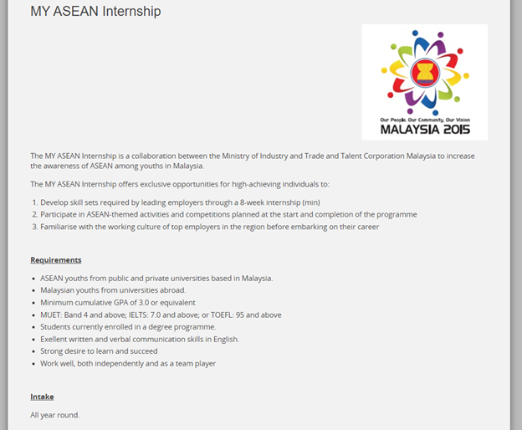
(Figure 8: The details on benefit of joining MY ASEAN Internship program and its application requirements)
(snapshot from https://www.cimb.com/en/careers/graduates-interns/malaysia/my-asean-internship.html)

The Complete Banker Programme (TCB)
TCB programme is a 2 year programme to develop graduates into a leader of tomorrow. In Year 1, graduates have to attend intensive classroom for 1 month. This classroom focusing on foundation building knowledge where banking products, services and how financial markets work will be introduced. This will help graduates to understand more and adapt themselves well to the ‘real’ working world through real life case studies, projects and field trips. The next 11 months involving job rotations, graduates will have to work in 4 different business units in order to complete career track. Throughout this hands-on period, a deeper understanding on the operations of CIMB will be gained and graduates may have to work in a different country with all-time coaching and mentoring.
In Year 2, after completing job rotations, graduates given the chance to choose own development programme which is called elective development for 3 months. Next, there will be job placement for 9 months. Placements in any CIMB office will be based on strength, interests and business requirements.
The options given for elective development included:
1)Regional rotation
2)External rotation with CIMB partners
3) Industry 4.0 related short courses
4) Chinese language and cultural immersion
5) S.W.A.T pool

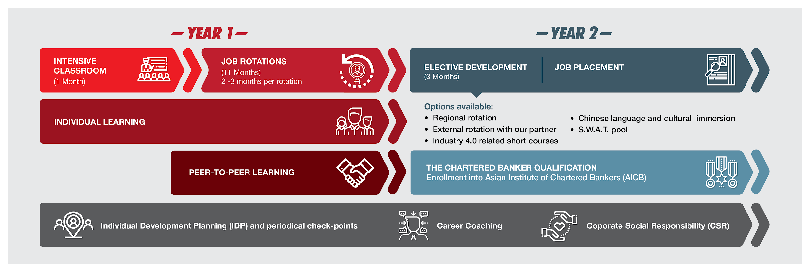
( Figure 7 : The Complete Banker )
(Sources:https://www.cimb.com/en/careers/graduates-interns/malaysia/the-complete-banker-experience.html)

CIMB FUSION
This programme enable graduates to work with CIMB and at the same time, working with another world-class employer in different industry. Graduates get the chance to gain 2 different work experiences and able to decide which employer to work for at the end of this programme. Partners of the CIMB FUSION Programme included PwC, Accenture, DXC-Technology, ZICOlaw and TFM

CIMB-PwC | CIMB-Accenture | CIMB-DXC Technology | CIMB-DXC Technology | CIMB-Teach for Malaysia
4 years, 3 months joint employment programme | 2 years joint employment programme | 2 years joint employment programme | 3 years joint employment programme | 3 years, 2 months joint employment programme
Designed to give fresh graduates a unique opportunity to gain work experience in banking while also working towards their professional accounting qualifications. | Designed to give fresh graduates a unique opportunity to gain work experience in banking as well as consulting. | Fresh IT graduates enjoy a unique opportunity to develop as a banking professional whilst working with one of the world’s largest technology companies. | Law graduates can build an excellent foundation in financial services while training to become lawyers. | Designed to help fresh graduates and young professionals emerge as socially-conscious leaders with the technical skills to succeed in the financial industry.
Eligibility:  Graduates with a Second Class (Upper) or equivalent in Accounting and Finance | Eligibility:  Graduates from all degree backgrounds with a Second Class (Upper) | Eligibility:  Graduates with a Second Class (Upper) or equivalent in IT-related fields | Eligibility:  Fresh graduates with a law degree. | Eligibility:  Fresh graduates and young professionals below the age of 26 from all degree backgrounds.

(Sources:https://www.cimb.com/en/careers/graduates-interns/malaysia/cimb-fusion.html#HP)
Reflection
We feel grateful to have a fruitful acquisition from CIMB. Through this visit, we gained new experiences and knowledges on banking sector, and our perspective towards this sector have changed. After the visit to CIMB, we have more understanding on the working environment in banking sector. Besides, we learnt that besides financial departments, IT departments play an essential role in a banking company, as it is the medium of all banking procedure, include service management, financial and administration, applications and infrastructures. Data management is an important assets of a banking companies and require high-level protection, as it not only stores customers information, it also act as a guideline to help banking company to improve their system and decide the future path.
Besides, this visit also gave us more detailed information of our available carrier in the future. Banking is actually one of the available options we can consider to get into since there are also demands on manpower who have capability to work with big data. However, getting into this sector are not easy as the criteria of qualification is high. This gave us an impact on knowing that what is still lacking among us in order to have higher potential in market.
Therefore, we need to improve ourselves in order to have higher potential and more competitive in the market. We will learn more new things, gain more knowledge and experience outside the lectures, besides work hard to perform well in academic. We will also be active in extracurricular activities to gain new skills apart from academic field. This is important because soft skills will also be considered by employers when taking new employees.

Conclusion
In conclusion, the main activities of the CIMB business is consumer banking, corporate banking, comprising investment banking and Wholesale banking. They even have Group strategic & Strategic investment and Treasury & Market which is a centre market between Malaysia, Singapore, Indonesia, and Thailand. CIMB as the top five major banking group in ASEAN where around 39,000 employees are work with CIMB group and it separates in 16 country across ASEAN, Asia and beyond. Now, the combining banking convenience with the latest technology, the Digital Lounge from CIMB provides comfortable banking activities to the consumers. With 16 strategic locations in major malls, longer operational hours and service on holidays, customers can easily perform more banking activities without time restrictions.

Reference
- https://www.cimb.com/en/who-we-are/overview/our-brands.html#read
- https://www.cimb.com/en/who-we-are/overview/our-presence.html#read
- https://www.coursehero.com/file/15437928/Introduction-of-CIMB-Berhad/
- https://www.coursehero.com/file/24133972/Introduction-of-CIMB-bank-Malaysiadocx/
- https://www.cimbniaga.com/en/personal/products/branchless-banking/digital-lounge/introduction.html
- https://www.cimbbank.com.my/en/personal/products/accounts.html
- https://www.cimb.com/content/dam/cimbgroup/pdf-files/News/Appendix%201%20-CIMB%20Group%20Organisation%20Structure.pdf
- https://www.cimb.com/en/who-we-are/overview/awards/2018.html#read
- https://www.cimb.com/en/careers/working-at-cimb.html
- https://www.cimb.com/en/careers/graduates-interns/malaysia/my-asean-internship.html
- https://www.talentcorp.com.my/initiatives/myasean-internship
- https://www.cimb.com/en/careers/graduates-interns/malaysia/internship-oppportunities.html

