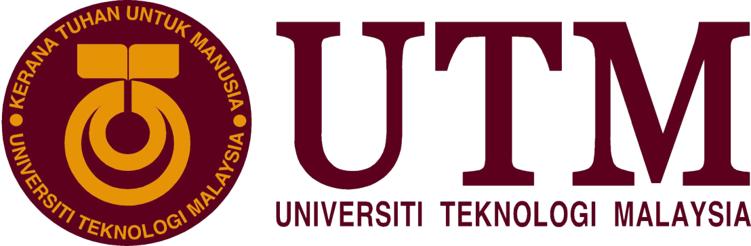

SCHOOL OF COMPUTING
FACULTY OF ENGINEERING

SCSP 1513 SECTION 03
TECHNOLOGY & INFORMATION SYSTEM
SEMESTER 1 2018/2019

INDUSTRIAL VISIT 1
CICT

LECTURER’S NAME: DR SHARIN HAZLIN HUSPI

NAME | MATRIC NUMBERS
NG YOONG FENG
RACHEL LIM JIA CHYI
NUR SYAFIRA BINTI MOHD SYARIPUDDIN | A18CS0202
NURUL ASYIKIN BT HARYANTO

INTRODUCTION

On 1st October 2018, we had our first industrial visit to the Centre for Information and Communication Technology (CICT). CICT is located at Block D07 and it is opposite of N24. The visit started from 11:00a.m to 12:30p.m at Dewan Seminar of CICT. After our previous class, we walked from N28 to CICT and reach there before 11.00pm. After that, we took our attendance in Dewan Seminar with UTMSmart. Around 11.20pm, the talk begun. We were given a talk about the introduction of the organization, management of CICT, safety in CICT, customer service provided in CICT and the future achievement and planning of CICT. The speaker of the talk is Encik Mohd Zahari Bin Zainal Abidin. He is Penolong Kanan Teknologi Maklumat of CICT. After the talk, we had a visit at Computer Lab PPICT and Gallerium. After the talk, we had a visit at Computer Lab PPICT and Gallerium. He gave a short brief of Computer Lab PPICT then we proceeded to Gallerium. In Gallerium, he introduced the historical computer and computer components.

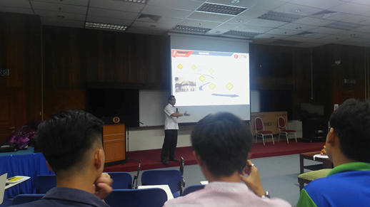

Figure 1

A SHORT VISITATION TO CICT GALLERIUM

All of us were taken to visit some places in CICT. We were first led by Mr Mohd Zahari to the Pusat Perkhidmatan ICT Pelajar (PPICTP) at the third floor. Facilities and equipment provided in the PPICTP are around 200 computers, 3 project discussion areas, printing and scanning area, CD or DVD burning, binding and lamination, and the specialize multimedia and content authoring production lab (SMAL) which allow staffs and students in UTM to access for teaching, learning and research resources with ease. PPICTP is also a One Stop Centre for ICT Services if students encountered with any trouble regarding on UTM ACID account, Wi-Fi and software installation. After that, we also paid a visit to CICT gallerium. There were a series collection of older model computers (Figure 2), computer components (Figure 3), servers (Figure 4), printers (Figure 5), and controller displayed in the gallerium. As we walk around, Mr Mohd Zahari gave us a full explanation on the functions of these old models and development of these models one by one.

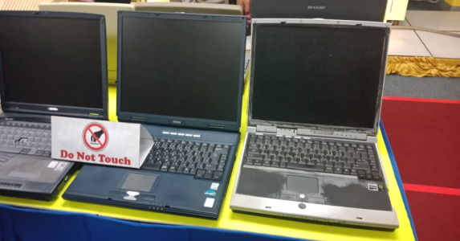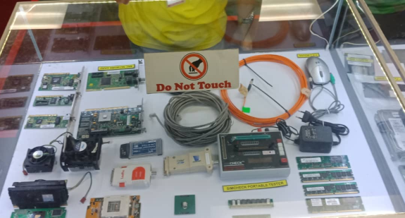
Figure 2 Figure 3

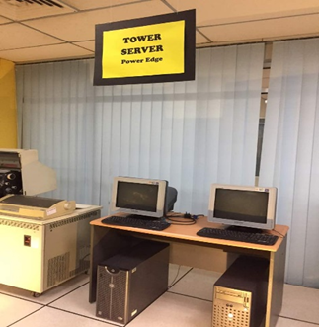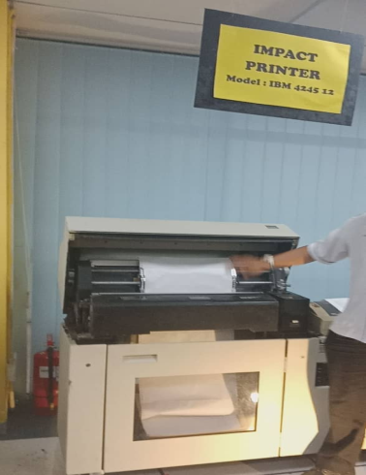
Figure 4 Figure 5
ORGANIZATION STRUCTURE

The director of CICT is PM Dr. Mohd Shahizan Othman. There are 5 main department under director. The first one is Deputy Director ADM which is in charge of application development management by Dr. Mohd Murtadha Mohammad. Next, Dr. Syed Norris Hikmi Syed Abdullah as Deputy Director IOM in charge of infrastructure and operation management. Samsudin Nyat is Deputy Director SM and in charge of strategic management. Deputy Director CICTKL is responsible by Nik Kamal Izuddin Nik Ibrahim which station at CICTKL. After that, Siti Mariyam Mamat is responsible of business development and Sabrena Omar is Senior Assistant Registrar. There are 99 staffs in UTM JB, 18 staffs in UTM KL, 63 staffs in PTJ JB and 5 staffs in PTJ KL. There are total 185 staffs’ works in CICT. With the cooperation of all the staff, CICT is able to operate smoothly and thus improve in the future.

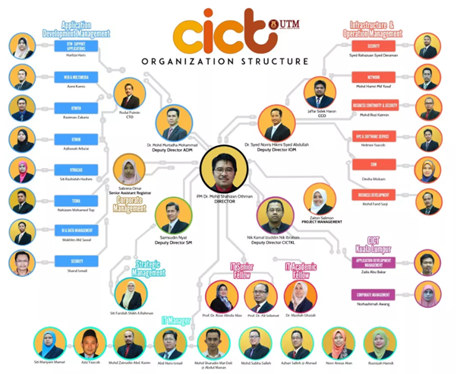

Figure 6

Figure 6 is screenshot of organization structure from http://cict.utm.my/organization-structure/
SERVICES PROVIDED

CICT provides 4 types of service to the student and staff of UTM. The services are infrastructure and security, application development, software and facilities.
First of all, the infrastructure and security provided is ACID and UTM official email account. Once we register in UTM, CICT help us to register the account and create a matric card. This account actually gives us a lot of convenient. The matric card is a identity card of UTM, it store all our information inside and able to access by certain authority only. When we go to library, we can use it to borrow books and lend a discussion room as well as car rental at Student Mall. The information inside is share to certain authority such as hospital and police station, so when we go to hospital with matric card, they will able to identify us as a UTM student. Next, the email given by CICT is a permanent account. All the official information and letter will be sent to the email. We can use it to contact the lecturer or make complain to CICT. CICT guarantee the student and staff the safety of our information inside the database. Thus, CICT provide a high-end security system to guard the database and ensure there is no misuse of the information.
As a top 5 of the research university in Malaysia, CICT provide High Performance Computing (HPC). HPC is used for research purpose. Researcher in UTM needs a supercomputer like HPC to analysis and interprets data. HPC is different from normal computer, it has high processing speed and it can store a lot of data and information. HPC in UTM is more advanced. This is because it is connected to foreign country for cooperation with other university and of course data sharing in research too. HPC in UTM connect to a university in Indonesia. When researchers in Indonesia want to run the HPC, they can borrow the unused HPC in UTM to run together. HPC is a highlight and the reason why there are so many researchers chooses UTM as their research platform among other university.
Video conferencing and streaming is an example of infrastructure provided by CICT. According to the information given by CICT, with video conferencing UTM can save budget up to RM400,000 in 2017. This is a rough calculation for lecturers take flight to UTM, Kuala Lumpur for official task or meeting. During Minggu Mesra Mahasiswa, video conferencing was used to connect both UTM Johor and Kuala Lumpur. CICT also prepares live streaming online at Facebook page so that we can watch the event from elsewhere with Wi-Fi connection.
Besides, CICT provides UTMWiFi. The coverage of Wi-Fi is whole UTM. CICT had succeeded to install total of 1600 access points. Therefore, everyone in UTM can access to Wi-Fi with ACID. Making whole UTM in the Wi-Fi zone gives convenient to everyone. In addition, CICT provide some license software to download such as Nvivo, Matlab and Endnote. Some research purposed software also available to download. Furthermore, CICT provides Virtual Private Network (VPN) service to access UTM intranet from outside of UTM campus.
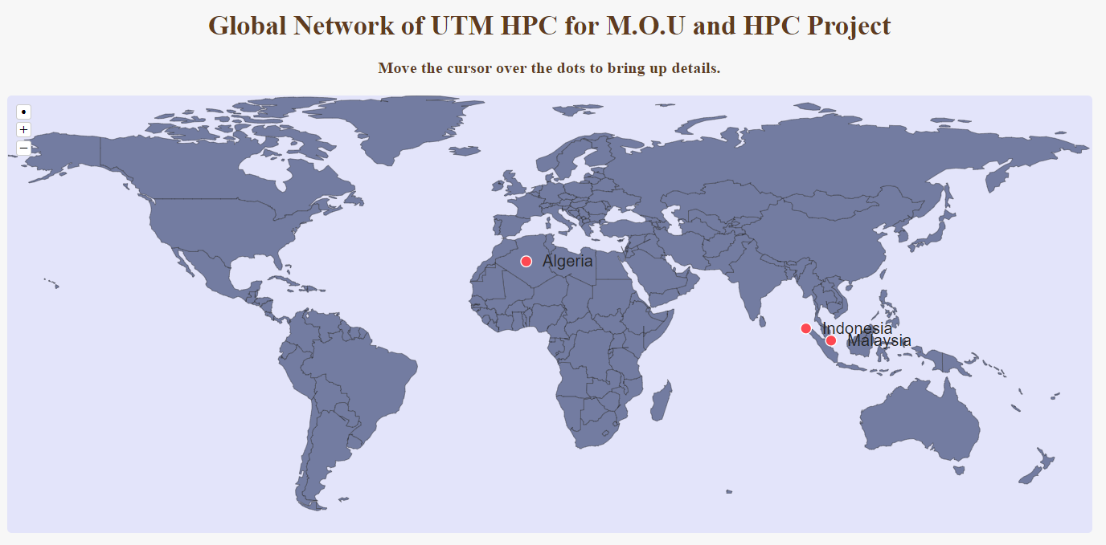
Figure 7
Figure 7 is screenshot of Global Network of UTM HPC from https://hpc.utm.my/

ACHIEVEMENT

The new data center UTM is the largest data center among the universities in Malaysia which had certified with TIER-3 Designed Data Centre that includes 3 major namely Network and Security, Hosting and Cloud services. The impact of this certification is ICT application services is accessible for 24 hours, proper maintenances and higher business opportunity, extra cloud services and hosting services especially in southern region. In the aspect of system development, CICT UTM was also certified with SAGA (Standard Accounting System For Government Agencies) 2017 by Accountant General's Department of Malaysia (AGD) on 22 November 2017.

Integration between systems | UTMFin-product of innovation that recognized by Accountant General's Department of Malaysia
User’s access controlled | Safety of data is guaranteed
Table 1

Table 1 showed the impact of the certification of SAGA. Sources from slide CICT Services Information 2018.

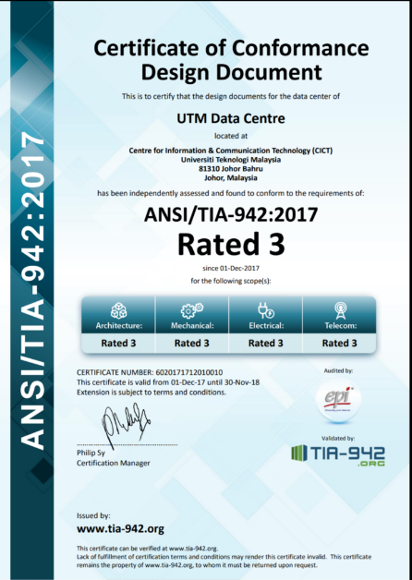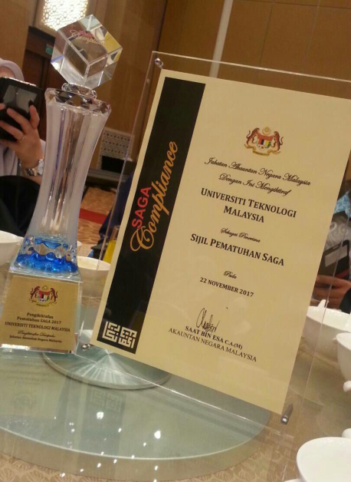

Figure 8 Figure 9

Figure 8 and 9 showed the certificate of TIER-3 Designed Data Centre and SAGA respectively. Sources from CICT website.
INFORMATION SYSTEM THAT DEVELOPED OR MAINTAINED BY CICT

Information System | Explanation
Information Database System (Student/Lecturer/Staff) | UTM has a system that recorded all the individual’s information regarding personal information, academic information, activities and achievement.
E-learning System | CICT developed an online platform where the lecturers can organize the course outline and insert all the information ,assignment so that the students can accessed to it
ACID ID | CICT provides every member of UTM an online identification account which can use to access in UTM Wi-Fi, UTM Portal, E-learning and e-mail.
UTM Portal | CICT developed an online portal for all the UTM students, lecturers and staffs that consist of many kinds of services which enable the users to explore more interesting information and things in UTM.
Mobile Application Software  - School of Computing | CICT created a software system that enables all the students from school of computing can access it to have more understanding regarding their courses in computer science.
2. GuideMe@UTM | This app is developed for the students in UTM especially the first year students to know what are the services and facilities provided in UTM.
3. Usmart | CICT developed this system so that students can only take their attendance in class by using their own ACID ID.
4. BusUTM | This is an app that enables the students to track the school buses and identify the bus that they need to get on board.

Table 2

Table 2 showed some of the information system that developed and maintained by CICT. Sources from slide CICT Services Information 2018.

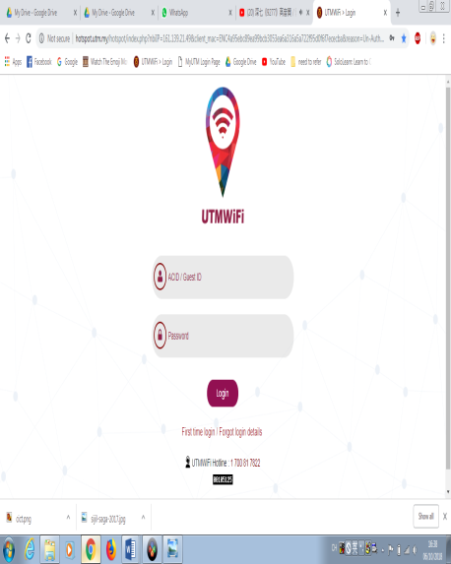
Figure 10
Figure 10 showed the webpage of UTM Wi-Fi. Sources from UTM webpage.

REFLECTION

  - What is your goals/dream with regard to your course/program?
First of all, we really hope that we capable of developing computer systems, design, construct, install, test and maintain highly scalable data management in big data environment. So that, we have opportunity to be part of system analysts, system developers, database technologists, data engineers, data architects, data analysts or so on. Being part of the field of computer science became a great pride to us because this field plays an important role in the life of the society in which it is able to change their lifestyle. Besides, we also hope that we succeeded being computer scientist in both local and global industries and organization where we competent in applying fundamental knowledge, computational principles and skills in computer science. The most important thing is we able to devote to our beloved country or an organization in order to develop an existing data system to be more systematic, sophisticated and creative. Therefore, we really have a big dream to the advance of data engineering through this data engineering program.

  - How does this visit impact on your goal/dream with regard to your program?
This first industrial visit at the Centre for Information and Communication Technology (CICT) does give us a positive impact towards our goals. First of all, we feel enthusiasm to achieve our goals after hearing an informative talk from Encik Mohd Zahari Bin Zainal Abidin because it gives us hope that we will make our dreams come true. Besides that, these visits make us more interested to learn and explore deeply about computing field after been told and introduced about the history of technology and the historical computer and computer component at Gallerium. Visiting CICT was a good introduction about technology to us because we got lots of new information about how huge and large could technology be that makes us blown away a second such as video conferencing and streaming is an example of infrastructure provided by CICT that can save budget up to RM400,000 in 2017. Last but not least, this visit allows us to draw up measures to be undertaken to achieve the goals that have been dreamed. To create success it should start from the beginning. Therefore, we got inspired and encouraged to make our dream and goal become reality in the future.

  - What is the action/improvement/plan necessary for you to improve your potential in the industry?

We reflect that we need to make an action to improve our potential in this industry. For example, we need to diverse our skills in using basic applications software do not just depend on one source therefore we need to explore and mastered variety of basic application software such as for we could learn to use Microsoft Excel, VisiCalc and SuperCalc for spreadsheets. Other than that, we must be bold and confident to present our idea so that people will trust and believes on us. Fostering our communication skills also important thus in the future we be able to make our client trust and believes to use our product. We also realize that we need to strive to find additional knowledge not only rely on lecture in that way we could be an up-to-date and proactive computer scientist.

CONCLUSION

As a conclusion, we can conclude that this industrial visit at CICT UTM Johor Bahru, plays an important role to get idea how important data engineering program for some organization especially for university organization. It is not only data engineering, the other courses in the school of computing such as software engineering, network engineering and graphic engineering also help the system keep running. From this visit, it also reminds us to always be grateful for what we have found now. As we can see, how easy the current student to access all the infrastructures provided by the university compares to the previous generation. From the visitation to CICT gallerium, we can differentiate how much the equipments and devices changed from years to years. We also can conclude that visit to CICT very gives a big enthusiasm to us to achieve our goals to be success in the computer science field. The achievements of CICT also showed how great the CICT staffs and engineers in order to develop the system continuously. Indirectly, they also become a source of inspiration to us to do our best in future. Therefore, we hope the visit to CICT become a tradition to do so that all the students get the benefit (useful knowledge) together.
REFERENCES

Slide CICT Services Information 2018

Unit Web dan Multimedia CICT UTM (2018). Video Pencapaian CICT 2017. Retrieved on October 6, 2018 from www.youtube.com

Achievement. Retrieved on October 6, 2018 from www.cict.utm.my

Shahrul Hafiz (2017). CICT Dan PHB Terima “Certificate of Conformance Design Document”. Retrieved on October 8, 2018 from www.news.utm.my

CICT Organisation Structure. Retrieved on October 6, 2018 from www.news.utm.my

High Performance Computer. Retrieved on October 6, 2018 from www.cict.utm.my

Bachelor of Computer Science (Data Engineering). Retrieved on 8 0ctober, 2018 from www.comp.utm.my
UTM High Performance Computing. Retrieved on October 6, 2018 from www.hpc.utm.my
Spreadsheet. Retrieved on October 9, 2018 from www.en.wikipedia.org

