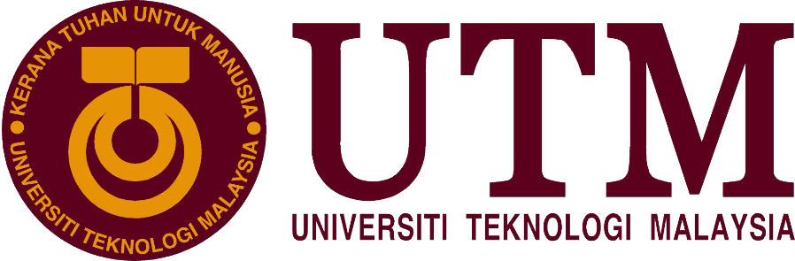

Industrial Visit Report

“New Academia Learning Innovation (NALI) 2018”

Course/ Section: SCSP/ Section 03
Lecturer’s Name: Dr. Sharin Hazlin Huspi
Group Members: Ng Jing Jie (A18CS0172)
Rachel Lim Jia Chyi (A18CS0236)
Tan Rouxuen (A18CS0257)
Yoo Kah Hoo (A18CS0281)

Contents

No | Title | Page
1. | Details of Journey | 2
2. | Introduction of NALI | 3
3. | Exhibition Content | 4 - 9
4. | Trends in NALI 2018 | 10
5 | Reflection | 11
6. | Conclusion | 12
7. | Reference | 13

Details of Journey

On 25 and 26 September 2018, New Academia Learning Innovation (NALI) held an exhibition at Dewan Sultan Iskandar, UTM Johor Bahru from 8am to 5pm. Our group members visited this exhibition on the first day after attending our classes. There is total of 101 booth held in the hall designed with attractive posters. We decided to separate into group of 2 to visit the booths.

Throughout this exhibition, we gained an insight on the innovation products in teaching and learning. Every booth have its unique ideas and learning models. Some example of booth that we visited including Σ-PaLuVed, Embedding design thinking in project-oriented problem-based learning approach and forming teams using personality types differences.

Besides of having exhibition, competitions, keynotes sessions and workshops were carried out in this NALI Symposium too. This provides a platform for NALI practitioners to share and present their research findings and innovations findings to public in NALI fields.
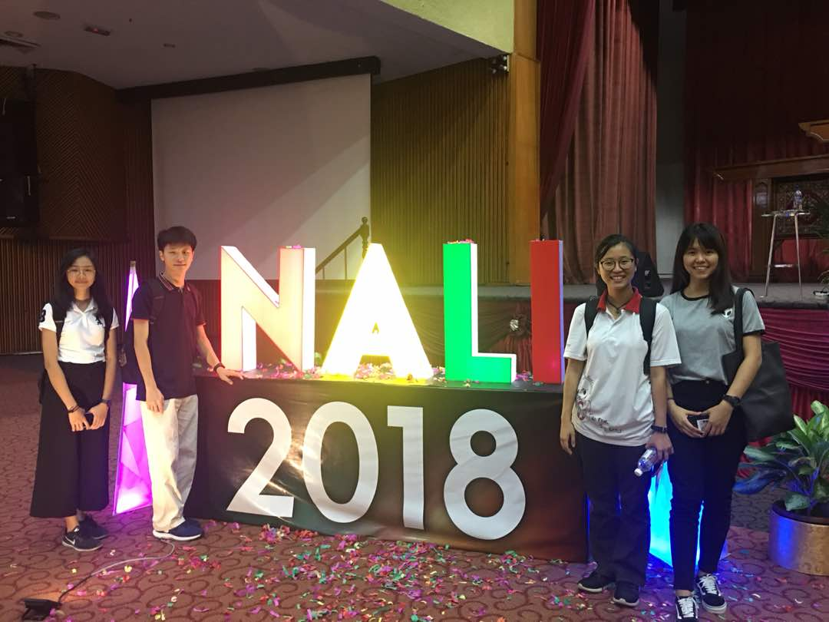

Figure 1: Our Visit to NALI 2018 (members from left: Tan Rouxuen, You Kah Hoo, Rachel Lim Jia Chyi, Ng Jing Jie)
Introduction

New Academia Learning Innovation (NALI) mainly focus on transforming the learning and teaching landscape in the higher education to be future-ready in an era of 21st Century Learning. It’s a celebration for innovative teaching and learning practices. At the same time, promoting best practices in higher education.
NALI provides a platform where research and innovation products in teaching and learning in line with Education 4.0 can be shared and recognized. Through this platform, educators and students are exposed to innovative teaching and learning methods. Besides, academicians can use this platform to exchange opinions, ideas and knowledges on teaching and learning in higher education.
NALI Framework was introduced in 2013. According to Professor Dr. Rose Alinda Alias, Deputy Vice Chancellor in Academic & International, learning emphasis shifts more and more from the all-knowing instructor perspective to student-centred learning towards nurturing an entrepreneurial academia. There are 2 modes under the New Academia Learning Innovation Model, which is :
- Learning Mode (Pedagogy/Andragogy) – Problem Based Learning, Service Learning, Peer Instruction, Case Study Teaching
- Learning Materials (Digital Resources) – UTM MOOCs, UTM-MIT BLOSSOMS / STEMazing UTM, Student to Student Edutainment

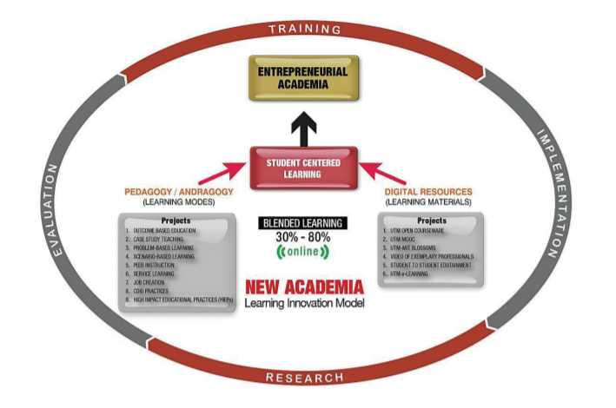
(Figure 2 : Model of NALI)
( Resources : http://ctl.utm.my/nali/pengenalan/ )

Exhibition Content

We managed to interview 3 booths in NALI which are the Project Oriented Problem Based Solving, Personality Type and Sustainable Development to get the information about their exhibition content from the speakers and discuss in the new technology and invention in learning.
First, we went to an exhibition that is embedding Design Thinking in Project – Oriented Problem – Based Learning Approach in Software Engineering course which is held by School of Computing, Faculty of Engineering, UTM and the speaker is Mrs. Noraini Ibrahim. She introduced us about the Project-Oriented Problem-Based Learning (PoPBL) that approach in their teaching in Software Engineering course in UTM, Johor. She mentioned that the Design Thinking (DT) implementation in the Software Engineering PoPBL framework is not only focusing on technical skills in the software project development but also to empower learners with creative skills that are critical for software engineers to solve the real-stakeholders problems in industry-context settings. In this program, design thinking had implemented with the PoPBL by having 4 stages which are empathizing and define the problems, ideate, prototype, and test. Students have to empathize the client’s problems and define clearly the analysis and then give the ideas to solve the problems and develop a prototype demo and presentation to the stakeholders. In 2012, students who involved in PoPBL program had to cooperate with the real-stakeholders, Iskandar Malaysia in Johor to increases the awareness to the public about low carbon immersion and how to reduce the low carbon. Let students solve the real problems with their professional skills, creativity and design thinking was the special part of the PoPBL mentioned by the speaker. They acquire some soft skills through this program such as communication skill because they will cooperate with their team members. Collaboration and teamwork are very important for them at that moment.

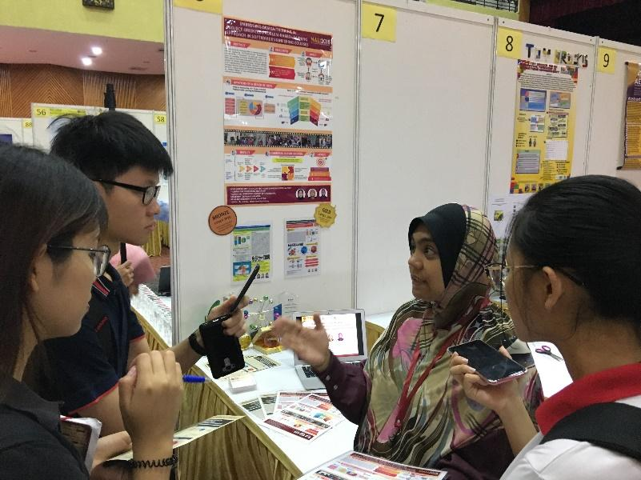
( Figure 3: Mrs. Noraini was explaining to us about Project-Oriented Problem-Based Learning (PoPBL) )

After that, we went to another exhibition booth that is Effective Team Formation using Personality Type Differences in an Interdisciplinary Engineering Education Project which was conducted successfully by Professor Hayati Abdullah, Professor Sya Azmeela Shariff, Professor Fauzan Khairi Che Harun and Professor Norhanisah Abdullah from School of Professional and Continuing Education in Universiti Teknologi Malaysia (UTM). We are so grateful to have Professor Hayati Abdullah to brief us about their project where their team formation was based on the Keirsey Personality Types. She mentioned that lecturers used to divide students according to their gender, race and grades but now they formed a team of 4 members based on the 4 types of personality to cooperate and develop a Hospital Food Delivery Robot. The team members from 4 different school of engineering have their different roles when they have to work as a team and conduct this project. As a result, all of the 15 groups from this project are completed successfully their robotic project above-average marks. This showed that team members with different personality types worked well together in an interdisciplinary project. The design of the idea interdisciplinary project involving elements of 4th Industrial Revolution is a creative utilization of the CDIO approach. The innovation in this study involves the use of the personality types instead of the common methods of team formation for an interdisciplinary project. The results also showed that personality inventories can be used as an academic guidance tool in forming effective teams.
Artisan  Quick thinking and dynamic, confident, outgoing, often become the first to take action. Resilient and adaptable, can persuade others to see their point of view. In direct, they are great storytellers. | Guardian  Individuals who loyal with a great respect for authority.  They respect the rights of others with their passion and talent for monitoring.  Guardians are great planners who always build in contingency.
Rational  Great strategists who can analysis problems from multiple perspectives and will bring well thought-out argument and profound reasoning to concepts and ideas.  Strong-willed and independent, the rational is practical and adept in making decisions based on sound logic. | Idealist  Calm, easy-going and steady.  They have a strong desire to improve their surroundings and the people they meet.  They are creative and passionate and even can move
(Table 1 shows the 4 types of Keirsey Personality)

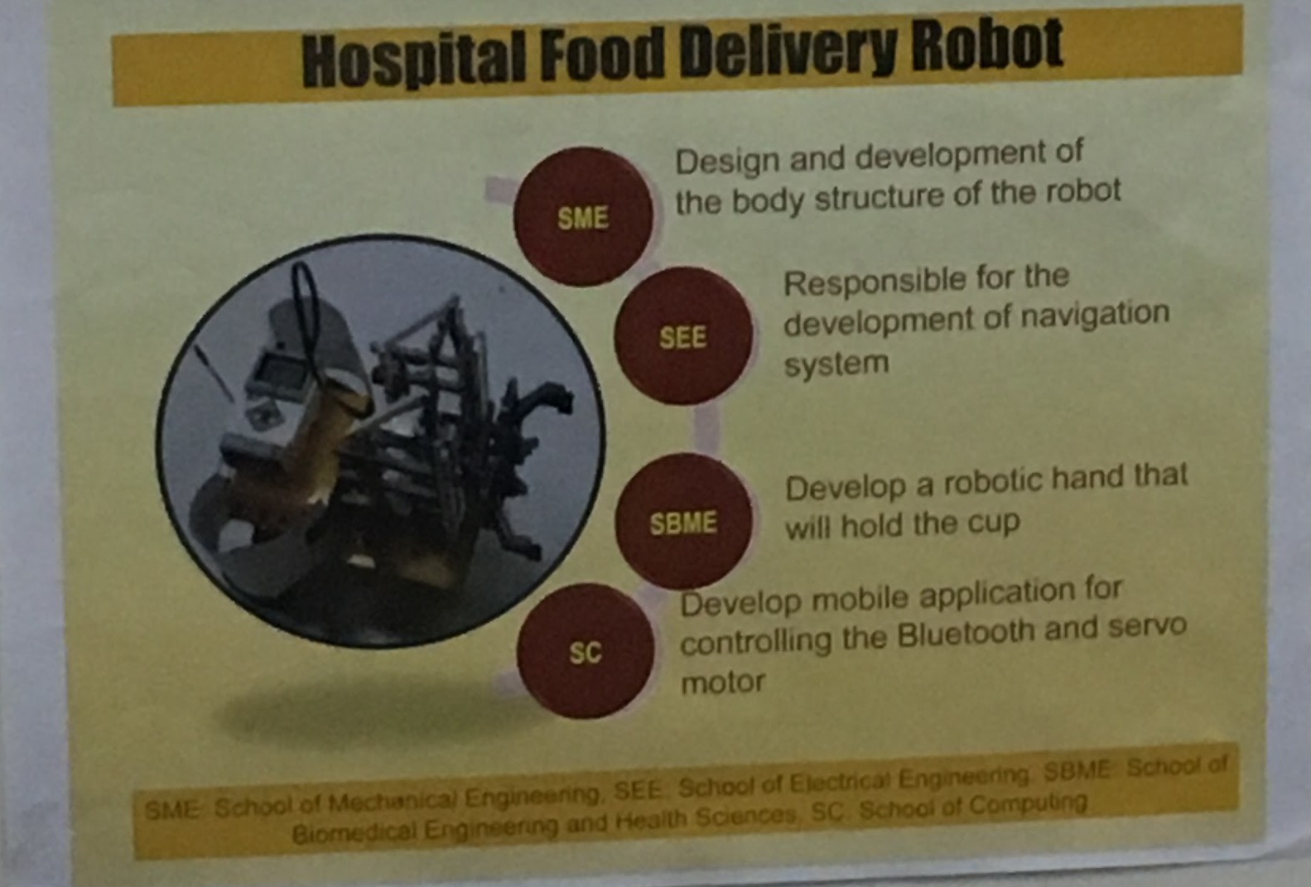
(Figure 4 shows the 4 different School of Engineering and their respective roles.)
Finally, we visited to a booth exhibiting on a unique learning module named Σ-PaLuVed (Electronic Problem Based Learning For Sustainable Development Indicator). The details about this course is explained to us by Pn Noradila Rusli. This module is designed for assisting instructor to let students of Z-generation understand more about sustainable development by integrating games into this module. It is divided into 3 tasks. In first task, students are required to play a simulation game implemented with the concept of sustainable development called eCity. In this game, students are required to solve different game modules such as transportation module and achieve certain objectives. During the process playing the game, they will need to have understanding on the concept of sustainable development while facing different situations, at the same time they will also develop problem-solving skills in real life. After task 1, students will be given task 2, where they need to do an online assessment using “KAHOOT!” prepared by instructor, to evaluate their understanding on what they learned in the game and class. Finally, students will proceed to task 3, which is writing a report on their experiences playing the game and their reflection towards this game, besides their understanding on sustainable development. Now, this learning module is conducting in Universiti Teknologi MARA (UiTM) as an elective course.

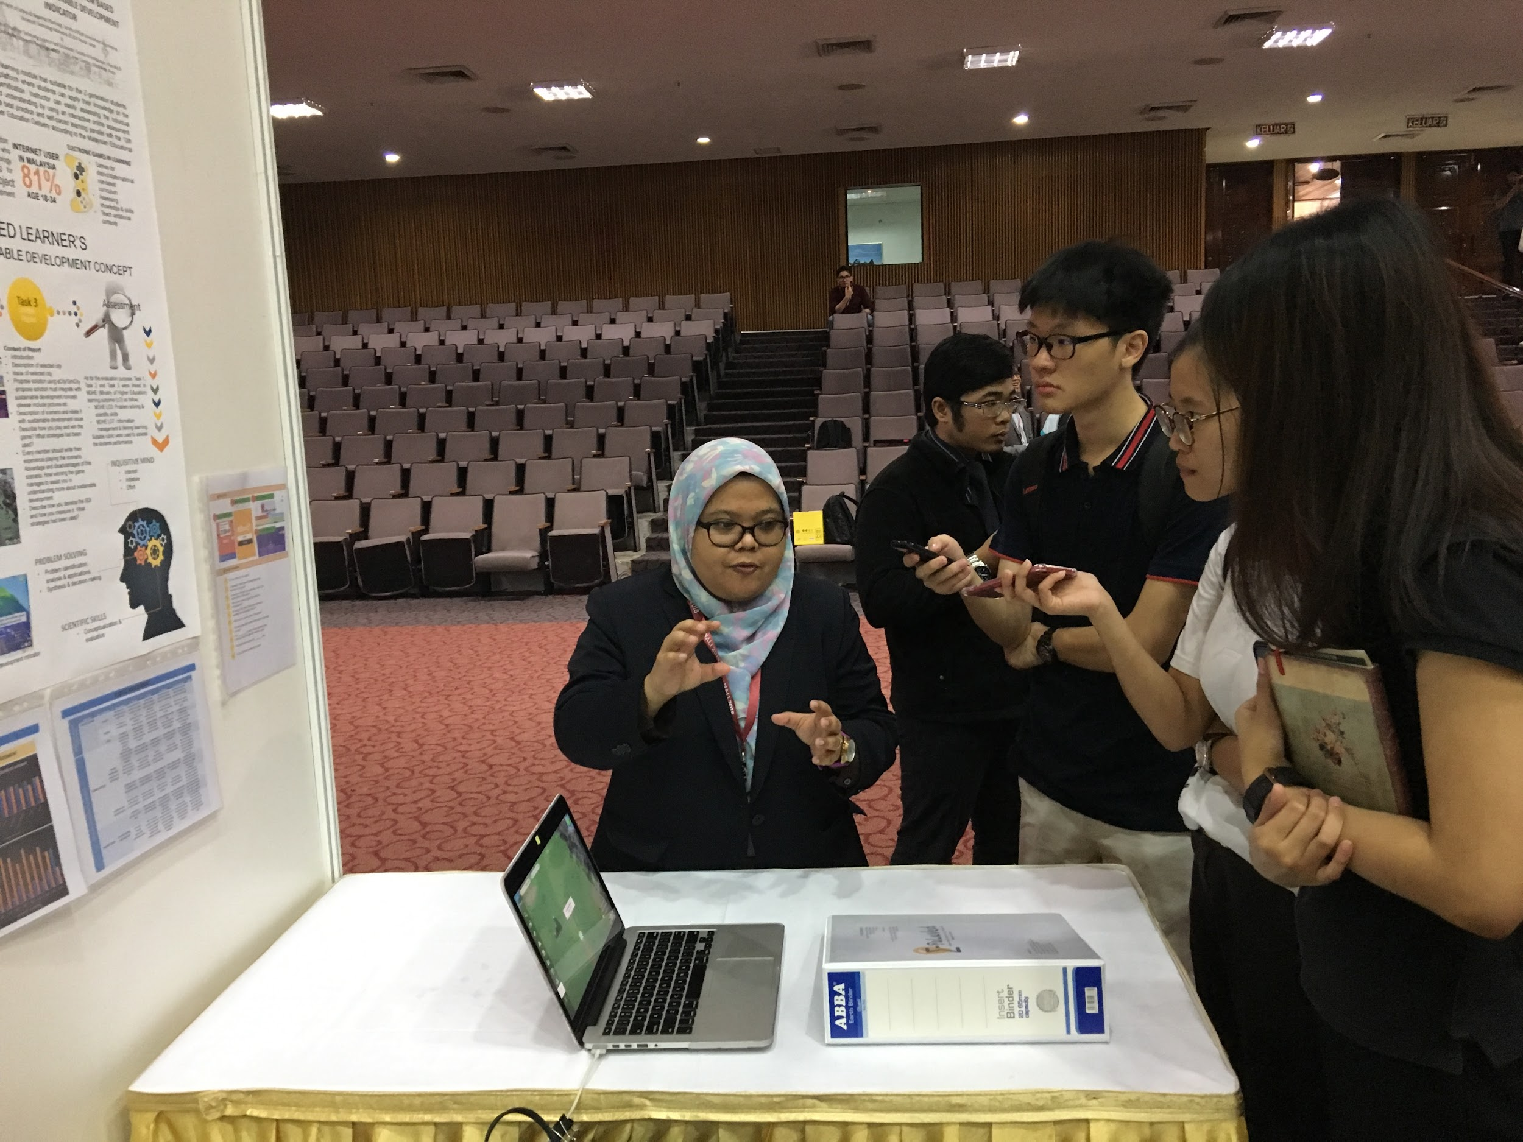

(Figure 5: Pn Noradila Rusli is explaining to us on the system of Σ-PaLuVed)

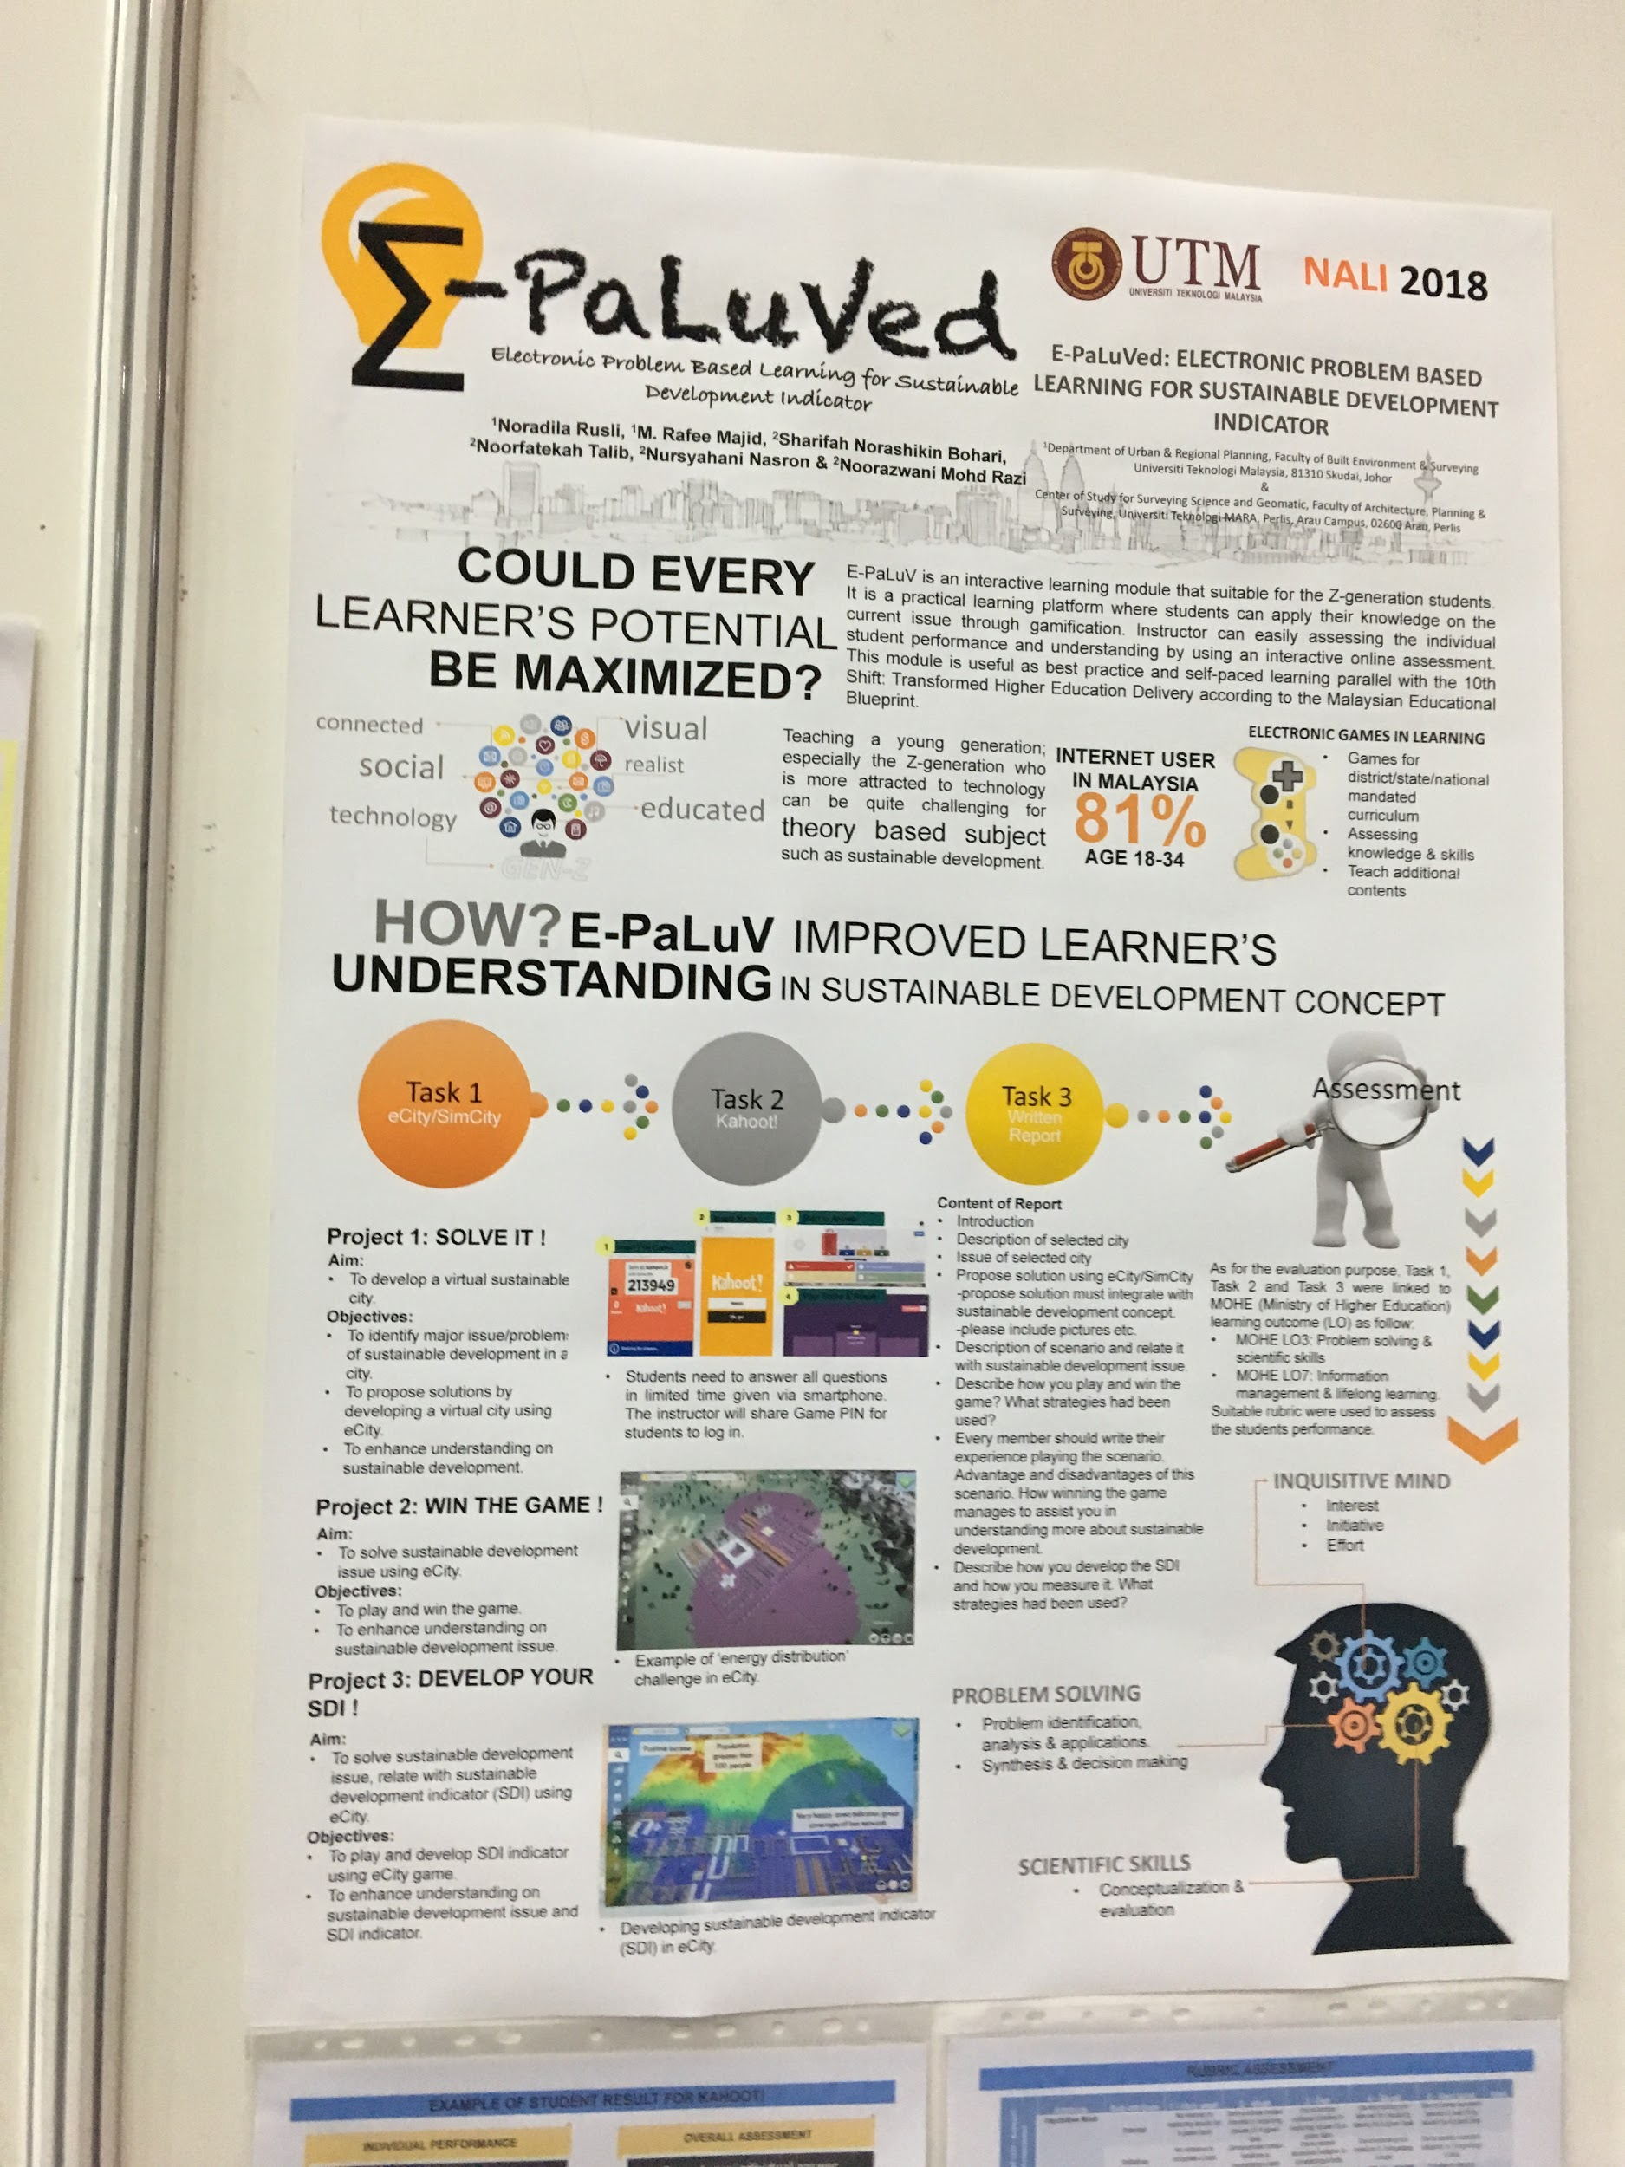

(Figure 6: Infographic of Σ-PaLuVed)

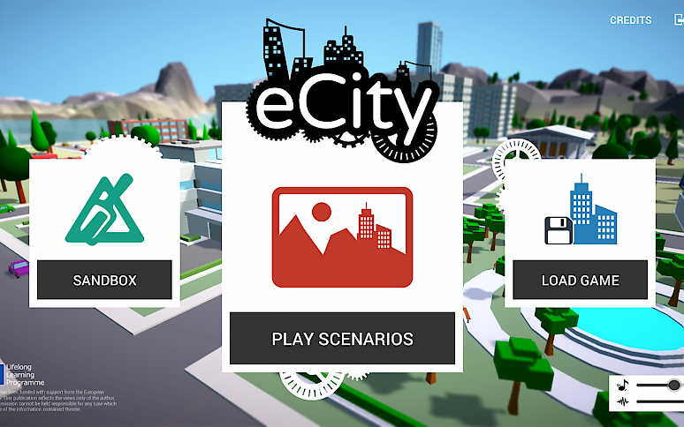

(Figure 7: eCity, a city simulation game (snapshot taken from http://ecity-project.eu/en/game/))

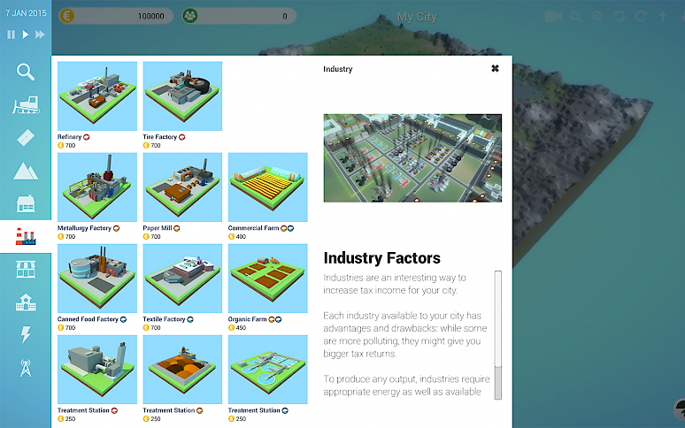
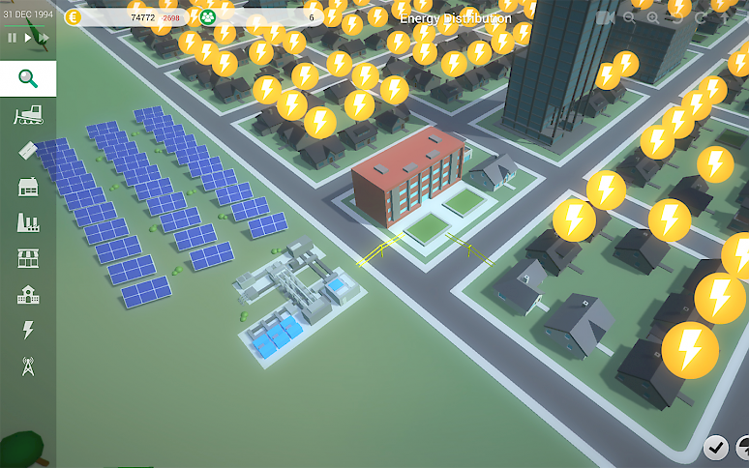
(Figure 8: Gameplay of eCity (snapshot taken from http://ecity-project.eu/en/game/))

Trends In NALI 2018

Nowadays the demand of the industries for the skilled employees is always growing because of the rapid changing of technology. Students are expected to graduate from university with professional skills, soft skills and creative thinking for pursuing their careers in the future.
NALI is a program that blends the technology in education and practicing the students with the practical situations of industries where they can use the concepts that are being taught in the class to solve the tasks.Instead of focusing on the teaching and learning the contents from textbook, students are now asked to practice project-based learning (PBL) as researchers believed that goals, real-life problems, challenges and interaction can be used to engage students and increase their learning outcomes. PBL is a concept of “learning by doing” by giving students the opportunity to develop knowledge and skills through engaging projects set around challenges and problems in the real world. PBL students are able to investigate and respond to an authentic, engaging, and complex problem with sustained attention. The implementation of this concept in education is not only to follow the trend in the world but also to enlarge the knowledge of students. By using technology in academic, animations and videos are implemented during the class and these technologies can address the challenge of the attention span of students. Now the technologies enable the faculty to facilitate students to work on with industrial projects in a collaborative environment, understanding distinct roles in industries and also the importance of communication with team members during their tasks. They will present their works in the form of YouTube videos or in front of the audience to develop the interpersonal skills for example communication skill, team-working and emotional intelligence. Students can develop the self-learning through the flip learning technique because the technique is to let students explore the topic given to them and discuss it in the next class.

Reflection

Ng Jing Jie :
As a student, I personally think that NALI is a useful and good platform for us and the educators as well to make learning and teaching process more interesting. In this NALI model, there is blended learning using the digital teaching materials in class, which is really difference from the traditional teaching. I am sure this will provides us a better learning experience.

Rachel Lim Jia Chyi :
It is a very good experience for me to attend this NALI exhibition 4.0 as I have the opportunity to explore more about learning innovation and trend in this new 21st century. After visiting exhibition booths, I was so impressed that there are so many new learning innovations like project-based learning and game-based learning for students to solve the real-life challenges that they may face in the future. I think this innovation helps students have more passion and interest in learning as it is not a boring task anymore for them either I.

Tan Rouxuen :
NALI inspired me that academic also can be fun by using the technology to study and not like the traditional learning is more boring for the students. Students are more attractive in studying because their lecturers are using technology to each them such as the online app, online program and online games. This innovation may let the students more understanding what thy studying and may perform well in their career later.

You Kah Hoo:
After visiting to NALI 2018, I realised that people starts finding new ways to impart knowledge to students instead of traditional method. More and more educators found that the traditional education system is outdated and less effective to the new generations compared to the past, and they start to find new way of education system which is more suitable for students nowadays such as through gamification and utilising technology and internet, and also implement important skills such as problem solving into the system to produce high-quality human assets. I feel glad to see these changes and hope these initiatives are able to put into practice in the near future.

Conclusion

In conclusion, the role of New Academia Learning Innovation (NALI) in higher education is inevitable. In the process of nurturing graduates who holds the keys to a brighter future for the nation, educators have to make the good use of innovative learning and teaching practices. Also, educators and students should start practicing NALI models with an open minded,

References

- Professor Dr. Rose Alinda Alias, Professor Dr. Baharuddin Aris (2016) A GUIDE TO NEW ACADEMIA LEARNING INNOVATION
http://utmlead.utm.my/wp-content/uploads/2017/08/NALI_10_pages-1.pdf (Accessed on September 30, 2018)
- http://ctl.utm.my/nali2018/ (Accessed on September 30, 2018)
- http://ctl.utm.my/nali/ (Accessed on September 30, 2018)
- https://news.utm.my/2018/06/new-academia-learning-innovation-nali-2018-symposium/ (Accessed on October 2, 2018)
- http://ctl.utm.my/nali2018/exhibition/ (Accessed on October 2, 2018)
- http://ecity-project.eu/en/game / (Accessed on October 2, 2018)

