

UNIVERSITI TEKNOLOGI MALAYSIA
FACULTY OF ENGINNERING
SCHOOL OF COMPUTING

PUBLIC LECTURE TALK 1
MDEC--E-REZEKI AND GLOBAL ONLINE WORKFORCE (GLOW)

Name: Rachel Lim Jia Chyi
Matric No.: A18CS0236
Course: SCSP 1513 Technology and Information Systems
Section: 03
Lecturer: Dr Sharin Hazlin
Date: 7th October 2018

TABLE OF CONTENT

NO. | CONTENT | PAGE
1. | Executive Summary | 3
2. | Introduction | 4
3. | Details of the talk | 5
4. | Details Description | 6-10
5. | Reflection | 11
6. | Conclusion | 12
7. | Reflection | 13-14

- Executive Summary

This report provides an introduction of the e-Rezeki and GLOW initiatives. These programs are a global platform for people to work on Internet and creating community of capable digital workers.
The research draws attention to the benefits and impacts of these programs . The report finds that these programs is contributing to the improvement of our country’s economy.

- Introduction

The school of computing from faculty of engineering had organized an industrial talk by Malaysia Digital Economy Corporation Sdn. Bhd. (MDEC) on their programs e-Rezeki and Global Online Workforce (GLOW) on 24th of September 2018 at Block N28a, Universiti Teknologi Malaysia. This industrial talk is specially organized for all the first-year school of computing undergraduate students to understand the function of e-Rezeki and GLOW which is introduced by MDEC to offer a safe and trustworthy source of income for Malaysia citizens who have a household income of below RM 4,000 monthly^{[1]}.

- Details of the talk

The talk is started from 11 am so the students were asked to gather at the Lecture Hall N28a by 10.55 am. The talk is conducted by Mr. Mohd Ihsanuddin Jamhari who is a Global Online Workforce Master Trainer and a graphic designer of xSuN Graphyx. The duration of this talk is 1 hour included a short Q&A session. All the questions that being asked by the students were answered clearly by Mr. Mohd Ihsanuddin Jamhari. The industrial talk is ended at 12 pm.

- Detailed Description

The talk that was conducted by Mr Mohd Ihsanuddin Jamhari includes the introduction and explanation of e-Rezeki and GLOW with the benefits, participants and the impact of these programs to Malaysia.
First of all, the talk was about GLOW initiatives which is one of the largest program for digital academic in Malaysia. This program is specially introduced by MDEC, government-owned agency under Kementerian Komunikasi dan Multimedia Malaysia (KKMM) for the Malaysians to improve the economy status of Malaysia digitally ^{[3]}.
Before in details, he introduced that Malaysia Digital Economy Corporation (MDEC) had launched a few programs like e-Usahawan which is a program that provides training and teaching for the citizens to promote their products online selling by using the correct techniques. The purpuse of this program is also meant to give exposure and inspire Malaysian citizens as well as micro-entrepreneurs of Small and Medium Enterprises towards digital entrepreneurship to generate rewarding returns through global platform digitally ^{[3][9]}. Program like e-Rezeki and GLOW are introduced as a global platform for the citizens to work on Internet at anywhere and anytime when they are free as they can just finished their work without punch in to office. The participants will also be profiled, trained, qualified and matched against suitable tasks or work on this digital platforms ^{[11]}.
He introduced that e-Rezeki is a program that enables citizens, especially low-income groups, generates additional income by working digital projects via online crowdsourcing platform^{[12]}. The purpose of this program is to benefit the citizens, especially the Bottom 40 percent of household based on income (B40) by enabling and connecting them digitally to income opportunities ^{[5]}. It is online platform where citizens can register as digital workers and perform simple digital-based tasks at the eRezeki centres that provides facilities such as computers and connectivity for the participants if they do not have these facilities ^{[1]}.Then, the e-Rezeki participants will be matched with digital work in line with their respective skills and knowledge like data entry and analysis, accounting and finance, transcript and translate ^{[12]}. Income opportunities on e-Rezeki catered to citizens with difference skills namely Digital Micro Tasks, Digital Work and Digitally Enabled (Crowd services). Therefore, participants will have no worries although they are not expert in Information and Communications Technology (ICT) as there are so many type of income opportunity ^{[12]}. He mentioned that a part of the digital micro tasks, it involved many small task and local platform namely Grab which is one of the platform that provides services like driving and picking up passengers.
Category | Digital Works | Digitally Enabled Tasks | Digital Micro Tasks
Description | Domain specific work / tasks such as application development, creative work and language-based work. Requires specific skills to perform the work and longer time to perform the work / tasks. | Work / tasks such as survey, running errands and domestic services which were distributed online but has to be performed offline / on-site. | Simple task involving data entry, processing of images or actions that requires nospecific skills or high level of skills to perform the tasks. Tasks can be performed and completed within few minutes.
Example | • Web Development  • Mobile Application  Development  • Creative Design e.g.  Graphic, Logo  • Software Testing  • Audio/Video Transcription  • Document Format  Conversion  • Video Footage/Sound Clips | • Mystery Shopper  • Part-time work / crew  • Running Errands / Delivery  services  • Domestic Services such as  Plumber, Electrician,  Cleaner etc. | • Data Entry  • Data Cleansing  • Photo / Image Moderation  • Download-Install  • User Experience (UX)  Feedback  • Search Engine Optimization  (SEO)  • Social M
Table 1 showed the summary of the 3 categories of work on e-Rezeki (Source from eREZEKI PARTNERSHIP MODEL WITH HIGHER LEARNING INSTITUTIONS (HLIs) ^{[8]})
After that, he started to talk about Global Online Workforce (GLOW) which is also an initiative by MDEC that aims to create a community of competitive digital workers among Malaysia citizens who can earn jobs or projects from global crowdsourcing platforms in order to generate alternative incomes. He also mentioned that GLOW is initially named as e-Rezeki Global High Income but to avoid confusion among the citizens, they changed the name to GLOW. This program is to teach and assist the participants to use the global crowdsourcing platform to ‘sell’ their professional skills. He mentioned that the 5 famous creators of the digital paltform like Alibaba, Amazon, Airbnb, Uber and Facebook having a same concept of sharing economy which is an economic model based on sharing under-utility assets from spaces to stuff to skills for monetary or non-monetary benefits. This is mean that they provides a platform to let the people to buy-sell online, sharing information, use their stuff like cars to pick-up passenger and use their skills to earn alternative income. For example, freelancers can use their skill and knowledge to accept many kinds of jobs like translator, journalist and software programmer. This program is an alternative job opportunity for our citizens who have the professional skills.

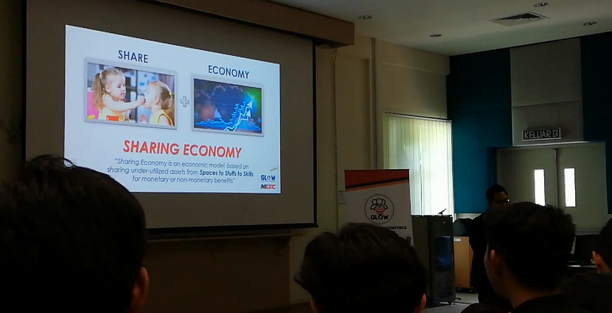
Figure 1 showed one of the slide presentation about sharing economy.

Sharing Economy
SPACE | Office Space and Place to Stay | 
STAFF | Transportation Services | 
SKILL (SERVICES) | Professional and Personal Services | 
Table 2 showed some of the example of Sharing Economy. (Source from Taxonomy of the sharing economy Visioncritical2014 ^{[10]})

The lack awareness of the potential of digital economy has caused B40s household still depending on single source of income. Therefore, MDEC and Astro cooperated togather to hold a campaign with the message of “YouCanDuit” to explain to the citizens that the programs were easy for everyone to learn when it can enable them to increase their income ^{[7]}. Besides, MDEC also had organized many programs and talks at unversity and college such as Universiti Teknologi Malaysia and Universiti Malaysia Sabah^{[2]}. so as to let the students understand the function and benefits of e-Rezeki and GLOW. Citizens can also increasing their understanding of the programs from MDEC through the advertisement on Internet and TV shows. There are some requiments needed to join these programs^{[6]}:
- Malaysians who are 18 years old and above.
- Experienced freelancers or crowd workers in local and global crowdsourcing platforms.
- Individuals who wish to be crowd workers with qualifications in various aspects such as technology and Internet, creative and design, languages and linguistic.
- Experienced offline and face-to-face freelancers.
- Unemployed graduates and retrenched workers with the commitment to become crowd workers
One of the benefits of these programs is creating a community of full time and high quality crowd workers among the Malaysia citizens. It can also establish a sustainable model on the GLOW program through cooperation with strategic partners. Besides, it can also provide an additional source of income for our citizens through various types of digital platform ^{[6]}. Mr Mohd Ihsanuddin Jamhari also showed us some examples of those who involved and succeed in these programs like Miss Suhaiel Binti Amdan who works as translator and transcriber via this digital platform. She is able to earn US $15 per hour and her total income is roughly RM58,000 annually. Besides, Our previous Prime Minister Dato' Sri Haji Mohammad Najib bin Tun Haji Abdul Razak said that 101,693 individuals had undergone training on crowd-sourcing and digital services through e-rezeki program and a total of 57,572 people succeeded in generating income with total RM 81million in the newspaper The Star^{[4]}. This shows us that if everyone especially the B40s can join in these programs and earn additional income via this global platform, definitely it can increase the economy of Malaysia digitally. This will lead our country to undergo transformation from a developing country to a developed country as there will be no more existing of low-income group.
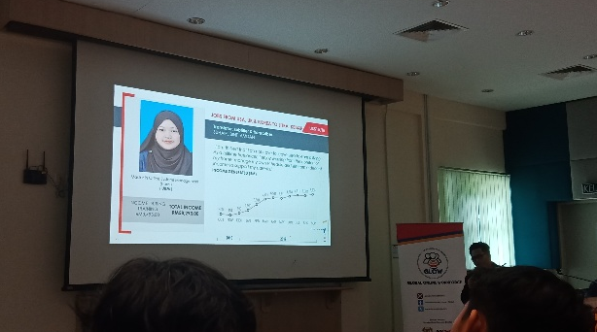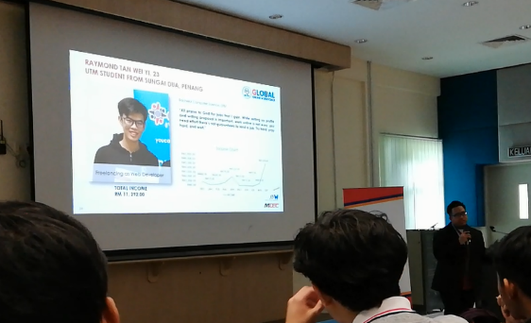
Figure 2 Figure 3
Figure 2 and 3 showed examples of those who get involved in the programs.

- Reflection

First of all, I was so grateful to have such a great opportunity to attend this talk on the programs like e-Rezeki and GLOW that conducted by MDEC. From the talk, I am able to enhance my understanding of these program.
From this talk, I believed that I had learned a lot of new knowledge about the global platform like e-Rezeki and GLOW from the experience of those people who already involved and succeed through these program. Besides, I had understand the benefits and impacts of e-Rezeki and GLOW that are brought to our citizens and country. Hence, I really hope that these type of programs can be often conducted by the government as it really can help to improve the financial income of the citizens through this digital global platform.
On the other hand, I think it is very useful to me as it gives us a concept about what can I do after my graduation or even during my study in university. For example, I can use my professional knowledge and skills like data analysis and programming to accept the job offers from e-Rezeki and GLOW.
Lastly, I hope this kind of activity related about these digital academic can be held more often. This can helps us to be exposed to more ideas that can contribute to our country.

- Conclusion
As a conclusion, the industry talk is very beneficial to all the students who had participated. We have gained many new information about the e-Rezeki and GLOW initiatives by MDEC. This industry talk has induced us into deep thoughts on what is the new trending of digital platform, what can we do in the future and what is the impact of the new global platform to our country.

- Reference
- EREZEKI PROGRAMME FOR MALAYSIANS TO EARN SUPPLEMENTARY INCOME ONLINE (https://www.mdec.my/news/erezeki) Accessed September 29, 2018

- Training of Trainers Global Online Workforce
(http://www.ums.edu.my/v5/en/banner-link/6971-training-of-trainers-global-online-workforce) Accessed September 30, 2018

- E-Usahawan Program
(https://eusahawan.mdec.my/en/program-eusahawan/) Accessed September 30, 2018

- Digital Economy Growth Benefiting Many (https://www.thestar.com.my/news/nation/2017/11/10/digital-economy-growth-benefiting-many/) Accessed September 30, 2018

- Now everyone can benefit from the digital economy
(https://erezeki.my/about) Accessed September 30, 2018

- What is Global Online Workforce
(https://glowmalaysia.com/what-is-global-online-workforce-freelancer/?lang=en) Accessed September 30, 2018

- Case study: Winning strategy behind Astro and MDEC’s eRezeki and eUsahawan campaign
(https://www.marketing-interactive.com/case-study-winning-strategy-behind-astro-and-mdecs-erezeki-and-eusahawan-campaign/) Accessed September 30, 2018

- eREZEKI PARTNERSHIP MODEL WITH HIGHER LEARNING INSTITUTIONS (HLIs)
(http://www.fke.utm.my/wp-content/uploads/2017/03/eRezeki-for-HLIs-Collaboration.pdf ) Accessed September 30, 2018

- 8 Hours Sponsored Digital Marketing Training (eUsahawan)
(https://eusahawancourse1.peatix.com/) Accessed September 30, 2018

- Taxonomy of the sharing economy and examples Visioncritical2014
(https://www.researchgate.net/figure/Taxonomy-of-the-sharing-economy-and-examples-Visioncritical-2014-This-figure-shows_fig1_298722427) Accessed September 30, 2018
- E rezeki digital work corporate deck—e-Rezeki Brief 2017 and introduction to e-Rezeki Digital Work
(https://www.slideshare.net/AsyrafAhamed1/e-rezeki-digital-work-corporate-deck) Accessed October 1, 2018

- E-Rezeki (https://erezeki.my/about) Accessed October 2, 2018

