INDUSTRIAL TALK 2

NEW ACADEMIA LEARNING INNOVATION FOR EDUCATION 4.0 REPORT

SUBJECT : SCSP1513-03

LECTURER NAME : DR. SHARIN HAZLIN BINTI HUSPI

NAME MATRIX NO

NINA KHAIRINA BINTI MOHD KHAIRIL A18CS0175

NUR AFIQAH BAHIAH BINTI ROSLI A18CS0180

NUR AIN BINTI ABU BAKAR A18CS0181

NUR ALIA BINTI JAMAL A18SC0184
1.0 EXECUTIVE SUMMARY

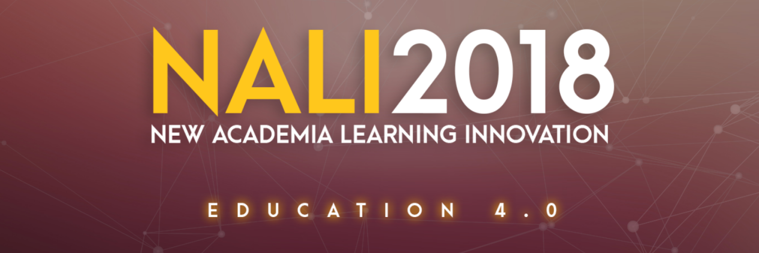
source from : monsoonconsultant

  - Objectives of NALI
From the website , objectives of New Academia Learning Innovation (NALI) includes to align UTM teaching and learning models, activities, materials, environments and systems with Malaysian National Higher Education Strategic Plan, needs of employers and requirements of accreditation bodies.Not only that, NALI was introduced to emulate best teaching and learning practices from the World’s best universities. Next, NALI’s objectives is to develop UTM own identity related to teaching and learning models, activities, materials, environments and systems.Last but not least, it is formed to create meaningful and interactive learning activities, materials, environments and systems appropriate to UTM Graduate Student Attributes.

1.2 Background
Based on the New Academia Book (Akademia Baru : Inovasi Pembelajaran, 2013), Centre for Teaching and Learning (CTL), UTMLead has been given a great responsibility to carry out initiatives under NALI which emphasizes the concept of entrepreneurship. There are two modes under NALI – Pedagogy/ Andragogy and Digital Resources, all of which contains 15 projects. Retrieved from UTMLead. “Akademia Baru Inovasi Pembelajaran” book were introduced in 2013 to guide instructors on implementation of the NALI model.

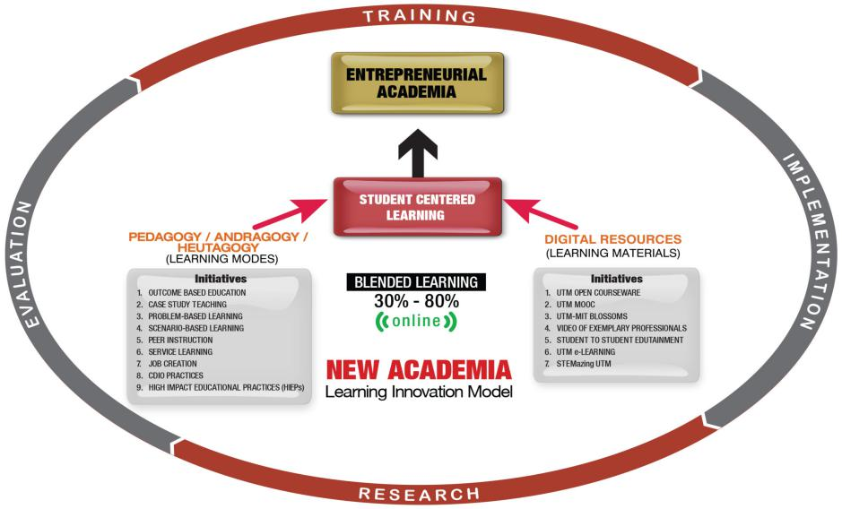
Source from : utmlead

1.3 Concept and Initiatives
The concept of NALI can be defined as in comparison to traditional teaching e.g., face to face learning, the concept of blended learning is emphasized in this model, based from NALI website. Blended learning is a combination of active and systematic strategy with the use of digital teaching materials in class. This encourages better and more meaningful learning experience. UTM NALI initiatives to enrich Teaching and Learning (T&L) are based on well-known and best teaching and learning practices which have been proven to be effective. These best practices include for example Case Study Teaching, Problem-based learning and Peer Instruction.the highlight of iniatiatives at the moment is the Entrepreneurial Academia.

2.0 INTRODUCTION

The NALI for Education 4.0 Exhibition and Competition was held on 25th and 26th of September at Dewan Sultan Iskandar, UTM. The event was organized by CTL, & selected faculties from UTM & ASIA Technological University Network (ATU-NET). NALI 2018 is a celebration for innovative teaching and learning practices. The exhibition and competition is open to all. Individual and group participation (up to 6 members) is accepted and combination of educators, students and industry is highly encouraged.Then, the project submission has to be related to teaching and learning or NALI. To prepare this report, we had visited three booth in order to get information from exhibitors and discuss on the new technology and invention in learning. The booth that we visited are 21,36,32.

The tentative of the program is as below.
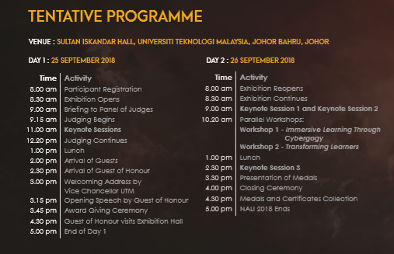

3.0 CONTENT
3.1 Booth 32 :WarpUp App
Warm Up Your Brain (WARPUP) is a mobile application education for ADHD Student Year 2. ADHD or known as Attention Deficit Hyperactive (ADD) is a complex syndrome of impairments in development unfolding of the unconscious self-management system of the brain. ADHD can cause many problems in different areas of life such as friends, jobs or schoolwork. The student with ADHD often has trouble focusing and paying attention in class as they can be easily distracted. Therefore, with the innovation to invent the Warpup application, it really helps the ADHD children in many aspects, especially in education. Moreover, the Warpup application contains the note with melody, tree note map, game hunter and all the videos is directly link to Youtube. The Warpup is a very good application as it contains full chapter for every subject and follows school syllabus. There are two levels in this application which is an easy level and hard level. Easy level is a multiple choices question whereas the hard level is kind of fill in the blank question. This application will help autism kid with their communication skills as this application are very interactive, concise and fun. Next, it provides simple notes for easy understanding so that it can help the student during the examination. For example, student year 6 can use this application for a quick go through the lesson. Besides, this application is free and easy to access. The Warpup application is approved by Kementerian Pelajaran Malaysia and has tested on ADHD children. In conclusion, Warpup gives an impact on ADHD children where they become more focus on towards the subject and enhance their problem-solving skill and literacy skill.
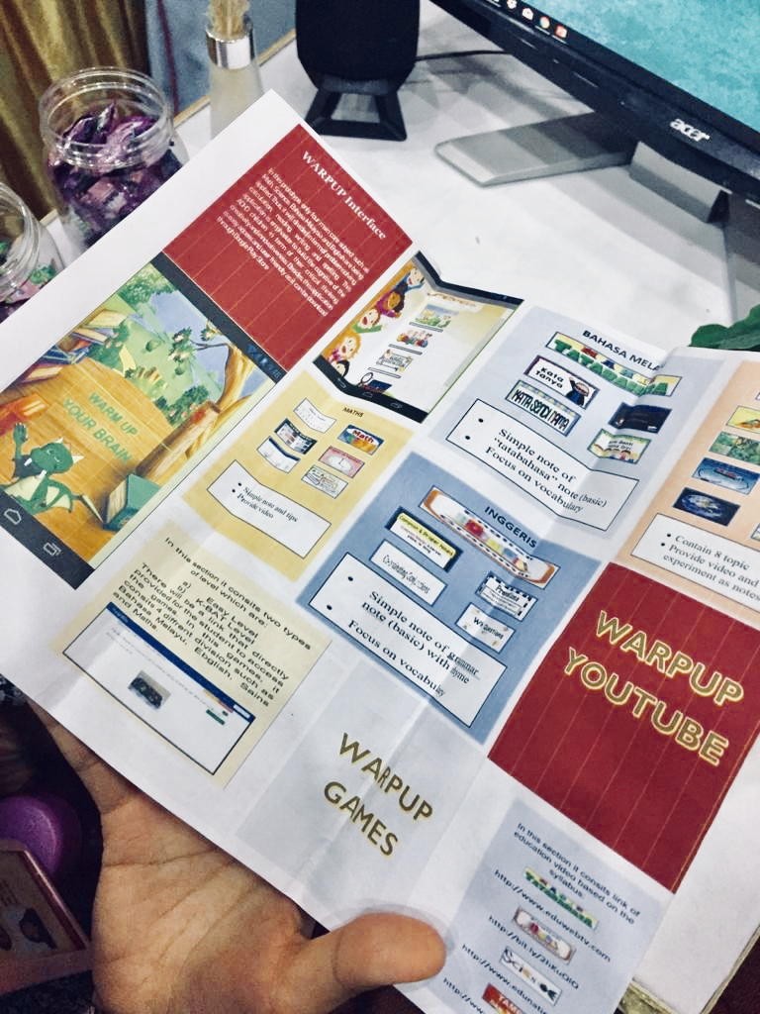

3.2 BOOTH 21 :Effective Team Formation Using Personality Type Differences in an Interdisciplinary Engineering Education Project
The objective of the project is to utilize the Keirsey Temperament Personality Assessment Test to identify a range of personality types for forming affective teams in an interdisciplinary project for an introductory engineering course. There are four temperament groups in the Keirsey theory namely the Guardian, Artisan, Rational and Idealist.

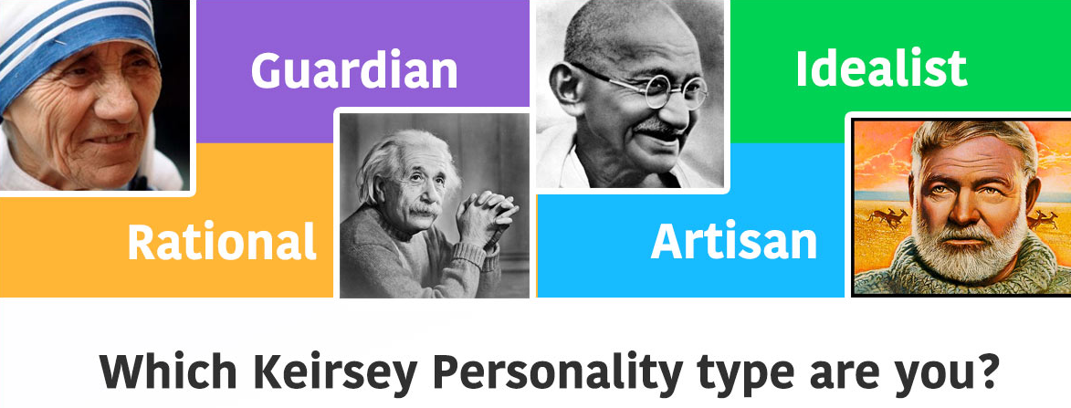
In order to achieve the objective, a total of 282 students were divided into 15 teams and team formation was based on their Personality temperament. Each team needs to work on an interdisciplinary project to develop a hospital delivery robot that will deliver a cup of water between two location. At the end of project, a competition was held and their project were assessed in terms of innovation and presentation skills. The results are as shown below.
( Source from exhibitor ) (Source from exhibitor )

Types of Temperament and their fact
Source from website:
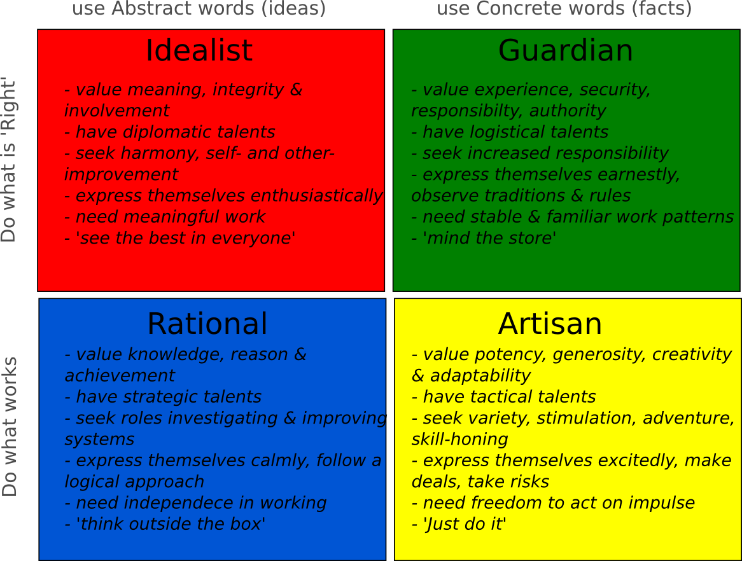

Based on the exhibitors on booth 21, members in all the teams work really well together. Students enjoy getting to know their peers from other courses. Not only that, they were enthusiastic during the group practical, put effort towards the project and play their role well. Meaning that, by having diversity in terms of different personality types in a team have resulted in good overall performance when working together.

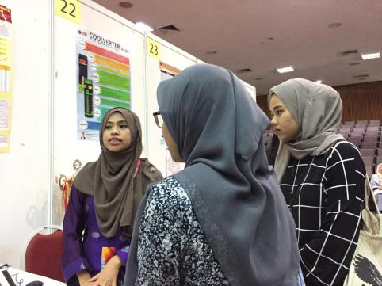

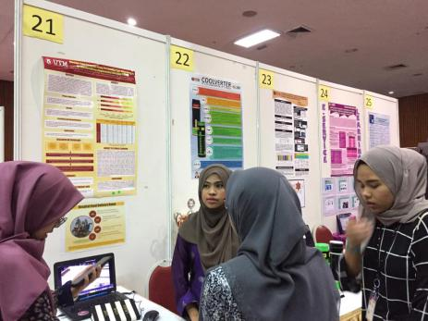

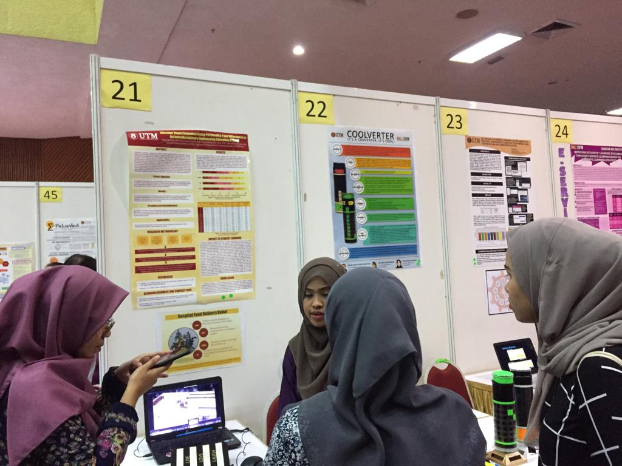

3.3 Booth 36: Monsoon Simulation (MonsoonSIM)
MonsoonSIM is the ERP simulation game that offers a powerful experiential learning platform for business studies. It is a powerful education platform covering hundreds of business concepts ready to be determined by learners through immersive, competitive simulations. Even though there are numerous business games out there, MonsoonSIM is designed to educate staff and employees of large organization to understand how work effective using an integrated computerized or ERP system. The game starts with a very simple scenario and evolves as the same progresses. Players can play together in a team or they can be off-site anywhere on the cloud. Teams will compete to see which team can produce the most profit. MonsoonSIM can be configured to run within a day or even up to a month. It is all determined by the game facilitator and the players. The game starts with a few departments, giving players who are totally new to the game a chance to get knowledgeable with the screen to steer. The game can start at a lower speed, then the game gets incrementally complexed as more departments are added into the game. As a student, having a better understanding of the enterprise system and ERP concept will greatly broaden your knowledge about how a business enterprise is being run. You will learn why the failure of one department can affect the other departments to the point that it may even drop the whole operation of an enterprise regardless from any background of education. In summary, MonsoonSIM is a best possible platform to aid all levels of staff to learn the entire integrated process within an enterprise, learn to work better with each other and appreciate the power of an integrated ERP system.
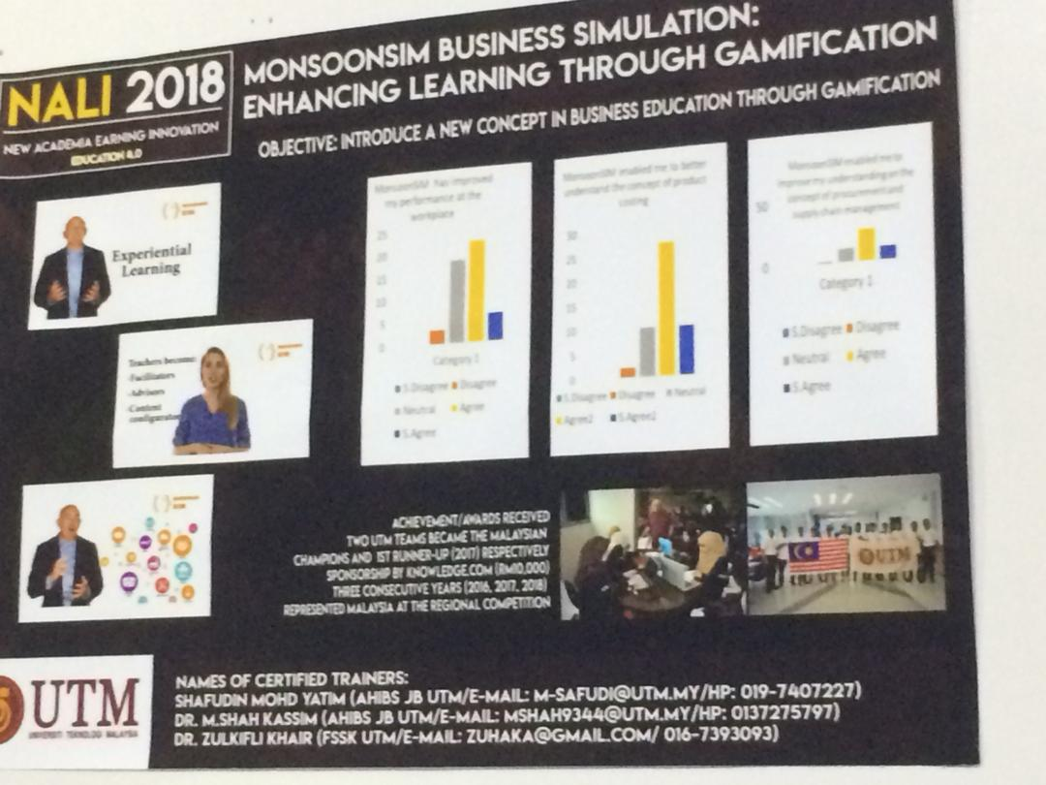

4.0 TRENDS IN NALI
By scanning through each booth from the exhibition, we get to see NALI is rising towards the digital world. Along with NALI’s objective which is to create a meaningful and interactive learning environments, UTM have took part to create an interaction between lecturers, teachers with the students for a better quality in education. Some prototypes and feedbacks were presented during the exhibition to prove the effectiveness of their project. Most of the exhibitions were based on entrepreneurship where they encourage students and people at young age to develop a critical thinking which is also a part of learning process. Changes are done for better quality in education and also students’ performances. UTM has considered ways of learning for all personalities and made teaching and learning easier as explained from 3 different booths.
5.0 REFLECTION
The most obvious difference between the style of teaching and learning is the use of technology. The presents of technology is not meant to spoonfeed students but it also develop their imagination to think creatively and come up with better innovation in the future. Back then there were no electronic devices even internet to stay connected among students and teachers. Now everything is at the fingertips, sharing information are way easier, assignments submission could be done at any time online with internet connection. Technology grows faster than people and for us in the education field we have to stay in pace with current changes. There are always pro and cons in changing the way of teaching and learning. For instance, the advantage is education can be limitless. This way people from all parts of the world could study without having to attend the class physically by joining to an open online courses. It has help to save a huge amount of money and time. A disadvantage to that may be the interaction between educator and student can be limited and there may exist fake information as it is an open source website. Besides, the advantage is more websites and application has ease the process of teaching. For example, Kahoot website allows two way interaction between students and lecturer. Students could respond to any question online using their own mobile phones and without needing to set appointment with the lecturer. But then, this may also effect students’ soft skills in terms of communication. When they depend too much on gadgets, they may lack in terms of soft skills and this issues need to be overcome so that these students are equipped with good quality in academics and soft skills overall. Everything happens for a reasons and the growth of technology in education have changes these students’ way of thinking, how it applies to them and the impact on their career soon. All in all, changes in education is meant to set students on par with current modernisation.
We have come up to a conclusion that UTM has taken a leap to help the next generation in providing better learning quality so that they would produce one in a million graduates. Innovation in academic learning could motivates younger generation to always seek for knowledge and to always improve themselves for a better future especially in digital world. As we know they will be more computer scientist and IT experts five to ten years from now, the next generation will have to compete and develop multi talent to enable them to obtain a decent job and to be able to have that, university is their place to build themselves.

