INDUSTRIAL TALK 1

GLOBAL ONLINE WORKFORCE PROGRAM - MDEC REPORT

STUDENT NAME : NUR AFIQAH BAHIAH BINTI ROSLI

MATRIX NO : A18CS0180

LECTURER NAME : DR. SHARIN HAZLIN BINTI HUSPI

SUBJECT : SCSP1513-03

DUE DATE : 7TH OCTOBER 2018

DATE OF TALK : 24TH SEPTEMBER 2018

TIME : 11:00 AM - 12:00 PM

PLACE : DEWAN SEMINAR N28A

Report on MDEC Global Online Workforce (GLOW)
by Nur Afiqah Bahiah bt Rosli (A18CS0180)

1.0 Executive summary

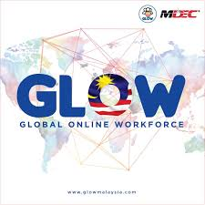

  - Objectives of GLOW

The Global Online Workforce (GLOW) project started in November 2017 and placed in Entrepreneur Hub, Level 3 Block N28 School of Computing, Faculty of Engineering Universiti Teknologi Malaysia. GLOW program is a government initiative to create more visibility and awareness to the Malaysian public to make full time freelancing as an alternative career path. ( Source from GLOW Centre MDEC)

  - Background

The Global Online Workforce - GLOW (formerly known as eGlobal Freelancer) is a program under the Malaysia Digital Economy Corporation Sdn. Bhd. .The Malaysia Digital Economy Corporation Sdn. Bhd. (MDEC), previously known as Multimedia Development Corporation, is a government-owned institution responsible for the management of the Multimedia Super Corridor in Malaysia as a technology industry and commerce zone. This government-owned agency launched in 1996 to pioneer the transformation of Malaysia’s digital economy. Its roots stemmed from vision 2020, the plan to develop Malaysia into a fully-developed nation by 2020. It has introduced three (3) major program including eUsahawan, eRezeki and Global Online workforce (GLOW). ( Source from : https://www.mdec.my/about-mdec )

1.3 Program Under GLOW

GLOW has offered three (3) program which is Higher Learning Institution (HLI), Fast Track and Premium Program. HLI program offers elective subjects for future graduates from selected faculties. Next, you can learn how to get involved in global freelancing through Fast Track Program. 1 or 2 day is an effective and proven method to provide deep exposure workshop. Other than that, Premium Program is a full-time paid programs and intensive exercises with experienced mentors. Details are as shown below.

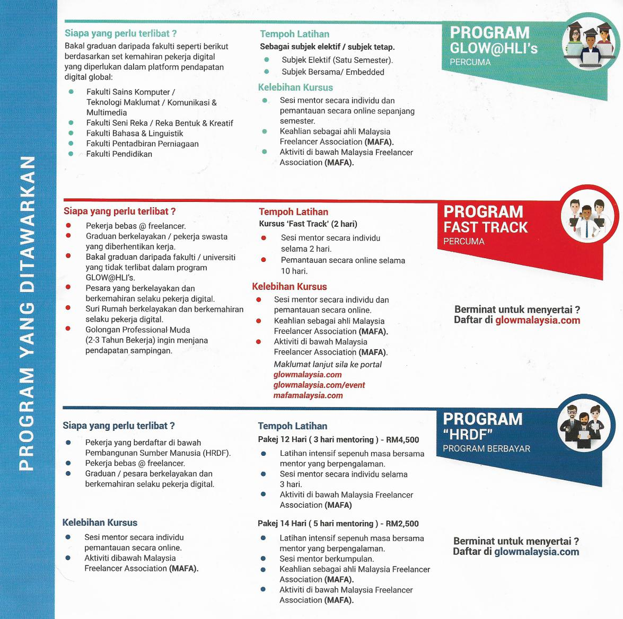

( Source from brochure GLOW)

1.4 Finding and Conclusion

GLOW is a program that guides Malaysians to generate income through digital work via crowdsourcing . Crowdsourcing is a digital revenue method in which work is offered and implemented digitally on a global platform. This program had moved equivalent and corresponding with this era of science and technology.Freelancing in Malaysia is becoming more colorful, diverse and increasingly important to the economy than ever before offering lucrative income alongside greater flexibility. Thus, the programs offers great opportunities for Malaysians to upgrade their economy and skills.

2.0 Introduction

On 24th of September (Monday) , I had quite a exciting opportunity to participate in Industry Talk 1 titled MDEC Glow Online Workforce (GLOW). It was held at Dewan Seminar N28a from 11:00 am until 12:00 pm. This talk was organized by Technology and Information System’s lecturers of School of Computing. There was about 3 sections of Technology and Information Systems (SCSP1513) students participated in this talk. This occasion was dedicated to introduced GLOW and its program to students.

3.0 Content

3.1 About the speaker

Mohd Ihsanuddin Jamhari was graduated from Universiti Teknologi Malaysia in Master’s Degree Technical, Vocational Education and Training. Before that, he was graduated from Universiti Teknikal Malaysia Melaka in Bachelor’s Degree in Electrical and Electronics Engineering. He is now a full-time freelancer in graphic design with 6 years of experience in creative industry. Not only that, he is the master trainer for eRezeki and GLOW program. Other than that,he is a team member of XSuN Graphyx that focus on graphic design, branding and typography. (Retrieve from : https://my.linkedin.com/in/mihsanj )

3.2 GLOW and its benefits

The Global Online Workforce program is a government initiative to create more visibility and awareness to the Malaysian public to make full-time freelancing as an alternative career path. Currently, MDEC collaborates with some of the largest global crowdsourcing platforms such as Freelancer.com and Upwork.com.Through this program, MDEC aspires to train and nurture qualified apprentices to become successful and capable online freelancers in global platforms. GLOW is implemented to create a community of full time high quality crowd workers among Malaysians. Not only that, it can establish a sustainable model on the Global Online Workforce Program through engagement with strategic partners . It is can also provide alternative sources of income for Malaysians via multiple online platforms. Besides that, it is believed to be capable to develop a support program for Malaysian freelancers to remain motivated, driven and committed in earning digital income via crowdsourcing platforms.

3.3 How MDEC get people to join and who can join

#YOUCANDUIT is a digital campaign to raise additional revenue from Malaysians via eRezeki, eUsahawan and Global Online Workforce Program (GLOW) digital initiatives. To convert B40s, Karnival #YouCanDuit was organised in eight states to engaged B40s BTL. Interactive activities, DJ and celebrities appearance and radio cruisers were arranged to keep the participants engaged.Other than that, MDEC has launched the eRezeki and eUsahawan campaign, in an effort to increase the income of Malaysians at the bottom 40% of the income pyramid (under B40s category). The campaign also aimed to enable and connect this group of Malaysians to digital income opportunities. The campaign kick-started with a Sibergurus comedy web series on MDEC owned YouTube channel. In the series, three key characters, Siberudin, Siberjeya and SiberOng – portrayed the challenges B40s faced due to low income, and how eRezeki and eUsahawan changed their lives. B40 targeted ads were also placed on YouTube, social media and other relevant websites to drive traffic to the online videos. ( Retrieve from : https://youcanduit.mdec.my/bm )Search Engine Marketing was also in place to catch users searching aboutGLOW, eRezeki and eUsahawan online.

Generally, everyone can be involve in this program but to be exact, experienced freelancers or crowd workers in local and global crowdsourcing platforms, committed individuals aspiring to be crowd workers with qualifications and capabilities in various disciplines such as ICT, creative and design, languages and others. Second, experienced offline and face-to-face freelancers, registered individuals in employment programs by ministries, government agencies and at state level. Third, unemployed graduates and retrenched workers with the commitment to become crowd workers need to be involve in this program. Besides that, graduates from the faculties listed below with digital worker skills sets necessary to leverage on global digital platforms:

- Faculty of Computer Science / Information Technology / Communications & Multimedia.
- Faculty of Creative Design / Creative & Design.
- Faculty of Languages & Linguistics.
- Faculty of Business Administration.
- Faculty of Education.

3.4 The impact of GLOW program to Malaysia

It is safe to say that GLOW has increased Malaysia's Gross National Index, bridging the income gap and improving standards of living. This is because the campaign that promoted MDEC’s program has generated 78% ROI, reached 10 million Malaysians on TV and radio; generated 52 million impressions on social media; attracted 50,000 footfalls to Karnival #YouCanDuit over eight states, where 30% of them registered on the spot. To date, 259,411 Malaysians registered and 150,581 of them are trained under the eUsahawan and eRezeki programs. They collectively generated RM76,093,328 additional income. ( Retrieved from , https://www.marketing-interactive.com/case-study-winning-strategy-behind-astro-and-mdecs-erezeki-and-eusahawan-campaign/ ) . Below are some of the results from MDEC’s program retrieved from digitalnewsasia.com )

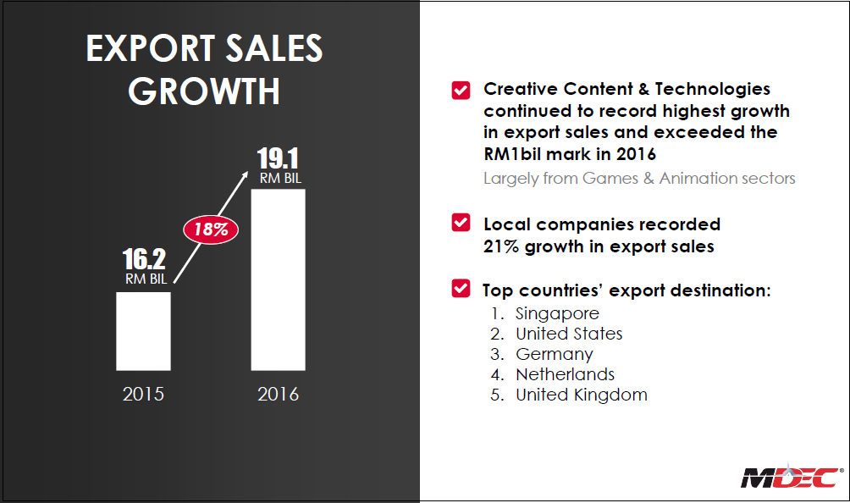

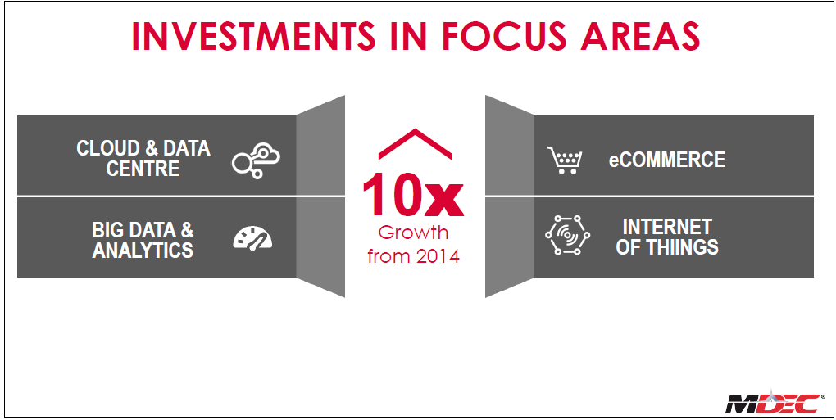

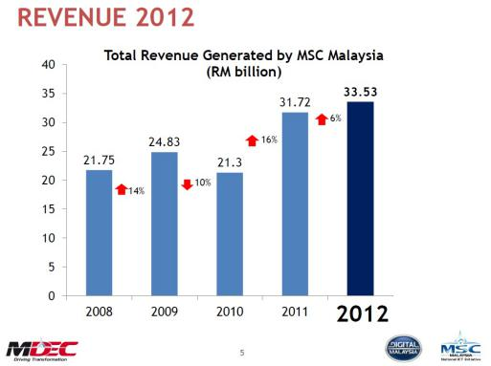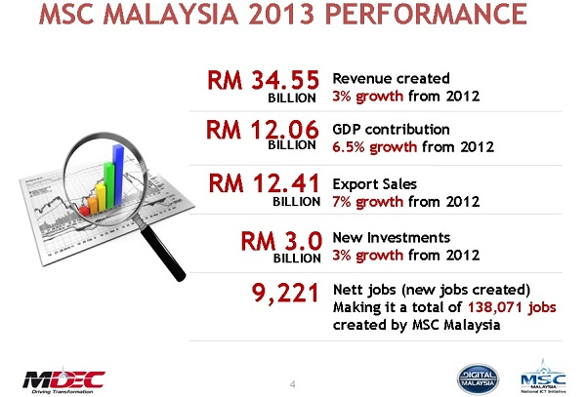

Not only that, GLOW has attracted investors to invest in Malaysia because of its skilled and viable people. Furthermore, the number of unemployed graduates will decrease due as the program have given the opportunities to generate a full time stable and consistent digital income monthly. It has given them the opportunity to show their talent and skills internationally .Students are also able to increase their income as various incentives offered to qualified individual and using the knowledge they have learned in the field. Besides, they can have the experience working with global digital platform. Furthermore, the development of the Multimedia Super Corridor (MSC )Malaysia initiative, the platform to nurture the growth of local tech companies whilst attracting foreign direct investments (FDIs) and domestic direct investments (DDIs) from global multinational companies will continue to increase. Below are some of success stories from GLOW program.

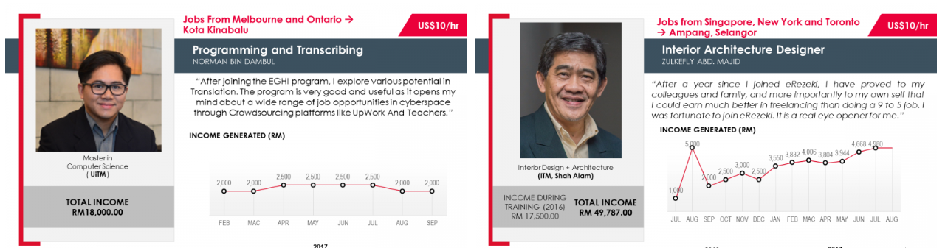

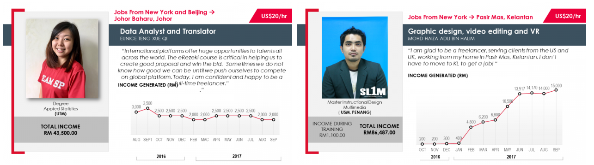
Figure : Successful stories from GLOW program
(Source from : https://glowmalaysia.com/success-story/?lang=en )

3.5 Reflection from the Industrial Talk

From the industrial talk , it encourages me, as Malaysians to embrace technology in their day-to-day lives to improve their socio-economic well being. In this era of Fourth Industrial Revolution, we have to improve and develop our technical skills so that our jobs can not be replaced by non-human technology. Not only that, it teaches us to always grab for opportunity to be a better person at our field and life generally. In order to achieve that, we have to become a creative human being and be good at critical thinking and complex problem solving. We also have to work on our decision-making skills as we have to choose the best choices. For example, if we just graduated and waiting to be employed, we have to think other strategy as back up plan in case something happen. Another example, we can always choose a better job that offer better salary, opportunity and stable position as the GLOW program offers. In addition, GLOW program teaches us to keep broadening our knowledge with joining programs, work with international company and improve our skills.
As a conclusion, we have to always prepared and ready for changes in our life because the world is always swift. To be well prepared, continue learning, reading and writing for good. Welcome to the new world.

