Industrial Visit 1-CICT Report

Topic: Industrial Visit 1 – CICT UTM
Date: 01 October 2018
Time: 4.00pm - 6.00pm
Venue: Centre for Information and Communication Technology
Section: Section 06
Lecturer: DR NOR BAHIAH AHMAD
Prepared by: Nurfa Hadirah binti Tabri
Yeoh Kai Xiang
Tan Chong Lim
Md Belal Hossain Santo
Md Mostafizur Rahman Masud

Table Of Content

No | Content | Pages
1. | Cover page | 1
2. | Table Of Content | 2
3. | Introduction | 3
4. | Details Of Journey | 4
5. | Detailed Description | 5-8
6. | Reflection | 9
7. | References | 10

- INTRODUCTION

Recently, a visit to Centre for Information and Communication Technology (CICT) was organised by School of Computing. CICT is located at Block D07, Universiti Teknologi Malaysia 81310 UTM Johor Bahru, Johor, Malaysia, which is at the centre of UTM. CICT is a support unit that offers and delivers ICT services for the university (staffs and students) especially in ICT infrastructure, system development and academic / administrative activities. The purpose of visit is to expose students about services and contribution of CICT to UTM. It is a great chance for students to learn more knowledge and information.

2. DETAILS OF JOURNEY

The industrial visit was held on 1st October 2018 and it took about 2 hours through the visit which was from 2pm to 4pm at CICT, UTM Johor. The students gathered at N24 at 1.55pm and walk to CICT at 2pm. One of the staff of CICT assisted us to Seminar Hall located level 4 for briefing session. A small talk of approximate 1 hour was given by Mr. Mohd Zahari Zainal Abidin, as assistant IT officer of UTM. The brief was about history, achievement, vision and mission, and services provided by CICT for staffs and students. After the short brief, we were brought to CICT Gallery. The old generation of facilities was exhibited in the gallery. The CICT officer explained in details about the history of the technology used by UTM before ending the session. The visit was ended on 2pm.

- DETAILED DESCRIPTIONS

  - Organization Structure

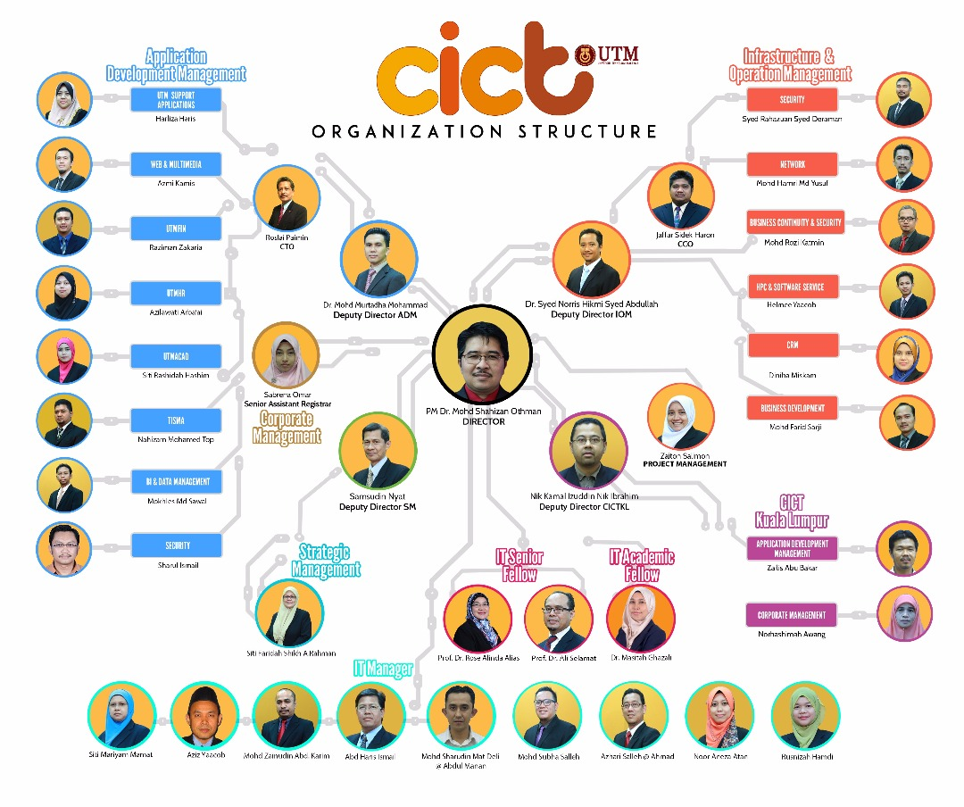

  - Services

CICT has provided a lot of services for the convenient of the students and staffs. Below are the services that was provided by CICT.

Infrastructure & Security | Application Development | Software
ID Account & Access | System Development | Antivirus
Email | Mobile Apps | Wi-Fi Hotspot @UTM extention
UTM Hosting | Multimedia Development | Software Licence By UTM
UTM Ads | Web Development | Microsoft Product
ICT Security | Internet Portal | Microsoft Office
High Performance Computing | Crowd Funding | Research Software
Video Conferencing & Streaming
Wi-Fi
Virtual Private Network(VPN)

Other Facilities:
- CICT Galleria: The Center for Information and Communication Technology (CICT) Universiti Teknologi Malaysia (UTM) launched an Information Technology Galleria located at the UTM main campus.
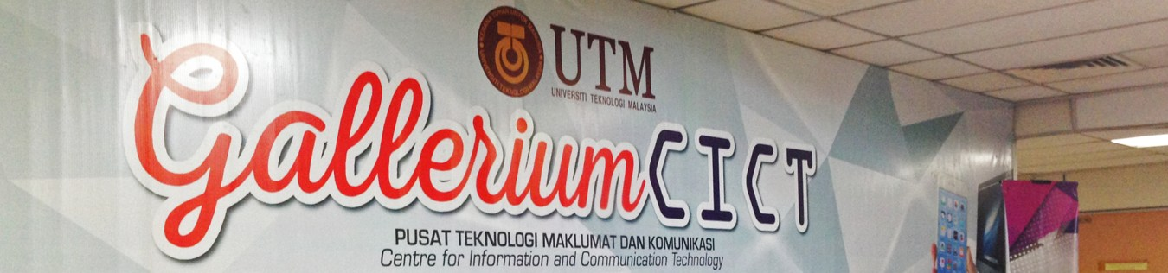

- Training Lab: CICT provides Computer lab for class & training.
  - Information system developed and maintained by CICT

An information system is software that helps us organize and analyse data. CICT also develops information system itself and does the maintenance as well. The university database system includes Academic Information Management System (AIMS), Students Information System, eLearning system etc. UTM develops these information system to store the data of students, staffs and other information. This can help the administration of university to organise and analyse data easier. Next, eLearning system provides a new platform for lecturers to communicate with their students. Lecturers can give a task to students online and the submissions of task can be done by uploading files to eLearning.
CICT also does the maintenance of the information system from time to time. Users will receive email from CICT regarding the maintenance of information system so that they know the reason they cannot access the system. During the maintenance period, all the university information system might be temporarily closed. Users can only access to the database system after the system restored.

  - Achievement
We are about to discuss the achievements accomplished by CICT in 2017. All of the achievements are the proofs of quality services provided by CICT to all the users and indicate the results of good teamwork among the CICT team.
On 22th of November 2017, team CICT had honourably received the Standard Accounting System For Government Agencies Award 2017 from the Accountant General’s Department of Malaysia (AGD). Team CICT had successfully prepared the best technical report and this had qualified them to receive the award. Although competing with 416 agencies national-wide, UTM was able to stand- out and received the awards. Besides receiving award in national level, CICT also achieve success in UTM internally. On 7th of February 2017, CICT had recognised to be the most active Responsibility Centre (Pusat Tanggungjawab) in the Prime Aerobics Program Series2/2017 for Arcturus Zone. 50 out of 123 staffs, which is 40.7% of the CICT staffs had attended this program in Stadium Azman Hashim UTM Johor Bahru. Their presence, commitment and the spirit are the elements of success of the program.
Last but not least, the effort of CICT in increasing the Wifi coverage in UTM campus had achieve success too. Before 2011, there was a limited Wifi coverage with slow internet access. In 2013, the hardware had been upgraded and there is 50% Wifi coverage for Residential College and 60% for Academic and Admin Building. Then, there was a huge improvement for CICT in 2016 because they managed to achieve 100% Wifi coverage in Residential College and Academic and Admin Building, which was supported by LTE 4G to 100% coverage in UTM campus.
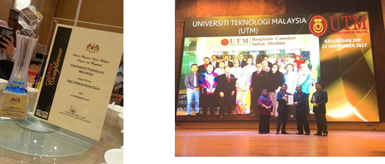

- REFLECTION

CICT has contributed a lot of services for the convenient of UTM community especially the students and the lecturers. The technology provided by CICT also make the teaching and learning processes much more easier and convenient which appropriate with their function as a support units that delivers ICT services for the university.

Our goals are not only to be a software engineers, but also to be the people who involved in developing an IT literate society in Malaysia and build technology or software that ease our daily activities. We also would like to contribute to develop our country through technology and improves the quality of life as we embraced the future of digital technology.

Other than that, the visit to CICT helped us to change our perspective toward our course Software Engineering as there is a lot of careers that can be explored and not limited to software engineers only such as IT manager and so on. The visits also helped us to acknowledge that developing and maintaining a system needs a lot of human sources and involved a lot of IT field such as designing, security and much more. Therefore, we believes that we should improves our skills and our effort to achieve our dreams.

In order to improves our skills, I think we should participate in workshop and competition involving ICT to enhance our skills and creative thinking. We also should sharpened our leadership and entrepreneur skills to expand our knowledge and ICT involvement in the industry.

In conclusion, the visits really motivates us to improves our skills in order to achieve our goals and market ourselves in the industry. The visits also opened our eyes to the variety of career choices in the industry and everything can be improves such as evolution of the computer and the system and also ourselves.

5. REFERENCES
1. http://cict.utm.my/ict-knowledge-repository-2/
2. http://cict.utm.my/about/about-cio/
3. http://cict.utm.my/contact/

