Reports of New Academia Learning Innovation 2018 for Education 4.0

Topic: NALI Symposium
Date: 30th September 2018
Time: 10.30am - 1.00pm
Venue: DEWAN SULTAN ISKANDAR
Section: Section 06
Lecturer: DR NOR BAHIAH AHMAD
Prepared by: Nurfa Hadirah binti Tabri
Yeoh Kai Xiang
Tan Chong Lim
Md Belal Hossain Santo
Md Mostafizur Rahman Masud

- INTRODUCTION
Recently, an exhibition, New Academia Learning Innovation or preferably known as NALI 2018 was held at Dewan Sultan Iskandar, Universiti Teknologi Malaysia at 25th and 26th September 2018. This exhibition was opened for all educators to represent their research, innovation, and insights on improving teaching and learning lessons. The theme that was raised in this exhibition is Education 4.0 which is interesting as it depicts on how education should evolve with high technology in this 21st century and how the educators are implementing it. In another side, NALI 2018 is also a platform for sharing and recognizing innovation products and research outcomes in teaching and learning practices. There were also competition, workshop and talk series which benefits the educators as they improve their competency to practice effective teaching and learning processes.

- WORK PLAN
As the exhibition started its first day on 25th September, we went to Dewan Sultan Iskandar at 10.30 a.m. and gathered to visit the booth. To make the visits more effective, we split into three groups to collect the information from our booth respectively. Three booths were chosen to be included in this report. Below are the lists of the booth that we went:
- MonsoonSim Business Simulation: Enhancing Learning through Gamification.
- Instilling Soft Skills among Form Six Students.
- The Use of Video Recording via Telegram Application as an Effective Tool to Improve Oral Presentations Skills.
Around 11.00 a.m., a keynote session by Prof. Dr. Mustahak Al-Atabi, the CEO and Provost of Heriot-Watt University Malaysia was held with ‘Education 4.0: A New Paradigm of Innovation' as his main focus. Then, the keynote session was continued by Prof. Ir. Dr. Zainuddin Abdul Manan, the Deputy Vice-Chancellor (Academic and International), UTM as the speaker.
After gathering enough information and listening explanations of the research from the representatives of each booth, we dismissed around 1.00 p.m.

- DETAILED DESCRIPTIONS
Each booth that we visit during NALI 2018 are exciting as they implemented technology and more effective learning and teaching skills in education. Therefore, we have more detailed descriptions of each booth that we went during the exhibition.

  - MONSOONSIM BUSINESS SIMULATION: ENHANCING LEARNING THROUGH GAMIFICATION

MonsoonSIM (Monsoon Simulation) is an educational platform for people to learn about how to operate a business. Its simulations included hundreds of business techniques, and it let us to explore those business concepts through the competitive game. It focuses on ERP (Enterprise Resource Planning) and teaching on theory how it actually works. Through the simulation game, one could learn about the concept of ERP, Business Process Integration, integrated business system, the concept of running a huge business and the importance of teamwork in running a huge business.
There will be several teams compete in the game, and one team will consist of five players. In the beginning, every team will be given initial cash, retail locations, and others. One required to buy and sell simulated products in the game through retail, marketing, procurement, etc. Players will need several strategies in order to win the game. The game will run through simulated time which is 90days, such that one day in the game equals to 20 seconds in real life. Players can access to finance, forecast, production, HR, and others during the limited duration. There are several ways to gain profit such as marketing and B2B (Business to Business). At certain level of playing the game, the player can hire workers to improve productivity and HR to provide counseling for workers. After the duration ended, the team that gained the highest point throughout the game, after considering the highest sale, highest profit, etc. will be the winner.
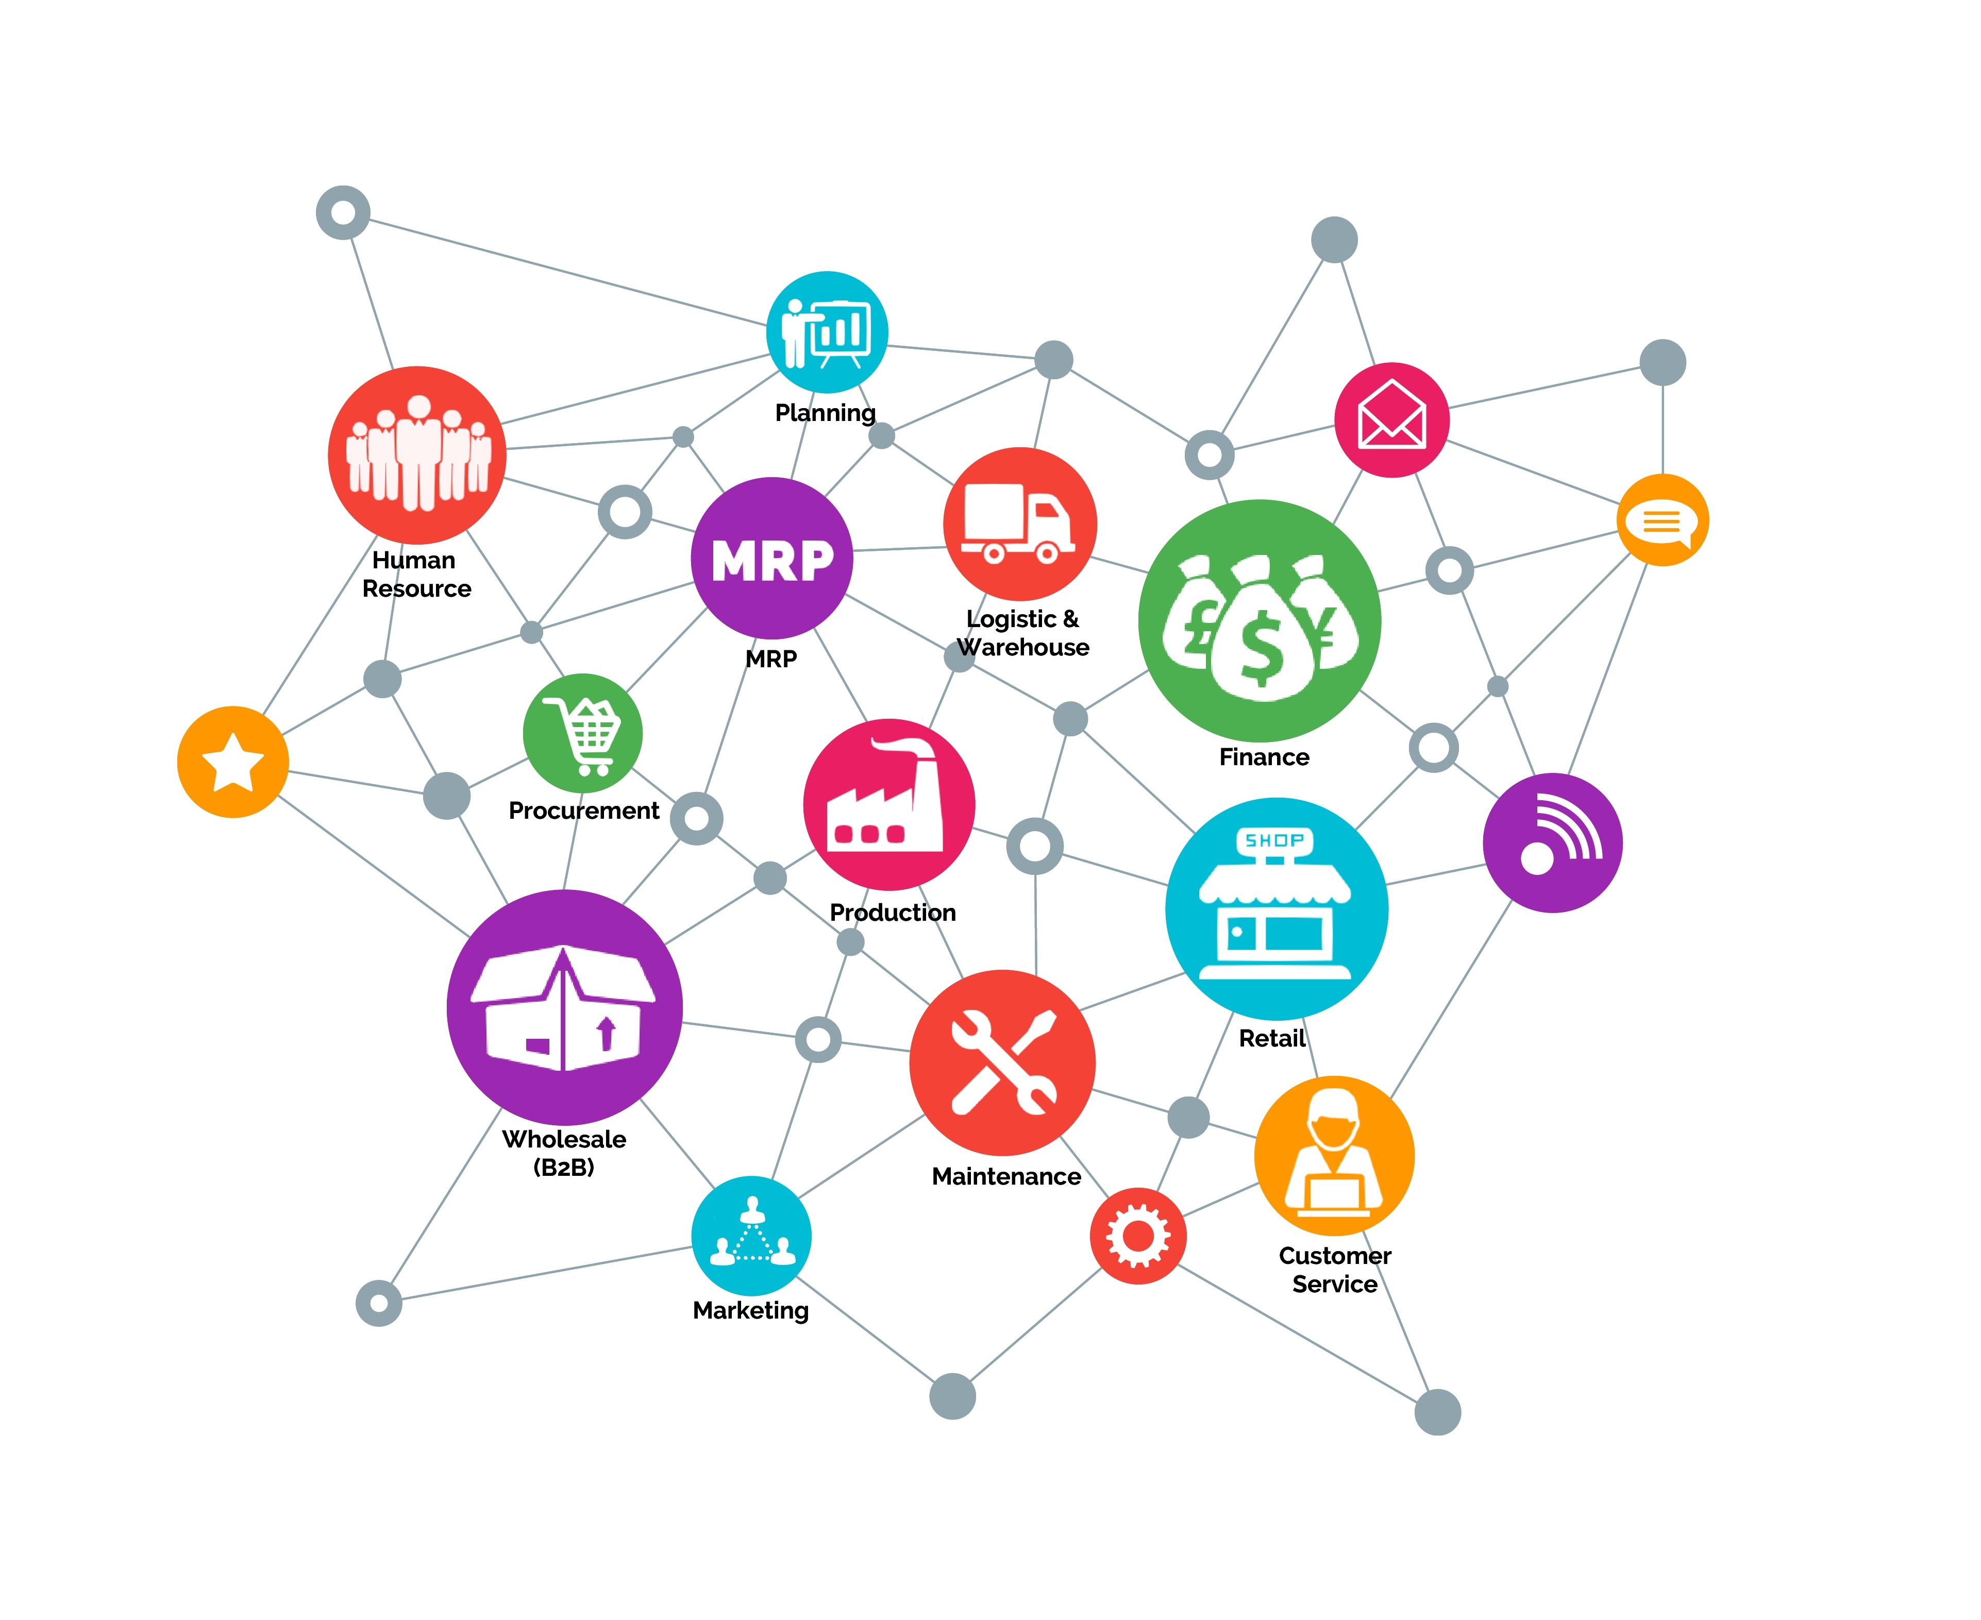

As a student without any basic in commerce and business, MonsoonSIM is a good simulator for beginners to understand how to operate, maintain and expand our business. Besides learning something about business, one of the important lessons that we could learn from the game is, every decision we make would make a huge impact on the results. Before we make any decision, we must consider all of the consequences wisely to bring the maximum benefits and minimize our losses. By the way, we must also learn from our mistakes and make our mistakes more beneficial.
Besides, one of the most significant elements in dominating in the game is teamwork. In order to success, teamwork is so important, and the distribution of job to all of the team members is significant too. Everyone plays an important role in the business. For example, the team must allocate someone for procurement, someone to check the remaining stock, someone to regulate the price, someone to do some marketing, someone to forecast the market need and so on. If there is a disagreement, we must communicate in a peaceful manner, tolerate and thinking from a different perspective in order to get the most effective strategy to overcome our difficulties.

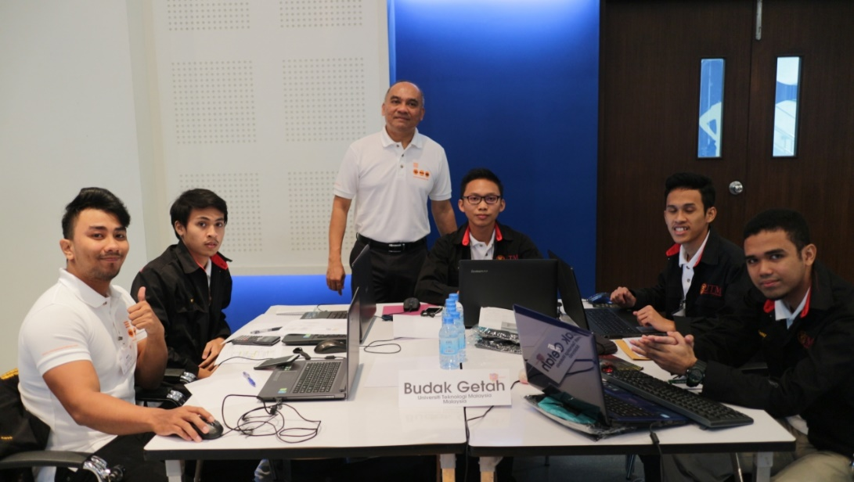
REPRESENTATIVE TEAM OF UTM TO INTERNATIONAL COMPETETION IN THAILAND (2017)

  - INSTILLING SOFT SKILLS AMONG FORM SIX STUDENTS

Form Six is one of many choices for Sijil Pelajaran Malaysia (SPM) leavers to further their education in tertiary level. Therefore, it has become a platform for them to flourish their creativity, talents, and skills in order to be an impactful and visionary youth that will reflect the development of the country in the global stage.
Based on three objectives, a research was conducted to review the effect of instilling soft skills among Form Six students. The three objectives consist of seven soft skills are exploring the instillation of soft skills by Form Six teachers, identifying the soft skills equipped among Form Six students, and constructing Form Six’s Soft Skills Framework. By using qualitative method, 12 respondents were selected to be interviewed to acquire the research data. Then, based on the data, the researchers were able to construct the Form Six’s Soft Skills Framework that explain the efficacy of Form Six students based on the teachers’ instillation.
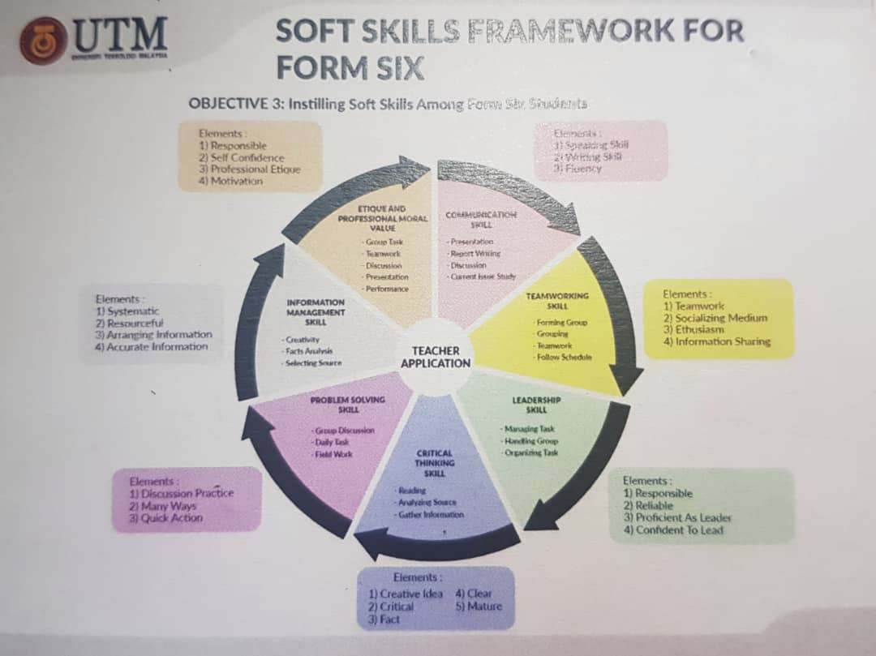

This Soft Skills Framework for Form Six shows the element of soft skills that should be used as guidance for them to adapt to 21st-century learning skills. Basically, soft skills are a combination of skills such as communication skills, social skills, attitudes, social intelligence, emotional intelligence, and career attributes. It is also can be considered as interpersonal skills. In NALI 2018, they gave priority to seven elements of soft skills which are communication skill, team working skill, leadership skill, problem solving skill, critical thinking skill, information management skill, and, ethics & professional moral value.

  - THE USE OF VIDEO RECORDING VIA TELEGRAM APPLICATION AS AN EFFECTIVE TOOL TO IMPROVE ORAL PRESENTATION SKILLS

These booth set forth the idea of telegram as a platform to improve their oral skills which is quite interesting as they were proving that social networking is not a waste of time but can be used as a learning tool. It worked by doing self-recording a video of student presenting their research or report before posting it in telegram group where their peers could give instant feedback on the student presentation skills. Hence, students could create an improvement from the feedback. The idea is students no longer have to be nervous and scared during their presentation in class. Instead, they can use telegram to mock presentation and prepared themselves for the real presentation.
The representatives of the booth, Ms. Jagjit Kaur Gian Singh, said that the objectives of the research are to enable self-observation via Telegram Application to improve students’ oral skills, provide practice of oral presentation frequently and demonstrate the ability to engage in lifelong learning activities. The current generation has grown up with the technology so learning not only applicable in class but also could be conducted out of classroom environment. This way learning can be more effective and interesting for students.
This new approach in learning oral presentation skills also could be a platform of engaging learning and as an opportunity to share knowledge and skills to improve their way of speech, pronunciation, and gestures during presentation. This two way engagement could build up their confidence as they reflect on their previous videos. Other than that, it is a convenient way to practice and hone their oral skills as it is flexible for them in term of time and place because it can be done anywhere and anytime.
On the other hand, the impact on students learning is it can fit different learning style and more relevance as technology has become essentials nowadays especially for students in the 21st century. This alternative also preparing students for the workplace as they need to present their ideas, thoughts, and project confidently to their employers at the same time becomes a techno-savvy. In a nutshell, Social Network Services (SNS) like Telegram can be maximized to its potential use to serve a greater purpose in education such as to improve oral presentations skills.

- REFLECTIONS
In NALI 2018, we can see a trend where most of the educators took a step forward on implementing effective learning among students by using technology. This shows that education is having a revolution towards a new digital era where pen and papers are no longer needed in learning and teaching practices. Thus, we can see clearly that NALI 2018 is a platform to expand this ideology of advanced education and sharing the latest innovation in education. In this exhibition, some of the booths also use gamification which is quite a hit among the students. The researcher not only trying to improve learning and teaching lessons but also to attract students to find that learning could also be a fun thing.
If these trends continue to evolve, the education in the future might be much more interesting. Maybe students do not need to attend university in order to get a scroll of degree. They can just enrolled in online courses and attends virtual lectures and opening an era where teaching and learning are beyond classes, schools or university. Generally, technology gives both educators and students the benefits to improve in many aspects, and education has become much more accessible for everyone as there are no limitations of who, where and how old they are in order to gain knowledge. There are so many possibilities in the future that will design our education system that could change the world, as education is a fundamental that will born leaders, politician, doctors, lawyers, engineers and so many more.
In conclusion, on our visits to NALI 2018, we were catching a glimpse of the future education, and we were gaining a lot of new information from different perspectives. We also gain a new experience during the visits, and we really hoped that exhibition like NALI should be held more often in other places.

- REFERENCES

- ctl.utm.my/nali2018/exhibition
- http://www.monsoonsim.com/guide.html?stage=ABOUT_MSIM
- https://www.youtube.com/channel/UCDucdUulEc_7cY-bQpJxGow

