A REPORT ON INDUSTRIAL TALK 1

Topic: MDEC E-Rezeki
Speaker: COACH NUR ASHIKIN HALIL
Date: 24th September 2018
Time: 4.00pm - 6.00pm
Venue: Seminar Hall, N28a, School of Computing
Section: Section 06
Lecturer: DR NOR BAHIAH AHMAD
Prepared by: TAN CHONG LIM A18CS0255

Introduction About The Speaker Of The Talk
This industrial talk 1 was organized by Malaysia Digital Economy Corporation (MDEC) with E-Rezeki as their program. The speaker of the talk was Coach Nur Ashikin Halil from UTM, Skudai, Malaysia. She is one of the successful examples from freelancing in digital work platform. Before she joined E-Rezeki, she was a marketing exec assistant. After attended the three months eGHI program, her total earned was RM108,000. Her expertized skill included transcript, virtual assistant, and translation.

What Is E-Rezeki?
E-Rezeki is one of the program organized by Malaysia Digital Economy Corporation (MDEC) under campaign #YOUCANDUIT. The purpose of the program is letting citizen, especially from group B40 to earn extra income via online crowdsourcing platform. There are several ways for its user to earn income such as digital micro-task, digital works, and digitally-enabled task.

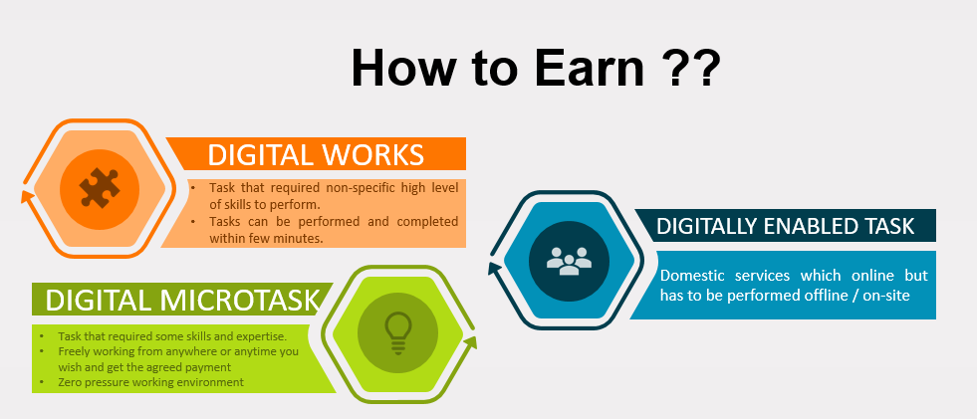

The digital micro task is a simple task including data entry using online forms, editing duplicated data, reviewing photos and images, downloading task, SEO related task and much more. Meanwhile, digital works are for the freelancer with minimum skills to work for other people via the platform. Tons of jobs are available in the platform such as website designing, mobile app development, logo designs, graphic design, digital marketing, virtual assistant, writer, copywriting, transcript, just to name a few. The digitally-enabled task is a task that has to be done offline or on-site. For example, one can find a plumber, electrician, cleaners or event part-time crews from the online platform but the workers need to perform their work in a specified location. E-Rezeki allows its participants to earn extra income, at the same time, they can learn some skills by doing their jobs. Jobs can be done anywhere, everywhere and anytime provided one has internet access by using freelancer.com as a platform. Although it is an online platform, it is incredibly safe from fraud and scam. Freelancer.com performs like a man in between two parties, that is, the freelancer and the client. If there are a misunderstanding or dishonesty on one of the party, they will act as the intermediate between the two parties. Thus, there is no doubt that it is suitable and safe for every Malaysian from students, graduates, housewife and the unemployed.

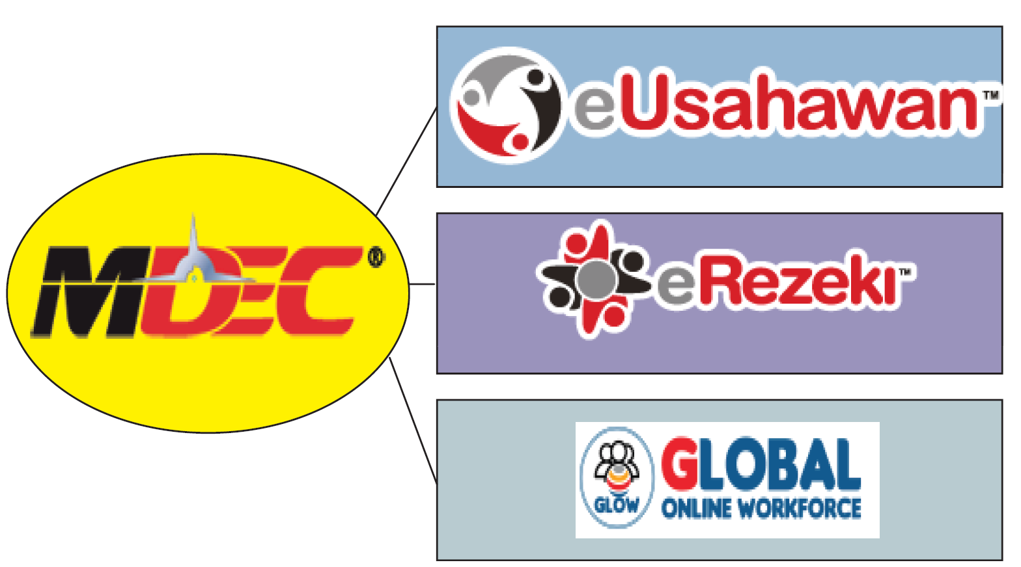

The Effort Made By MDEC In Expanding E-Rezeki
E-Rezeki online is available for Malaysian citizens with a minimum age of 18 years old. Malaysian citizens with income below RM4,000 a month are preferred to join this program than those whose income are above RM4,000. However, they do not prohibit those citizens to join this program. Registration can be done online or walk-in at E-Rezeki center or representative of E-Rezeki for all Malaysian citizen. There are ten E-Rezeki training centers nationwide, including in Kedah. In the effort of expanding e-Rezeki program, various program organized by E-Rezeki under MDEC to allow people to know more about this E-Rezeki. For example, campaign, seminar, sharing of success stories and other activities were organized nationwide for everyone to join. Campaign #YOUCANDUIT is one of the most active campaigns, carried out from time to time, to promote E-Rezeki and eUsahawan under MDEC. The latest program is Program Santuni Rakyat with the aim to aid the citizen in the aspect of health, economy, and family.

Impact Of E-Rezeki To Malaysia
Program E-Rezeki brings enormous positive impact to Malaysia in the aspect of the economy, pretty contrary to popular belief. As a matter of fact, it allows Malaysian to earn income in their extra time, and at the same time, they learned some extra skills beyond their full-time jobs, which generally is fairly significant. This program also generally improve cash flow in Malaysia. This highly enhances the balancing of the economy in Malaysia. Besides, Malaysia’s economy will be better as there will be significant cash flow from another country to Malaysia since they are paying us in their own country’s currency. E-Rezeki, for the most part, creates a community of full-time high quality crowd workers among Malaysians. It is significant to drive the promotion and development of crucial technology hubs for the country’s industries especially the information and communication. According to our ex-Prime Minister in the 26th MSC Malaysia Implementation Council Meeting, he stated that “eRezeki will be rolled out across multiple Digital Work Centres, and this work center can be in the form of Urban Transformation Centre, Rural Transformation Centre, community colleagues and mosques to impact rural and urban low-income households,”. This means that eRezeki brings a huge impact on Malaysia’s economy in term of balancing it.

Reflection Form The Talk
From the talk, it is well known that in this century, the digital industry plays an important role in a country’s economy. Freelancers make 30 % of the workforce globally and are expected to increase by 20% in the next few years. It is more than 30 million from people around the world. In 2018, it digital economy contributed 18.2% to Malaysia’s gross domestic product (GDP) and is expected to exceed more than 20% in 2020. It provides tons of job opportunities to fresh graduate, which solve the critical problem regarding lacking jobs for fresh graduate. In the IT field, freelancing is indeed a good choice for people to get themselves involved. For example, a programmer can write a program for his client on freelancer without having to physically travel to the client’s location. Working from home is a dream for most people, and it provides a zero-pressure environment for them and at the same time, it significantly increase their productivity. Besides, eRezeki, as one of the digital industry, provide opportunities for people from lower income family to further their studies to universities by providing an online part-time job as economic support for them. If one does not have any professional skills, there are a variety of jobs, without one to have any expertise skill to be chosen. Therefore, there are no excuses that one could not perform the task. One of the biggest challenge faced by most of the freelancer, as mentioned by the speaker from the talk is communication skills. A freelancer needs to communicate with his client in order to perfect his job. Since the platform is international, English language plays an important role in freelancing. Another big challenge is teamwork, which is harder to achieve compared to traditional method of doing the job, since everything is done virtually via an online platform. The main way to communicate is through words. It is a fact that online jobs have its benefits but it also has its disadvantages.

Reference
- https://erezeki.my/about
- https://youcanduit.mdec.my/bm
- https://www.jobstreeteducation.com.my
- https://www.facebook.com/myerezeki/photos/a.1021231174575201/2062130127151962/?type=3&theater
- Embun Majid (2018, January 22), Have more eRezeki and eUsahawan programmes. Retrieved from New Straits Times: https://www.nst.com.my/news/nation/2018/01/327668/have-more-erezeki-and-eusahawan-programmes
- NST Business ( 2018, February 8), PM Najib's digital economy vision takes shape, bringing tremendous benefits to country. Retrieved from New Straits Times: https://www.nst.com.my/business/2018/02/333442/pm-najibs-digital-economy-vision-takes-shape-bringing-tremendous-benefits
- ROZANA SANI (2017, November 22), Not all footloose and fancy-free in freelancing. Retrieved from: https://www.nst.com.my/education/2017/11/305961/not-all-footloose-and-fancy-free-freelancing

