

SEMESTER I 2018/2019

INDUSTRIAL TALK REPORT 2:
NALI EXHIBITION

SCSP1513:
TECHNOLOGY AND INFORMATION SYSTEM
(SECTION 05)

LECTURER NAME : DR. NOR AZIZAH SA’ADON
GROUP NAME : TETRAHEDRON
GROUP MEMBERS :
NO. | STUDENT NAME | STUDENT ID | NALI ID
1. | LUQMAN AL-HAKIM GHANI | A18CS0102 | 21
2. | MOHAMMED ALI BAQA’AIL |  | 36
3. | MOHAMAD FAIZ HAKIMI BIN ISHAK | A18CS0107 | 53
4. | MUHAMMAD RIDZWAN SYAH IRWAN | A18CSO112 | 45

DUE DATE: 7TH OCTOBER 2018
New Academia Learning Innovation (NALI) 2018 Exhibition Report
By : Group Tetrahedron

On 25th and 26th September, New Academia Learning Innovation (NALI) 2018 Exhibition was held at Dewan Sultan Iskandar, UTM Johor Bahru. The exhibition was brought by UTM Academic Leadership (UTMlead) in collaboration with School of Education, Faculty of Social Sciences and Humanities UTM and Asia Technological University Network (ATU-NET). At the exhibition, we manage to visit four booths and gain information about how innovation are implemented to teaching and learning. The booths are as follow.
Booth ID | Title
45 | E-PALUVED: ELECTRONIC PROBLEM BASED LEARNING FOR SUSTAINABLE DEVELOPMENT INDICATOR
36 | MONSOONSIM BUSINESS SIMULATION: ENHANCING LEARNING THROUGH GAMIFICATION
53 | ADAPTING GAMIFICATION APPROACH IN MASSIVE OPEN ONLINE COURSES TO IMPROVE USER ENGAGEMENT
21 | FORMING INTERDISCIPLINARY ENGINEERING TEAMS USING PERSONALITY TYPE DIFFERENCES

For booth 45, E-Paluv short for Electronic Problem Based Learning for Sustainable Development Indicator. E-Paluv is an interactive learning module that suitable for the Z-generation students. It is a practical learning platform where students can apply their knowledge on the current issues through gamification. Instructor can easily assess the individual student performance and understanding by using an interactive online assessment. This module is useful as best practice and self-paced learning parallel with the 10th Shift: Transformed Higher Education Delivery according to the Malaysia Educational Blueprint. E-Paluv works based on three task.
Task 1 is about eCity or SimCity, a city simulation game where you are challenged to solve different engineering issues. In this task, students must be able to do three project on the simulation game. The first project is to develop a virtual sustainable city. The objective on this project is to identify major issue or problem of sustainable development in a city, to propose solutions by developing a virtual city using eCity and to enhance understanding on sustainable development. The second project is win the game. The aim for this project is to solve sustainable development issues using eCity. The student need to play and win the game so that they can enhance their understanding on sustainable development issue. Next, after finishing with project 2, student must do project 3 which is developing the Sustainable Development Indicator(SDI). This project aiming to solve sustainable issue, relate with SDI using eCity. The objective is to play and develop SDI Indicator using eCity game and to enhance understanding on sustainable development issue and SDI indicator.
After that, the student will continue with task 2 which is Kahoot!, a free game-based learning platform. In this task, students need to answer all the questions in limited time given via smartphone. The instructor will share Game Pin for students to log in. Then, the student will write a report which is the third task. The report must have the following content.
Describe how you develop the SDI and how you measure it.
Description of selected city
Introduction

Every member should write their experience playing the scenario
Issue of selected city
content

Description of scenario and relate it with sustainable development issue

Describe how you play and win the game? What strategies had been used?
Propose solution using eCity/SimCity

After all the task finished, the teacher will do the assessment. As for the evaluation purpose, Task 1, 2 and 3 were linked to MOHE (Ministry of Higher Education). Suitable rubric was used to assess the student performance.
Learning outcome (LO) as follow:
- MOHE LO3: Problem solving and scientific skills
- MOHE LO7: Information management and lifelong learning

After attending the NALI Exhibition, I was impressed on how innovation in this 21th century can be implement for upgrading the teaching and learning to a new level. By using the innovation and technology, teaching and learning become more affective and fast. This environment makes a new meaning for the use of technology. I believe that, when every school and learning institute in Malaysia apply the innovation and technology on teaching and learning, Malaysia will become a developed country with first class minded citizen in no time.
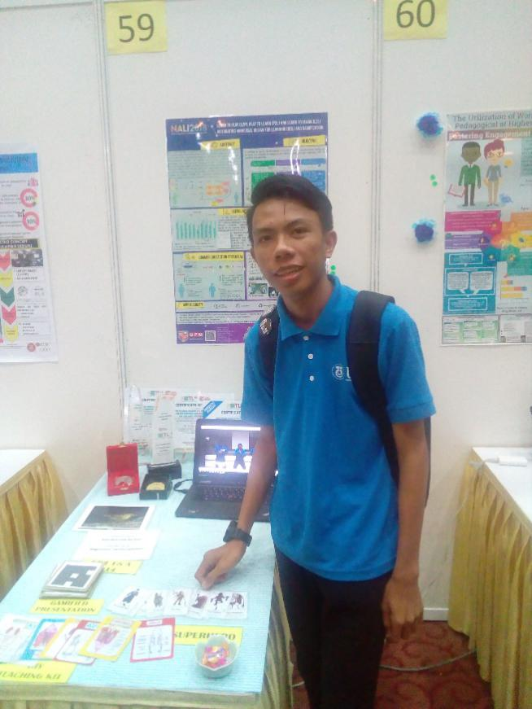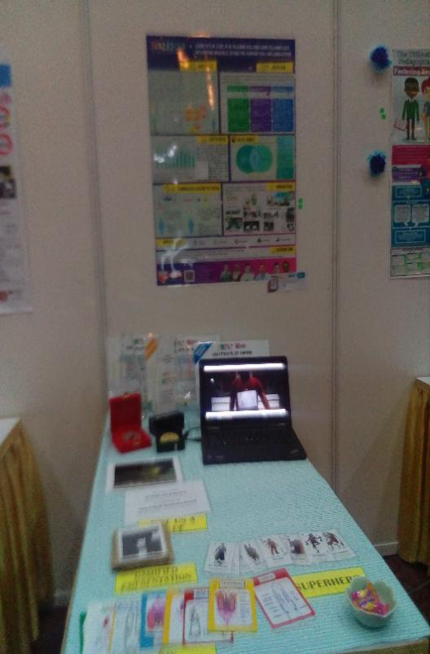

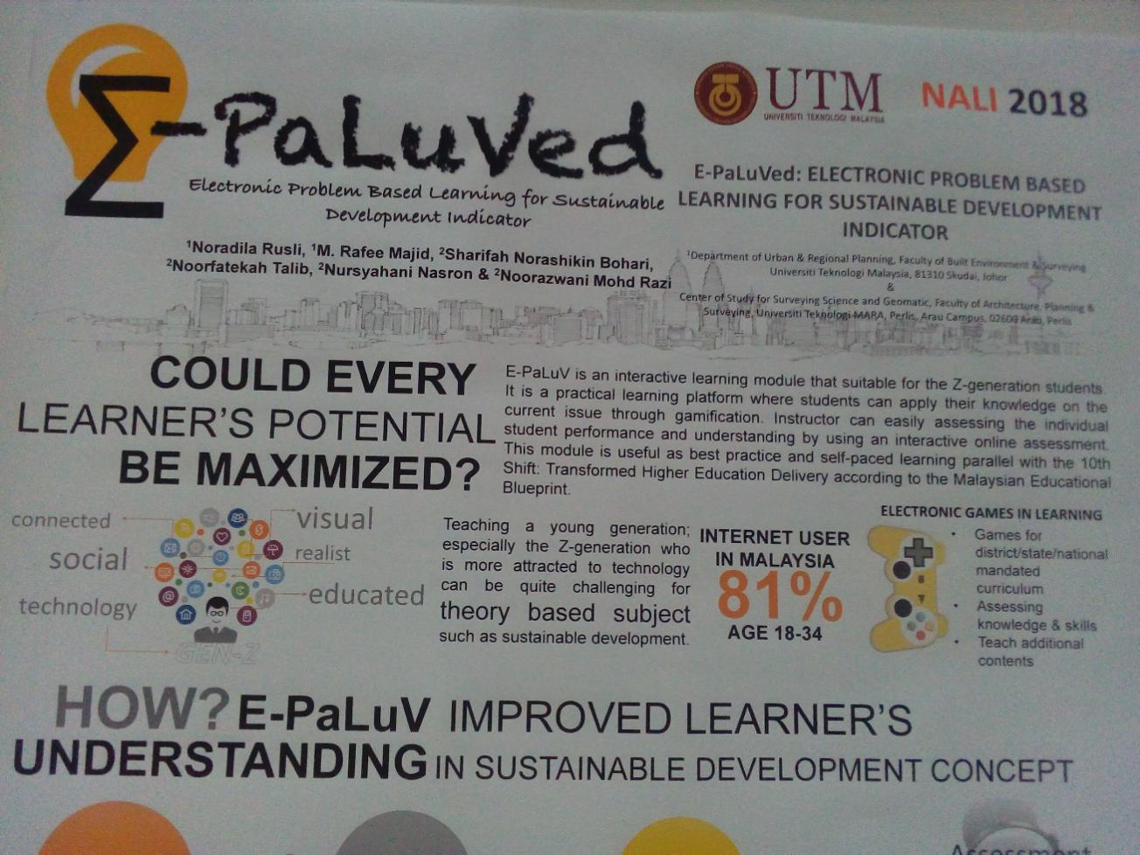
Therefore, for the booth 53, ENHANCING LEARNING THROUGH GAMIFICATION is a simulation game where the participants play a game that has many modules that teach them about business in a practical and entertaining way, then they make a presentation about what they have leant while playing this game.
The objective of this program is:
Introducing a new way of business education through Gamification.
MONSOONSIM BUSINESS SIMULATION aims to make a new way of education which lets the students learn through a simulation game that give them the experience they need for the job.
Benefits:
*Anyone can join this program .
*The certificate of this program can boost your CV.
*The program give you the experience you need for business.
Awards received:
*Two UTM teams became the Malaysian champion and 1st runner-up (2017) respectively.
*Sponsorship by Knowledge.com (10,000RM) for three consecutive years (2016,2017,2018).
*Represented Malaysia at the regional competition.

Names of certified trainers:
*Shafudin Mohd Yatim .
*Dr.M.Shah Kassim.
*Dr.Zulkifli Khair.

My view:
I think MONSOONSIM BUSINESS SIMULATION program is an interesting way of teaching and it could potentially make learning easier and more enjoyable to students

Name of speaker:
Mohamad Shah Kassin.
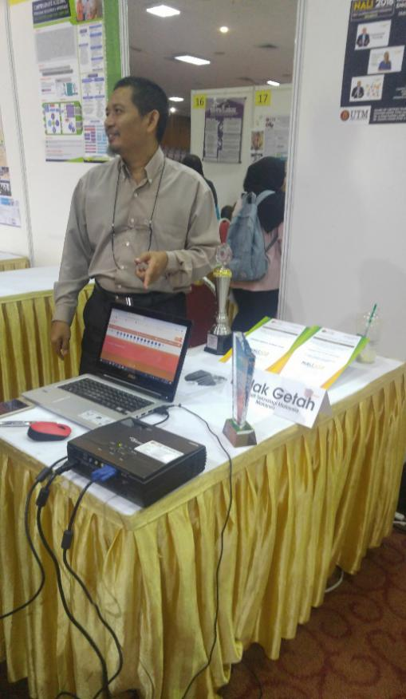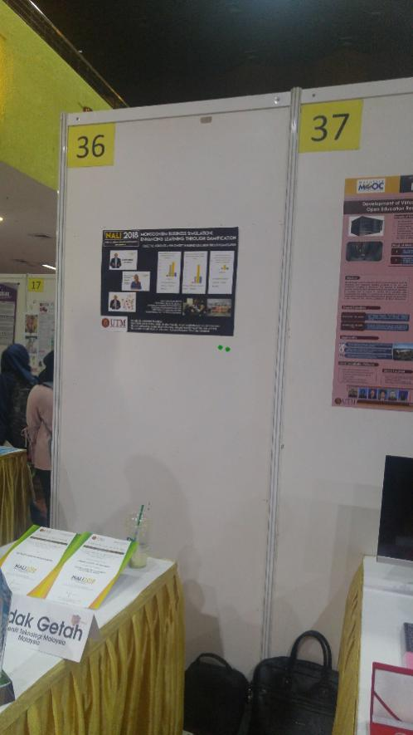

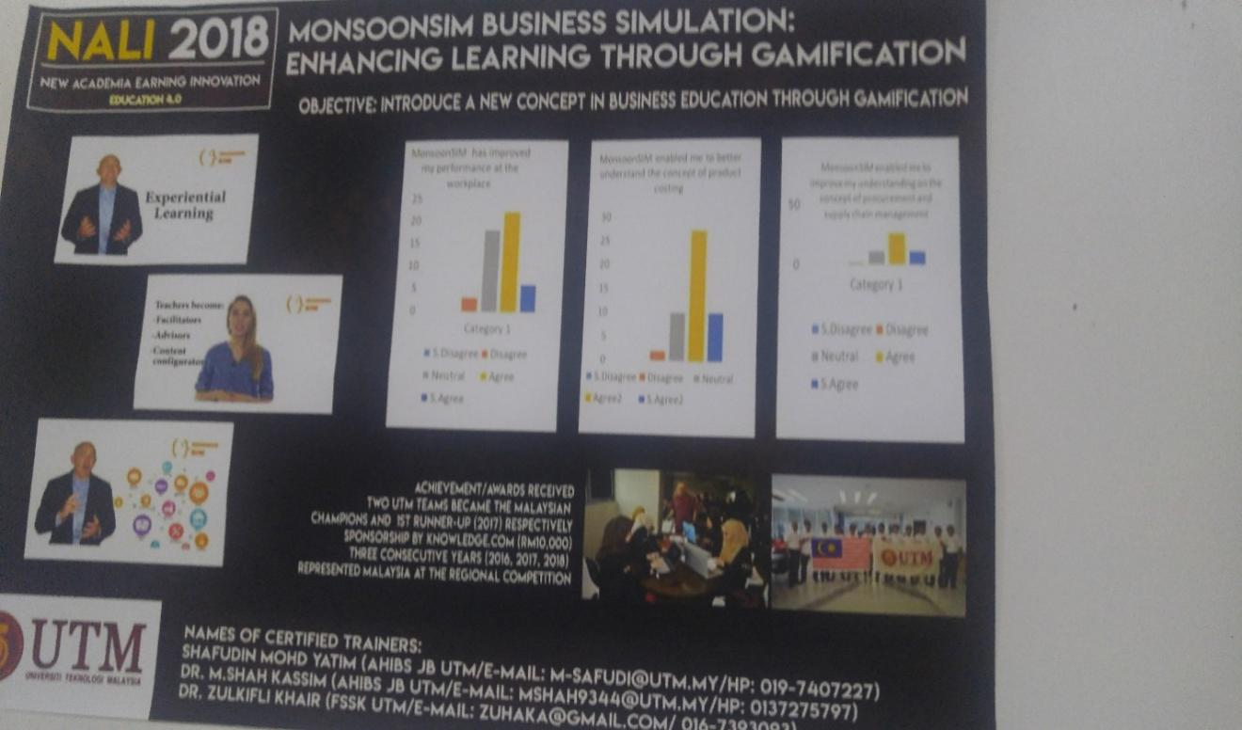
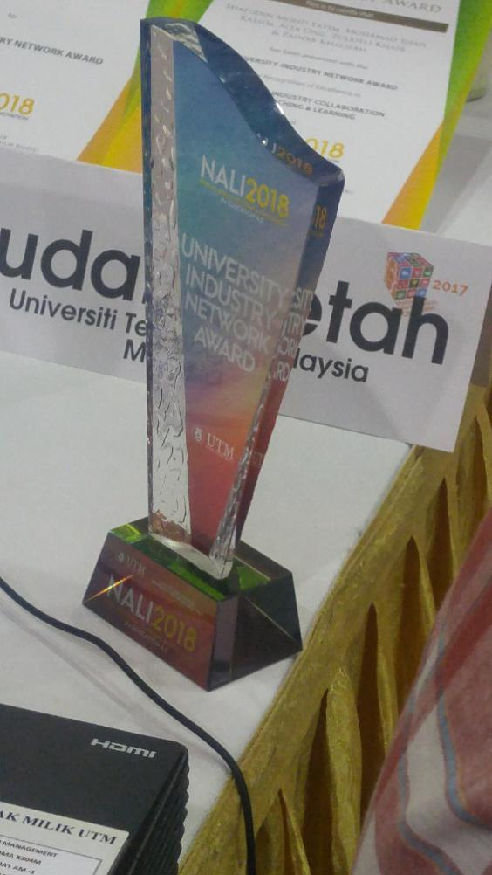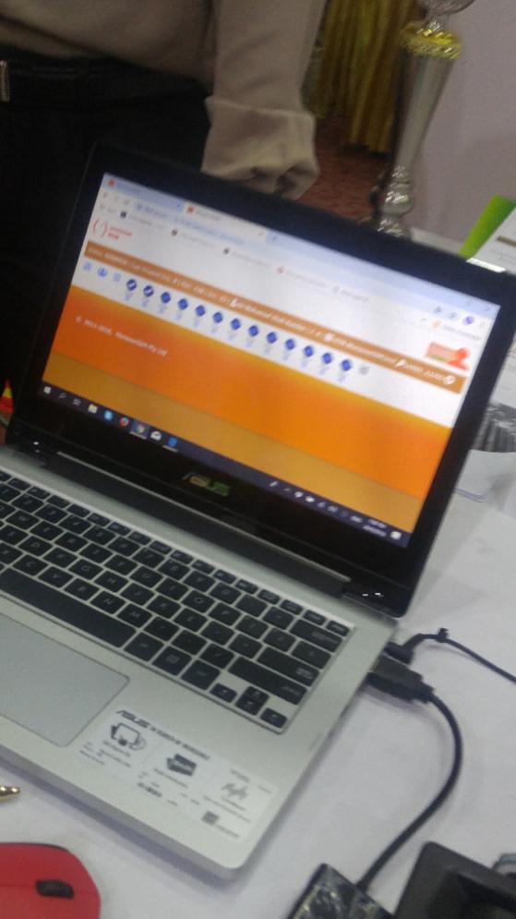

In addition, for booth 53 the topic that were discuss is adapting gamification approach in massive open online courses to improve user engagement. Gamification has become another platform for a student to increase their knowledge in every aspect of knowledge. This is because student nowadays always spent lot of their leisure time to play games. In other to prevent students from wasting their time by playing bad games, so this approach is really good for us as a students. It can make us spend our time wisely at the same time had some fun by playing an educational games. Other than that, gamification also helps student to understand more about their subjects study. Massive Open Online Course(MOOC) has give an opportunity for students to enhance their skills in their own preferred study. MOOC is a model for delivering learning content online to any person who wants to take a course with no limit on attendance. By using MOOC gamification can be spread widely by lecturer or even by student himself to another student. Besides, student do not need to worry if they fails when playing the games or how many time they want to play that games because gamification approach in Massive Open Online Course does not have any time limit or how many time you must play it. In conclusion, adapting gamification approach in Massive Open Online Course to improve user engagement is a good steps to the students nowadays in other for them to succeed in every life challenging that they had or will encounter in their life.
My view:
I think that gamification is a good thing for a youth nowadays but depends on how you use it in your daily life. If you make a wrong choice then it will be a bad thing to you and vice versa.
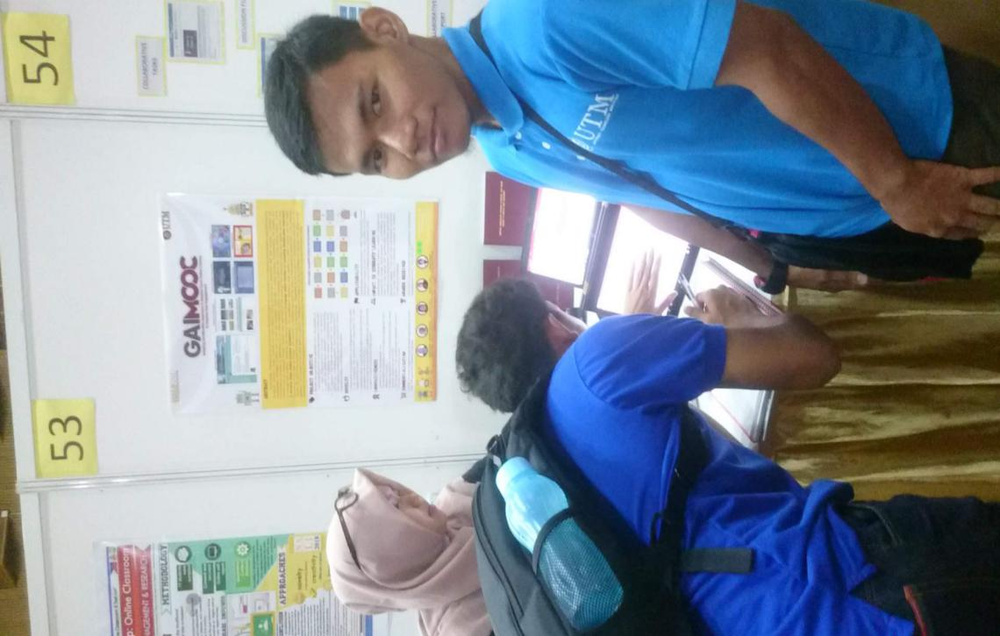

Lastly, in booth 21 we visits a booth that discuss about forming interdisciplinary engineering teams using personality type differences. There are four personality type that they were focus on. First is artisan. This personality describe about our courages to be a confident person, quick-thinking and dynamic. Second, is guardian. In other to form interdisciplinary engineering teams we must have personality type of guardian which mean that we need to be a loyal towards each other and always respect each other. Third, is rational. Rational mean that someone need to have a great strategist to form a team with others. Someone with rational personality can view problems from multiple perspectives,will bring well thought-out arguments and independent one. Lastly, is idealist. Idealist is a personality more to easy-going one. People with this personality is always calm, steady and have a strong desire to improve their surroundings and the people they meet. This personality type is really important to form interdisciplinary engineering teams among each other.

My View:

Those personality is important to form a good team in any circumstance but to form a team you must have a good cooperation among each other. So in my opinion even we do not have all the four personality type as long as we have enough faith in our team members and good cooperation we still manage to overcome the problem that we has to face.

