The Global Online Workforce (GLOW) Program By Malaysia Digital Economy Corporation (MDEC)
By: RIDZWANSYAH IRWAN
On 24th of September, MDEC was held a talk about GLOW program. The speaker of the talk is Nur Ashikin Halil, one of the program participant.
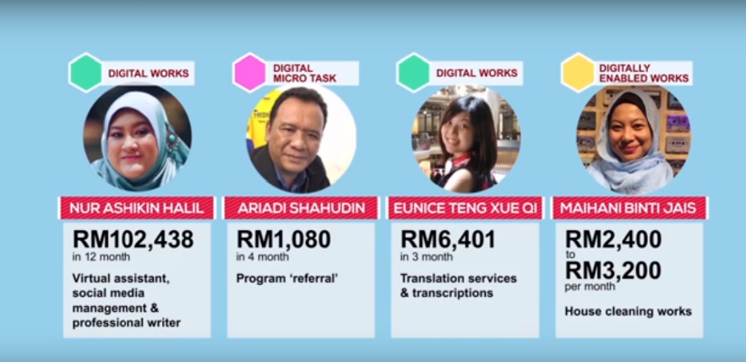
The participant that have success in the program
Source: erezeki.my

GLOW or first known as E-rezeki is a program by MDEC that was launch 17 June 2015 by the 6th Prime Minister Dato' Sri Haji Mohammad Najib bin Tun Haji Razak. GLOW is a program that enables Malaysian citizens, especially low-income groups that household income of below RM4000 per month (B40, generate additional income by doing digital assignments via online crowdsourcing platform. This programs are not limited for the citizens that expert in ICT, because there are many kind of job that GLOW offer for all the participant. The main purpose of this program is to coach, mentor and nurture full time crowd workers that are able to consistently earn a stable digital income of more than RM2,000 monthly. The program aims to generate fixed and stable digital income for Malaysians via crowdsourcing. Crowdsourcing is the future as it enables digital works to be offered and delivered online. Currently, MDEC collaborates with some of the largest global crowdsourcing platforms such as Freelancer.com and Upwork.com.
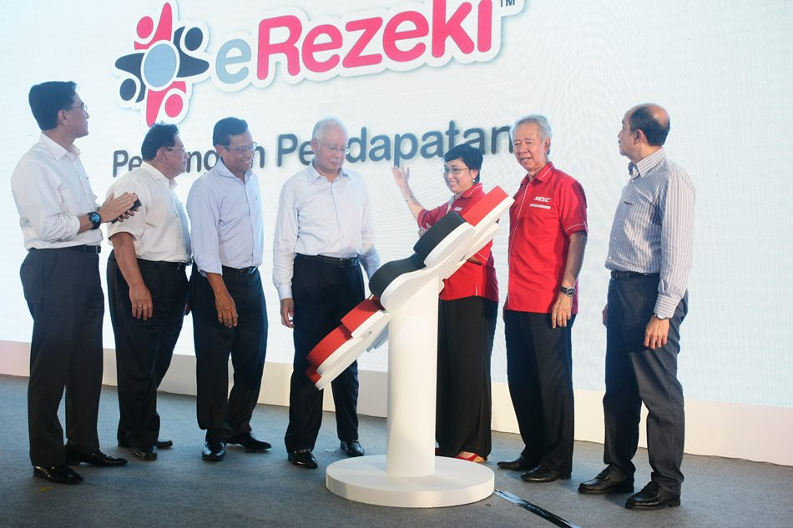
GLOW(E-rezeki) launch ceremony
Source: Amanz.my

Through this program, MDEC aspires to train and nurture qualified apprentices to become successful and capable online freelancers in global platforms. The reason why MDEC implement the program are because to create a community of full time high quality crowd workers among Malaysians, to establish a sustainable model on the Global Online Workforce Program through engagement with strategic partners, to provide alternative sources of income for Malaysians via multiple online platforms and to develop a support program for Malaysian freelancers to remain motivated, driven and committed in earning digital income via crowdsourcing platforms.
The main job that being offer on this program is digital micro task, digital works and digital-enabled task. Digital micro task is a simple task involving data entry, processing images or actions that required non-specific high level of skills to perform. Tasks can be performed and completed within few minutes. The examples of digital micro task are data entry of online form, removing duplicated data and video or image review. Besides, digital works is an online platform for freelancers to get hired and get paid. As a freelancer, the participants are enable to freely working from anywhere or anytime and choose any job that suits with the skills and expertise. For example, development of a website, mobile application development, creation of logo, graphic designs software testing, or audio or video transcription work. Next, digital-enabled task is a works or tasks such as survey, running errands or domestic services which online but has to be performed offline or on-site. The jobs are, conducting survey, products price watch, event part-time crews, running errands, plumber or electrician.
The citizens that sign up on the program will be able to get a lot of benefits from it. One of the benefit is the flexibility of working online. The citizen can do the job without effect their main job and only need an internet, a laptop and personal time management. This is due to some of the job that being offer by the program can be done anywhere and anytime. In addition, GLOW can be benefit to the citizen through increasing the quality family time. This is especially to women and can be applied to men also because as a working mother or father, its hard balancing the time for work and family. On the other hand, by joining the GLOW program, the working mother or father can work online. Working online allowing the citizen to work from their home giving the much-needed flexibility to spend time with the family. Besides, the other benefit that the Malaysians can gain from the program is it can save a lot of money. The citizen doesn’t need to buy fuel for the car or buy public transport tickets to go to the workplace. It also saves money for your food when at the workplace since you can get much cheaper food when cooking at home. Other than that, even the fee to register this program are free.
Moreover, the other benefit why Malaysian need to join the program now are various incentives offered to qualified individual, opportunities to generate a full time stable and consistent digital income monthly, helps individual to become disciplined and independent workers by having to complete the digital works within a stipulated timelines and requirements by employers, generate digital income based on individual capability, and opportunities to start a business for digital works to increase digital income monthly.
MDEC have do many program to give information about how important the Global Online Workforce program give benefit to the citizen of Malaysia. For example, MDEC have do a lot of talk, sharing success stories and even create video about the program on their website and others such as Youtube and Facebook. Besides, MDEC also has made a tutorial class for those who want to join the program. In the class, they will teach you how to register for a job, how to find a job regarding your own interest and tips on how to finish the job within the time schedule that has been given to you by the company or someone that offer the job.
The Malaysian citizen that want to participate in this program are must comply with the following basic terms.

Basic Terms
1.Malaysian citizen
2.Malaysian that listed under B40 group
3.Open for individual who are 18 years old and above

Besides the basic terms, the citizen that want to participate in this program must fulfil one of the following side conditions.
Conditions
1. Experienced freelancers or crowd workers in local and global crowdsourcing platforms
2. Committed individuals aspiring to be crowd workers with qualifications and capabilities in various disciplines such as ICT, creative and design, languages and others.

3. Experienced offline and face-to-face freelancers.
4.Registered individuals in employment programs by ministries, government agencies and at state level.
5. Unemployed graduates and retrenched workers with the commitment to become crowd workers.

The participant that joining this program will be given their scope of jobs by using the selection criteria. The selection criteria are as follows.
- Specialized skills sets in IT - programming, website development, mobile apps development
- Creative design - graphic design, multimedia
- Linguistics - translation, transcription in foreign languages such as Mandarin, Arabic, French
- Proof of specialized skills set – portfolio, resume, certifications or work assignments
The participant that give commitment to participate in the full time intensive training for 3 months at the E-rezeki Apprentice centres and commitment to become active digital workers able to consistently generate a minimum digital income of USD500 / RM2,150 monthly. In addition, English language proficiency is important to be master so the participant be able to develop work proposals and interact with international employers or organizations.
The E-rezeki or Global Online Workforce (GLOW) program has gave a lot of big impact to Malaysia and its citizen since it been launch in 2015. A lot of citizen under B40 group that joining the program have been success and manage to increasing their household and now has a stable income. on the other hand, the economics of Malaysia are getting good day by day in line with Malaysia's goal of becoming a developed nation by 2020. Other country has look Malaysia as a highly potential developing country and have interested to make Malaysia as a place of investment. The improvement of the economics has make Malaysia be able to cooperate with other country in terms of business partnership.
To summarize, after attending this industrial talk, I have become more interested to know more about working on an online platform. I discovered that by joining this such of program, it gave me a lot of opportunity to know any jobs on the internet that really suits me rather than just sit on the office doing the things that we do not like. As everyone have their own point of view, but I really think that after the talk, finding money is not that hard as many people think. We can find money with our skills as long as we trust in ourselves that we can do the jobs. Besides, I discovered that even that our simplest skill like photography, or even just reviewing a photo or video can give us a lot of benefits if we put enough creativity and effort into working on them. On the internet, even the simplest things can be valuable if we can sell them to the person that need them. Last but not least, I learn that the Malaysia government has do a lot of works to help its citizen out of poverty and increasing their income. This is the reason that make me should be proud and being thankful as the citizen of Malaysia.

References
- https://erezeki.my/
- https://www.mdec.my/
- https://glowmalaysia.com

