MASS AND ENERGY BALANCE SMJC 2223 ASSIGNMENT 1

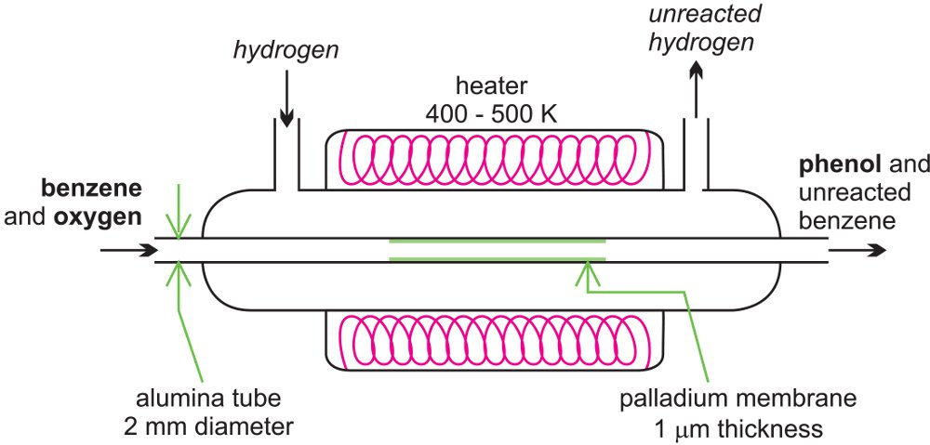

A microreactor being used to produce phenol from benzene.

- Phenol production proses and manufacturing process are used.
- Chemical reaction and mixing are the unit operations used in the process.
- Feed A: Hydrogen
Feed B: Benzene and oxygen
Product C (desired): Phenol
Product D (undesired): Unreacted benzene
Product E (unreacted): Unreacted hydrogen

