

SMJC 2223
MASS AND ENERGY BALANCE
ASSIGNMENT 1:

UNIT OPRERATIONS

LECTURER: DR.NABILAH BINTI ZAINI
TITLE: BIO-OIL PRODUCTION BY FAST PYROLYSIS
NAME | MATRIC NO.
- SHARWEEN PILLAY A/L SANGARAN | A17MJ0230
- JEEVANESWARAN A/L KUPPUSAMY | A17MJ0192

Date of submission: 8 October 2018

BIO-OIL PRODUCTION USING FAST PYROLYSIS

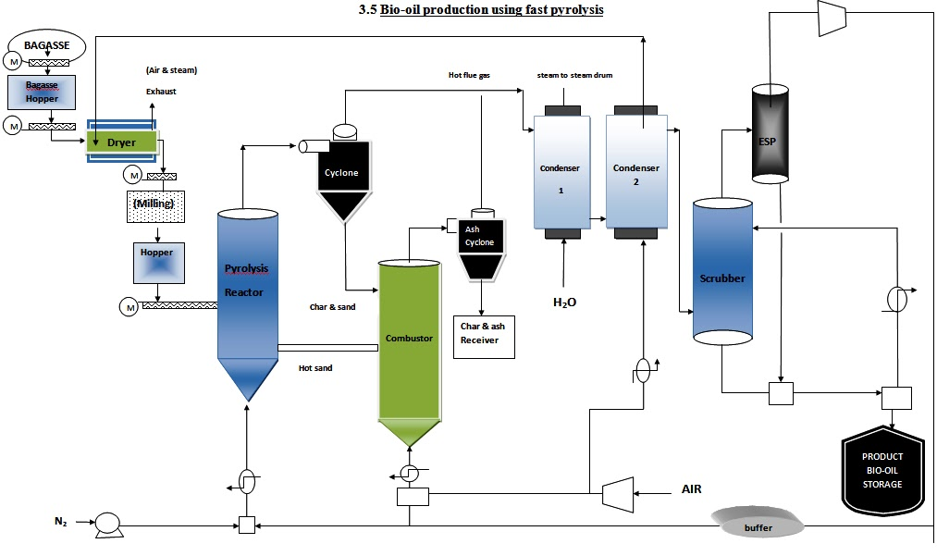
Figure 1: Bio-oil Production using Fast Pyrolysis Procee

UNIT OPERATIONS
- DRYER

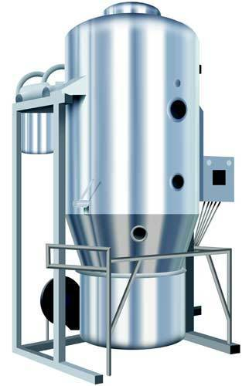

- Used to remove the water vapour from compressed air.

- REACTOR

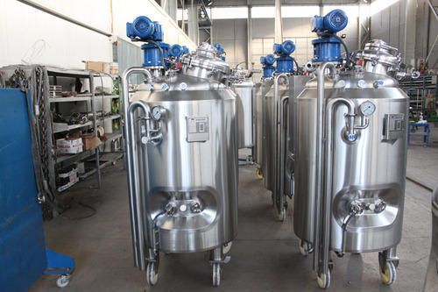
- To increase the impedance of the process sysyem.

- CYCLONE

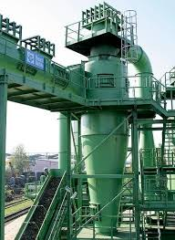

- Separation method of removing particluars from an air, gas or liquid steam without the use of filter.

- COMBUSTOR

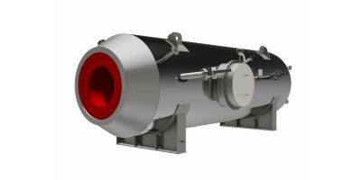

- A component or area of a gas turbine where combustion takes place.

- CONDENSER

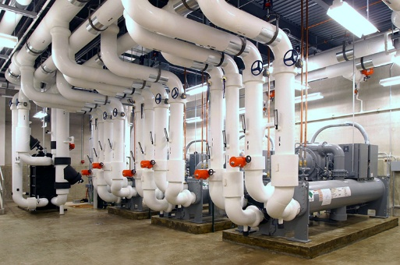

- Used to condense a substance from its gaseous to its liquid state by cooling.

- SCUBBER

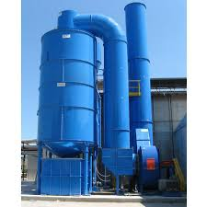

- An air pollution control device to remove particles or gases from industrial exhaust steam.

- COMPRESSOR

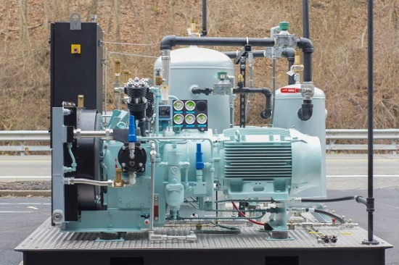
- A device that increase the pressure and corresponding saturation temperature of the refrigrant vapour.

- PUMP

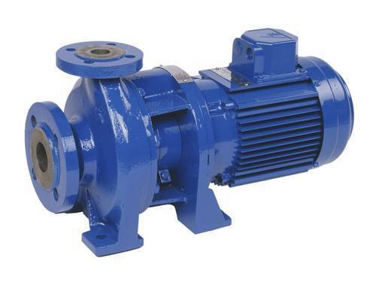

- A mechanical device that converts mechanical power into hydraulic energy.

PROCESS OF BIO-OIL PRODUCTION

- In the fast pyrolysis process, indirect heat, followed by cooling, is used to convert biomass at 400-800°C into CO₂, CO, and CH₄ gases (medium heating value gases), Bio- Oil liquids and solid char. A flow diagram of the process is shown in figure below. The conversion of biomass to Bio-Oil occurs in the absence of oxygen in the pyrolysis reactor . Oxygen is excluded to prevent the biomass or its products from combustion (use a N₂ gas as a fluidizing medium). Gasification is different from fast pyrolysis, or thermolysis, because it is a combustion process in which enough oxygen, through air, is supplied for the carbon and hydrogen in the fuel to form a rich mixture of CO and hydrogen in the product gas. The product gas from gasification will contain up to 60% nitrogen and have a lower heating value of 107 to 484 Btu/ft³ whereas the heating value of fast pyrolysis gases range from 484 to 807 Btu/ft³. The products exit the pyrolysis reactor in a gas state that includes vapors, aerosols, and a suspension of small solid particles. A cyclone separates most of the solid particles from the vapors, where they are then deposited to the char collector. The gases are then condensed in a quench system, which converts most of the vapor into liquid Bio-Oil. The non-condensable gases are recycled to supply the energy needed in the process, while the Bio-Oil and char can be sold as commercial products.

