THINK-PAIR-SHARE ASSIGNMENT 1
FARAH AIN BINTI JOHAR (A17MJ0182)
NISHA VELOO (A17MJ0209)

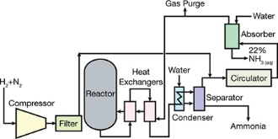
Process 1: Production of fertilizer (ammonia).

- Type of process : Haber process
- Type of reactor : Catalytic Reactor
- Unit operations involved :

NO | UNIT OPERATION | TYPE OF UNIT OPERATION | UNIT OPERATOR | CHEMICAL SUBSTANCE
1. | Fluid flow process | Filtration | Filter | Trace gases, carbon dioxide and water
2. | Heat transfer process | Heat exchange | Heat exchanger | Ammonia and unreacted nitrogen gas and hydrogen gas
3. | Mass transfer process | Gas absorption | Absorber | Water, ammonia gas
4. | Separation process | Separation | Ammonia Separator | ammonia, hydrogen, nitrogen, traces of methane
5. | Condensation process | Condensation | Condenser | Gaseous NH3, un reacted N2 and H2, impurity gases.
6. | Reaction process | Chemical reaction | Catalytic  Reactor | Iron catalyst, ammonia gas, hydrogen gas, nitrogen gas.

