PROCESS OF MANUFACTURE OF SULFURIC ACID
(DOUBLE-CONTACT PROCESS)

1)Example of chemical engineering process.
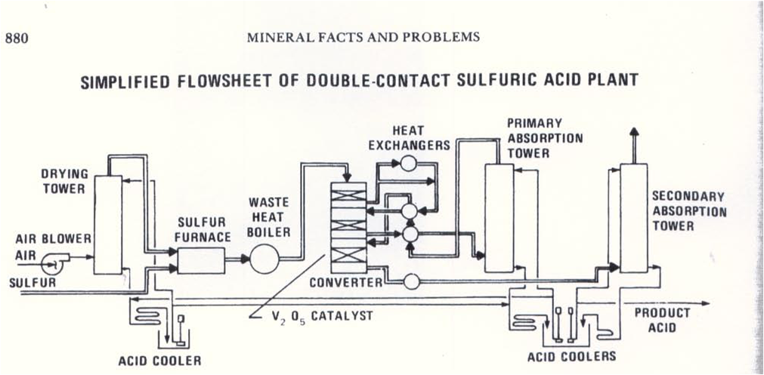
2)Unit operations involved.
- Air blower
- Positioning the blower before the drying tower (‘pusher’ blower) results in savings in capital cost of the blower because the inlet gas will be more dense and requires less power to compress. The gas being handle is simply air so no special materials of construction are required. However, the heat of compression of the gas is absorbed by the drying acid system thus increasing the heat load on the acid coolers.

- Drying tower
- Drying Tower is a vertical cyclindrical vessel designed to contact process gas and strong sulphuric acid (93 to 98.5% H2SO4) for the purpose of drying the gas. The tower may be constructed of specialty alloys such as the high silicon stainless steels, nickel-chromium alloys or the more traditional brick lined carbon steel. The tower will be equipped with a packing support, packing, acid distributor, and mist eliminator.

- Acid cooler
- The absorption of water into sulphuric acid is an exothermic reaction and will cause the temperature of the acid to rise unless the heat of absorption is removed. The heat is typically removed in either a plate heat exchanger or anodically protected shell and tube heat exchanger.

- Sulfur furnace
- A sulphur furnace is generally a large horizontal cylindrical vessel of carbon steel lined internally with refractory brick. An air stream enters the furnace at one end and liquid sulphur is fed in at the same end through a sulphur gun. Sulphur atomization is achieved usually by a simple spray nozzle or spinning cup. The furnace is closed coupled to a boiler in which much of the heat of the sulphur combustion is removed.
- A sulphur furnace provides for the complete combustion of molten sulphur with oxygen to sulphur dioxide according to the following reaction:

S(s) + O2(g) = SO2(g) H_{f @ 25}°C = -70.94 kcal/mol

- The reaction is highly exothermic resulting in a large temperature rise. A side reaction of sulphur dioxide with oxygen forms sulphur trioxide.

SO2(g) + ½ O2 = SO3(g) H_{f @ 25}°C = -23.45 kcal/mol

- The design of the sulphur furnace must achieve good gas mixing and full combustion of sulphur prior to leaving the furnace and entry to the boiler section. Sulphur droplets impinging on baffle or checker walls will vapourize immediately and burn to sulphur dioxide. The internals of a sulphur furnace are important to ensure complete combustion of sulphur to sulphur dioxide.
- Unburned sulphur that does impinge on the carbon steel surfaces of downstream boilers, ducting and heat exchangers will corrode the steel. Evidence of this type of corrosion will be evident during equipment inspections.

- Waste heat boiler
- A boiler is a vessel in which water is continuously vapourized into steam by application of heat. A primary objective in designing a boiler is to provide for the greatest possible efficiency in absorption of heat. Other objectives are production of pure steam and safe, reliable operation.
- Boilers in acid plants are waste heat boilers cooling gases from sulphur furnaces, regeneration furnaces and between catalyst beds.

- Converter
- In the converter, sulphur dioxide (SO2) reacts with oxygen (O2) in the presence of a catalyst to form sulphur trioxide (SO3) according to the following reaction:

SO2 + 1/2 O2 <=> SO3 DH = Btu/lb
- Provides single or multiple beds in which the catalyst is placed
- Provides for the distribution of gas across the catalyst bed.
- Provides for the collection of gas to exit the converter
- Catalyst in converter : - vanadium pentoxide content imparts a higher activity to the catalyst making it suitable for use in the lower catalysts passes where a substantial amount of the SO2 has been converted to SO3.

- Heat exchangers
- cooling the gases to approximately 160–190 °C in a heat exchanger

- Primary absorption tower
- sulfur trioxide already formed is absorbed in the intermediate absorber in sulfuric acid with a concentration of 98.5–99.5 wt%. The intermediate absorber is preceded by an oleum absorber if required. The absorption of the sulfur trioxide brings about a considerable shift in the reaction equilibrium towards the formation of SO3, resulting in considerably higher overall conversion efficiencies when the residual gas is passed through one or two secondary contact beds

- Secondary absorption tower
- The sulfur trioxide formed in the secondary stage is absorbed in the final absorber.

3)Chemical substances at single unit operation.
Stage 1
Sulfur is imported from Poland or the USA. We can also obtain sulfur from the impurities in fossil fuels such as coal. In the first stage of the process, sulfur is burned in air to make sulfur dioxide gas:
sulfur + oxygen sulfur dioxide
S(l) + O₂(g) SO₂(g)
Stage 2
In the next stage, we convert the sulfur dioxide to sulfur trioxide:
sulfur dioxide + oxygen sulfur trioxide
2 SO₂(g) + O₂(g) 2 SO₃(g)
The reaction happens on a catalyst
A catalyst is a substance that alters (usually speeds up) the rate of a chemical reaction, but remains chemically unchanged itself at the end of the reaction.
catalyst of vanadium(V) oxide to speed up the reaction. As much sulfur dioxide as possible is changed into sulfur trioxide, and releases of sulfur dioxide are prevented because it is a gas that causes acid rain.
Acid rain is so called because it has a pH value below 5 due to acidic pollutant gases in the atmosphere.
acid rain.
Stage 3
In the final stage, the sulfur trioxide is converted into sulfuric acid. The sulfur trioxide gas is absorbed into very concentrated sulfuric acid (a 98 per cent solution of H₂SO₄ in water), producing a thick fuming liquid called oleum. The oleum is mixed carefully with water, and the sulfur trioxide in the oleum reacts with the water as follows:
sulfur trioxide + water sulfuric acid
SO₃(g) + H₂O(l) H₂SO₄(l)
THANK YOU
  - SHANTHI A/P SOUNTHARARAJAN
  - YASHUIVINIJEE A/P K. MANIENDARAN

