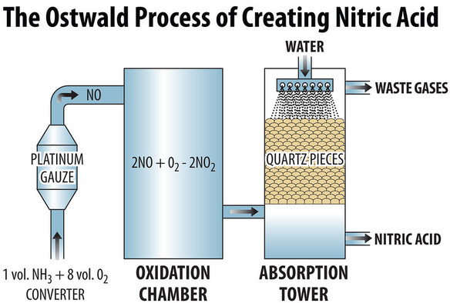
The Ostwald process is a chemical process for making nitric acid (HNO₃).
Ammonia is converted to nitric acid in 2 stages. It is oxidized by heating with oxygen in the presence of a catalyst such as platinum with 10% rhodium, to form nitric oxide /nitrogen(ii)oxide and water/steam. This reaction is strongly exothermic, making it a useful heat source once initiated:^{[3]}
4 NH₃ (g) + 5 O₂ (g) → 4 NO (g) + 6 H₂O (g) (ΔH = −905.2 kJ/mol)
Stage two encompasses two reactions and is carried out in an absorption apparatus containing water. Initially nitric oxide is oxidized again to yield nitrogen dioxide/nitrogen(iv)oxide.[3] This gas is then readily absorbed by the water, yielding the desired product (nitric acid, albeit in a dilute form), while reducing a portion of it back to nitric oxide:

2NO (g) + O₂ (g) → 2 NO₂ (g) (ΔH = −114 kJ/mol)
3NO₂ (g) + H₂O (l) → 2 HNO₃ (aq) + NO (g) (ΔH = −117 kJ/mol)

The NO is recycled, and the acid is concentrated to the required strength by distillation.
4NO₂ (g) + O₂ (g) + 2 H₂O (l) → 4 HNO₃ (aq)

Typical conditions for the first stage, which contribute to an overall yield of about 98%, are:
- pressure is between 4–10 standard atmospheres (410–1,000 kPa; 59–150 psi) and
- temperature is about 870–1,073 K (600–800 °C; 1,100–1,500 °F).
A complication that needs to be taken into consideration involves a side-reaction in the first step that reverts the nitric oxide back to N₂:
4NH₃ + 6NO → 5 N₂ + 6 H₂O
This is a secondary reaction that is minimised by reducing the time the gas mixtures are in contact with the catalyst.

