
\

STATISTICS ASSIGNMENT
GROUP 10
GROUP MEMBERS:
TANG JUN SIANG A11SC0203
HIEW SUHUA A11SC0205
NURAMALINA BINTI AHMAD TAHIR A11SC0232
NURUL AINA BINTI MANSOR A11SC0234
AISYAH AMIRAH AHMAD SENUSI A11SC0273
SHAMSUL SHAHMIE BIN RAMLEE A11SC0254

PROGRAMME : BACHELOR OF SCIENCE (INDUSTRIAL
MATHEMATICS)
COURSE : SSCM 1103
LECTURER : DR. ARIFAH BAHAR
ACADEMIC SESSION: 2011/2012
CONTENTS
No | Topic | Pages
1 | Introduction | 1
2 | Data Analysis:  Question (I) | 2
3 | Question (II) | 3-4
4 | Question (III) | 4
5 | Question (IV) | 5-6
6 | Question (V) | 7-8
7 | Question (VI) | 9
8 | Summary | 10
9 | Conclusion | 11
10 | References | 12
11 | Appendices | 13-15

INTRODUCTION
Arthritis is a joint disorder featuring inflammation. A joint is an area of the body where two different bones meet. A joint function’s is to move the body parts connected by its bones.
Arthritis can be treated by using radioactive gold (195 Au-aurothiomalate). Gold therapy is indicated for patients with active disease who are not responsive to conservative therapy. To minimize patient risks, contraindications must be considered, and careful clinical and laboratory monitoring must be performed under close supervision by the physician during therapy.
Linear regression is an approach to modelling the relationship between a scalar variable y and one or more explanatory variables denoted by X. The case of one explanatory variable is called simple regression. More than one explanatory variable is multiple regression.
The simple linear regression uses a number of variables to predict some unknown variable. Regression studies can help identify potential trend reversal areas. Using regression lines and channels, an investor can look for early identification of reversals in price after penetration of a previously validated regression levels. In technical analysis, simple linear regression can also help to identify what has been acceptable in terms of valuation levels and project those acceptable levels in the future.
The purpose of completing the assignment is to test the linearity between the two variables: days after injection and serum gold % concentration. The other purpose is that we want to investigate the validity of the assumption based on the data given. Next, we come to our next objective that is to study the most suitable method to be used to construct linear regression model. Lastly, we also want to know how to tackle nonlinearity if exists.

DATA ANALYSIS
The data set in Appendix shows the serum gold concentrations found in randomly sampled blood taken from patients who were given an initial dose of 50 mg. Follow-up readings were made at various times, ranging from one to seven days after injection. The retention is expressed as a percentage of the patient’s day-zero serum gold concentration.
- Data Simulation
Simulate 25 uniform random numbers to choose 25 pairs of data to be studied.

No | Days after Injection | Serum Gold % Concentration
1 | 5 | 57.2
2 | 3 | 78.6
3 | 2 | 72.5
4 | 3 | 64.6
5 | 4 | 68.7
6 | 2 | 70.9
7 | 3 | 69.8
8 | 6 | 48.0
9 | 5 | 58.2
10 | 5 | 59.9
11 | 5 | 55.8
12 | 3 | 69.4
13 | 1 | 83.1
14 | 7 | 36.6
15 | 3 | 63.7
16 | 6 | 49.8
17 | 1 | 83.4
18 | 6 | 40.8
19 | 2 | 79.0
20 | 2 | 80.2
21 | 5 | 53.5
22 | 2 | 81.6
23 | 2 | 78.7
24 | 6 | 46.1
25 | 5 | 59.3

- The estimation of the intercept, and the slope, using least squares method.

By using Microsoft Excel:

Days after Injection(x) | Serum Gold % Concentration(y) | x² | y² | x*y
5 | 57.2 | 25 | 3271.84 | 286
3 | 78.6 | 9 | 6177.96 | 235.8
2 | 72.5 | 4 | 5256.25 | 145
3 | 64.6 | 9 | 4173.16 | 193.8
4 | 68.7 | 16 | 4719.69 | 274.8
2 | 70.9 | 4 | 5026.81 | 141.8
3 | 69.8 | 9 | 4872.04 | 209.4
6 | 48.0 | 36 | 2304 | 288
5 | 58.2 | 25 | 3387.24 | 291
5 | 59.9 | 25 | 3588.01 | 299.5
5 | 55.8 | 25 | 3113.64 | 279
3 | 69.4 | 9 | 4816.36 | 208.2
1 | 83.1 | 1 | 6905.61 | 83.1
7 | 36.6 | 49 | 1339.56 | 256.2
3 | 63.7 | 9 | 4057.69 | 191.1
6 | 49.8 | 36 | 2480.04 | 298.8
1 | 83.4 | 1 | 6955.56 | 83.4
6 | 40.8 | 36 | 1664.64 | 244.8
2 | 79.0 | 4 | 6241 | 158
2 | 80.2 | 4 | 6432.04 | 160.4
5 | 53.5 | 25 | 2862.25 | 267.5
2 | 81.6 | 4 | 6658.56 | 163.2
2 | 78.7 | 4 | 6193.69 | 157.4
6 | 46.1 | 36 | 2125.21 | 276.6
5 | 59.3 | 25 | 3516.49 | 296.5

N=25, ∑x =94, ∑ =430, ∑y =1609.34, =108139.34 and =5489.3

=
= 5489.3
= -561.82
= – 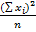
= 430 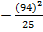
= 76.56
Slope, =
=
= -7.34
Intercept, =
= – (-7.34)*()
= 91.97

- The linear regression model
91.97 –7.34

- The significance of linear relationship
Hypothesis Statement
Using a t-test approach
Test Statistic
∑x =94, ∑ =430, ∑y =1609.34, =108139.34 and =5489.3
=
= 5489.3
= -561.82
= –
= 430
= 76.56
= 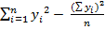
= 108139.34 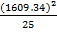
= 4540.33
= = -7.34
Var () = 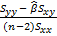
= 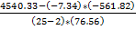
= 0.2366
= 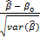
=
= -15.09
Regression Statistics
Multiple R | 0.954002687
R Square | 0.910121127
Adjusted R Square | 0.906035724
Standard Error | 4.277660388
Observations | 24
ANOVA
 | df | SS | MS | F | Significance F
Regression | 1 | 4076.400675 | 4076.400675 | 222.7738758 | 5.42886E-13
Residual | 22 | 402.5643246 | 18.29837839
Total | 23 | 4478.965
 | Coefficients | Standard Error | t Stat | P-value | Lower 95% | Upper 95% | Lwer 95.0% | Upper 95.0%
Intercept | 92.02184547 | 2.029636348 | 45.33908034 | 3.17181E-23 | 87.81263731 | 96.23105363 | 7.81263731 | 96.23105363
 | -7.374430239 | 0.494078938 | -14.9256114 | 5.42886E-13 | -8.399087243 | -6.349773235 | .399087243 | -6.349773235

Decision Rule
Reject if | | >
Obtain critical value using table of t distribution, = = 2.069
Conclusion
Since = 15.09> 2.069, we reject and conclude that the sample data provide enough evidence in significance level at α = 0.05 that the existence linearity between days after injection and the serum gold concentration.

- The validity of the assumption
- Linearity assumption: From the scatterplot, we can see that it satisfied the Straight Enough Condition that is the scatterplot look straight enough.

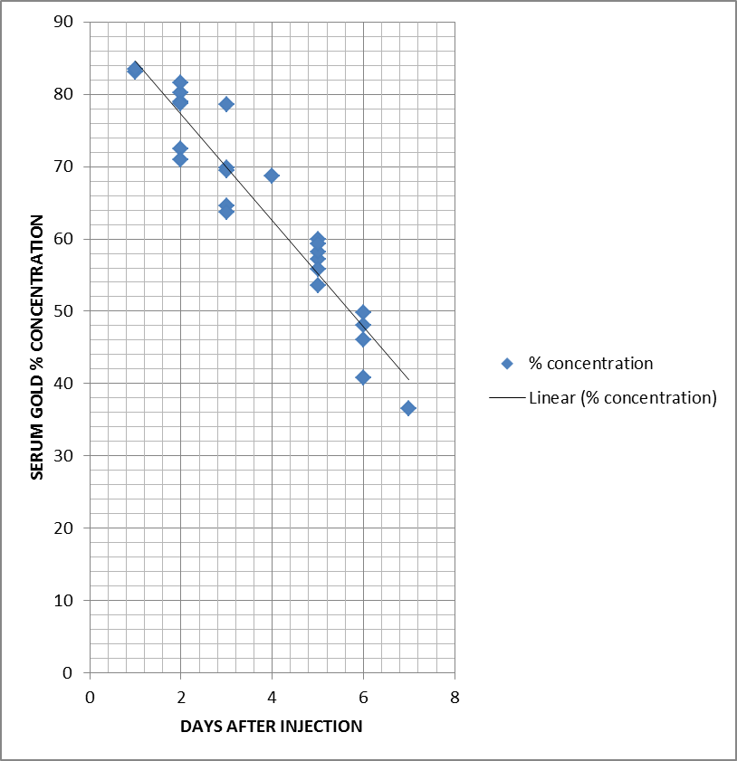

2. Independence assumption:
These data are times series which raise our suspicious that they may not be independent. To check, here's a plot of the residuals against time (days), the x-variable of the regression.
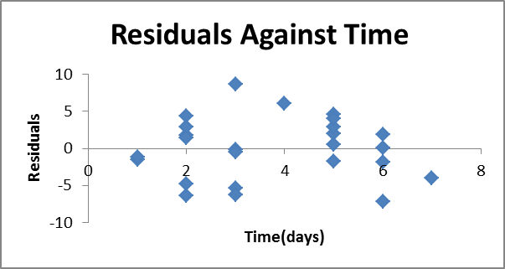
We see a hint that the data oscillates up and down, which suggest some failure of independence, but not so strongly that we can't proceed with the analysis.
3. Equal variance assumption (does the plot thicken? condition):
The residuals shows no trends in the spread which mean that the spread is quite constant.
4. Normal population assumption:
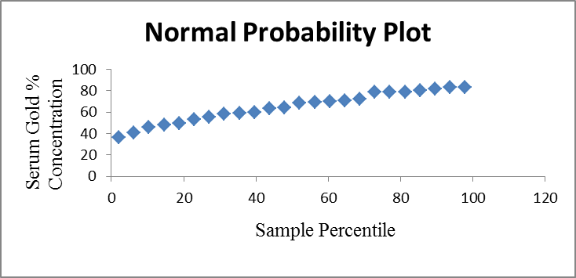
We assume that the data we have been used to be a normal data.

- How to tackle the nonlinearity if exists
In general, whenever a regression model can be “made” into a linear model, this is the preferred route to pursue for estimating the respective model. The linear regression model is very well understood mathematically and from a pragmatic standpoint, is most easily interpreted. Therefore, returning to the simple exponential regression model of Y as a function of the X, we could convert this nonlinear regression into a linear one by simply taking the logarithm of both sides of the equations.
If we now substitute log(Y) with y, we have the standard linear regression model. Thus, we could log-transform the Y data and then use Multiple Regression to estimate the relationship between X and Y, that is, compute the regression coefficient b₁.

SUMMARY
We had three group meetings. Each group member was given a task to complete. Each meeting minutes was uploaded to the E-portfolio by different group members.
In the process of doing this assignment, everything is done and completed, our group just having some technical problems. Firstly is how to use the Microsoft Excel properly. This is because most of us are beginner in using Microsoft Excel. So, we need to spend a lot of time to understand the process of using Microsoft Excel.
We also facing error problem. When we did calculations, sometimes we will key in wrong values. It will affect our answer. Moreover, we will be very careful in substituting the values into the formula to avoid any silly mistakes. This is because we need to restart our calculation if we do the wrong step of calculation.
Fortunately, with co-operation of all the group members, all the problems we facing are successfully solved, and slowly the questions become easier to solve. Each of us read, understand and solve the questions together and then write down the best answers for each question together. We learn more about the linear regression model including the assumptions and linearity of the graph after we done this assignment. We want to regard our special thanks to Dr. Arifah Bahar for her advises to us to complete our assignment successfully.

CONCLUSION

We are randomly chose 25 numbers from 100 data given by using computer (Microsoft Excel).We calculated the estimation of the intercept, b₀ and the slope, b₁ by using least squares method. To complete this, we are using Excel to construct the linear regression model.

After we had completed the calculation and the linear regression model being constructed, we came to model it by using scatterplot. Here, we get the significance of linear relationship, which is the linearity exist between the two variables: days after injection and serum gold % concentration. When the number of days after injection increases, the serum gold % concentration decreases. By using linear regression model, we found that we can predict the value of data between two variables. We can also check our assumption about the relationship between the number of days after injection and the serum gold % concentration. With scatterplot and linear regression line, we can understand that the number of days after injection is strongly related to the serum gold % concentration. We also know how to tackle nonlinearity if exists.

REFERENCES
- BASIC STATISTICS FOR SCIENCES AND EDUCATION, FADHILAH YUSOF, ZALINA MOHD DAUD, MAIZAH HURA AHMAD, ROBIAH ADNAN, ZARINA MOHD KHALID, ARIFAH BAHAR, NORHAIZA AHMAD, PEARSON MALAYSIA SDN. BHD. 2009.
- APPLIED STATISTICS FOR ENGINEERS AND PHYSICAL SCIENTIST, JOHANNES LEDOLTER ROBERT V. HOGG, PEARSON EDUCATION INTERNATIONAL.
- INTRO STATS THIRD EDITION, RICHARD D. DE VEAUX, PAUL F. VELLEMAN, DAVID E. BOCK, PEARSON EDUCATION INTERNATIONAL.

FIRST MEETING MINUTES
Day : Thursday
Date : 15/12/2011
Venue : C08 413
Time : 3.00p.m-4.30p.m
Members attended:
- TANG JUN SIANG
- HIEW SUHUA
- NURAMALINA BINTI AHMAD TAHIR
- NURUL AINA BINTI MANSOR
- AISYAH AMIRAH AHMAD SENUSI
- SHAMSUL SHAHMIE BIN RAMLEE
Report:
- We discussed about the strategy for doing the assignment given.
- Between the methods of SPSS, excel, online random number generator and using calculator manually, we had choose to use calculator and excel to complete our assignment.
- We had finished doing data simulation and the estimation of the intercept, b₀ and the slope, b₁ using least squares method by using calculator.
- We also constructed the linear regression model.
- We had decided our next meeting on next Tuesday, 20/12/2011 at 8.00p.m at KTR hall.

SECOND MEETING MINUTES
Day : Tuesday
Date : 20/12/2011
Venue: C08 413
Time : 10.00a.m-12.00p.m
Members attended:
- TANG JUN SIANG
- HIEW SUHUA
- NURAMALINA BINTI AHMAD TAHIR
- NURUL AINA BINTI MANSOR
- AISYAH AMIRAH AHMAD SENUSI
- SHAMSUL SHAHMIE BIN RAMLEE
Report:
- We had key in the data into excel.
- We compared the answer by using calculator and excel.
- We online to search the information about radioactive gold (195 Au-aurothiomalate).
- Each of us is given a task to complete.

THIRD MEETING MINUTES
Day : Tuesday
Date : 20/12/2011
Venue : KTR hall
Time : 8.30p.m-11.00p.m
Members attended:
- TANG JUN SIANG
- HIEW SUHUA
- NURAMALINA BINTI AHMAD TAHIR
- NURUL AINA BINTI MANSOR
- AISYAH AMIRAH AHMAD SENUSI
- SHAMSUL SHAHMIE BIN RAMLEE
Report:
- Finally we have come to our last meeting.
- Tang Jun Siang collected all the data from all the members and finalized it again.
- Our statistics assignment was completed successfully.

