

PROBABILITY AND STATISTICAL ANALYSIS (SCSI 2143)

SEMESTER 2 2017/2018

HOW WELL PEOPLE ARE AWARE ABOUT THEIR DATA SECURITY

NUR EZETTY EZRA BINTI AZMILY (A17CS0153)
NURHALIMAHTUN SUHADAH BINTI AHMAD BAHTIAR (A17CS0165)
TASSVINI A/P GUNASEHARAN (B17CS3030)

1/2 SCSR

SECTION: 08

LECTURER:
DR NOORFA HASZLINNA BTE MUSTAFFA

Contents
1.0 Introduction 3
2.0 Methodology 4
3.0 Data Analysis 5
3.1 Data Collection 5
3.2 Hypothesis Testing for one sample 6
3.3 Correlation Analysis 8
3.4 Linear Regression 10
4.0 Conclusion 12

Introduction

Does anyone actually concern about their personal data? Personal data is an information relating to an identified a person. Personal data issues can arise in response to information from a wide range of sources, such as healthcare records, criminal justice investigations and proceedings, financial institutions and transactions, residence and geographic records and so on. The most usual information that have been stole by cybercriminals such as mobile phone numbers, email address and etc.
We need to measure how well the users know about their data security through their daily internet usage. Internet usage has been quite broadly used world widely, requiring the users to register and share their personal data with an organization. For example, Instagram, Facebook, Twitter, WhatsApp requires the users to give their personal information such as phone number and email to the organization in order to use those applications. Even in some website registration such as for education purpose or financial purpose (banking) would require the users to give their identity card number, full name and address. Hence, it is important for user to know to whom and what are the organisation going to do with their personal data so that it would not come biting in the future.
We are aiming to give out questionnaires to at least 30 peoples within the Universiti Teknologi Malaysia in different courses from Faculty of Computing. This is to differentiate the awareness different people had. This method can be used to identify the trends and determining the magnitude of the topic. We are also planning to do a one-to-one interviews with some of the samples to see the participant’s viewpoints. So we can have a better understanding on how well they were exposed to the awareness about data security. Statistical data on the percentage of data leaking in our country and world wide through a duration of years recently are also important to see the status of data security in Malaysia.
We are interested in this topic because we ourselves are taking network and security course, and we would like to know how far the students in Faculty of Computing knows about their network security by taking 30 samples from UTM and analyse it.

Methodology

We are using SPSS and manual calculation to obtain the results in this project. This is based on the technique of each test that we have learnt in class that suitable to be used for this project.
We are using one sample t-test on awareness of people while using internet and frequency of people sharing their personal info on internet from their sample mean.
We are using correlation coefficient method to the relationship between the awareness of people while using internet and frequency of people sharing their personal info on internet.
Finally, we are also using the ANOVA to test significant difference between means of the awareness of people while using internet and frequency of people sharing their personal info on internet.

Data Analysis

3.1 Data Collection

The data that we use to analyse was the one we took from our sample. For this project, we need to find a sample data from Faculty of Computing students by handing out surveys to 30 persons. Each person need to answer 10 questions for the survey. The survey contain different type of level of measurements (nominal, ordinal, interval, ratio) which will each test the user how well do they know about their data security. Below are the questions asked in the survey.
For this project, we used the application SPSS to analyse and perform our inferential statistics. The techniques that we use is hypothesis testing of one sample, correlation using ordinal data, and regression using ratio data.
A hypothesis test (or test of significance) is a standard procedure for testing a claim about a property of a population. In addition to estimation, hypothesis testing is a procedure for making inferences about a population. Hypothesis testing allows us to determine whether enough statistical evidence exists to conclude that a belief (i.e. hypothesis) about a parameter is supported by the data. To conduct a Hypothesis Testing, we must establish the steps, hypothesis statement, test statistic, level of confidence, and lastly conclusion or decision rule.

3.2 Hypothesis Testing for one sample

Based on our project result from survey, a sample of 30 students in UTM has been obtained. From the survey, we wanted to know whether the students with mean 34.9000 and standard deviation 14.70949 have more than 24 people are aware about sharing their personal info on internet. Using 0.05 significant level to test whether people than 24 people are aware about sharing their info on internet. In our survey, we believe that less than 24 people are lack of awareness on sharing info on internet.
Hypothesis:
H0 : µ = 30
H1 : µ > 30
Test statistic (t-test)
$t_{0}= \frac{\overline{x}-μ_{0}}{s/\sqrt{n}}$ = $\frac{34.900-30}{133.01/\sqrt{50}}= -0.140$
Significance level, α = 0.05
Degree of freedom, ν = n – 1
= 30 – 1
= 29
P-value = 1.699

By, using SPSS,
- VAR00001 – awareness
- VAR00002 – frequency information sharing on internet
T-Test
Figure 1 One sample statistic

Figure 2 One sample test

Since the p-value, 1.699 is greater than α which is equal to 0.05. The action taken is failed to reject the null hypothesis. As a conclusion, there have not enough evidence to support that peoples are not aware about sharing their info on internet. Most of people sharing their personal info to get attention from others whom reading their details and they didn’t realise the bad impact which will they will face after sharing their information on internet.

3.3 Correlation Analysis

We are using Pearson’s product-moment correlation coefficient
In the correlation test, we test the relationship between number of people aware about sharing their info on internet and frequency personal info sharing on internet. We produce the data by using Pearson’s Technique since both sample are ratio type.
Hypothesis statement :
H0: No relation between number of people aware about sharing their info on internet and frequency personal info sharing on internet.
H1: Have relation between number of people aware about sharing their info on internet and frequency personal info sharing on internet.

Figure 3 Correlations

Reject null hypothesis. There is enough evidence to support the claim that there is a relation between number of people aware about sharing their info on internet and frequency personal info sharing on internet.

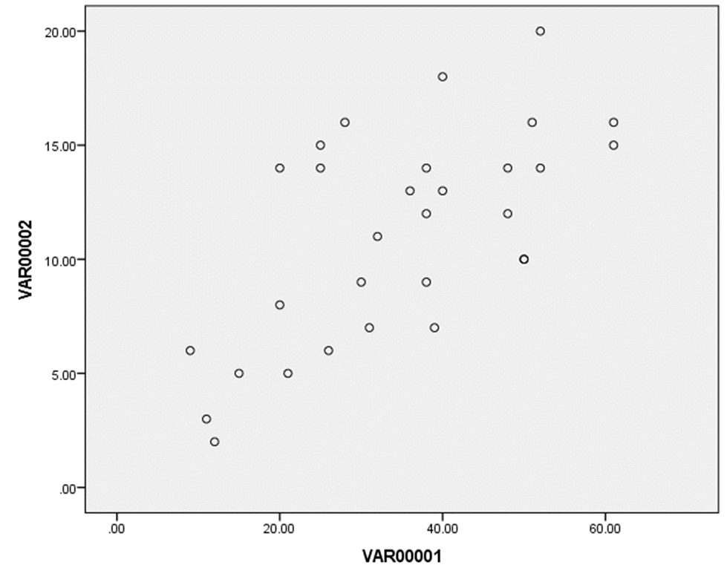
Figure 4 Scatter plot Awareness against Frequency sharing personal info on internet

Based on the result above, frequency of personal info sharing on internet and number of people aware about sharing their info on internet have 0.951 significant value at 0.01 significant level. Since the significant and the gradient of the graph show a positive, there have a positive relationship between frequency of personal info sharing on internet and number of people aware about sharing their info on internet. Since the correlation coefficient 0.951 is in between 0.8 and 1.0, it indicates that the strength of relationship is strong as there have a few outliers in the scatter graph. Since the p-value = 0.00 show in the table smaller than α = 0.01.
Reject null hypothesis. We have sufficient evidence to prove that there is relation exists between frequency of personal info sharing on internet and number of people aware about it. As, a conclusion, as the frequency of people sharing their data increases, number of people who are aware about sharing their info on the internet also increased.

3.4 Linear Regression

Least Squares
In the regression test, we test the relationship between x variable and y variable is described by linear function, as changes in y are assumed to be caused by changes in x.

$∑x$ = 1047 $\overline{y}=$ 11.13
$∑y$ = 334 $\overline{x}=$ 34.9
$∑xy$ = 12933
$∑x^{2}=$ 1096,209

$b1=$ 12933 – $\frac{1047(334)}{30}$
1096,209 $-$ $\frac{{(1047)}^{2}}{30}$
= 2.094

$b0=$ 11.13 – 2.094(34.9)
= 11.584

$$\hat{y}=11.584+2.094x$$

Figure 5 Regression in SPSS

Conclusion

From this project we have learn on how to do inference statistic based on data from previous project.
We have done one sample t-test for the mean between number of people aware about sharing their info on internet and frequency personal info sharing on internet.
We have done one sample t-test for mean of between number of people aware about sharing their info on internet and frequency personal info sharing on internet.
Other than that, from ANOVA test, we know that the significant difference between mean of people aware about sharing their info on internet and frequency personal info sharing on internet
From the analysis, it shows that there is a positive relationship between mean of people aware about sharing their info on internet and frequency personal info sharing on internet. Its means that the people are more aware about sharing their info on internet.
Lastly, we conclude that people out there have cybersecurity awareness when they are using social media platform as they don’t share many personal things on internet. This means that they are actually less expose to strangers and they have the awareness to protect their privacy.

