Which faculty are you from?

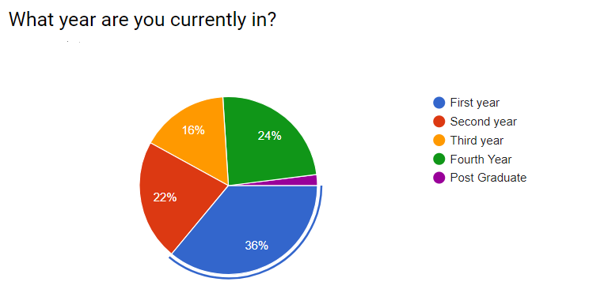

What are your favourite sports? (answer could be more than one) or none

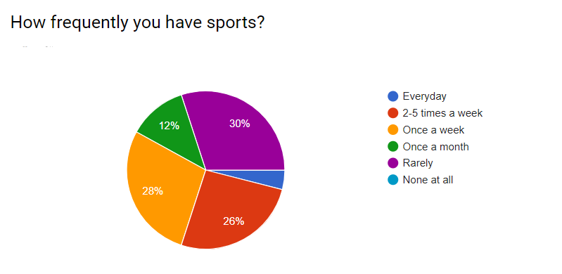
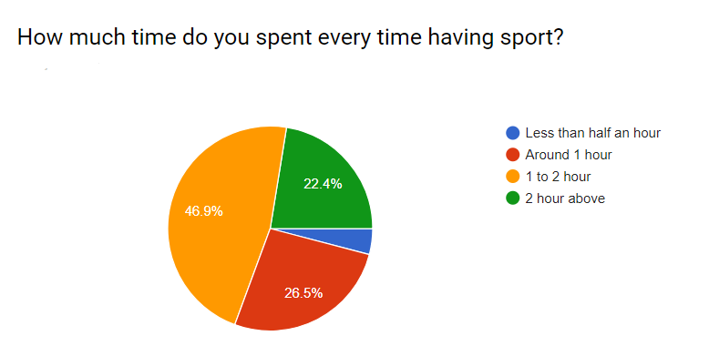

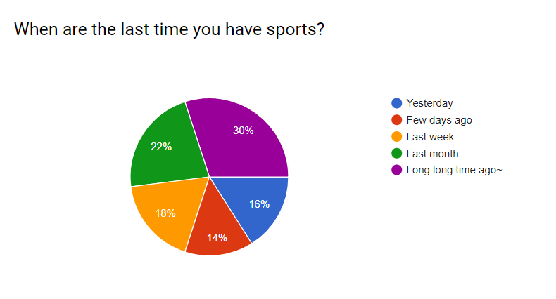

Why do you do sports? (Could be any reason)

Why do you hate or do not have sports? (Could be any reason)

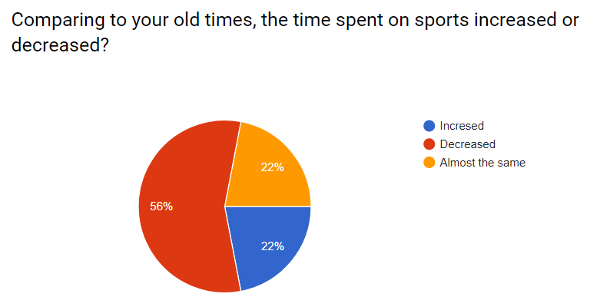

Why do you think this happened?

