

Probability, Statistic and Data Analysis
Project: Sport among Students
Part 2 (Data Testing)

Member:
Daniel Nizri
Syuraikh Ezzuddin
Muhammad Afiq Afwan
Muhammad Syahmi

Lecturer:
Dr. Chan Weng Howe

Date of submission:
22 May 2018

Introduction
The purpose of this report is to investigate the students of University Technology Malaysia (UTM) regarding their sport and recreational activities around the campus. The report will also include the time or money spent toward any particular sports or activities. A recent studies conduct by Statistic Brain Research Institute shows that around 36,250,000 people around the age of 5 and 18 play organized sport each year in America alone. So we want to know whether this statistic also reflect on the UTM student that range around 19 to 26 years old.
From this finding we are hoping to come out a conclusion toward the activities among the student. Hopefully from the result we could increase or improve on any categories so that it could lead to a better youth society.
From this potential testing, we would like to make out a complete conclusion regarding our test topic on whether the hypothesis,variable and even correlation between each others.

Type of Data Testing and Review

Hypothesis Testing
Variables and elements:
- Hypothesis statement
- Test Statistic on mean and standard deviation
- Level of confidence
- Conclusion/Decision Rule

Chi-square Test & Contingency Analysis
Variables and elements:
- Goodness-of-fit
- Expected and observed variables

Correlation Analysis
Variables and elements:
- Scatter plot
- Population correlation coefficient
- Sample correlation coefficient

Data Testing and Review

Students involvement in sports activities
Test 1: Test statistic for proportion (right tail test)
Number of population=55
Student that plays sport=38
Students that do not play sports=17
Probality that students play sport=0.69
Significance level: 0.05
Null Hypothesis: p=0.5
Alternate Hypothesis: p>0.5
z-value= 2.818
Conclusion: Null hypothesis is rejected as there is sufficient evidence that show that there are more than 50% of students that plays sport.

Days spent in a week for sport activities
Test 1: Hypothesis testing on mean(left-tail test with unknown variance)
Number of population=38
Population mean=4
Sample mean=3.378378
Sample standard deviation=1.551905
Significance level= 0.05
Null Hypothesis: mean=4
Alternate Hypothesis: mean<4
z-value= -2.4692
Conclusion: Null hypothesis is rejected as there is suffiecient evidence that show that the mean of students that play sport weekly is lower than 4

Test 2: Test on mean, variances(chi-square table)
Number of sample=14
Population standard deviation=1.552
Sample standard deviation=1.730464
Significance level=0.05
Null hypothesis: standard deviation=1.552
Alternate hypothesis: standatd deviation>1.552
Chi-square-value of a = 22.36
x-square value for sample = 16.16
Conclusion: Fail to reject null hypothesis as there is not enough evidence stating so.

Type of sport
Test: One-way Contingency Table
Sport | Badminton | Cardio | Futsal | Netball | Others
Observed | 6 | 11 | 5 | 7 | 7
Expected | 7.2 | 7.2 | 7.2 | 7.2 | 7.2

Null hypothesis: proportion is all same
Alternate hypothesis: at least one of the proportion is not equal
Significance level: 0.05
x-square for a = 2.8889
x-square for sample = 0.5766
Conclusion: Fail to reject null hypothesis as there is sufficient evidence stating so.

Time spend on sport during a session vs Play in a Week
Test: Correlation test
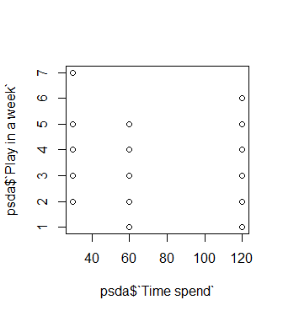
Conclusion: There is no correlation between these variables

Time spend during a session vs Expenses
Test: Correlation Test
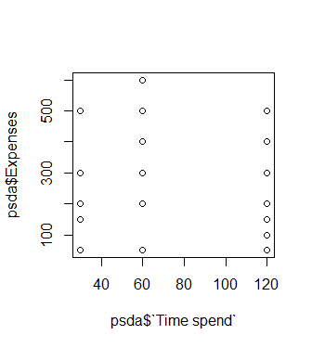
Conclusion: There are no correlation

Days vs Expenses
Test: Correlation Test
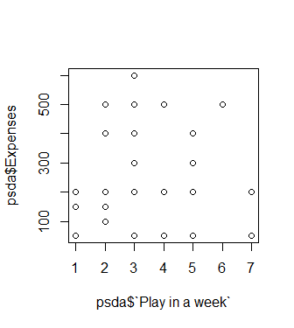
Conclusion: There are no correlation

Conclusion
As we can conclude from this finding,in hypothesis testing, there is suffiecient evidence that show that the mean of students that play sport weekly is lower than 4. Also, there is no correlation between days and expenses, time spend during session and expenses and time spend in a session and days played.
From the testing, a most of the calculation is being done using R-programming to implemented the use of it on a real life situation.

