COMPUTER LITERACY ASSIGNMENT 3
SSCM 1303

LECTURER NAME:
DR NORHAIZA BT AHMAD

GROUP MEMBER NAME:
SIA JIA YONG 911103-01-6097
OOI CHUN LIN 910131-08-5693
LAU MUN HING 910218-08-6023

Exercise 4 Question 1

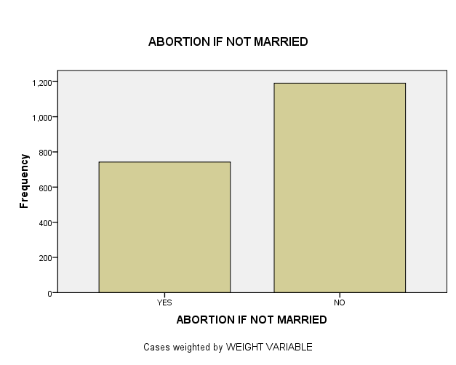

ABORTION IF NOT MARRIED
 |  | Frequency | Percent | Valid Percent | Cumulative Percent
Valid | YES | 742 | 16.4 | 38.4 | 38.4
Valid | NO | 1191 | 26.4 | 61.6 | 100.0
Valid | Total | 1933 | 42.8 | 100.0
Missing | NAP | 2513 | 55.7
Missing | DK | 53 | 1.2
Missing | NA | 13 | .3
Missing | Total | 2579 | 57.2
Total |  | 4512 | 100.0

We can see from the chart, the graphic is a bar chart with the categories at the bottom, the X-axis, and the frequency scale at the left, the Y-axis. The variable label ABORTION-IF NOT MARRIED is displayed at the top of the chart. We see from the frequency distribution that there are more “no” 26.4% answers than “yes”, 16.4% answers, when respondents were asked if a woman should able to get an abortion for not married. There are 55.7% is NAP(Not Appropriate), 1.2% is DK(Don’t know) and 0.3% is NA(Not Answered).
But for valid percent excluded missing value, we can get to know that 38.4% of respondent answered “yes” while 61.6% of respondent answered “no”.

Exercise 6
1.
Report
AGE OF RESPONDENT
VOTE FOR KERRY, BUSH, NADER | Mean | N | Std. Deviation
KERRY | 47.58 | 1339 | 16.878
BUSH | 48.93 | 1476 | 16.035
OTHER | 46.95 | 41 | 12.371
Total | 48.27 | 2856 | 16.400
The youngest mean age group is respondents who voted for other which is 46.95 whereas the oldest mean age group is respondents who voted for Bush which is 48.93.

2.
Group Statistics
 | RESPONDENT'S SEX | N | Mean | Std. Deviation | Std. Error Mean
TOTAL FAMILY INCOME | MALE | 1789 | 17.92 | 5.100 | .121
TOTAL FAMILY INCOME | FEMALE | 2016 | 16.83 | 5.540 | .123

Independent Samples Test
 |  | Levene's Test for Equality of Variances |  | t-test for Equality of Means
 |  | F | Sig. | t | df | Sig. (2-tailed) | Mean Difference | Std. Error Difference | 95% Confidence Interval of the Difference
TOTAL FAMILY INCOME | Equal variances assumed | 24.423 | .000 | 6.265 | 3804 | .000 | 1.086 | .173 | .746 | 1.426
TOTAL FAMILY INCOME | Equal variances not assumed |  |  | 6.296 | 3798.587 | .000 | 1.086 | .172 | .748 | 1.424

Man has a highest mean income. Yes, because the significance value is less than 0.0005 so for sure is more than 0.05.

3.

Group Statistics
 | BELIEF IN LIFE AFTER DEATH | N | Mean | Std. Deviation | Std. Error Mean
AGE OF RESPONDENT | YES | 2178 | 45.13 | 16.648 | .357
AGE OF RESPONDENT | NO | 453 | 46.40 | 17.390 | .817

Independent Samples Test
 |  | Levene's Test for Equality of Variances |  | t-test for Equality of Means
 |  | F | Sig. | T | df | Sig. (2-tailed) | Mean Difference | Std. Error Difference | 95% Confidence Interval of the Difference
 |  |  |  |  |  |  |  |  | Lower | Upper
AGE OF RESPONDENT | Equal variances assumed | 5.497 | .019 | -1.471 | 2629 | .141 | -1.274 | .866 | -2.973 | .424
AGE OF RESPONDENT | Equal variances not assumed |  |  | -1.429 | 636.274 | .153 | -1.274 | .891 | -3.025 | .476
Respondents who don’t believe in life after death contribute highest mean age of respondent which is 46.40. No because the significance value more than 0.05.

4.

Paired Samples Statistics
Pair 1 |  | Mean | N | Std. Deviation | Std. Error Mean
Pair 1 | R'S MOTHER S SOCIOECONOMIC INDEX | 44.774 | 1379 | 19.8009 | .5333
Pair 1 | R'S FATHER S SOCIOECONOMIC INDEX | 48.184 | 1379 | 19.1088 | .5146

Paired Samples Test
 |  | Paired Differences |  |  |  |  | t | df | Sig.  (2-tailed)
 |  | Mean | Std. Deviation | Std. Error Mean | 95% Confidence Interval of the Difference |  | t | df | Sig.  (2-tailed)
 |  |  |  |  | Lower | Upper | t | df | Sig.  (2-tailed)
Pair 1 | R'S MOTHER S SOCIOECONOMIC INDEX - R'S FATHER S SOCIOECONOMIC INDEX | -3.4098 | 20.9974 | .5655 | -4.5192 | -2.3005 | -6.030 | 1378 | .000
Respondent’s father’s socioeconomic index has the highest mean socioeconomic status. Yes because the significance value is lower than 0.0005 and for sure is lower than 0.05.

EXERCISE 7

1) The higher the age of the people, the higher the tvhours.
2)

Correlations
 |  | AGE OF RESPONDENT | HOURS PER DAY WATCHING TV
AGE OF RESPONDENT | Pearson Correlation | 1 | .127**
AGE OF RESPONDENT | Sig. (2-tailed) |  | .000
AGE OF RESPONDENT | N | 4496 | 1982
HOURS PER DAY WATCHING TV | Pearson Correlation | .127** | 1
HOURS PER DAY WATCHING TV | Sig. (2-tailed) | .000
HOURS PER DAY WATCHING TV | N | 1982 | 1986
**. Correlation is significant at the 0.01 level (2-tailed).

Correlations
 |  |  |  | AGE OF RESPONDENT | HOURS PER DAY WATCHING TV
Spearman's rho | AGE OF RESPONDENT |  | Correlation Coefficient | 1.000 | .134**
Spearman's rho | AGE OF RESPONDENT |  | Sig. (2-tailed) | . | .000
Spearman's rho | AGE OF RESPONDENT |  | N | 4183 | 1845
Spearman's rho | HOURS PER DAY WATCHING TV |  | Correlation Coefficient | .134** | 1.000
Spearman's rho | HOURS PER DAY WATCHING TV |  | Sig. (2-tailed) | .000 | .
Spearman's rho | HOURS PER DAY WATCHING TV |  | N | 1845 | 1847
**. Correlation is significant at the 0.01 level (2-tailed).

Yes, my hypothesis was supported with the three things. No, the coefficient is not 0. My prediction of the hypothesized direction of the relationship between age of respondents and the hours per day watching tv is positive.Positive 0.134 correlation coefficients tell me there is a direct relationship between age and tvhours. When age of the respondents increases, the hours per day watching tv increases.

3) The strength of the relationship between age and tvhours is weak. The hours per day respondents have to relax might also influence the amount of television that people watch.

5)
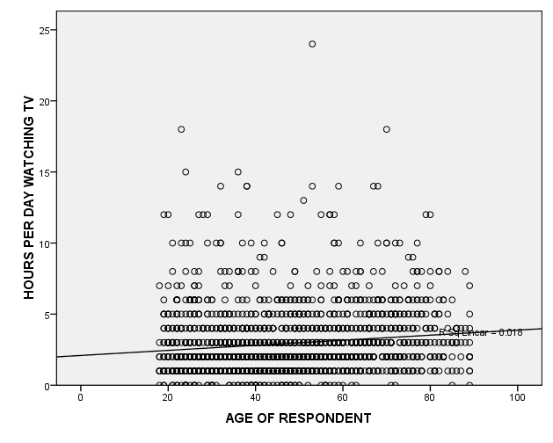

Variables Entered/Removed^{b}
Model | Variables Entered | Variables Removed | Method
1 | AGE OF RESPONDENTª | . | Enter
a. All requested variables entered.
b. Dependent Variable: HOURS PER DAY WATCHING TV

Model Summary
Model | R | R Square | Adjusted R Square | Std. Error of the Estimate
1 | .127ª | .016 | .016 | 2.131
a. Predictors: (Constant), AGE OF RESPONDENT

ANOVA^{b}
Model |  | Sum of Squares | df | Mean Square | F | Sig.
1 | Regression | 148.212 | 1 | 148.212 | 32.634 | .000ª
1 | Residual | 8993.903 | 1980 | 4.542
1 | Total | 9142.115 | 1981
a. Predictors: (Constant), AGE OF RESPONDENT
b. Dependent Variable: HOURS PER DAY WATCHING TV

Coefficientsª
Model |  | Unstandardized Coefficients |  | Standardized Coefficients | t | Sig.
 |  | B | Std. Error | Beta | t | Sig.
1 | (Constant) | 2.047 | .137 |  | 14.917 | .000
1 | AGE OF RESPONDENT | .016 | .003 | .127 | 5.713 | .000
a. Dependent Variable: HOURS PER DAY WATCHING TV
Y = a + bX
Y refers to the value of the hours per day watching tv, a is the Y-intercept (the point where the line crosses the Y-axis, b is the slope of the line which describes the relationship between the age of respondents and the hours per day watching tv, and X is the value of the age of respondents.
We know that the linear relationship between the age of respondents and the hours per day watching tvis not perfect. The correlation coefficient is 0.134, and the scatterplot showed a lot of cases that did not fall directly on the line. Thus, it is clear to us that knowing the age of respondents will not tell us the hours per day watching tv.We are only analysing a sample of cases and not the whole population to which we want to generalize our findings about the relationship between age of respondents and the hours per day watching tv. It is clear that there are some outliers in our findings.We draw a best fit line to show the relationship between the age of respondents and the hours per day watching hours. For these reasons, it is conventional to write the formula for the line as
Ŷ = a + bX + e, where e refers to error.
Since we do not know the actual value of errors that we make, we choose to ignore the e.
Ŷ = 2.047 + 0.016X
2.047= the Y-intercept is interpreted as the hours per day watching hours (our dependent, or Y variable),
0.016 = the slope of the linethe age of respondents (our independent, or X variable).
Since X refers to the value of the independent variable, and age of respondentsis our independent variable, all we have to do is enter 12 (age of respondents) into our equation as follows:
Ŷ = 2.047 + 0.016(12)
Ŷ = 2.239
We find that the age of respondents which is12 is associated with the hours per day watching tv is 2.239 hours. In sum, the error tells us about the distance from actual values of Y (the answers that the GSS survey respondents gave) and predicted values of Y (the ones you calculate based on the GSS respondent’s information in the “X” variable).
Error = the difference between a predicted value of Y for a given case and the actual value of Y for a given case (Ŷ-Y).

