Assignment 3 (SPSS)
Section : 2
Lecturer : Dr Norhaiza Binti Ahmad
Group member
- Chew Siew Cheng
(910617-08-5722 / A11SC0251)
- Lee Sze Jie
(910811-08-5056 / A11SC0248)
- Ng Siew Hui
(911127-13-5242 / A11SC0228)

Chapter Four Exercises :

Statistics
ABORTION IF NOT MARRIED
N | Valid | 1933
N | Missing | 2579
Mode |  | 2

ABORTION IF NOT MARRIED
 |  | Frequency | Percent | Valid Percent | Cumulative Percent
Valid | YES | 742 | 16.4 | 38.4 | 38.4
Valid | NO | 1191 | 26.4 | 61.6 | 100.0
Valid | Total | 1933 | 42.8 | 100.0
Missing | NAP | 2513 | 55.7
Missing | DK | 53 | 1.2
Missing | NA | 13 | .3
Missing | Total | 2579 | 57.2
Total |  | 4512 | 100.0
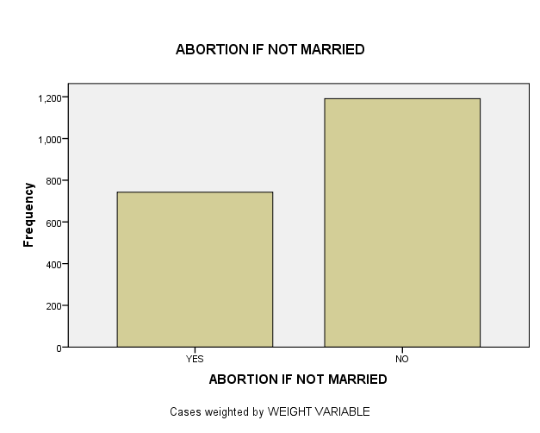

The graphics above show the rate of abortion if not married. We see from the frequency distribution that there are more “NO”, 28.4%, answers than “YES”, 16.4% answers, when respondents were asked if a woman should be able to get an abortion if not married. A much smaller number, 1.2%, selected “don’t know”, “DK” while not answered, NA, was 0.3% of the sample. The 55.7% “NAP” (Not Appropriate) was that portion of the sample that was not asked this question. The missing values, which include NAP, DK and NA were excluded from the “Valid Percent”.

Chapter Six Exercises :
1.
Case Processing Summary
 | Cases
 | Included |  | Excluded |  | Total
 | N | Per cent | N | per cent | N | per cent
AGE OF RESPONDENT * VOTE FOR KERRY, BUSH, NADER | 2856 | 63.3% | 1656 | 36.7% | 4512 | 100.0%

Report
AGE OF RESPONDENT
VOTE FOR KERRY, BUSH, NADER | Mean | N | Std. Deviation
KERRY | 47.58 | 1339 | 16.878
BUSH | 48.93 | 1476 | 16.035
OTHER | 46.95 | 41 | 12.371
Total | 48.27 | 2856 | 16.400
- The group which had the youngest mean age is the group of someone else which is 46.95 years old.
- The group which voted for Bush had the oldest mean age which is 48.93 years old.
2.
Group Statistics
 | RESPONDENT'S SEX | N | Mean | Std. Deviation | Std. Error Mean
TOTAL FAMILY INCOME | MALE | 1789 | 17.92 | 5.100 | .121
TOTAL FAMILY INCOME | FEMALE | 2016 | 16.83 | 5.540 | .123

Independent Samples Test
 |  | Levene's Test for Equality of Variances |  | t-test for Equality of Means
 |  | F | Sig. | t | df | Sig.  (2-tailed) | Mean Difference | Std. Error Difference | 95% Confidence Interval of the Difference
 |  |  |  |  |  |  |  |  | Lower | Upper
TOTAL FAMILY INCOME | Equal variances assumed | 24.423 | .000 | 6.265 | 3804 | .000 | 1.086 | .173 | .746 | 1.426
TOTAL FAMILY INCOME | Equal variances not assumed |  |  | 6.296 | 3.799E3 | .000 | 1.086 | .172 | .748 | 1.424

- Male has the highest mean income which is 17.92.
- Yes. The significance value is .000 for both versions of the t test. Actually, this means less than 0.0005.
3.
Group Statistics
 | BELIEF IN LIFE AFTER DEATH | N | Mean | Std. Deviation | Std. Error Mean
AGE OF RESPONDENT | YES | 2178 | 45.13 | 16.648 | .357
AGE OF RESPONDENT | NO | 453 | 46.40 | 17.390 | .817

Independent Samples Test
 |  | Levene's Test for Equality of Variances |  | t-test for Equality of Means
 |  | F | Sig. | t | df | Sig. (2-tailed) | Mean Difference | Std. Error Difference | 95% Confidence Interval of the Difference
 |  |  |  |  |  |  |  |  | Lower | Upper
AGE OF RESPONDENT | Equal variances assumed | 5.497 | .019 | -1.471 | 2629 | .141 | -1.274 | .866 | -2.973 | .424
AGE OF RESPONDENT | Equal variances not assumed |  |  | -1.429 | 636.274 | .153 | -1.274 | .891 | -3.025 | .476
- The group which does not believe in life after death had the highest mean age which is 46.4 years old.
- No. This is due to the significance value is more than 0.05
4.
Paired Samples Statistics
 |  | Mean | N | Std. Deviation | Std. Error Mean
Pair 1 | R'S MOTHER S SOCIOECONOMIC INDEX | 44.774 | 1379 | 19.8009 | .5333
Pair 1 | R'S FATHER S SOCIOECONOMIC INDEX | 48.184 | 1379 | 19.1088 | .5146

Paired Samples Correlations
 |  | N | Correlation | Sig.
Pair 1 | R'S MOTHER S SOCIOECONOMIC INDEX & R'S FATHER S SOCIOECONOMIC INDEX | 1379 | .418 | .000

Paired Samples Test
 |  | Paired Differences |  |  |  |  | t | df | Sig.  (2-tailed)
 |  | Mean | Std. Deviation | Std. Error Mean | 95% Confidence Interval of the Difference |  | t | df | Sig.  (2-tailed)
 |  | Mean | Std. Deviation | Std. Error Mean | Lower | Upper | t | df | Sig.  (2-tailed)
Pair 1 | R'S MOTHER S SOCIOECONOMIC INDEX - R'S FATHER S SOCIOECONOMIC INDEX | -3.4098 | 20.9974 | .5655 | -4.5192 | -2.3005 | -6.030 | 1378 | .000

- Socioeconomic status of respondent’s father has the highest mean which is 48.184.
- Yes. This is due to the significance value is lower than 0.005 and as well as is lower than 0.05

Chapter Seven Exercises :
1. Hypothesis : In our opinion, a weak positive relationship between the age of people and the number
of hours watching television per day. As the age of people increases, the number of
hours for watching television per day will also increases.

2. Pearson Correlation :
Correlations
 |  | age  AGE OF RESPONDENT | Tv hours  HOURS PER DAY WATCHING TV
AGE OF RESPONDENT | Pearson Correlation | 1 | .127**
AGE OF RESPONDENT | Sig. (2-tailed) |  | .000
AGE OF RESPONDENT | N | 4496 | 1982
HOURS PER DAY WATCHING TV | Pearson Correlation | .127** | 1
HOURS PER DAY WATCHING TV | Sig. (2-tailed) | .000
HOURS PER DAY WATCHING TV | N | 1982 | 1986
**. Correlation is significant at the 0.01 level (2-tailed).

From the table above, the Pearson coefficient for the relationship between the age of respondent and hours per day watching television is 0.127 and it is positive. This tells us that, just as we predicted, as the age increases, the amount hours of watching television also increases. The relationship between age and hours per day watching TV is actually quite weak. The hypothesized direction of the relationship was positive between this two variables. The probability value is .000, which is well below the conventional threshold of p < 0.05. Thus, our hypothesis is supported. There is a relationship (the coefficient is not 0), it is in the predicted direction (positive), and we can generalize the results to the population (p < 0.05).

3.
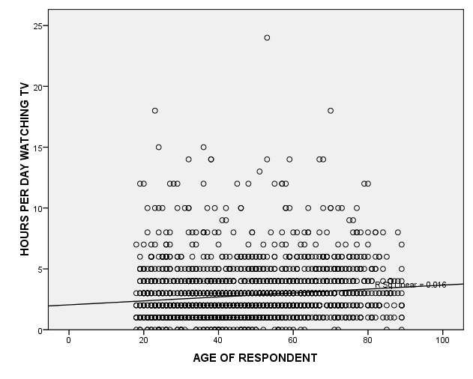
The strength of the relationship between age and tvhours is weak. With a correlation value of 0.127 and an R-square value of 0.016, this shows that age does not really affect the amount of television watched by people. There are many other factors that might also influence the amount of television watching by people is the television program and show. For example, the television program such as Cartoon, Cooking Competition Show, Travel movie and some interesting movie and so on also can attract more audiens like children, teenagers or housewife to watch television. Thus, people will spend more of their time to watch television at home.

Variables Entered/Removed^{b}
Model | Variables  Entered | Variables Removed | Method
1 | age AGE OF RESPONDENTª | . | Enter
a. All requested variables entered.
b. Dependent Variable: tvhours HOURS PER DAY WATCHING TV
5.

Model Summary
Model | R | R Square | Adjusted R Square | Std. Error of the Estimate
1 | .127ª | .016 | .016 | 2.131
a. Predictors: (Constant), age AGE OF RESPONDENT

ANOVA^{b}
Model |  | Sum of Squares | Df | Mean Square | F | Sig.
1 | Regression | 148.212 | 1 | 148.212 | 32.634 | .000ª
1 | Residual | 8993.903 | 1980 | 4.542
1 | Total | 9142.115 | 1981
a. Predictors: (Constant), age AGE OF RESPONDENT
b. Dependent Variable: tvhours HOURS PER DAY WATCHING TV

Coefficientsª
Model |  | Unstandardized Coefficients |  | Standardized Coefficients | t | Sig.
 |  | B | Std. Error | Beta | t | Sig.
1 | (Constant) | 2.047 | .137 |  | 14.917 | .000
1 | age AGE OF RESPONDENT | .016 | .003 | .127 | 5.713 | .000
a. Dependent Variable: tvhours HOURS PER DAY WATCHING TV

From the Coefficient table above, we can obtain an equation that relating the age of people and the number of hours watching television per day.
The equation is :
Y = a + bX
tvhours = 2.047 + 0.016age.
The value of 2.047, Y-intercept (or constant), is interpreted as the average of spending hours for watching television per day with the effects of age . While 0.016 is the slope of the line. We can use this equation to predict the number of hours watching television of a particular person by substituting that person’s age into the equation (age) and calculate out. Beside that, we can also substitute the number of hours for watching television into equation to calculate the age of people. By looking at the equation, we can say that the number of hours spent watching television increases by a very small margin whenever there is an increase in age.

