
E - PORTFOLIO
SKEE 1223
Dr. Muhammad Farabi

By:
Muhammad Rohullah Fajar
(A17KE0320)

Group Project Using Quartus
I want to share my experience for creating group project with my team. This project given by our lecture Dr. Muhammad Iqbal, our goal is to able to create circuit by using application called as Quartus. In this project our lecturer giving us some problem , from that problem me and my team need to solve the problem given. My team included 3 member me , Amirul Aiman Bin Razman and Nurul Iman Binti Mohammad Sofi.
By using the Altera Quartus II Software, our team need to design a combinational logic circuit using only 4-to-16 decoders (74154 chip) and two-input NAND gates to produce the 12-digit identity card number of your group leader. In this time we chose Aiman as our leader in this group. There is some list of the problem should we solve :
- The design steps .
- The Quartus circuit layouts .
- Corresponding timing diagram for each of the outputs .
- And assignment report also UTM e-portfolio .
On the first week , our group member tried to collect all the information how to do use the Quartus application. And also we are downloaded the application and try to watched the in youtube side, and also for more easier to solving the problem we were trying to ask our second year senior how to do the task. In this time we are using Altera Quartus version 13.1.
After a week studying the application by our self, we were gathering for our first meeting on 26th April 2018, in that time we came out with a truth table, corresponding with the logic gates that we used. According to the IC number from Aiman’s we created the truth table for our first step work.
I1 | I2 | I3 | I4 | NO |  | IC |  | 01 | 02 | O3 | O4
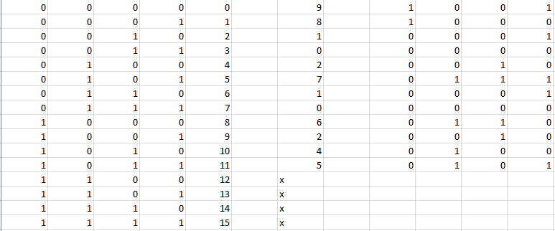
Figure 1. Creating Truth Table

Next after the truth table completed , we are creating the logic circuit layout by using Quartus. Absolutely the application is already installed , according to the truth table we had get before, we made our circuit layouts based on the truth table. Actually its not easy to create our circuit, a lot of problem we got in that moment, such as wrong input has been inserted , error message popped out because of program cant do run analysis, and the worst was our project file corrupted , so because of that we need to create our new file project again from start. At last our circuit created and the program can be run and its success.
Here is some steps to build up the diagram in Quartus
- Build up a truth table as indicated in diagram above.
- Fill up all the IC number.
- Bring out all the value represented by each number.
- Build up the diagram by taking all the minterms from each output. (O1,O2,O3,O4)
- Stimulate the timing diagram.
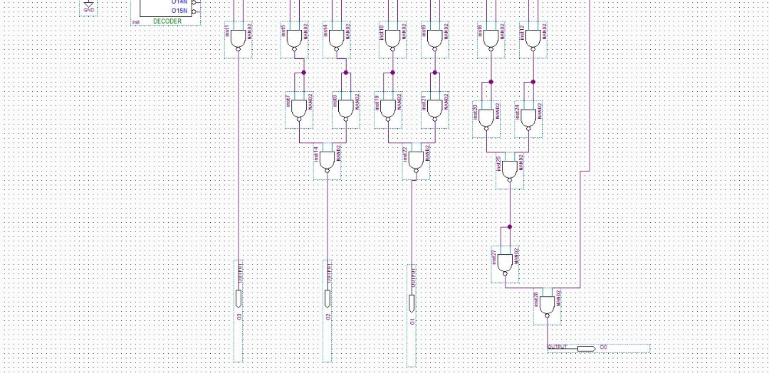
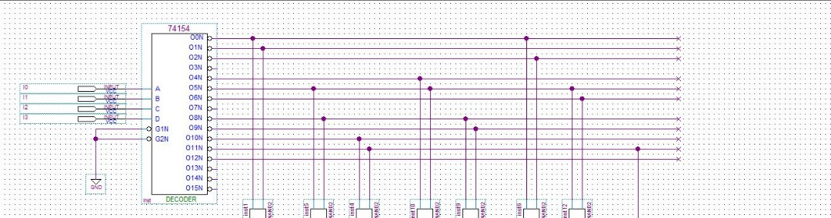

Figure 2. Circuit Layout
After the circuit layout successful to run and analysis, our team can proceed for the work to create waveform timing diagram. The timing diagram is also depends on the truth table and the circuit we had create. And the climax from our problem while do this step is the waveform able to run and create the waveform diagram, but the serial IC number it is not match with Aiman’s IC number. So we are trying to troubleshoot , searching for the mistakes we had miss . At last we found the solution of the problem, to resolve the problem we were changing the order of input and also the output opposite not like the first circuit we create. After saved the project file we were tried to run the waveform editor and our result has come same like the Aiman’s IC.
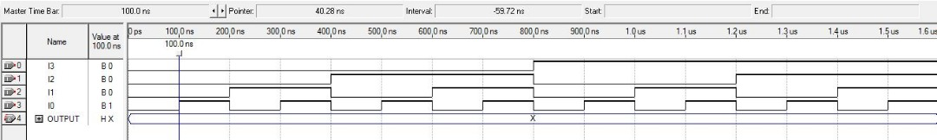
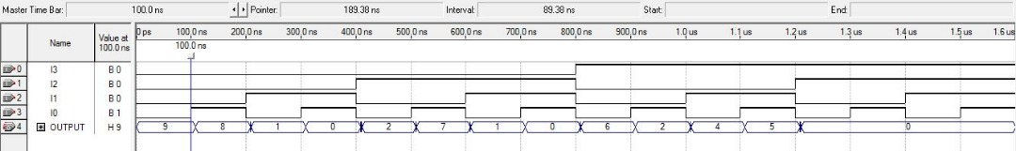
Figure 3. Waveform Timing Diagram
For the last work of this group project, we create our report file so we can submit it to our lecturer ,and also for individual assignment every member should make e – portfolio from the result of the group project. This whole process of making the project allows me to have a better understanding of using Quartus as well as getting a clearer picture of creating a whole circuit design practically. This is very crucial for every single person which will be an engineer one day. If there is no project like this we wont get to know on how to create and design a complete circuit perfectly. What we hope in the future are more and more project can be given to us student that can help me honing my practical skill which we can use it in our working field.

