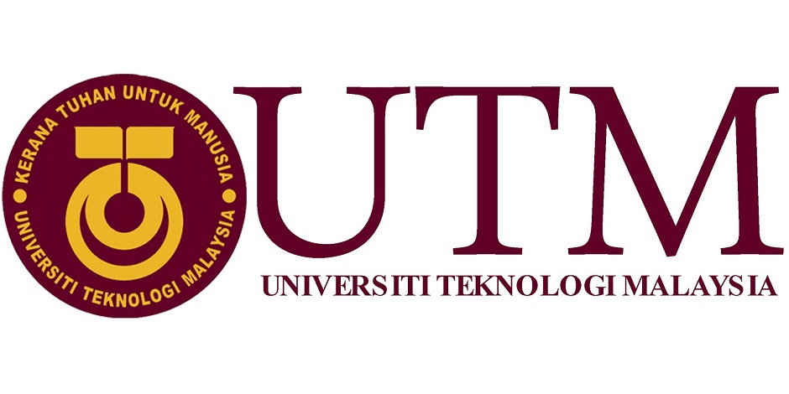
UNIVERSITI TEKNOLOGI MALAYSIA
FACULTY OF COMPUTING

PUBLIC LECTURE REPORT

TOPIC: 4th INDUSTRIAL REVOLUTION
SPEAKER : PROF DR. ROSE ALINDA BINTI ALIAS

INFORMATION SYSTEM & INFORMATION TECHNOLOGY
LECTURE : NOORMINSHAH A.IAHAD

NAME : NURUL NABILAH SAMSUL FAUDZIE
NO.MATRIC : A17CS0240

EXECUTIVE SUMMARY

The Faculty of Computing recently organised an public lecture about 4th Industrial Revolution by Prof Dr. Rose Alinda Binti Alias at Seminar Hall,N28a of Faculty of Computing. This event was introduce about what is the 4th Industrial Revolution ,how 4th Industrial Revolution impact the field of IT and what kinds of specification and requirement is needed for a career in IT correspond to 4th Industrial Revolution. This topic will make the new generation open their minded about the new revolution that make great change in their life. The 4th Industrial Revolution has potential to give the income to everyone and raise the economy of the world. The student also can prepare theirself about revolution that will happen. So, the revolution can be realized.

INTRODUCTION
The Industrial Revolution was the transition to new manufacturing processes in the period from about 1760 to sometime between 1820 and 1840. This transition included going from hand production methods to machines, new chemical manufacturing and iron production processes, the increasing use of steam power, the development of machine tools and the rise of the factory system. From that era, the evolution still happen in stages from 1.0 until now which is 4th Industrial Revolution.
- What is the 4th Industrial Revolution?
The Fourth Industrial Revolution, or 4IR, is the fourth major industrial era since the initial Industrial Revolution of the 18th century. The Fourth Industrial Revolution can be described as a range of new technologies that are fusing the physical, digital and biological worlds, and impacting all disciplines, economies and industries. Klaus Schwab has associated it with the "second machine age" in terms of the effects of digitization and on the economy, but added a broader role for advances in biological technologies. It still not sure yet how it will unfold but one thing is clear is to be integrated and comprehensive, involving all stakeholders of the global polity, from the public and private sectors to academia and civil society. We stand on the blink of a technological revolution that will fundamentally after the way we live, work and relate to one another. In its scale, scope and complexity, the transformation will be unlike anything humankind has experienced before.
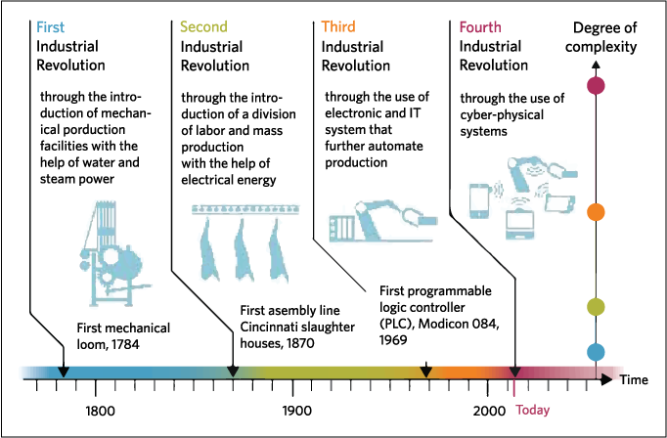

Why a 4th revolution is under way?
The 4IR affects to the life because human and technology will working together. The 4th revolution is under way because of
- Velocity in the industrial that evolving at an exponential rather than linear pace. It is because many industries are seeing the introduction of new technologies that create entirely new ways of serving existing needs and significantly disrupt existing industry value chains.
- Breadth and depth in the digital revolution and combines multiple technologies that leading to unprecedented paradigm shifts in the economy, business, society and individually.
- System impact involves the transformation of entire systems across countries, companies, and industries.

- How 4th Industrial Revolution impact the field of IT?
What is Education 4.0?
Education 4.0 is about anywhere anytime, personal, flexible delivery, peers and mentors, practical application, modular and projects, student ownership and evaluated and examined. This revolution focus to the life about technology and the humans live together. So, it gives the bigger impact to the field of IT. Lord Baker’s was plan to bring industrial revolution in the education sector by using technology. One of his plan is primary school should bring in outside experts to teach coding. From that ages, they will knows how to think about the algorithm thinking, creative thinking, critical thinking to make their self prepare to the revolution. Next point is young apprenticeships should be reintroduced at 14, blending a core academic curriculum with hands on learning and also student must learn how businesses work from the school. For the universities should provide part-time courses for apprentices to get Foundation and Honours degrees faster.
From that, the students and the young generation can field experience because technology can facilitate more efficiency in certain domains, curricula to make room for skills that solely require human knowledge and face-to-face interaction. The students can get opportunity to obtain real-world skills that are representative to their jobs. Next, data interpretation. Computer will soon take care of every statistical analysis and describe and analyse data and predict future trends. Exam also will change completely, student ownership and mentoring will become more important because their use the technology and the student will incorporate so much independence in their learning process. In this sector also already exists th applications and website using the IT. So, it become easy to students to learn something new from that. Though the future of education seems remote, the teacher and educational are vital to academic performance.
What is Industry 4.0?
Industry 4.0 is a name for the current trend of automation and data exchange in manufacturing technologies. It includes cyber-physical systems, the Internet of things, cloud computing and cognitive computing. The characteristic of industry 4.0 is interconnection, data, integration, innovation and also transition. A disruptive innovation is an innovation that creates a new market and value network and eventually disrupts an existing market and value network. From that it describes a process by which a product or service takes root initially in simple applications.
One of the industry 4.0 that can see now is uber disruption. Affected industry is regular private fleets of taxis. Usually, the regular taxis relied on hand signals while plying empty on roads or simply waiting at a taxis stand for a passenger to turn up. With using uber, it easy the passenger to get the cabs by using the mobile app. The digital disruption can overcome by using Uber mobile app and the taxi companies will change their style of functioning to get the customer and move forward and embrace the technique of Uber or provide better techniques.
Other that, Netflix disruption. Netflix is a website to watch the video that what you wish and it will streaming to computer or television. Who’s affected? This practice has hurt CBS,ABS, and NBC badly. They don’t have to monopoly anymore because the community in this world use the internet to access whatever they want. The solution to the problem that companies have to provide similar option with Netflix to stick with same level.
From the Industry 4.0, many of ting will transformed such as leadership transformation, blend physical and digital experiences, operating model transformation and work source transformation.
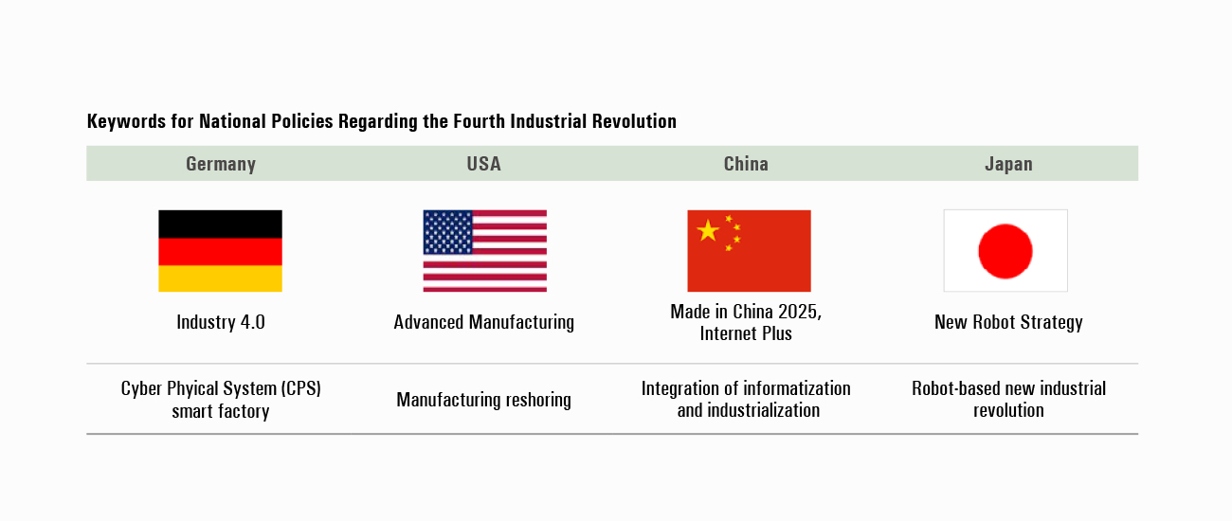
The above picture it’s about the country that start the industry 4.0 and their industry sector is among of best that use technology. I hope Malaysia will one of them in the next time.
- What kinds of specification or requirement is needed for a career in IT correspond to 4IR?
Because the 4th Industrial Revolution always related with IT, that person must be a creative person and smart to think smart idea or crazy idea although that idea look like impossible to achieved it. But in this globalization, no of ideas is impossible to achieved with help of technology and machines. For that, the requirement is needed for a career in IT is this world must start from the young generation to make them prepared their self for the future by give the education that use technology and knowledge and make their self think outside the box and be creative person because they is next leader to this country became success. Next, people must have soft skills and equability to maintain in this revolution because it have a lot of challenges and risk.
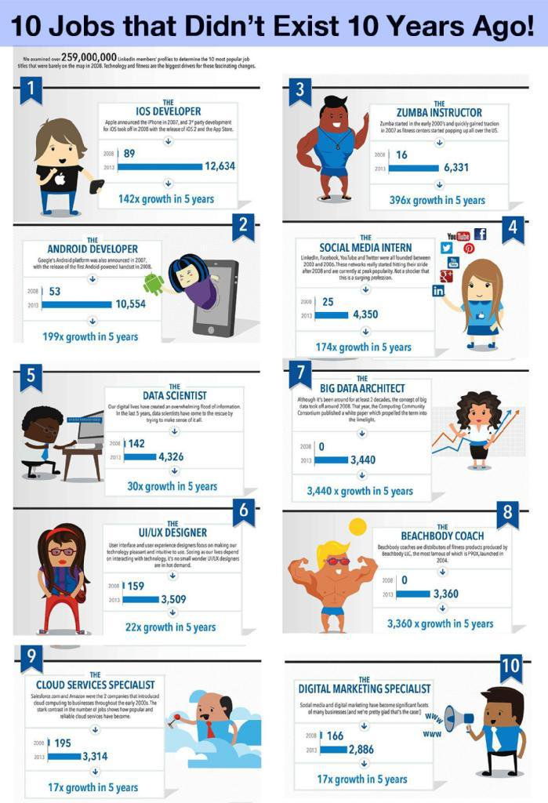

CONCLUSION
From this public lecture, I learn about what is the industrial revolution and why it important to people in this world. What I get is we must always get the new knowledge and learn it and produces the idea to make this world always develop. In digital revolution, knowledge is as necessary as ever although it not enough. From that, the factor of IT must be perform, creative and be crazy to think the idea to make the bigger revolution. From that, the speaker give us the task to think about the crazy idea when you wake up in the morning. Because of that, from what I thought is when wake up, I can access the applications that full of various food from other country that can taste and smell the food just from the picture we choose it.
But the basis is the young generation must get the enough education and always care about the news that government plan it because we should realize that day by day the world is build up or will loss it.

