

INDUSTRIAL VISIT REPORT
MAJLIS BANDARAYA JOHOR BAHRU (MBJB)
22nd November 2017

Industrial visit report submitted in partial fulfilment of the requirement for evaluation.

Faculty of Computing (Software Engineering)

Submitted to: Dr. Noorminshah Binti A.Iahad
Report by: GROUP 1
Nursyahira Sabrina Binti Mohd. Sukri
Feeraz A’Shaqif Bin Abdul Razak
Nurul Nabilah Binti Samsul Faudzie
Mohammad Fitri Bin Abidin
Miraj Ahmed

Table of Contents
INTRODUCTION OF ORGANIZATION 1-2
THE INDUSTRY INVOLVED 3-6
CAREER OPPORTUNITIES 7
THE APPLICATIONS OR SYSTEMS DEVELOPED. 8-11
REFLECTION 12-13
REFERENCES 14

INTRODUCTION OF ORGANIZATION


Majlis Bandaraya means City council in Malaysia, the authority who governs a city is known as City council. Majlis Bandaraya Johor Bahru(MBJB) previously known as Majlis Perbandaran Johor Bahru (1993) maintain the management and look after stuff of Johor bahru city centre and other areas of Iskandar Malaysia like from the Southeast - Tebrau,Taman pelangi,Pasir Pelangi,permas jaya,Taman Rinting and from Southwest – Tampoi,Larkin,Kempas. MBJB is under Johor Bahru state government and the name of the present mayor (datuk bandar) Tuan Haji Amran Bin A. Rahman. Just like other country councils MBJB also looks after the public health and sanitation, waste removal and management, town planning, environmental protection and building control, social and economic development and general maintenance functions of urban infrastructure. Majlis Bandaraya Johor Bahru has ten departments with seven branches ,
Departments
1.Jabatan Bangunan (Building Department)
2.Jabatan Kewangan (Monetary Department)
3.Jabatan Perancangan (Planning Department)
4.Jabatan Kejuruteraan (Engineering Department)
5.Jabatan Pelesenan dan Penguatkuasaan (License and Enforcement Department)
6.Jabatan Khidmat Pengurusan (Management Service Department)
7.Jabatan Lanskap (Landscape Department)
8.Jabatan Penilaian (Valuation Department)

1
9.Jabatan Pembangunan Kemasyarakatan (Community Development Department)
10.Jabatan Kesihatan (Health Department)
The Head quarter of MBJB is in Jalan Dato' Onn, Johor Bahru , Malaysia where all the meetings are been held. Though they have few branches throughout Johor Bahru ,
-Larkin
-Taman Sentosa
-Taman Pelangi
-Stulang
-Permas Jaya
-Bandar Baru UDA
-Tampoi
Including these branches all the responsibility of the city is upon them with the motto “ Berkhidmat, Berbudaya, Berwawasan” in English “serving , Being Cultured, insightful” .

2
THE INDUSTRY INVOLVED

1. Segget Updates : Community Based Design Landscape.
The Sungai Segget Rejuvenation project under the Johor Bahru Transformation (JBT) Programme is entering its third phase which involves landscaping and beautification of the area.
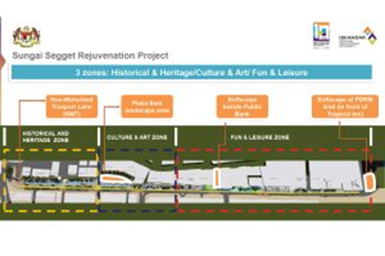
Proposed Concept for Sungai Segget Landscape Plan
The JBT Programme aimed to revitalise Johor Bahru, by providing thriving economic activities, city living and amenities that are aligned with the vision of Majlis Bandaraya Johor Bahru (MBJB) and Iskandar Regional Development Authority (IRDA).
Since 2010, the JBT programme has conducted a series of engagement with the various stakeholders involved including affected property and business owners along with the public. These engagements will continue to inform and obtain feedback from them on the various related components of the transformation.
Maimunah Jaffar, Head of Planning & Compliance of IRDA related that the design for the Segget landscape proposed is ‘a community based design’ derived from a series of seven previous engagements with the community between 2016 and 2017.
3
“The final engagements will be held on 16th and on 21st August in conjunction with a community-led initiative conducted by Dr Sharifah Salwa from UTM, which IRDA supports,” said Maimunah adding that IRDA will engage the public and obtain their feedback on the design of the Segget landscape.
Aiming to bring back the soul of Sungai Segget as one of the major tourist destinations of Johor, the proposed plan optimises road design to allow 60% pedestrian and 40% vehicular access which generates more economic activities to attract visitors and encourage land owners to develop their businesses in line with the project.
The design will also incorporate heritage, cultural and recreational elements. Once completed, Sungai Segget, is ideal for recreation purposes for all ages, transforming it into the pulse of Johor Bahru city centre. The three-proposed landscape concept are the Historical and Heritage Zone, Cultural and Art Zone, and Fun and Leisure Zone
2. Low Carbon Blueprint Handed Over
Menteri Besar Johor, Dato’ Mohamed Khaled Nordin today handed over the Iskandar Malaysia Low Carbon Society (LCS) Action Plans 2025 to the five local authorities.
The local authorities involved are Majlis Bandaraya Johor Bahru (MBJB), Majlis Bandaraya Johor Bahru Tengah (MBJBT), Majlis Perbandaran Pasir Gudang (MPPG), Majlis Perbandaran Kulai (MPKu) and Majlis Daerah Pontian (MDP).
Datuk Ismail Ibrahim, Chief Executive of IRDA said “Apart from the emphasis on low carbon development and green economic growth, the action plans are also aligned with the strategic spatial development plans of each local authority to ensure that the plans can all be implemented effectively.”
4
3. Down town JB : A Baseline community survey
Majlis Bandaraya Johor Bahru (MBJB) is collaborating with Think City Sdn Bhd (a subsidiary of Khazanah Nasional dedicated to community based urban regeneration) to breathe a breath of new life into downtown Johor Bahru.
The areas involved include Jalan Ayer Molek, Jalan Bukit Timbalan, Jalan Dato’ Dalam, Jalan Dhoby, Jalan Segget, Jalan Wong Ah Fook, Jalan Bukit Chagar and Jalan Lumba Kuda.
The collaboration is an effort to conduct a detailed survey of more than 800 buildings in the area, to seek views of the residents and business for future planning and development programmes. The data gathered will be analysed for the city regeneration programme which is powered by Khazanah Nasional.
Trained surveyors will be interviewing all businesses, households, and government organisations, including non-profit and educational institutions over the few weeks of February and March.
Only basic information is to be collected and all data will remain strictly confidential.
The surveyors can be recognised by their uniforms and ID tags. Each survey should not take more than 5 minutes of the respondents’ time.
4. A Unique Dynamic Development Initiative
The Ibrahim International Business District (IIBD) and Coronation Square JB projects were launched by His Royal Highness Sultan Ibrahim Ibni Almarhum Sultan Iskandar at PERSADA International Convention Centre.

5
Nestled within the city centre, the 250 acre development zone is a unique and dynamic development initiative by Johor Corporation (JCorp) with help from Majlis Bandaraya Johor Bahru as an effort to modernise the state’s capital.
“This strategic development is important as, among other things, JB has experienced a major population increase which has spurred a major economic growth and the existence of IIBD in the city will enhance the standard of living for the local community,” said Menteri Besar Dato’ Khaled Nordin.
IIBD will consists of a 6.32 acre zone known as the Coronation Square which aims to become a catalyst in the state’s transformation projects. A tie in project with JCorp, it will include the development of a medical suite, three apartment blocks an office tower and a hotel connected retail podium which will specifically allow 100 qualified Bumiputera entrepreneurs.

6
CAREER OPPORTUNITIES
Since Majlis Bandaraya Johor Bahru (MBJB) is a government public city council that specializes in public affairs, there are many job scopes in this council because it consists of many departments of organization. Other than that, not only inner organization jobs available. They also provides collaboration with other organization or government council so workers from there have opportunities to work or sign a contract.
We can apply for many jobs in this council since it has many departments such as;
1. Building Department
2. Monetary Department
3. Planning Department
4. Engineering Department
5. License and Enforcement Department
6. Management Service Department
7. Landscape Department
8. Valuation Department
9. Community Development Department
10.Health Department
For example, a graduate from Engineering course can apply to work in engineering department.
If someone specializes in specific areas that this council need to work with for any projects, they can sign a contract for the project. For example, if MBJB wants to build a building, they can reach outer architecture firm.

7
THE APPLICATIONS OR SYSTEMS DEVELOPED

There are 20 applications and system that are developed by MBJB for the convenience of Johor’s community.
No. | Applications / Systems | Details
1 | Sistem Maklumat Anggota (e-Anggota MBJB) | Staff Information System  The main system in MBJB which related to the information of the staffs.
2 | Sistem Aktivti Anggota (e-aktiviti MBJB) | Staff’s Activity System  System related to annual activity records
3 | Sistem Daftar Kedatangan (e-Kedatangan MBJB) | Staff attendance system. It consists of attendance monthly report and working hours for the staff.
4 | Sistem Pengurusan Fail (e-Fail MBJB) | Files Management System  Regarding the file registration and able to upload the appendix of a document.
5 | Sistem Pemindahan Kenderaan (e-MyVIS) | My Vehicle Transfer Record Check
6 | Sistem iPerolehan MBJB | Procurement System.
7 | Sistem Aplikasi Mobil (My SAM) | Mobile Application System  The applications from 1-4 where the staff can access it through their smartphones.
8 | e-PBT | - Counter Services Management System MBJB  -taxing, licensing ,renting ,billing  -Financial management system  - Evaluation Management System
9 | e-Khidmat | e-Services
10 | JOP | Johor e-payment Portal
11 | SISPAA | Public Complaint Management System
12 | OSC-ONLINE
13 | Sistem Pengurusan Gaji | Salary Management System
14 | e-Tracking SPKT | Department evaluation system
15 | iPDS | Work monitoring system of OSC unit
16 | i-Trafik MBJB | Traffic
17 | OPAC PSI | Online catalogue for Sultan Ismail Library
18 | PSI eBook | Online e-book search for Sultan Ismail Library
19 | MBJB SPOT | Android application for car parking management.
20 | iKepoh | Application for Johor community to address their complaints.

8
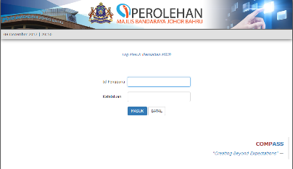
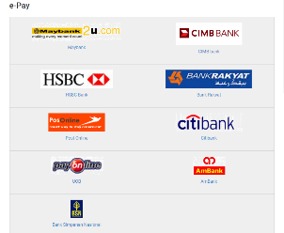
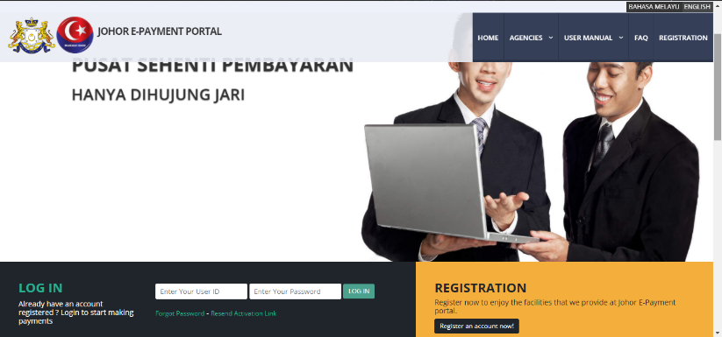
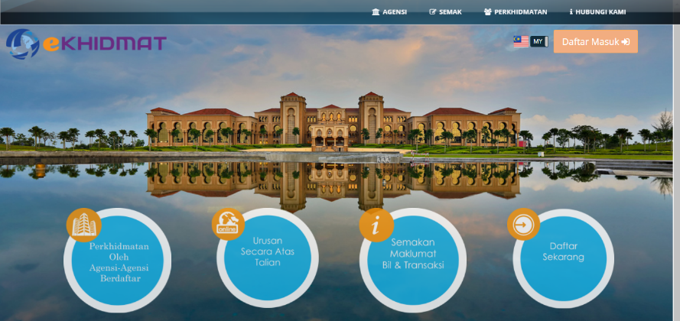
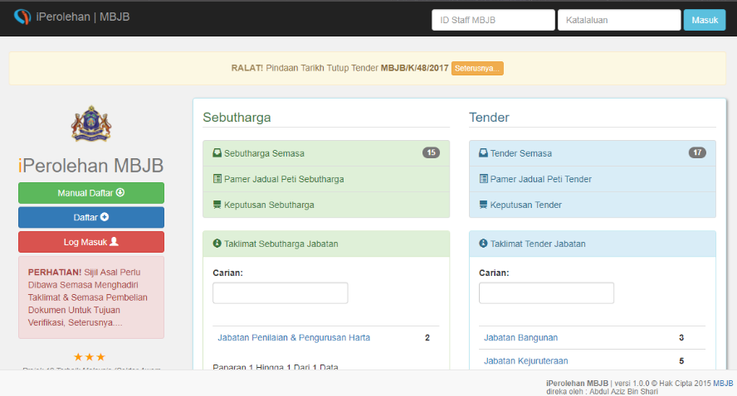
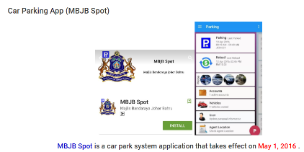
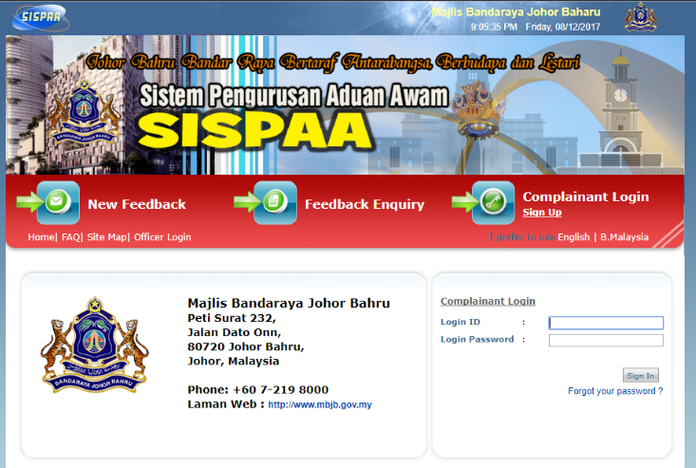
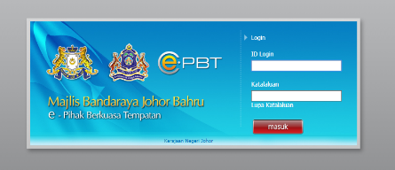

9
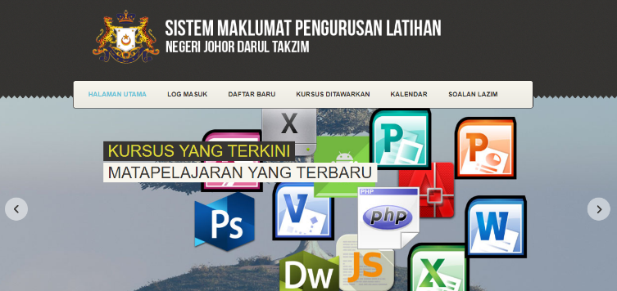
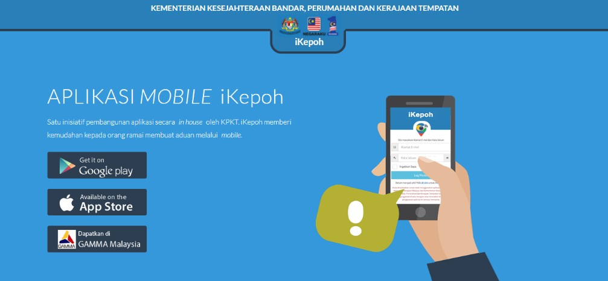
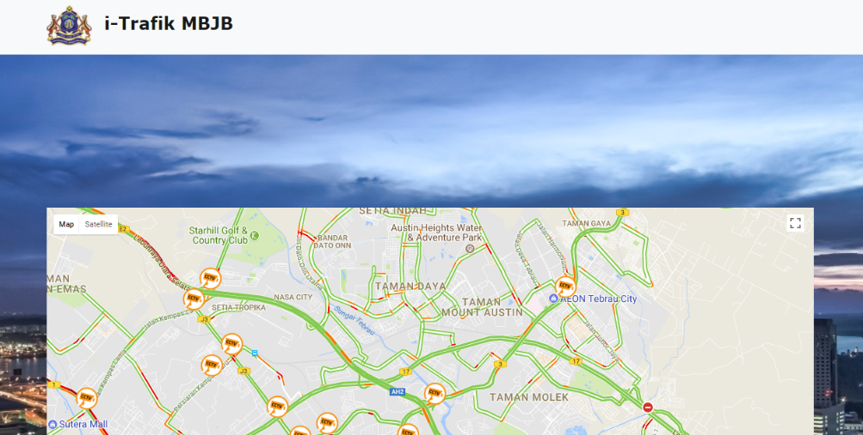
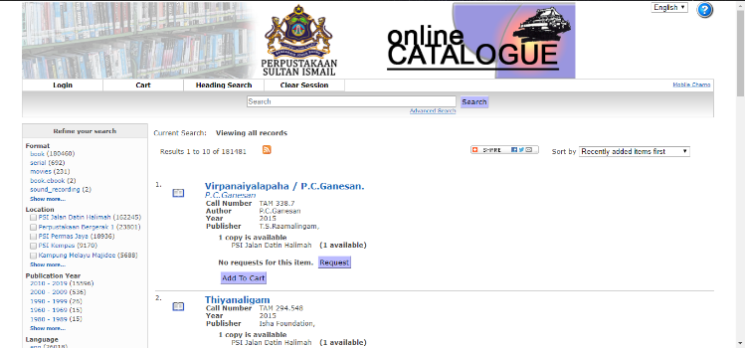
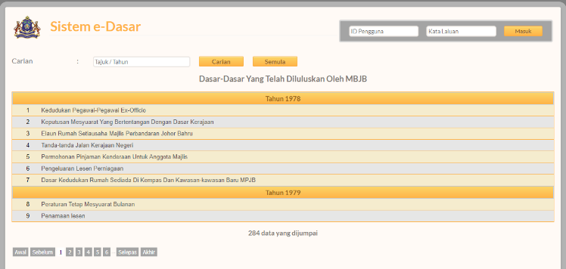
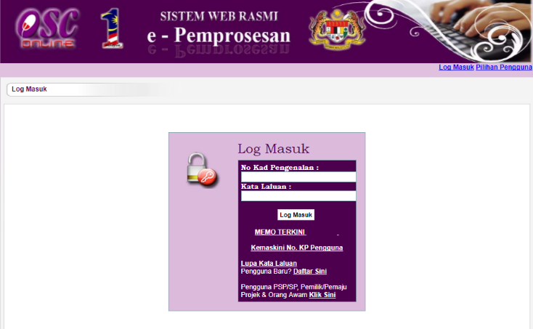
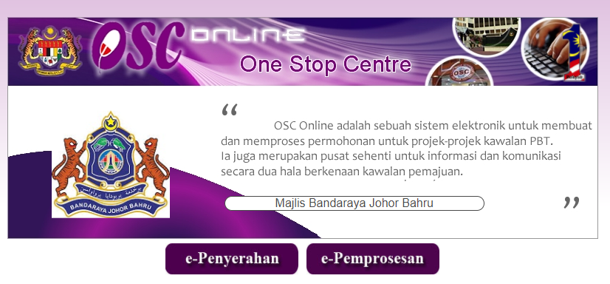
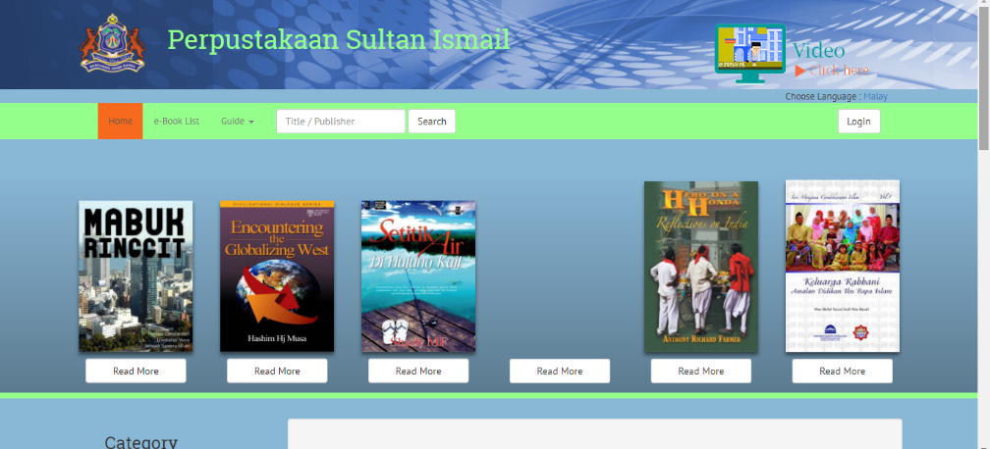

10
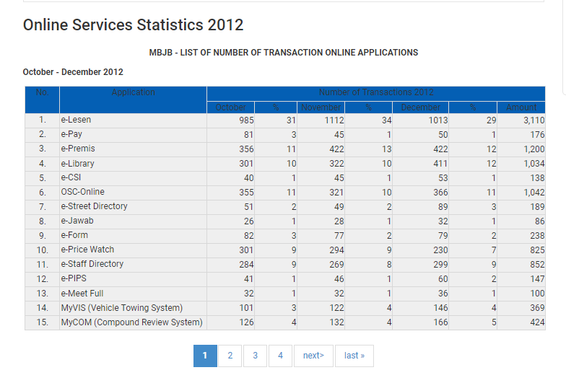
This statistics shows that Johorean use these applications to make transactions and other things and it is convenient for user as everything can be done without going to the counter.

11
REFLECTION

INFORMATION GAIN FROM THE VISIT AND THE IMPACT TO STUDENT (MBJB)

From the last industrial visit to MBJB (Majlis Bandaraya Johor Bahru) there are a lot of things that we learn. For example, before this we thought a single organization only operate via one department only.
While actually, in an organization. There are many department and specialize that involve. For example in context of MBJB. For ICT department, there are other subs department under them. Such as cyber security department, apps development department, multimedia and graphic department and etc. all of this department are working under the same roof to achieve one goals. Even though there are working under the same roof, each of this department has their own role and responsibilities to do.
From this visit, we learn that requirement of soft skills in working environment is very crucial. In working environment, we need to cooperate and working together with a lot of people. And this people not just come from the same background of studies. Most of them come from difference background of studies. Thus, soft skills and the way we interact with them is very important in order to avoid misunderstanding.
Basically, when we enter the working environment, the way we see things will be different. And after this visit, we know that CGPA is not everything. It still important, but if it is not tally with other skills such as soft skills. It will mean nothing.

12

Goal means something that is observable and measurable and has an end result on objectives to be achieved within a more or less fixed timeframe , so being a student from IT sector it is very much needed to learn about your future work and stuff. From a place that handles all the city stuffs and goods , it will be best option to gain that knowledge . when you develop an app that configures the traffic movement or the vehicles detection, for instance which number plate belongs to which vehicle and right now where it is something like tracker app. There are thousands of ideas you can get from this place as it has lot of sectors and as we living in an era of digitalisation , so it is like a place full ideas and knowledge for me.

Giving plan to improve a place which have already earned an enormous position . It’s critically important that those experiences be good ones, so people walk away feeling like, ‘Hey, I’m getting great service. My government actually gets what I need and it’s helping me get there.’”. still I can suggest few things that can be core of any council -
Plans can be taken to improve
• Action One: Look for targets of opportunity
• Action Two: Build capacity Executive Summary 7 Using Innovation and Technology to Improve City Services .
• Action Three: Seek internal and external champions .
• Action Four: Develop a compelling business case .
• Action Five: Formalize new practices with concrete laws and strategies .
• Action Six: Foster a culture of creativity and collaboration

13
REFERENCES

Websites :
http://www.mbjb.gov.my/ms

14

