


INDUSTRIAL VISIT REPORT

Media and Game Innovation Centre of Excellence MaGICX UTM
29th November 2017

Industrial visit report submitted in partial fulfilment of the requirement for evaluation.

Faculty of Computing (Software Engineering)

Submitted to: Dr. Noorminshah Binti A.Iahad
Report by: GROUP 1
Nursyahira Sabrina Binti Mohd. Sukri
Feeraz A’Shaqif Bin Abdul Razak
Nurul Nabilah Binti Samsul Faudzie
Mohammad Fitri Bin Abidin
Miraj Ahmed

Table of Contents
INTRODUCTION OF ORGANIZATION 1-3
ORGANIZATION STRUCTURE 4-8
THE INDUSTRY INVOLVED 9-10
CAREER OPPORTUNITIES 11
THE APPLICATIONS OR SYSTEMS DEVELOPED. 12-15
REFLECTION 16-17
REFERENCES 18

INTRODUCTION OF ORGANIZATION


Established in 2013, Media and Game Innovation Centre of Excellence (MaGICX) is a strategic cooperation between Universiti Teknologi Malaysia (UTM) and Iskandar Regional Development Authority (IRDA) to support and promote the development and ecosystem of creative industry that focuses on gamification and enrichment of digital content. MaGICX will play an integral part as the anchor for the Iskandar Malaysia Innovation Valley envisioned to offer industry players/SMEs/clients technical expertise/consultation, research/product development, business development, publishing, marketing and/or training in producing commercially.
Aspires to create an environment that contributes toward talent development, industry promotion, knowledge-sharing, and international collaboration, MaGICX’s credits include projects related to augmented reality, mixed and virtual environment, image processing, computer vision, multimedia software engineering, medical computing, computer interaction, human interface, usability, animation and technology, speech and signal processing, visualization, multimedia and software innovation, and emerging technology.

1
Vision
To be the anchor for Games and Gamification industry & the nucleus for Iskandar Malaysia Innovation Valley.
Mission
To provide necessary support and technical expertise in research, business development, publishing, marketing and training for industry players to develop commercially viable products and services.

People
Create a stimulating environment where everyone (internal teams, partners, businesses, researchers) will be inspired to be the best.

Partners
Nurture a winning network of researchers, businesses, investors, experts, students and consumers to continuously deliver

Research & Development
Be at the forefront of technological, social and business developments that will have an impact on the games & gamification industry.

Talent
Contribute to the effort in the development of human capital, which is the core fundamental of growth.

2

Portfolio
Create a portfolio of products that are commercially viable and able to enhance our brand name in the games and gamification industry.

Promotion
Initiate and engage in activities that will promote our capabilities in games research, design, and development.

3
ORGANIZATION STRUCTURE
Director

Fellows


Executives

Associate Members


4
IRDA Representative

Researcher
                         5                             

6


7

Incubatees


Interns


8

THE INDUSTRY INVOLVED
MaGICX provides consultation and content development that focuses on;

1. MaGICXcel Incubator Centre
Our MaGICXcel Incubator centre offers great working space & facilities, expert mentorship and sustainable to start-up.
2. Augmented Reality
Augmented Reality creates a new and innovative way to integrate technology into the real world to build new and exciting interactive experiences.
3. Kinect Enchancements
Harness the capabilities of the Microsoft Kinect to develop new and Interactive customer information centre.
4. Game & Gamification
We are able to develop applications that uses the concept of game mechanics and game design techniques to engage and motivate people to achieve their goals.
5. Mobile & Web App Development
We can develop beautiful and functional mobile & web applications and deliver the best solution for your business needs.
6. Training & Learning Programme
We provide various training courses that focuses on games development, mobile & web development and Augmented Reality development which varies from junior to professional level.

9
7. Virtual Reality
We are able to create interactive three-dimensional, computer generated environment which creates an immersive experiences for users.

8. MaGICXplore R&D Network
Tapping into our academia network headed by our research arm UTM-IRDA Digital Media Centre, we are able to advance our technical capabilities based on key research topics and conduct knowledge sharing sessions to the public.

10

CAREER OPPORTUNITIES

MaGICX capable to provide all range of computing field job as it requires many brain to contribute for it. Since MaGICX involved in many industries so there are broad range of career that fit in. However there are many future career that are not exist yet but someday the new careers will replace the current that we have. For now the career opportunities in MaGICX are as follows :
- Application analyst.
- Business analyst.
- Data analyst.
- Database administrator.
- Games developer.
- Information systems manager.
- IT consultant.
- Multimedia programmer and many more.
In the future, there might be IoT engineers, AR engineer, VR engineer and many more.

11

THE APPLICATIONS OR SYSTEMS DEVELOPED

MaGICX have developed many applications in a few categories which is mobile applications, mobile games, Augmented Reality , Virtual Reality.

Mobile Application & Augmented Reality
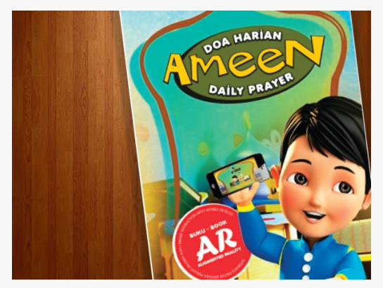
Ameen Daily Prayer
This application can teach users the daily prayer in a more interesting and interactive. This application using Augmented Reality (AR) technology to provide a new way on learning.
Ameen Daily Prayer AR application require users to scan specific marker using the camera application provided to show Ameen in 3D
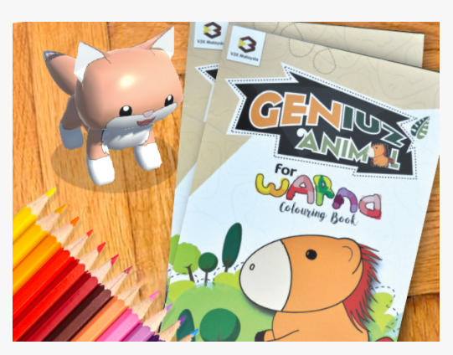
wARna
This application combines colouring activity with augmented reality technology designed to give you a magical experience while learning colouring.
You just need to colour the page in the special colouring book and after scanning with the wARna application, a 3D model will appear on screen on your device to that corresponds to the exact colour provided by you.
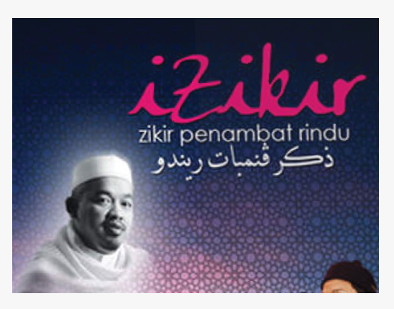
iZikir

Zikir Penambat Rindu: A collection of zikr that desire to get closer to God. Voice by Rabbani nasyeed group. Available in CD, iPad and iPhone version.

12
Mobile Games
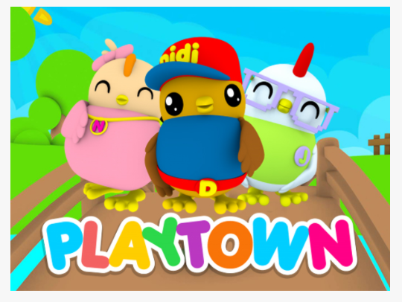
Didi & Friends Playtown
Didi & Friends Playtown is the combination of 12 games based on the very popular Didi’s children song. Each song has an interesting concept of the game and different delivery.

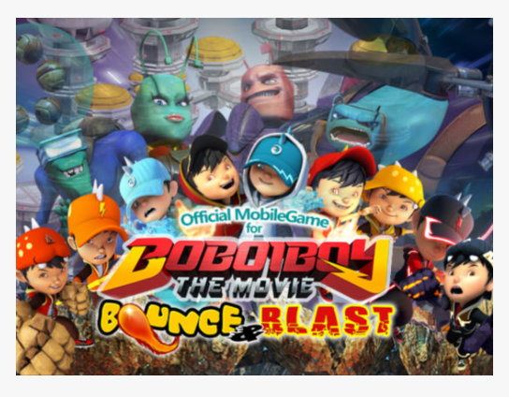
Boboiboy Bounce & Blast
BoBoiBoy is a Malaysian animated series produced by Animonsta Studios, centering on a boy who has superpowers and the ability to separate into three and he fight to protect the earth from alien that name Adudu threats who aim to conquer the Earth in the hunt for cocoa beans.

13

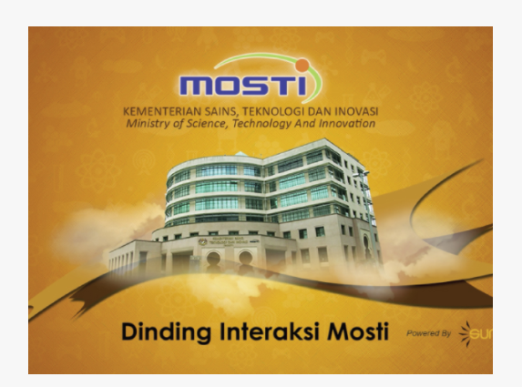
MOSTI Interactive Wall
Enjoy the element of interactive on the wall featuring the latest information, news, information on funds and grants, ePerkhidmatan, customer satisfaction, department or agency in accordance to their cluster, key performance index (KPI) and lastly enjoy the paper plane game using depth motion sensor technology.
This interactive wall is made exclusively by MaGICX for Ministry of Science, Technology and Innovation (MOSTI) Malaysia.
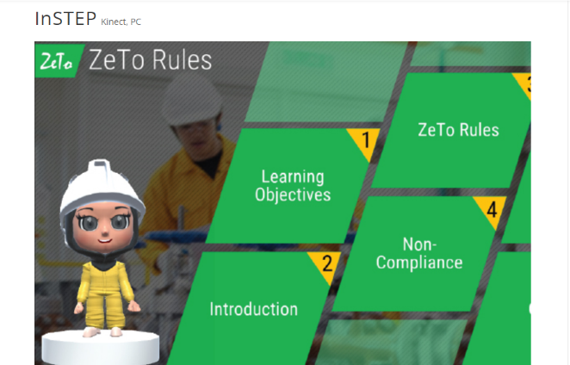
InSTEP
Using Kinect and PC to demonstrate the ZeTo rules.
*Kinect is an add-on device for the Microsoft Xbox 360 gaming system that enables users to control games, movies and music with physical motion or voice commands and without the need for a separate input controller like a joystick or keyboard.

14
The Exciting Future Of Education With Virtual Reality

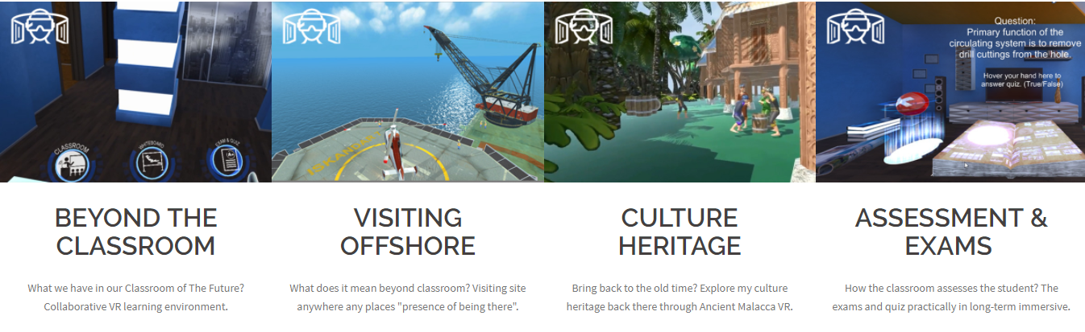
MaGICX Classroom of the Future, has been successfully launched by Malaysia Ministry of Education. In response to the challenge of the 4th Industrial Revolution, MoHE's intention to Redesigning Higher Education. MaGICX has implemented various initiatives and effected major moves to further prepare for 4th Industrial Revolution by introducing the concept of Classroom of the Future.
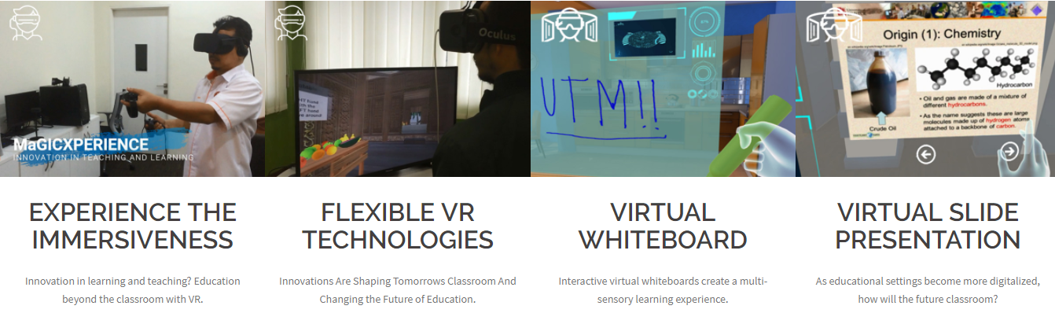

15
REFLECTION

The life cycle of motivation is very short, thanks to us; it’s our own making. The dictionary meaning of the word ‘motivation‘ is amusing: venerable Oxford dictionary defines it as ‘a reason or reasons for acting or behaving in a particular way. Making sure your goals are achievable is just as important as anything else. There's no point setting a perfect goal if it's unachievable, as you'll fail before you start. E.g. "become a better developer" vs "become the best developer in the world". This also applies to the other areas of SMART, for example: "get 100% code coverage" is specific, but probably not achievable and "get from 50% to 80% coverage by the end of the week" probably isn't an achievable timeframe for a 100k line codebase.
While talking about Media and Game Innovation Centre of Excellence (MaGICX), they aspires to create an environment that contributes toward talent development, industry promotion, knowledge-sharing, and international collaboration, MaGICX’s credits include projects related to augmented reality, mixed and virtual environment, image processing, computer vision, multimedia software engineering, medical computing, computer interaction, human interface, usability, animation and technology, speech and signal processing, visualization, multimedia and software innovation, and emerging technology.
Their vision is -“To be the anchor for Games and Gamification industry & the nucleus for Iskandar Malaysia Innovation Valley”. For a student of computer science specially from the software developing sector it should be the main motto to be a good developer, from the visit to MagicX I , personally got understand the difference between gaming and gamification, here Gamification means “anything digital production” so being a software developer it can be my tagline for better future.
16
Another point can be mentioned is that steadiness, they started their journey on 2013 though got successfully recognition on 2016 at the anniversary of Iskandar Malaysia, so they definitely gives a point of perseverance in my life. Summing up it can be said “success doesn’t come overnight” .
We are so amazed by how this company trying to innovate things by developing apps and system that different than others. They are implementing the element of gamification on each of their product. And most of their product using kinect interface which rather than use a remote control or screen touch to interact, they are using movement like hand gesture. Which make things much more interesting.
Education is changing right now. Technology and expanded knowledge of the learning process have already resulted in a metamorphosis of the classroom and of teaching methods. There will be even more changes in the future. One of their project is classroom of the future. Where they wanted to create a classroom that fully technological. Since we are moving into industrial 4.0. Education is no exception.
They also have a lot of other project, such as augmented reality, mixed and virtual environment, image processing, computer vision, multimedia software engineering, medical computing, computer interaction, human interface, usability, animation and technology, speech and signal processing, visualization, multimedia and software innovation, and emerging technology.
From this visit, we learn that the important of us to adapt in fast moving of technologies is very crucial. Industrial 4.0, Education 4.0, University 4.0, everything is evolve. We as computer science student especially, need to be more aware of this situation. We are the one that going to make the change. There is a lot of opportunities in the future. For us.

17

REFERENCE

Websites
http://magicx.utm.my/

18

