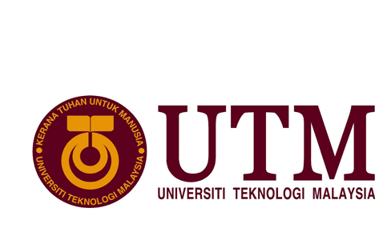

GROUP MEMBERS : MUHAMMAD SYAHMI BIN MUHAMMAD ZALY SHAH
MUHAMMED AFIQ AFWAN BIN MOHD SALMI
SHURAIKH’ EZZUDIN BIN SHUKRI

TASK : INDUSTRIAL REPORT 1 ( VISIT TO CICT,UTM)

LECTURER NAME : DR CHAN WENG HOWE

SECTION : 02
CONTENTS

INTRODUCTION……………………………………………………………………………………..3
DETAILS OF JOURNEY……………………………………………………………………………. 4
REFLECTION……………………………………………………………………………………………8

INTRODUCTION

The visit was held on 27th of September 2017 at the Centre of Information and Communication Technology (CICT),UTM.The visit was organised by Dr Chan Weng Howe,Dr Nazmona binti Mat Ali and other lecturers Technology and Information System lecturers from the Faculty of Computing,UTM,Skudai.The visit was attended by all first year faculty of computing students.
DETAILS OF JOURNEY

Below are the tentavtives about the visit :

TIME | ACTIVITY
8.00 - 8.30 | Student arrive at CICT
8.30 – 9.45 | Briefing by Deputy Director of Strategic Management CICT, Tuan Haji Samsudin
9.45 – 10.00 | Photography session
10.00 – 10.15 | Visit to PPICTP ( Pusat Perkhidmatan ICT Pelajar )
10.15 – 10.45 | Visit to CICT Gallerium

Table 1.1 : Tentatives on industrial visit to CICT

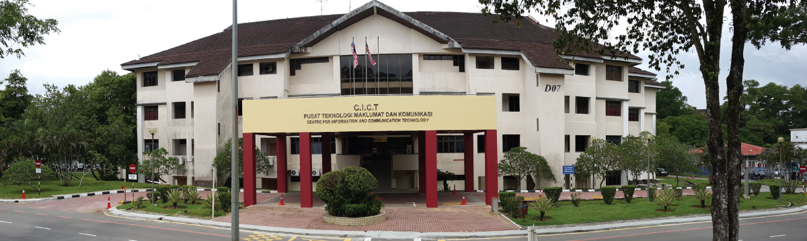
The visit starts with a briefing from Tuan Haji Samsudin,Deputy Director of Strategic Management CICT by introducing to the students the history of CICT.CICT actually is Centre for Information and Communication Technology. On 1975, the Computer Centre was established.Later on,Department of Computer Science was founded on 1981.Initially, the Computer Centre merged with Department of Computer Science becoming Department of Computer Science Faculty.Then, the Department of Computer Science was upgraded to Institute of Computer Science on 1984. Next, on 1991 the Institute of Computer Science was structured to Computer Science & Information Systems (FSKSM) and Computer Center UTM (PKUTM.Currently,it is known as the Information and Communications Technology (CICT) from 2004 until now

Figure 1.1 : The curent building of CICT
He also introduces to us about the organization structure of CICT that was being lead by Prof.Dr Ali bin Selamat carrying the portfolio as Director of CICT.Below are the organization structures of CICT.
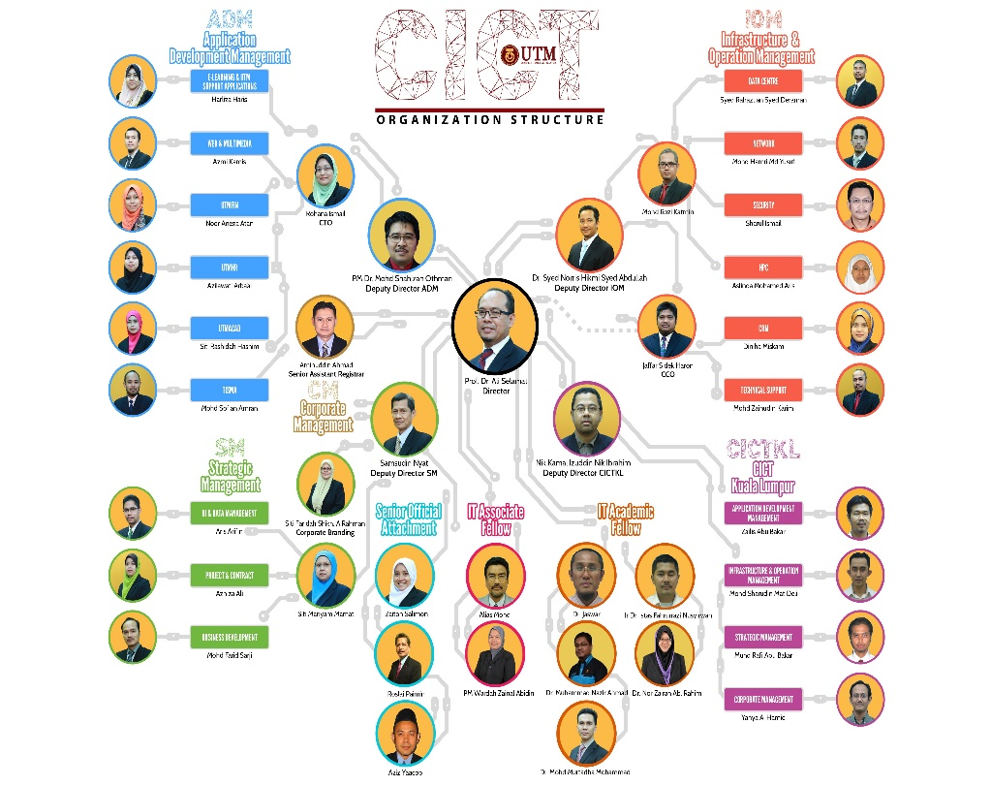
Figure 1.2 : The organization structure of CICT
Besides that, He also tells about the vision,mission,goals and the objectives of CICT.The vision of CICT is to make Centre Information & Communications Technology (CICT) as pulse quality ICT services and innovative towards realizing the aspirations of Universiti Teknologi Malaysia. The mission of CICT is to committed to providing ICT services to meet the needs of universities through computerization of administrative and academic activities, the provision of ICT infrastructure and training, research and consultancy services based on quality.There are four goals of CICT that is as follows :
Goals
- Provides ICT as a basic utility for university
2. Provide centralized services to enable customers to focus on their core business
3. Providing integrated services to facilitate access to information effectively
4. Make continuous improvements in ICT services

And the objectives of CICT is as follows :

Objective
1. Improving ICT competence in the university community
2. Expand the use of information technology in all activities of the university
3. A secure ICT infrastructure and facilities provided
4. Making reference point in the implementation of ICT services and universities
5. Exploring new technologies and services in the ICT

He also mentioned about the services and of CICT such as the interner,infrastructure and security,application development,web management and software.All of the sevices will be discuss in detailed later on the next topic.

The visit continues by visiting to the PPICTP or also known as Pusat Perkhidmatan ICT Pelajar.PPICTP is a centre for students if they encountered with any trouble regarding on UTMACID account,wifi,installation and deletion for software and antivirus,and many more.PPICTP also contains a computer lab with fast coverage of internet for students and it also contains seminar room for those who wants to make a seminar or online exam.

Then, we visit the CICT Gallerium where all the unused technologies that UTM used before is stored to show the younger generation of the early days of computer equipment used in UTM.There were many collection of artifacts at the CICT Gallerium such as Mainframe Terminal, Controller, Mainframe Data Storage, Magnetic Tape Unit, IBM Tape Control Unit, and many more.It is very important for us to know about the early computer equipmrnt used by UTM so that we can create more understanding and awareness, especially among the younger generation on the initial equipment that was used to carry out administration work on campus.Below are the pictures at the CICT Gallerium.
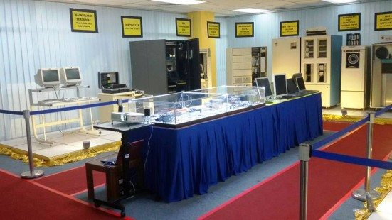
Figure 1.3 : Artifacts at the CICT Gallerium

REFLECTION

I have learned that long-term goals are best achived when I break them into shorter goals. My short-term goal is find a position that will put me in a forward-moving company with solid performance and future projections. As part of a team, I want to add value and continue to grow the company. My long-term goal will depend on where the company goes. Besides that, it is also involve growing with a company where I can continue to learn, take on additional responsibilities, and contribute as much value as I can. I love a company that emphasizes professional development opportunities. I intend to take advantage of all of these. My plan is to move into a position of responsibility where I can lead a team. By

The visit would improve my self abilities by introducing me to the environment of a working industry. It will give me a front edge view of the real thing. Next, by attending the visit. I also obtain the will to improve myself in every aspect in order to develop myself into a great data engineer in the future. I also have equipped my memory in what an industry looks like, and I also can use this as a guidance for my future.
Since currently CICT is developing the biggest big data centre in Asia,I personally think that this will be a big opportunity for me to learn and master big data because CICT have complete structure and facilities for me to learn more about big data

