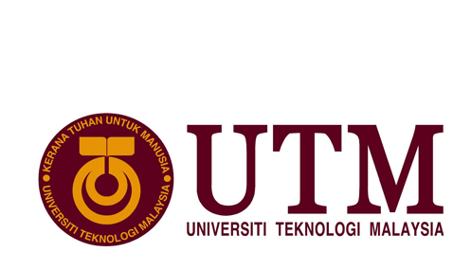

GROUP MEMBERS : MUHAMMAD SYAHMI BIN MUHAMMAD ZALY SHAH
MUHAMMED AFIQ AFWAN BIN MOHD SALMI
SHURAIKH’ EZZUDIN BIN SHUKRI

TASK : Industrial Report 2 ( Visit to Big Data Exhibition Week,KLCC & TM R&D Sdn.Bhd,Cyberjaya)

LECTURER NAME : DR CHAN WENG HOWE

SECTION : 02
CONTENTS

INTRODUCTION……………………………………………………………………………………..3
DETAILS OF JOURNEY……………………………………………………………………………. 4
REFLECTION……………………………………………………………………………………………16

INTRODUCTION

The visit was held on 3th of October 2017 at the Kuala Lumpur Convention Centre and Telekom Malaysia Innovation Centre,Cyberjaya.The visit was organised by Dr Chan Weng Howe,Dr Nazmona binti Mat Ali and other Technology and Information System lecturers from the Faculty of Computing,UTM,Skudai.The visit was attended by data engineering first year students.The aim of the visit is to give a brief overview to the students about big data analytics,IoT and many more.Through the visit,the students can undestand what is big data analytics,IoT and what it takes to be a data engineer and also data scientist.The visit also clarify the work prospect and the career path for the students so that we as a student know what the future can give to us.From the visit,the main important thing that we learn is that big data analytics and IoT is expanding and widely used around the world especially at the business,finance and government sector and it is a very important aspect in one’s organisation.The aim of the exhibition is that in this day and age we’re faced with an unprecedented influx of data, while everyone is aware of the value of data science and big data, harnessing its value and aligning it with strategic organizational goals still largely remains a challenge for most where most big data conferences are either too broad to be appreciated by techies or too technical to be useful for decision makers, Next Big Tech Asia aims to be the intersection for that missing link that connects the dots between big data and real-life use cases.Next Big Tech Asia 2017 is a big data conference happening in Malaysia that will illustrate actionable case-studies for the following sectors; Healthcare, Banking and Government. It is the anchor event for Big Data Week, the Global Festival of Data and it is jointly organised by MDEC and Knowledge Group.

DETAILS OF JOURNEY

Below are the tentavtives about the visit :

TIME | ACTIVITY
12.00 a.m | Depart from Kolej Tun Dr.Ismail to UTM,KL
8.00 a.m | Arrive at Kuala Lumpur Convention Centre (KLCC)
10.45 a.m | Arrive at Telekom Malaysia Research & Development,Cyberjaya
5.00 p.m | Depart to Kolej Tun Dr.Ismail,UTM JB
10.00 p.m | Arrive at Kolej Tun Dr.Ismail ,UTM JB

Table 1.1 : Tentatives on industrial visit to Kuala Lumpur

Below are the exhibitions content at the Big Data Exhibition Week:
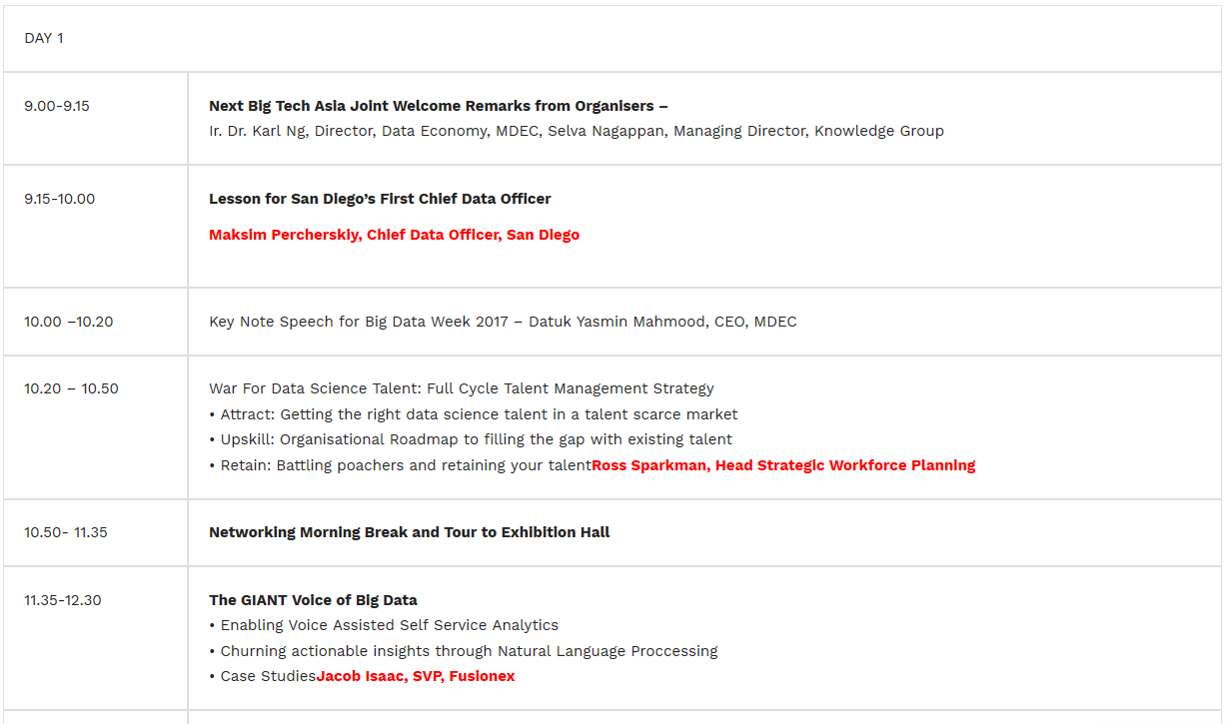
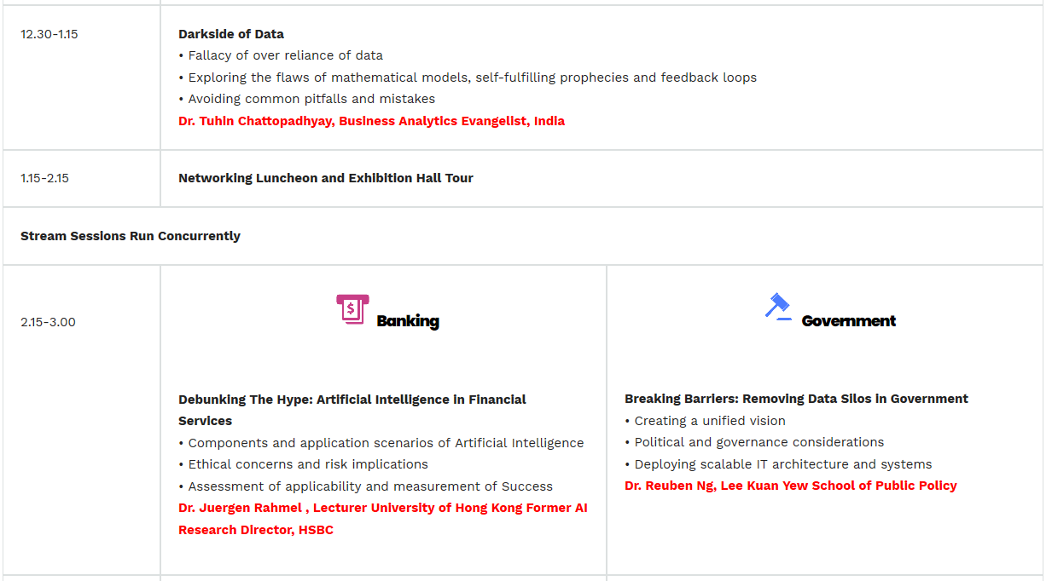
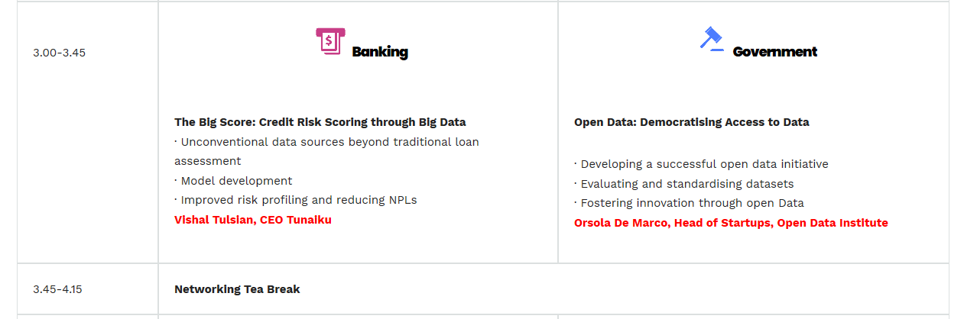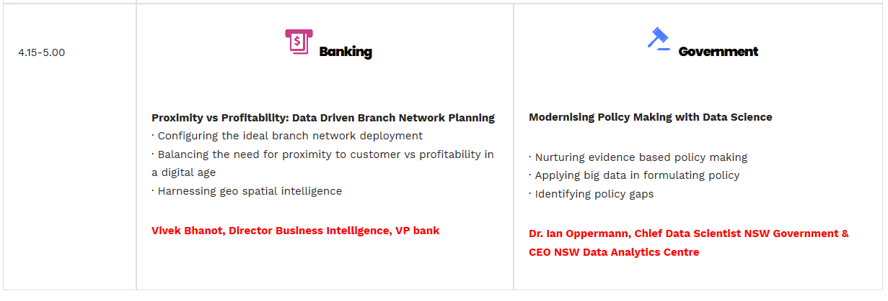

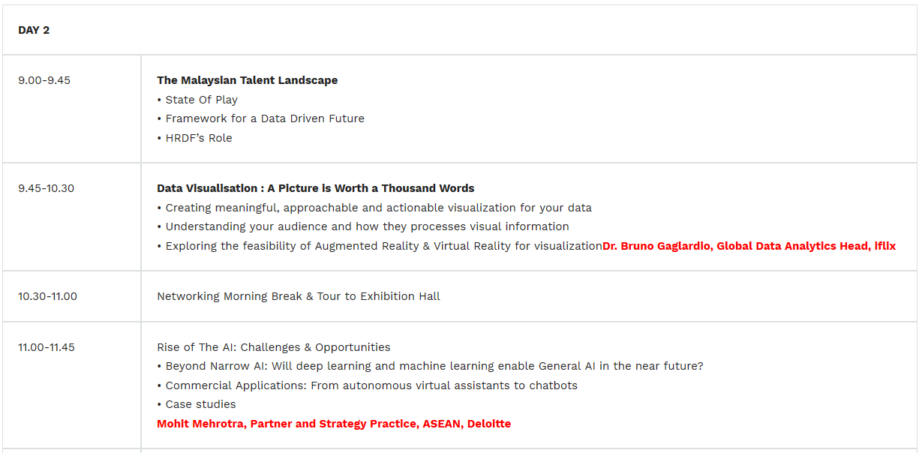
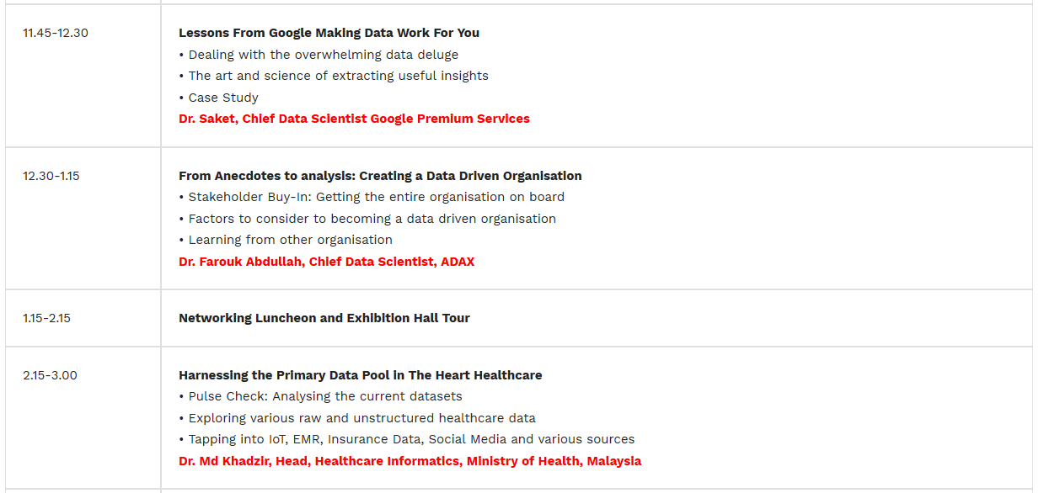
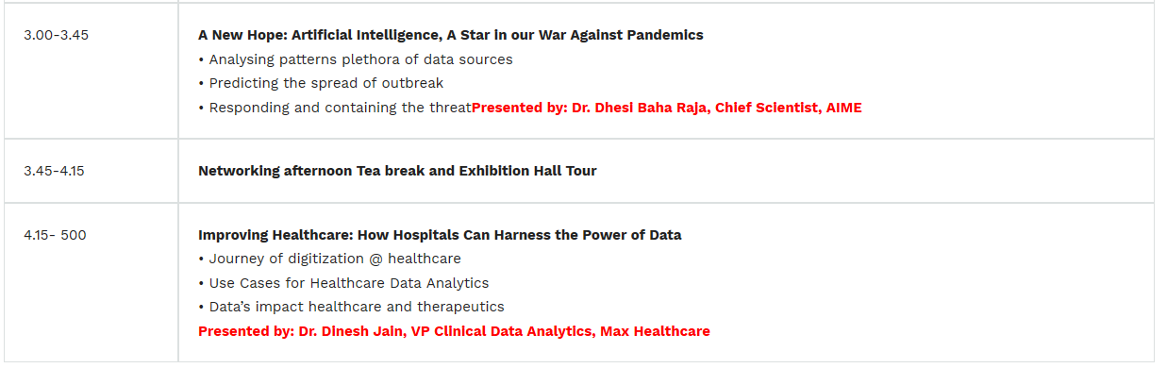

There were numerous well-known exhibitors from around the world such as Intel,Nokia,Teradata,Fusionex and many more.Below were the brief information about the exhibitors:
1.Fusionex

Fusionex is a multi-award-winning, leading software solutions provider specializing in Big Data Analytics, the Internet of Things, Artificial Intelligence, and Deep Learning. With offices in Asia, Europe, and the United States, Fusionex has an impressive track record of serving clients around the world.
Fusionex has a sizeable team of over 600 talented and dedicated individuals who consistently spread the message of high-quality, mission-critical, and ahead-of-the-market solutions with the world.
Fusionex is one of the fastest growing tech companies in its space and one of the largest tech companies in the region. It was featured in Bloomberg, Forbes, and the International Data Corporation who hailed Fusionex as a trusted partner in their customers’ journey to making data-driven decisions.
Fusionex enjoys strong partnerships with Microsoft, having won tis Global Partner of the Year award, HP, Dell EMC, IBM, AWS, Cloudera, and Alibaba Cloud. Fusionex was noted as an Analytics Vendor of Interest in Gartner’s 2016 Magic Quadrant report.
Fusionex’s motto is to bridge business and technology, offering a powerful “Fusion” “Ex”perience. With subject matter experts that combine industry best practices and state-of-the-art technologies, Fusionex continues challenging themselves to provide the most advanced offerings to their customers.

2.Adaptive Business Solutions


Change is the predominant characteristics of today’s business environment. The rapid rate of change has sparked an information explosion that has shaken even the most prestigious commercial enterprises. Agile organisations that can gather the right data, turn it into useful information and respond in a timely and appropriate manner will flourish; rigid organisations will falter. The ability to adapt has become the primary requirement for success. In this information intensive environment, companies need knowledge derived from stored data, and they need more. They need powerful and flexible solutions for getting the right information to the right people that need it – quickly. That is why Business Intelligence (BI) and Business Discovery (BD) solutions – tools that access, extract and clean data, analyse and turn it to useful information are a primary focus for businesses that are determined to ride the waves of change. Adaptive Business Solutions was formed to help organisations adapt to the ever changing business and technology needs. It was started by a group of software professionals who had extensive experience in the Data Warehousing and BI/BD segments. These key personnel are instrumental in delivering and supporting leading-edge data warehouse solutions since the mid 90s. We are also prominent in introducing BI/BD solutions from Qlik since June 2006, are responsible for opening up the market for Malaysia and delivering the first referral sites.

3. Datamicron

Datamicron’s product helps world leading organizations to remain competitive by managing and improving their business processes, operational excellence, human capital alignment and business strategy through the usage of data analytics. Our customers use Datamicron’s products for analysis, predictive and modeling, planning and monitoring, and drive successful performance in their business. Datamicron’s products can be used strategically on an enterprise level or leverage as a solution to operational requirements.

4.eBdesk

eBdesk is a research based software company that focus in Artificial Intelligence and Big Data. The company has successfully delivered solutions based on semantic technology (text mining and ontology), running on top of big data framework, to enable organization in capturing knowledge assets from various unstructured sources.
One of the innovative and popular showcase of eBdesk is Media Intelligence System. It delivers comprehensive content monitoring and analysis captured from both mainstream and social media. It provides a “sense making” and deep intelligence processes on unstructured content and transforms them into comprehensive insight to support the decision makers. It also guides the policy makers in managing public opinion.
eBdesk has been also embarking in several Government Big Data Analytic projects. The company helps the government in managing massive unstructured data, developing advanced analytics and visualization. Price Intelligence is one of eBdesk success story in big data project. It captures daily prices from million items sold in various online platforms. Implementing analytics on the price data, gives better understanding of online price characteristics and behaviors.
5. I-KNOWLEDGE ASIA

The I-Knowledge Asia is fully dedicated to supporting the Malaysian small and medium-sized enterprises (SMEs) Digital Entrepreneurs.I-Knowledge Asia enables Malaysia SMEs in developing and transition economies to become more competitive and connect to international markets for trade and investment, thus raising incomes and creating job opportunities, especially for women, young people, and future Digital Entrepreneurs. Entrepreneurship comes with a host of challenges. Rewarding challenges, but harsh challenges nonetheless. Experienced entrepreneurs have to deal with this no matter how long they’ve been in business — trying to establish a brand, adjust to match or exceed the competition and keep business profitable is a challenge no matter how many been in business.We help aspiring Creative Digital Entrepreneurs to learn how to brand, market and sell their products and services and leadership skills effectively through our intensive boot camps, workshops, one-to-one mentoring sessions and through access to our growing online resources.I-Knowledge Asia opens doors to aspiring Malaysian Digital entrepreneurs, SME owners, and forward-thinking entrepreneurs. KnowledgeCom
6.KnowledgeCom

KnowledgeCom Corporation (KCOM) is a specialized company that aims to UP-Skill the workforce of the nation by training and certifying public and private universities students, fresh graduates, government servants and professionals.With over a decade of experience, we design and deliver programs that will create high income, high employability – as catalyst for an efficient workforce on all types of sectors.We were incorporated in September 2001 and since then we have engaged with over 1000 companies/10000 students in providing our specialised services. Our motto, ‘Empowering Skills, Forging Success’’ has become our mantra in delivering exceptional results for government and private entities. Our list of clients includes a large amount of HRFD contributing companies, Government agencies, MNC companies, SMI/SME organization and public/private universities.We also have our subsidiary company, Global Strategic Partners (GSP) that publishes UP Magazine, first of its kind magazine that incorporates human resource management with development and training. UP Magazine is a quarterly magazine publication that is currently being circulated to approximately 20000 companies in 63 HR sectors in Malaysia. GSP also organizes workshops and conferences that only specializes on human capital development.

7.Teradata

Teradata empowers companies to achieve high-impact business outcomes through analytics. With a powerful combination of Industry expertise and leading hybrid cloud technologies for data warehousing and big data analytics, Teradata unleashes the potential of great companies. With approximately 10,000 professionals in 44 countries, Teradata helps companies improve customer experience, mitigate risk, drive product innovation, achieve operational excellence, transform finance, and optimize assets across consumer goods, financial services, healthcare, automotive, communications, travel, hospitality, and more. Teradata is recognized by media and industry analysts as a future-focused company for its technological excellence, sustainability, ethics, and business value. Visit www.teradata.com

Organisation Structure and Awards

Below are the board of directors for Telekom Malaysia Research and Development :

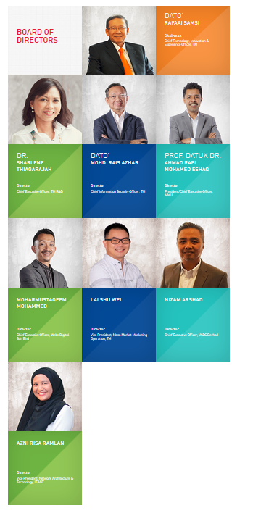
Below are the management staff of Telekom Malaysia Research and Development Centre:
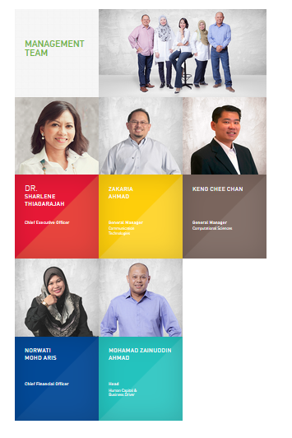

Below are the achievements of Telekom Malaysia Research and Development Centre:
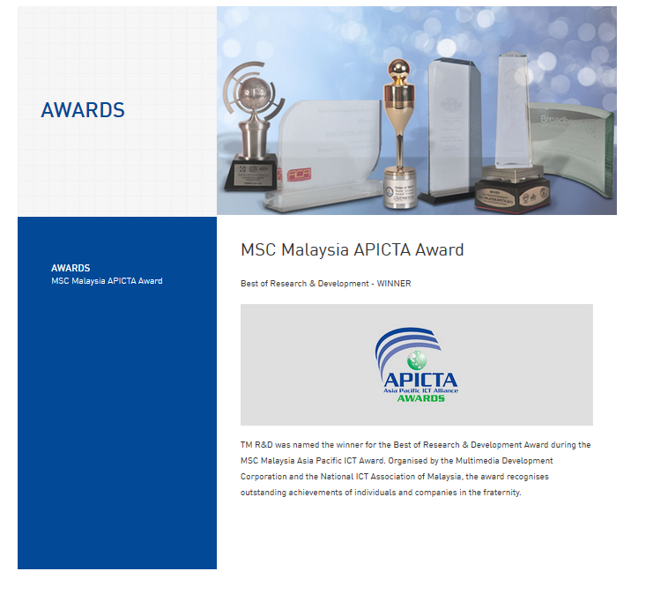

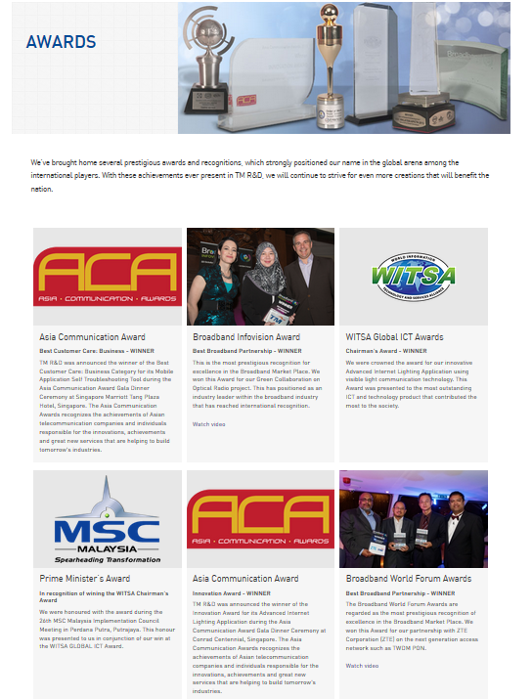

REFLECTION

I have learned that long-term goals are best achived when I break them into shorter goals. My short-term goal is find a position that will put me in a forward-moving company with solid performance and future projections. As part of a team, I want to add value and continue to grow the company. My long-term goal will depend on where the company goes. Besides that, it is also involve growing with a company where I can continue to learn, take on additional responsibilities, and contribute as much value as I can. I love a company that emphasizes professional development opportunities. I intend to take advantage of all of these. My plan is to move into a position of responsibility where I can lead a team. By the visit would improve my self abilities by introducing me to the environment of a working industry. It will give me a front edge view of the real thing. Next, by attending the visit. I also obtain the will to improve myself in every aspect in order to develop myself into a great data engineer in the future. I also have equipped my memory in what an industry looks like, and I also can use this as a guidance for my future.

