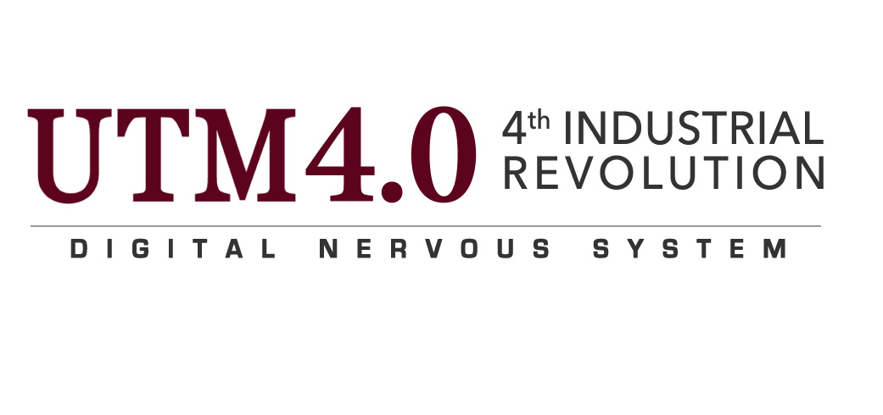

  - $4^{TH}$ INDUSTRIAL REVOLUTION

  - BY PROF.DR.ROSE ALINDA BINTI ALIAS

NAME : MUHAMMAD SYAHMI BIN MUHAMMAD ZALY SHAH

SECTION : SCSP SECTION 02

DATE : 18 SEPTEMBER 2017

LECTURER : DR. CHAN WENG HOWE

CONTENTS

1. EXECUTIVE SUMMARY......................................................................................................................... 2
2. INTRODUCTION......................................................................................................................................... 3
3. INTRODUCTION OF 4TH INDUSTRIAL REVOLUTION (4IR) ................................................. 4
4. HOW 4IR IMPACT THE FIELD OF IT ........................................................................................ 6
5. WHAT KIND OF REQUIREMENT/SPECIFICATIONS IS NEEDED FOR A CAREER
IN IT CORRESPOND TO 4IR................................................................................................................. 8

EXECUTIVE SUMMARY

Briefly,a speech that has been presented by Prof. Dr. Rose Alinda binti Alias regarding on 4th industrial revolution (4IR) were held at the seminar hall in N28A,Faculty of computing at University Technology Malaysia (UTM) last week.In her speech,she explained us about what is the 4th industrial revolution,what is industry 4.0,what is education 4.0 and UTM 4.0 4IR journey.It was very important for the speech to being held because as a science computer student,4th industrial revolution is very related to our field of study and we have to know how 4th industrial revolution is going to fundamentally alter the way we live,work and relate to one another that must be integrated and comprehensive as been said by Klaus Schawb,President of World Economic Forum (WOF).From the speech, we notice that there were not many students who knew about 4th industrial revolution.But after the speech, we knew a lot about 4th industrial revolution.I personally hope that there were more public lecture to be held in the future because there were more knowledge that we need to gain about IT related topics.

INTRODUCTION

Basically.the talk is about to introduce to the students about what is 4th industrial revolution ? and to introduce industry 4.0.Firstly,why it is called industry 4.o ?.The name industry 4.o is given because it is very closely related to manufacturing industry.Industry 4.o does not only complies on the manufacturing industry, but is also complies on education and it is called education 4.0.So what is education 4.0 ?.Education 4.0 is a concept whereby we contextualize the concept to education industry.So.we have to bare in mind that industry 4.0 is based on industry and education 4.0 is where we identify the technologies for the use of education.So that is the difference between industry 4.0 and education 4.0.Besides that,the speaker also introduces UTM 4th industrial revolution journey.

INTRODUCTION TO 4TH INDUSTRIAL REVOLUTION

What is the meaning of 4th industry revoution ?.According to Professeor Klaus Schawb,Founder and Executive Chairman of the World Economic Forum he says that We stand on the brink of a technological revolution that will fundamentally alter the way we live, work, and relate to one another. In its scale, scope, and complexity, the transformation will
be unlike anything humankind has experienced before. We do not yet know just how it will unfold, but one thing is clear: the response to it must be integrated and comprehensive, involving all stakeholders of the global polity, from the public and private sectors to academia and civil society”.

But according to Lord Baker, knowledge is as necessary as ever,
but it is not enough.It has to be connected with the real world through practical applications
ranging from engineering and IT to the performing, creative and culinary arts.And we need 21st century education for a 21st century economy. The economy is changing at an unprecedented pace. Every day, jobs are being lost in professions we used to regard as careers for life. The UK’s future workforce will need technical expertise in areas such as design and computing, plus skills
which robots cannot replace by flexibility, empathy, creativity and enterprise. Right now, this thinking is almost entirely absent from the core curriculum in mainstream schools”

So, Lord Baker himself made an 8-point education plan that is called Lord Baker’s educatonal plan.The plans are as follows:

- Primary schools should bring in outside experts to teach coding

- primaries should have 3D printers and design software

- Secondary schools should be able to teach Computer Science, Design and Technology or another technical/practical subject in place of a foreign language GCSE

4) The Computer Science GCSE should be taken by at least half of all 16 year olds

5) Young apprenticeships should be reintroduced at 14, blending a core academic curriculum with hands-on learning

6) All students should learn how businesses work, with schools linked to local employers

7) Schools should be encouraged to develop a technical stream from 14-18 for some students, covering enterprise, health, design and hands-on skills.

8) Universities should provide parttime courses for apprentices to get Foundation and Honours degrees

HOW 4IR IMPACT THE FIELD OF IT

Literally,it will transform most of our lives by inventing new, undreamed of things and making them in new, undreamed of ways just like what has been said by the economist expert, Richard Lipsey.Let us do not forget that the introduction of new technologies may have the following effects on society as well such as :

• Initial productivity slowdown and delayed productivity payoff from the new technologies
• Destruction of human capital (as many old skills are no longer wanted)
• Technological unemployment (temporary but serious)
• Widening disparities in the distribution of income, which tends to be temporary until
the supply of labor catches up to the new mix of skill requirements
• Big changes in regional patterns of industrial location (globalization)
• Big changes in required education
• Big changes in infrastructure (e.g., the information highway)
• Big changes in rules and regulations (intellectual property, antimonopoly, etc.)
• Big changes in the way we live and interact with each other

In terms of the impact in the field of IT, most experts says that it will may cause a disruptive in innovation.So,what is the disruptive in innovation actually is ?.According to the theory of disruptive innovation that was first coined by Harvard professor Clayton M. Christensen in his research on the disk-drive industry and later popularized by his book The Innovator's Dilemma in 1997 “An innovation that is disruptive allows a whole An innovation that is disruptive allows a whole new population of consumers access to a product or service that was historically only accessible to consumers with a lot of money or a lot of skill.Characteristics of disruptive businesses can include lower gross margins, smaller target markets, and simpler products and services that may not appear as attractive as existing solutions when compared against traditional performance metrics”.

So how does it works ?. Basically, As companies tend to innovate faster than their customers needs evolve, most organizations eventually end up producing products or services that are actually too sophisticated, too expensive, and too complicated for many customers in their market.Companies pursue these “sustaining innovations” at the higher tiers of their markets because this is what has historically helped them succeed by charging the highest prices to their most demanding and sophisticated customers at the top of the market, companies will achieve the greatest profitability.However, by doing so, companies unwittingly open the door to “disruptive innovations” at the bottom of the market. An innovation that is disruptive allows a whole new population of consumers at the bottom of a market access to a product or service that was historically only accessible to consumers with a lot of money or a lot of skill.

WHAT KIND OF SPECIFICATION AND REQUIREMENT IS NEEDED FOR A CAREER IN IT CORRESPOND TO 4IR

Basically there are two major requirement that we need for a career in IT correspond to 4IR.The two major requirements are as follows:

1. Data Analytics– to help companies make sense and derive insights from the data generated by technological disruptions.

2. Social skills such as persuasion, emotional intelligence & teaching others - higher demand across industries than narrow technical skills (programming or equipment operation and control)

