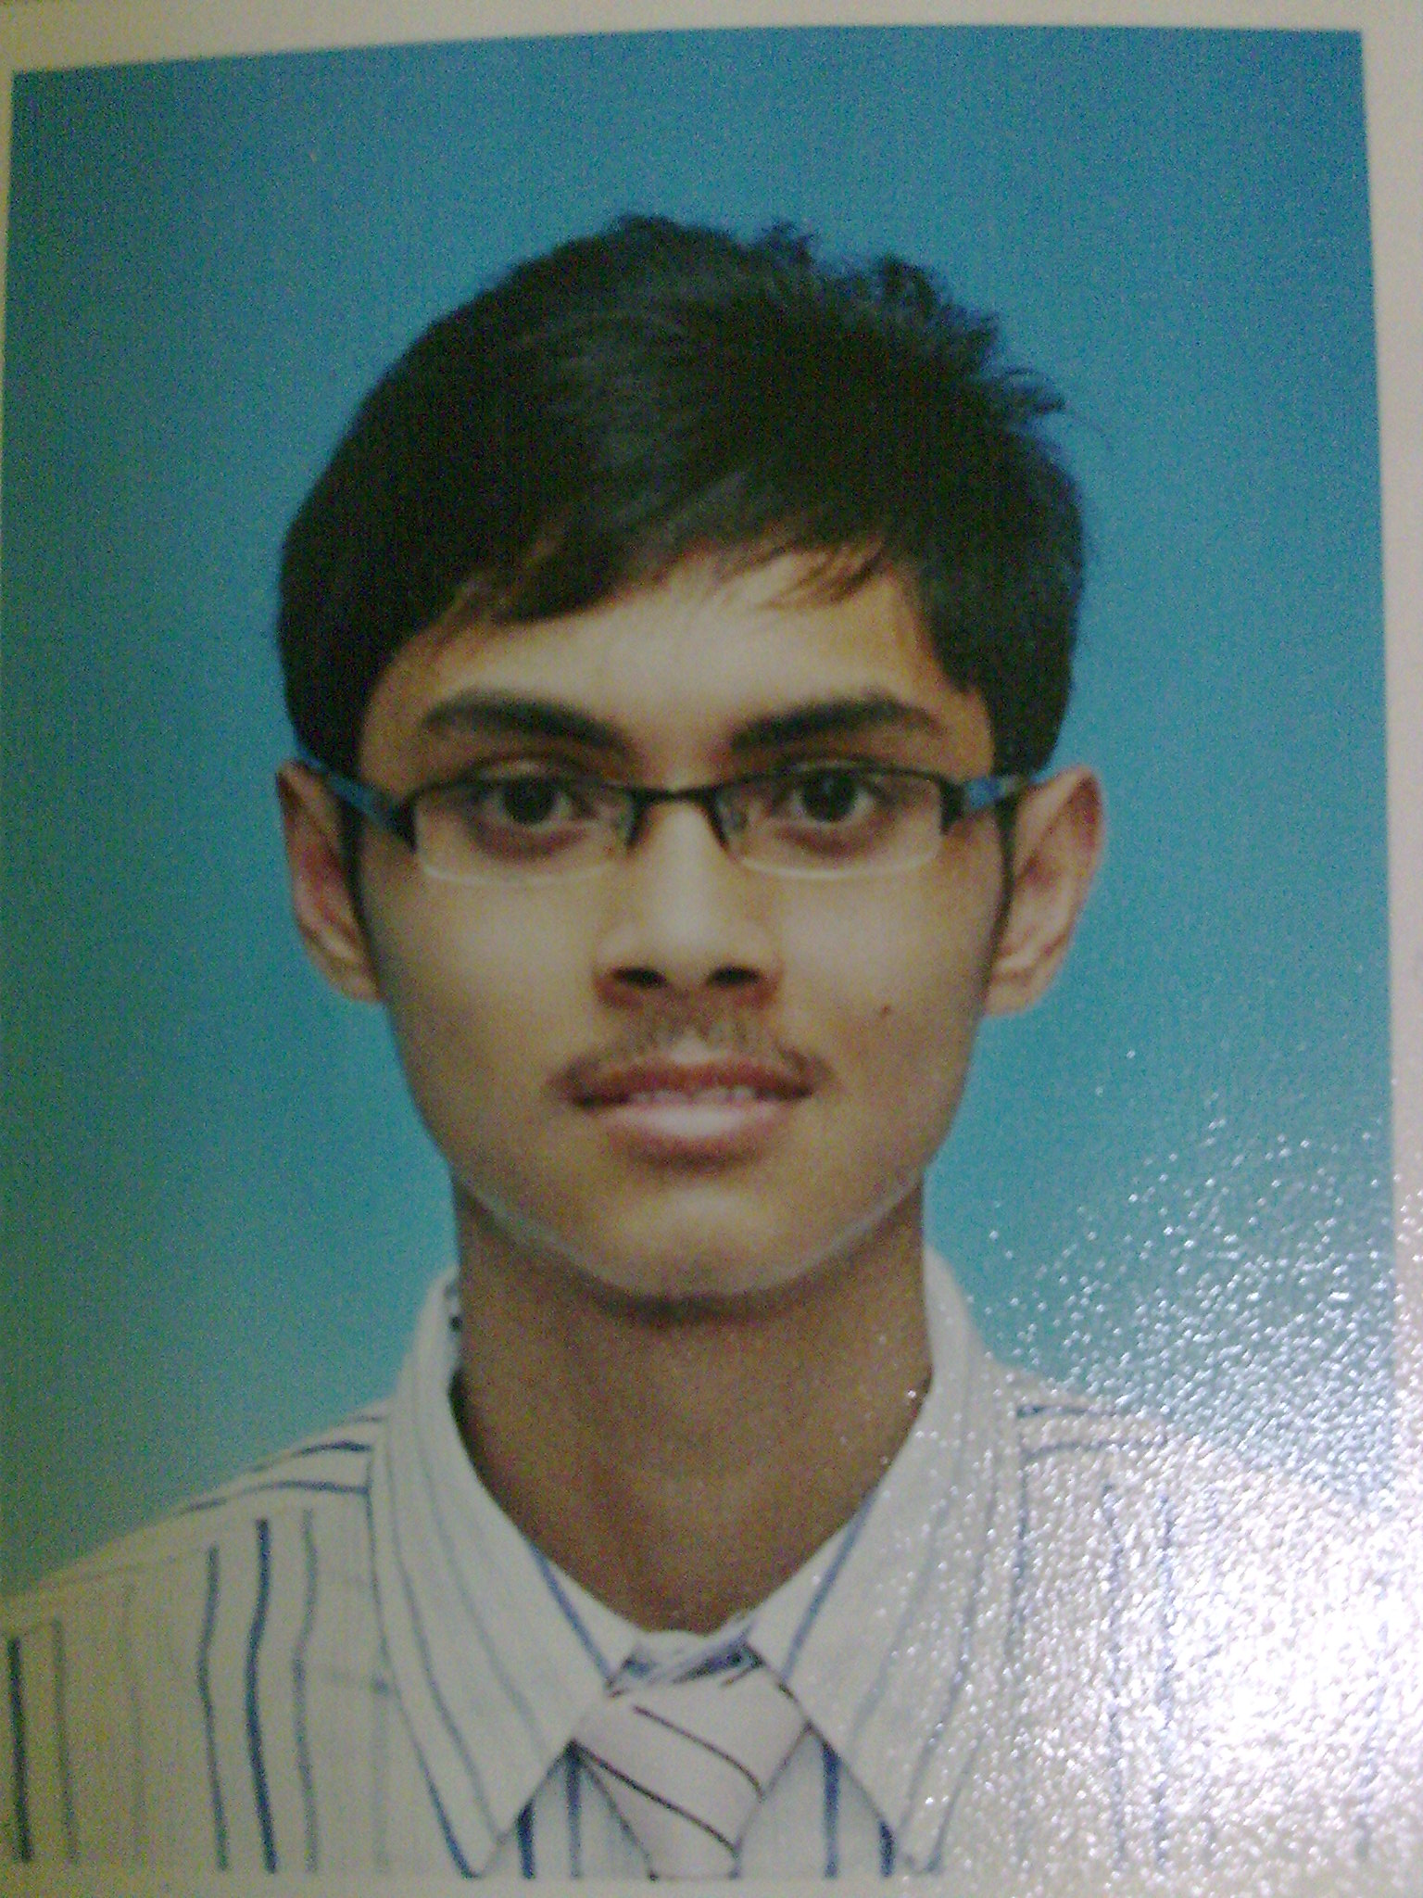

MUHAMMAD AMIRUL ASYRAF BIN SHUKOR
NO.11 JALAN 11,
TAMAN BAKRI JAYA,84200 MUAR,
JOHAR DARUL TA’ZIM
Phone (Mobile) : 013-7090695
Phone (Home) : 06-9865194

E-mail : kaizen_kmtj49@yahoo.com

Age : 19 years old Date of Birth : 08 November 1992

Personal Particulars

Nationality : Malaysia Gender : Male
Marital Status : Single IC No : 921108-01-6749
Permanent Residence: Malaysia Religion : Islam
Place of Birth : Muar, Johor Weight : 52 KG
Height : 170 CM

Educational Background & Qualification

2010-2011 : Johor Matriculation Technical College
Electrical and Electronic Engineering Studies
PNGS 1 : 3.78
PNGS 2 : 4.00
PNGK : 3.89

2008-2009 : Sekolah Menengah Teknik Perdagangan Johor Bahru
Electrical and Electronic Engineering studies
Sijil Pelajaran Malaysia (SPM):
7A, 1B and 2C (2A+,3A ,2A-)

2007 : Sek. Menengah Kebangsan Tun Dr. Ismail,Muar,Johor
Penilaian Menengah Rendah (PMR)
6A and 2B

2005-2006 : Sek. Menengah Kebangsaan Tun Perak,Muar

1998 : Sekolah Kebangsaan Parit Zain,Muar
Ujian Penilaian Sekolah Rendah (UPSR)
4A and 1C

Subject List

ELECTRICAL & ELECTRONIC ENGINEERING STUDIES

- Mathematics Engineering (Matriculation)
- Physics Engineering (Matriculation)
- Chemistry Engineering (Matricution)
- Engineering Drawing
- Electrical & Electronic Engineering (Matriculation)

Others:-

- Pendidikan Islam
- Kemahiran Dinamika
- Bahasa Malaysia
- Bahasa Inggeris
- Teknologi Maklumat(ICT)

Curriculum:-

SECONDARY SCHOOL

- Member of Pembimbing Rakan Sebaya(PRS)
- Kadet Remaja Sekolah.(Secondary School)
- Leader of Personal Audio System (Secondary School)
- Member of Football Club School
- Member of Personal Audio System Hostel

ACHIEVEMENT

- Ranking 2-'Pertandingan Pembangunan Bola Sepak Antara Teknik 2008 Peringkat Negeri'.
- Best student of Electrical & Electronic Engineering subject in SPM 2009 at Sek. Men. Teknik Perdagangan Johor Bahru.

MATRICULATION

- Dorm leader
- Member of Committee Badminton Club

Courses And Seminar Extended

2009 Seminar 'Manusia Hebat' by Profesional Motivation,Abang Raja Shamri at Sek. Men. Teknik Perdagangan Johor Bahru.

2009 Easy Physic in Sek. Men. Perdagangan Johor Bahru

2009 Easy Mathematics in Sek. Men. Teknik Perdagangan Johor Bahru.

2009 (Kursus Strategi dan Teknik Pembelajaran Berkesan & ke Arah Kecergasan dan Kecemerlangan Para Pelajar) at Sek. Men. Perdagangan Johor Bahru organize by school counsellor.

2003 (Kursus Perhimpunan Mesra Peringkat Kebangsaan) at Hotel Quality,
Kuala Lumpur.

Computer Skills

Microsoft Office - MS Words, Power Point, Excel, Publisher

Open Office- OO Words, Power Point, Excel, Publisher

Interpersonal Skills

1. Able to work hard.
2. Ability to work independent or in a group.
3. Self-reliance, hardworking and resourceful.
4. Willing to work for long hours and moderate traveling.
5. Love to learn something new.
6. Intermediary language:- Malay language - Speaking and Writing
English language - Speaking and writing
Basic in Arabic

Hobby / Interest Activity
- Playing football
- Playing Bowling
- Listening music
- Jogging

Extracurricular Activities

2009 (Program Keindahan Bersamamu) at Ulu Tiram,Johor Bahru organized by Kelab Remaja Johor.

2010 Actor in English Drama Competition at Johor Technical Matriculation
College.

2010 'Eksplorasi Berbasikal ke Tanjung Piai' at Pontian ,Johor organized by Jabatan Kokurikulum Johor Technical Matriculation College.

2010 Participant Kem Kaizen at Gunung Pulai.

2010 Manage the badminton competition on Curriculum Day in Johor Technical Matriculation College.

2011 Helping flood victims at Medan,Batu Pahat.
(19 Februari 2011)

2011 Engage in Rocket Competition Category Parachute.
(9 March 2011)

2011 Larian Hari Buruh Sempena Program “Jom Kita Sihat Bakri”.
(1 Mei 2011)

Miscellaneous

Resume Text : Firstly thank you because give me opportunity to introduce myself. My name is Muhammad Amirul Asyraf Bin Shukor. I live in Muar, Johor. But now, I was at Johor Technical Matriculation College at Pontian for ontinuing my studies after got my excellence SPM result. I’m Electrical and Electronic Engineering student and will graduate in the middle of April. I have one brother and three sisters. I was the oldest among my siblings. Furthermore my family is poor, definitely I have to study hard and wishes have a good occupation one day so that I can be able to support my family.
There are many good reasons to argue why I deserve this s cholarship. I am a hardworking and motivated individual with clear goals. I will make the best use of this scholarship to succeed in my studies which will help me get the best student in university soon. With this scholarship, I t will also help me to buy engineering books which almost the books are very expensive. With the scholarship I can accomplish and add to the I ncredible knowledge base that already exists at the university. Besides that, this scholarship will help my family especially my parent in terms of financial who had to give money for me. Other than that, with this scholarship, it will make me easier to pursue my aspiration to become success electrical engineer soon. Last but not least, with get this scholarship, I ensure I’ll graduate successfully in my studies at the university. Perhaps the strongest reason to my candidacy for this scholarship is that since I am aspiring for a career in the professional sector. Scholarship will go a long way in supporting me to realize my ultimate dream.
What I has mention before, my aspiration is want to be electrical engineer. The chosen field of study fits with my career aspiration. Firstly, in my studies, there are four important subject, namely electrical studies, mathematics engineering, physics engineering, and chemistry engineering. The acknowledgements from these four subjects are very important to design or create perfectly electrical or electronic equipment. Moreover, my chosen field of study trains me to be professional person, maturity in decision making, and wise to seek opportunities which are very needed to be a smart engineer. Other than that, I has also learn the ethics of engineering which guide the engineer to behave and more responsible to the society. We know that this professional occupation is vulnerable to corruption and with learn this ethics wishes the person can avoid self from doing that. I hope your company could consider my application and I really need this scholarship so that my financial problem can be solved.

References

- Name : Puan Rafisah Binti Selamat
IC No. : 770914-05-5958
Address : No.3,Jalan Gaya 1,Taman Saleng Gaya,81400 Senai,Johor.
Position : Lecturer.
Ijazah Sarjana Muda Kejuruteraan Elektrik (Telekomunikasi)
Universiti Teknologi Malaysia
Institution : Johor Technical Matriculation College.
Telephone : 013-7845959

- Name : Puan Nasitah Binti Sabini.
IC No. : 640315-10-6498
Address : No.3,Jalan Sukarela,Taman Dato' Onn,80350 Johor Bahru,Johor.
Position : Teacher.
Ijazah Sarjana Muda Teknologi Pendidikan (Pengajian Kejuruteraan Elektrikal dan Elektronik)
Universiti Teknologi Malaysia
School : Sekolah Menengah Teknik Perdagangan Johor Bahru.
Mobile : 019-7121287

