

REPORT ON CICT OPEN DAY

Topic : Cyberbully and ICT Entrepreneurship
Name : Ooi Kean Yit
Matric NO. : A16CS0184
Lecturer Name : Dr Aryati Bt Bakri
Code : SCSD1513
Section : 01

CYBERBULLY AND INFORMATION SECURITY AWARENESS
First speaker which is Dr. Mohd Murtadha Mohmad and his credit to Prof. Wardah Zainal Abidin together with Dr. Mohd Naz’ri Mahrin. He introduce about what is cyberbully and the information security awareness.
Cyberbullying or in the other words cyberharrassment is a form of bullying in electronics way. The case of cyberbully increases drastically and mostly are teenagers. Teenagers who are getting stereotype most probably suffer from the cyberbully. Nowadays getting online is easy, a single comment or post can hurt someone easily. Negative words and bad words hurt people the most. Cyberbully causes someone change their behaviors and actions so they become more withdrawn and quiet than they are used to.
According to the Malaysia’s law, misuse of devices and services which any comment or communication that involve sexual, rude, false, annoying with certain motives to harass someone, threaten and hurt someone else is a crime. Different from the traditional bully, cyberbullying is different. It can happen any time anywhere. As the internet is very widely used, cyberbullying messages and images posted can distributed to the world very quickly. Tracing the source is somehow impossible and difficult sometimes moreover deleting those messages or pictures doesn’t solve the problems.
Boys and girls seems to be equally to be targets of cyberbully online. While girls maybe more likely than boys to be targeted frequently monthly or more often. Meanwhile those youths who bully others online as well as those who are bullied offline are more likely to be targeted online. They feel emotional when using or after using internet and they will keep themselves away from friends and family. Those who get bullied will change their behaviors slowly, they feel like want to stop using phones and computers, they get nervous especially after they received message or email. If possible they will avoid anything about computers, phones, and internet.
Why Information security is important? This is because we want to ensure the availability of business. The risk of loss of confidentiality, integrity and availability of information assets. Protection of data and the information systems need the information security. This security system would increase productivity through best practices and having higher level of assurance with better competitive advantages, certainly enable business continuity and disaster recovery.
Nowadays, everyone having their handphones, smartphones which computing is happening everywhere and simple concept calling ‘BYOD’ which namely Bring Your Own Devices. BYOD mobile security is very low and people awareness about mobile security is very low, their chances to making user error is very high. They are easily exposed to the cyber threat which make them vulnerable and lose their information easily.

ICT ENTREPRENEURSHIP & SMALL BUSINESS INNOVATION
Dr. Afnizanfaizal Abdullah, manager of student innovation from Centre for Student Innovation(CSI) have invited to give a talk on ICT entrepreneurship. He focused on three aspect which are campus life, student logistics, and social services. He introduces the online thesis printing & binding services from the CSI which is a type of innovation that improve and solve the problems of printing thesis especially for final year students. Just send the soft copy of projects and make the payment online to the CSI will proceed their works and they will inform when the projects is done printing.
As to open our minds, he talks about Uber. Uber is a service of transportations other than taxi which is online and cheaper. Innovation on this, he talks about to Ubering the washing machines and ironing services to the students. Furthermore, he encourages students to create and open up our minds to think out of the boxes. Create an application that Ubering printing services of students owned printer and let them be the entrepreneur. This is the idea from one of his international student.

APPENDIX
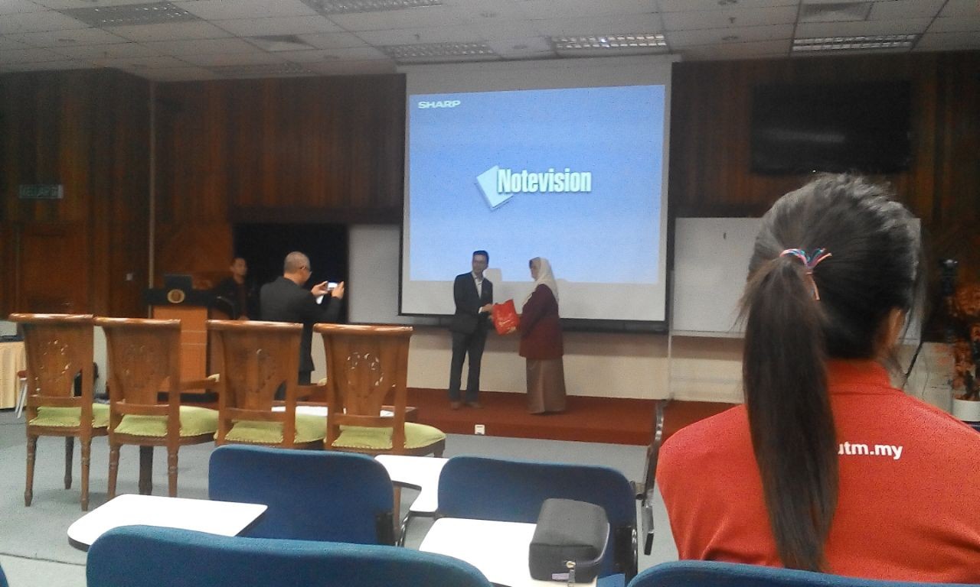
Photo 1 : After the first speaker finish his speech.

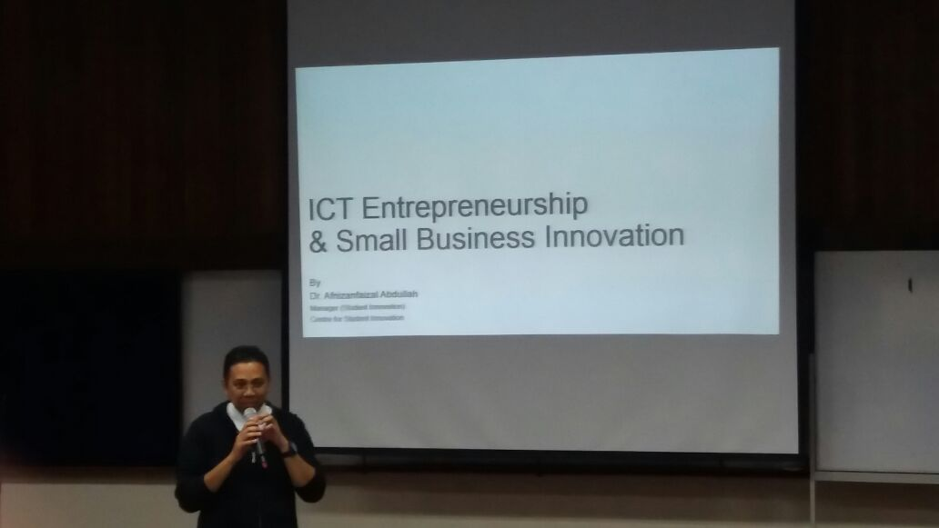
Photo 2: Second speaker talk about ICT Entrepreneurship.

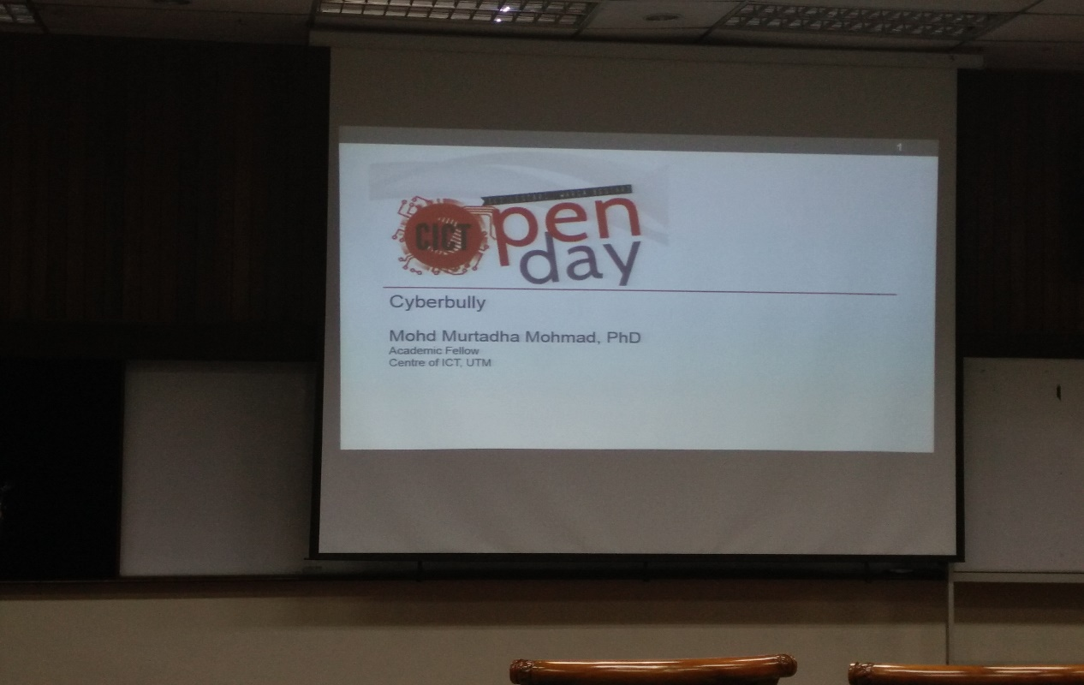
Photo 3 : Before the first speech start.

CONCLUSION
Cyberbullying is a big problem and need to handle it quickly and those who suffered from cyberbullying need to not hide themselves but seek for help. We can help whenever they get bullied and try to positive encouragement to them. They will come across some thought that there is still someone at their side and will not give up easily. While the information security is also needed to guard our information and privacy. Awareness should be rise to let people know they are actually put their information exposed to the bad guys.
On the other hand, ICT entrepreneurship is getting its part in the world now. Everyone can be entrepreneur and innovative idea is important. With a good idea, you may turn out to be a millionaire which is not surprising for now where a good example is the founder of facebook, Mark Zuckerberg. We as a student need to be more creative and innovative where UTM slogan always said innovative, entrepreneurial and global.

