
ASSIGNMENT 3

Group Assignment
Name :1) Nur Kamilia Khatun Binti Abdul Aziz Khan
(A16CS0160)
2) Nur Fazliana Binti Mohamad Huttiff
(A16CS0156)
3) Ooi Kean Yit
(A16CS0184)
Assignment 3
Topic : Visit to CICT
Lecturer Name : Dr Aryati Bt Bakri
Code : SCSD1513
Section : 01

Tentative Program
TENTATIVE PROGRAM
On 27 September 2016 (Tuesday), all the database students attended a program at CICT that just next to the faculty of computing.

Time | Activity
8.00 am – 9.00 am | - Dr Aryati starting speech by greeting the students and spoke for a few.  - Then followed by a talk about CICT from Tuan Hj Samsudin, Deputy Director of SM.
9.00 am -10.30 am | - 3 crew members of CICT brought the students to visit some of the place that famous in CICT by separate them into three parts. And each group conduct by 1 crew.  - The places that visit are:  - SMAL (Student Multimedia & Content Authoring Production Lab)  - Computer hall  - Supercomputer room  - CICT Gallerium
10.30 am | - All students dispersed

Brief Information about CICT
History
In 1975, Computer Center is established under the trend of fast rising in technology inside UTM compound. In 1981 Department of Computer Science is established. Computer Center is then combine with Department of Computer Science and become Department of Computer Science and Faculty Science. After that, in 1984, the status of Department of Computer Science is upgraded to Institute Science Computer (ISK). While 1991 ISK is divided into Faculty of Computer Science & Information System (FSKSM) and Computer Center UTM (PKUTM). In 2004 Computer Center is known as Center for Information & Communication Technology (CICT).
Vision
Center for Information & Communication Technology (CICT) become the main and most important ICT services with best quality and be innovative towards achieving the aspiration of Universiti Teknologi Malaysia.

Mission
Committed to provide services and fulfill the need of ICT in university through the activity of computing, management and academic, preparation of ICT infrastructure and training, researches and discussion based on quality services.

Aims
- Provide ICT as the basic utility of university
- Provide centered services to ease customers and let them focus to their own business.
- Provide integrated services to ease the access information effectively
- Make continuous improvements in ICT services
Objective
- Improving ICT competence in the university community
- Expand the use of information technology in all activities of the university
- Provide a secure ICT infrastructure and facilities
- Become reference point in the implementation of ICT services and universities
- Exploring new technologies and services in the ICT

Activities during the visits
First, we headed to SMAL (Student Multimedia & Content Authoring Production Lab).
CICT provide multimedia Lab for development such as montage, corporate video, promo video and quality video editing. They also provide graphics design for logo, presentation slide, web, bunting & banner. Chroma key studio in SMAL is one of the best setup for post video production such as removing and editing the background.
After that, we proceed to the Computer Hall which CICT having approximate 150 Microsoft computer and a few Mac computers ready to let students use it. In the computer hall also include the live streaming system which allow lecturers which are currently not available in the UTM campus enabling them to teach online and stream the video live to their students.
Next, we headed to Supercomputer room which is the server room. Server room is the core of the whole database in UTM in which the server holds all the student’s data, staff data, and monitor the network across UTM. The bandwidth of the network is around 2GBps. Due to protocols and security purposes, the details are not clearly defined by Mr. Rozy.
Last but not least, we go to CICT Gallerium which is the last place that keep all the equipment used since CICT started. We get to know about Mainframe CPU, IBM Data Storage and some old model. There are some old processor in the gallerium such as Intel Pentium II, AMD Processor 486, Intel Celeron and more. The time changed and many components also change from their sizes, prices and functions.

Lesson Learnt

CICT had provided a lot of technology facility that can be use by all student and staff. With the availability of CICT inside the campus, student will be easy to make their project or assignment using the facility that CICT had provided. All facility that CICT provided was free for all user inside the campus. Student doesn’t have to waste their money by rent a facility outside of the campus to make their project and assignment perfectly. Student can borrow all the facility inside the CICT with free.
CICT provide a graphic and multimedia room call SMAL (Student Multimedia & Content Authoring Production Lab). Student can use the room to make video editor or audio editor. Student doesn’t have to buy and install application such as Photoshop application because CICT already provide a quality application for user. Student also doesn’t have to travel to search a better place to make a footage because CICT already provide a Chroma key studio that give a quality product for student to make their projet.
Other than that, a computer hall maximum for 150 people was provided inside the CICT for all user. This shown that CICT really focus on student so they easy to do their project and assignment by using all the facility inside the computer hall. CICT also provide the faster internet hotspot inside the campus. This shown that CICT was really perform on providing a network to all users. Only student and staff inside the campus can use the internet hotspot from the CICT.
CICT can train student to become a professional in technology industry and using of technology facility and with this soft skill their can make their own business. Some of the computing student will use the facilities inside the CICT for their subject. As we can see that a lot of technology and facility that been provided at the CICT and all the facility are safe to use for all student and staff inside the campus.
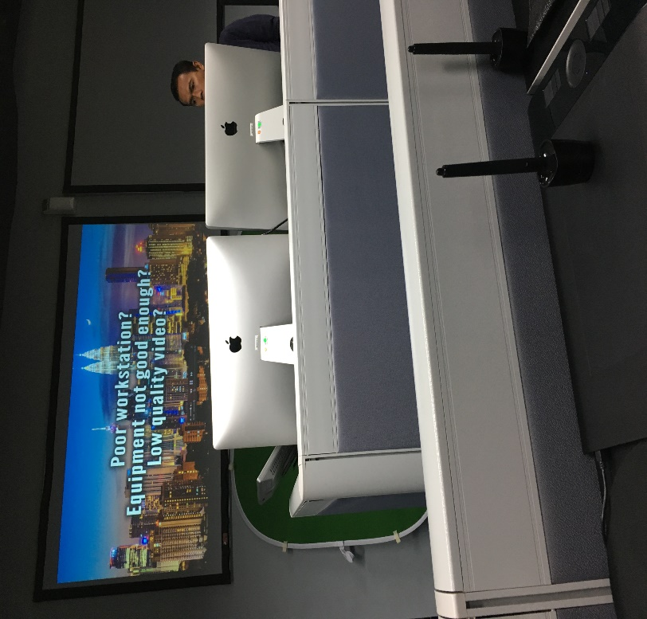

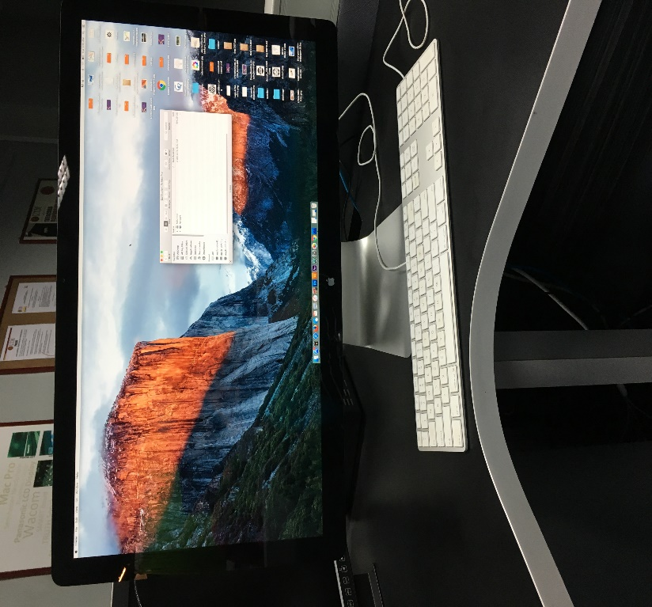

Apple MAC computer was provide inside the SMAL room.

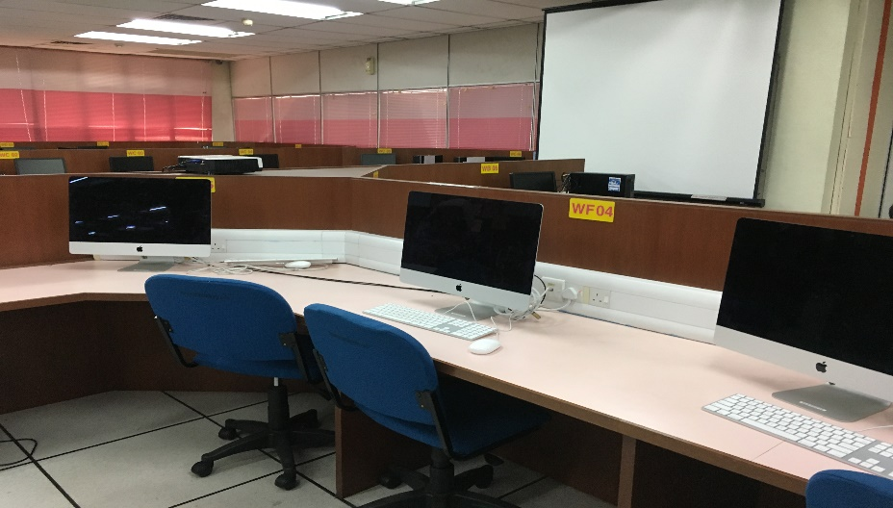
Computer Hall
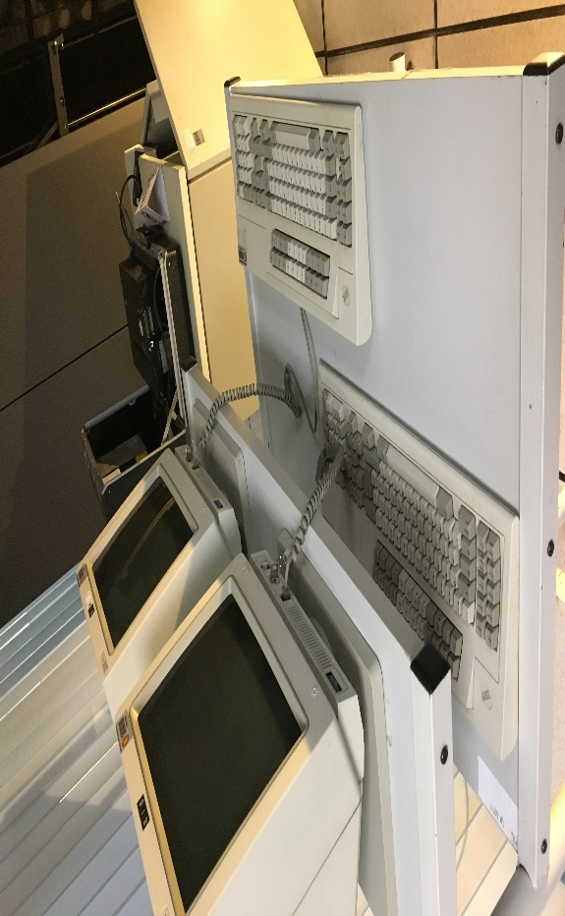
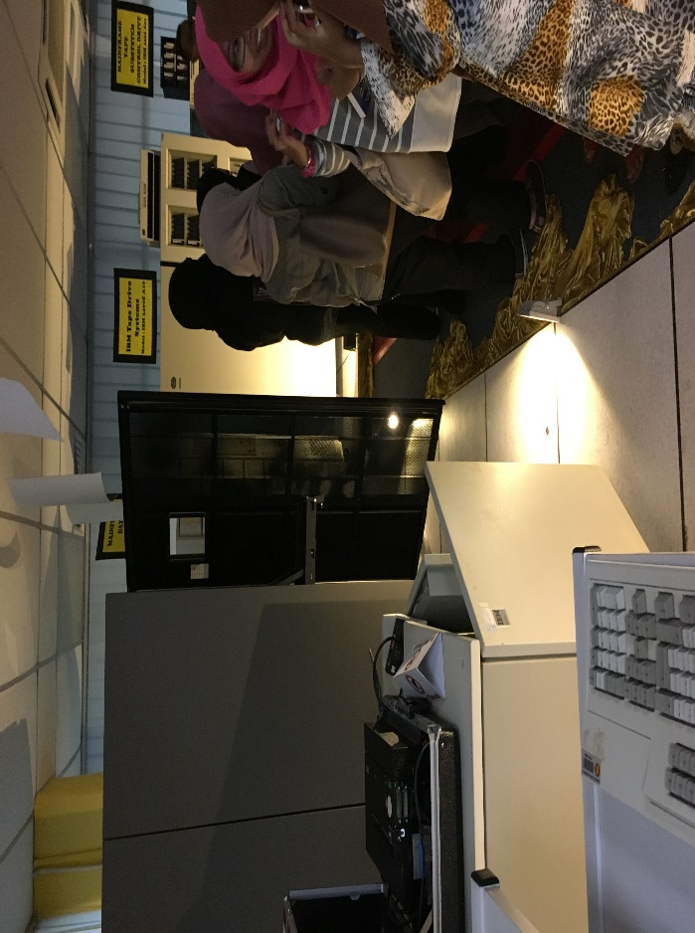
CICT Gallerium

