

SECR2043 OPERATING SYSTEM
SECTION-02

PROJECT PROPOSAL: PROPOSE A REAL-WORLD APPLICATION
LECTURER’S NAME : DR. ZURIAHATI

GROUP 1
GROUP MEMBERS:
Name | Matric No
NUR IRDINA ALIAH BINTI ABDUL WAHAB | A20EC0115
NAYLI NABIHAH BINTI JASNI | A20EC0105
MADINA SURAYA BINTI ZHARIN | A20EC0203
MUHAMMAD AMEERUL HADZIM BIN MUHAMMAD HABIB | A19EE0080

Executive Summary
We are from Group 1 and are assigned to describe applications using Process Scheduling regarding Round Robin and Multi-Level Queue. Our group has decided to make a video animation describing the application to see how Round Robin and Multi-Level Queue works. We decided that instant food drive thru system could be a good analogy to explain how the queue in the drive thru could be related to process scheduling.
Round Robin or RR is an example of preemptive scheduling in process scheduling. RR is widely used in interactive systems. Each process gets a small unit of CPU time or time quantum, q. The process will be preempted and added to the end of the ready queue as First Come First Serve. If CPU burst is more than time quantum, the job is preempted and placed at the end of the ready queue. The information will be saved in PCB and will be processed back afterwards. If the CPU burst is less than time quantum, the job will be finished. If there are any interruptions by I/O request, the information will be saved in PCB and linked to the I/O queue. Once the request is satisfied, the job will be returned at the end of the ready queue. In order to reduce the overhead, it is better to use a larger quantum as it will serve as an FCFS scheme. Small quantum will need a context switching. The flowchart below will show how we are going to present the idea through the animation scenario.
For the Multilevel Queue Process Scheduling, it is a hybrid environment where the queue is partitioned into 2 separate queues called foreground and background. For the foreground queue, it used the RR (Round Robin) algorithm while the background queue used the FCFS (First Come First Serve) algorithm. Generally, the scheduling has 2 things that need to be known. First of all, the scheduling has fixed priority scheduling where it prioritizes finishing executing the foreground queue first, then continuing to execute the background queue if the foreground queue is empty. The second point is each queue gets a certain amount of CPU time called Time Slice which it can schedule amongst its processes. The flowchart below will show how we are going to present the idea through the animation scenario.
For our project, fast food ordering will become the process, while the customer and workers will be analogy as foreground and background queue.

Project Flowchart

Round Robin
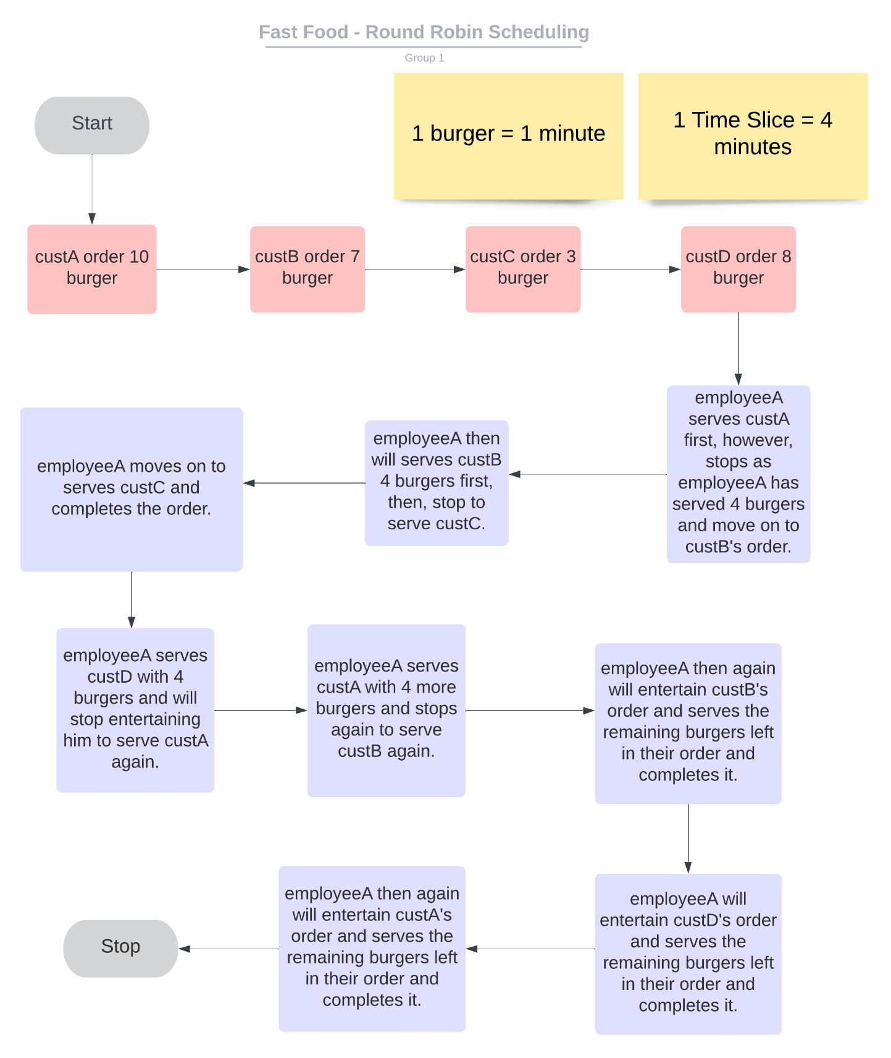

Multi-Level Queue

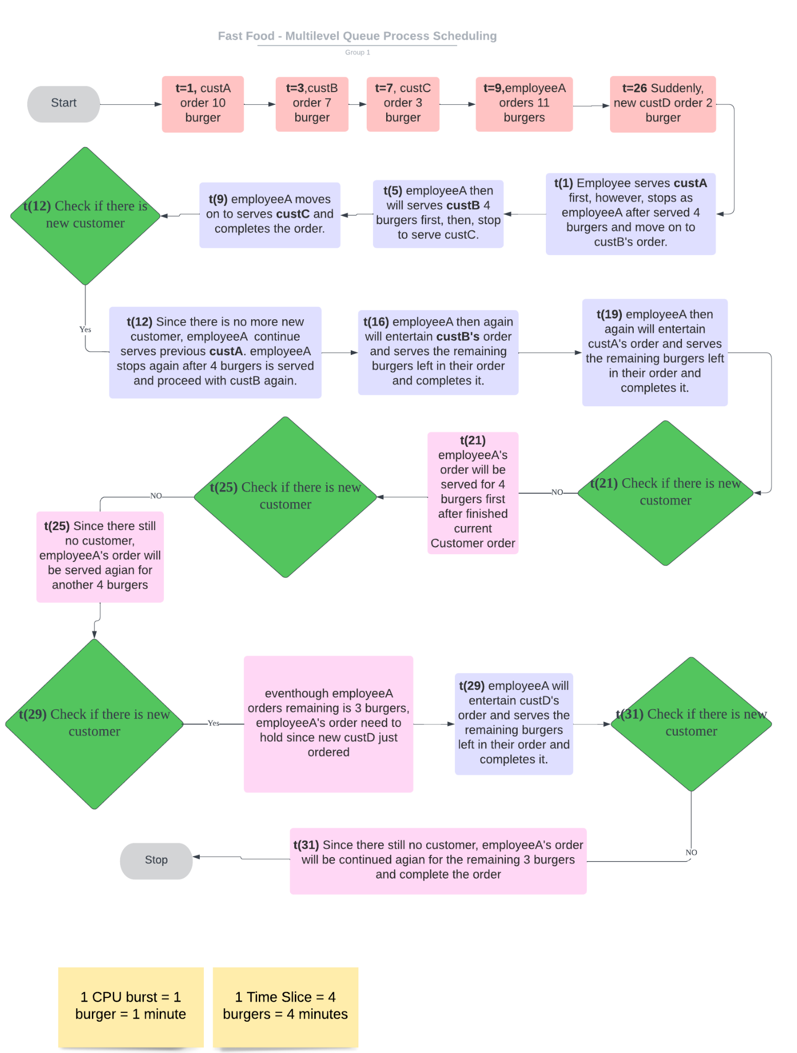

Project Time Table

 | Flowchart | Executive summary | Upload Proposal | Discuss Video | Create Video | Upload Video | Project Report | Upload Report
Week 13
12/6
13/6
14/6
15/6
16/6
17/6
18/6
Week 14
19/6
20/6
21/6
22/6
23/6
24/6
25/6
Week 15
26/6

