
2020/2021 – Semester 2

SECJ2154
OBJECT ORIENTED PROGRAMMING

Lecturer Name: Dr Ruhaidah Samsudin
Section 10

ASSIGNMENT CLASS RELATIONSHIP

GROUP MEMBERS:
NAME | MATRIC NO
Srivani Murugan | A19EC0305
Nurul Aqilah Binti Ahmad | A19EC0203
Nurul Syamira Binti Amat Jifri | A19EC0145

Question 2 page 199
Program:
public class Cat {
private String name;
private int age;
private int yearAdopt;

public Cat(String n, int a, int y) {
name=n;
age=a;
yearAdopt=y;
}

public String getName() {
return name;
}

public int getAge() {
return age;
}

public int calcnumOfYear() {
return (2021-yearAdopt);
}
}
public class Person1 {
private String name;
private String address;
private Cat[] myCat=new Cat[10];
private int numCat;

public Person1(String n, String a) {
name=n;
address=a;
}

public void adopt(Cat c) {
myCat[numCat]=c;
numCat++;
}

public void print() {
System.out.println();
System.out.println("Name: "+name);
System.out.println("Address: "+address);
System.out.println("Pet: "+numCat+" cat(s)");
for(int i=0; i<numCat; i++) {
System.out.print(" "+(i+1)+".");
System.out.println("\tName: "+myCat[i].getName());
System.out.println("\tAge: "+myCat[i].getAge());
System.out.println("\tNumber of year adopted: "+myCat[i].calcnumOfYear());
System.out.println();
}
}
}
public class AdoptionTest {
public static void main(String[] args) {
Cat c1=new Cat("Lily", 7, 2012);
Cat c2=new Cat("Kekwa", 7, 2014);
Cat c3=new Cat("Syoo", 4, 2012);

Person1 p1=new Person1("Ahmad", "Batu Caves, Selangor");
p1.adopt(c1);
p1.adopt(c2);
p1.adopt(c3);

p1.print();
}
}

Output:
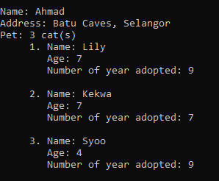

Question 3(i) page 200
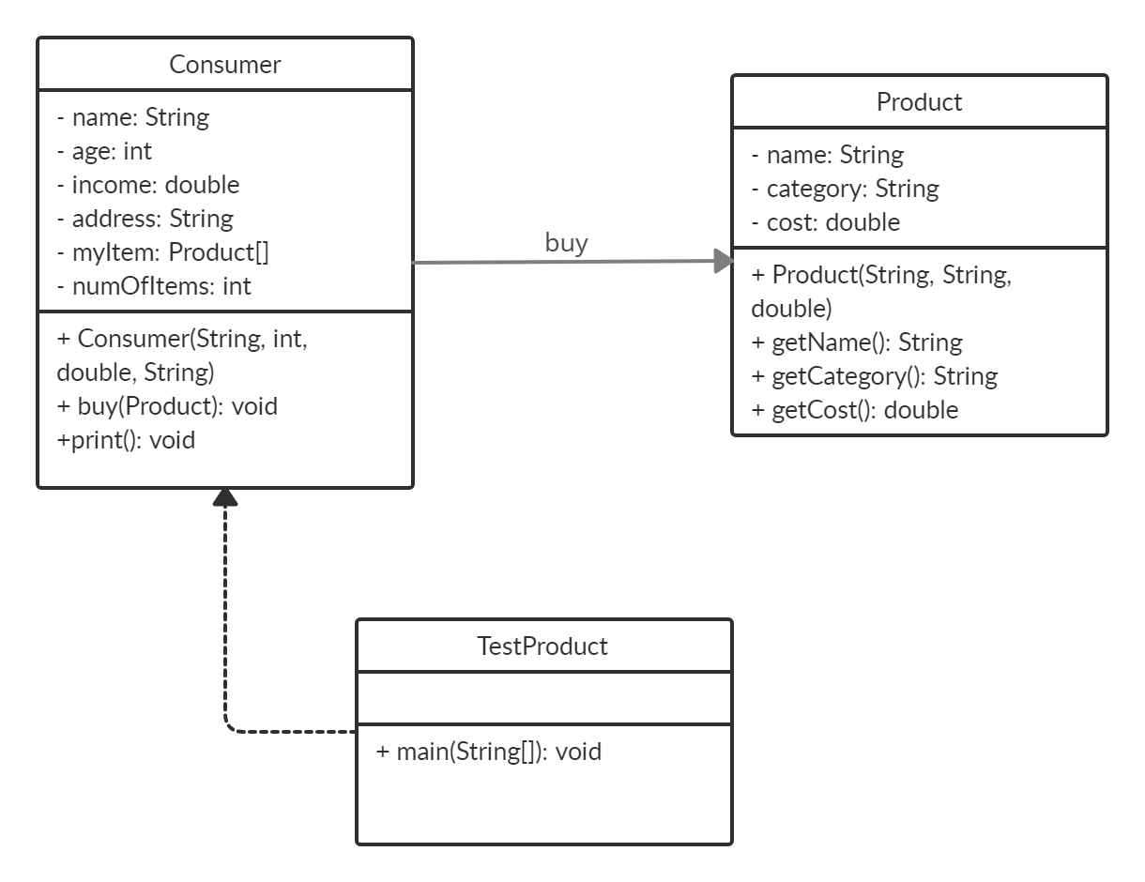

Question 3(ii)
Program:
//question ii
class Consumer
{
private String name;
private int age;
private double income;
private String address;
private Product[] myItem;
private int numOfItems;

// ii(a)
public Consumer(String n, int a, double i, String ad)
{
name = n;
age = a;
income = i;
address = ad;
myItem = new Product[5];
}

// ii(b)
public void buy(Product pr)
{
myItem[numOfItems] = pr;
numOfItems++;
}

// ii(c)
public void print()
{
System.out.println("--- Consumer information ---");
System.out.println("Name: " +name +"\nAge: " +age +"\nIncome: RM" +income +"\nAddress: " +address);

System.out.println("\n--- Purchased product information ---");
for(int i=0; i<numOfItems; i++)
{
Product pr = (Product)myItem[i];
System.out.println((i+1) + ") Product name: " + pr.getName());
System.out.println(" Product category: " + pr.getCategory());
System.out.println(" Product cost: " + pr.getCost());
}
}
}
// question iii
class Product
{
private String name, category;
private double cost;
// iii(a)
public Product(String n, String ct, double co)
{
name = n;
category = ct;
cost = co;
}
// iii(b)
public String getName()
{
return name;
}
// iii(c)
public String getCategory()
{
return category;
}

// iii (d)
public double getCost()
{
return cost;
}
}
// question iv
public class TestProduct
{
public static void main(String[] args)
{
Product p1 = new Product("Ramen", "Food and beverages", 16.50);
Product p2 = new Product("Pen Highlighter", "Stationary", 3.50);

Consumer c1 = new Consumer("Ahmad Adam", 23, 2500.00, "No. 15 Jalan Telawi, 40150 Shah Alam, Selangor");

c1.buy(p1);
c1.buy(p2);
c1.print();
}
}

Output:
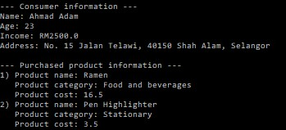
Question 6 page 203
Program:
class Lab {
private String labName;
private int capacity;
public Lab(String labName, int capacity) {
this.labName = labName;
this.capacity = capacity;
}
public String getLabName()
{return labName;}
public int getCapacity()
{return capacity;}
public void setLabName(String labName)
{this.labName = labName;}
public void setCapacity(int capacity)
{this.capacity = capacity;}
}
class LectureRoom {
private String roomName;
private String roomNo;
private int capacity;
public LectureRoom(String roomName, String roomNo, int capacity) {
this.roomName= roomName;
this.roomNo = roomNo;
this.capacity = capacity;
}
public String getRoomName()
{return roomName;}
public String getRoomNo()
{return roomNo;}
public int getCapacity()
{return capacity;}
public void setRoomName(String roomName)
{this.roomName = roomName;}
public void setRoomNo(String roomNo)
{this.roomNo = roomNo;}
public void setCapacity(int capacity)
{this.capacity = capacity;}
}
class FSKSMBuilding {
private Lab labs;
private LectureRoom lect;
public FSKSMBuilding() {
labs = new Lab ("Network Lab", 4);
lect = new LectureRoom ("N28", "F1R3", 2);
}
public String getName()
{return labs.getLabName();}
public int getLabCapacity()
{return labs.getCapacity();}
public String getNameRoom()
{return lect.getRoomName();}
public String getNoRoom()
{return lect.getRoomNo();}
public int getRoomCapacity()
{return lect.getCapacity();}
public String toString(){
return "The lab name is " + getName() + " and the capacity is " + getLabCapacity() + "\n"
+ "The lecture Room name is " + getNameRoom() + " , the room number is " + getNoRoom() + " and the capacity is " + getRoomCapacity(); }
}
public class FSKSMBuildingTest {
public static void main (String [] a){
FSKSMBuilding obj1 = new FSKSMBuilding();
System.out.println(obj1);
}}
Output:
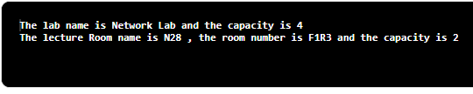
Question 6(i) page 203
Program:
class Question {
private String quesText;
public Question(String quesText)
{this.quesText = quesText;}
public String getQuesText()
{return quesText;}
public String toString() {
return quesText;}
}
class Answer {
private String ansText;
private double marks;
public Answer(String ansKod, double marks) {
ansText = ansKod;
this.marks = marks;
}
public String getAnsText()
{return ansText;}
public double getMarks()
{return marks;}
}

class LabAssignment {
private double percentage;
private Question quest;
private Answer ans;
public LabAssignment() {
percentage = 0.0;
}
public LabAssignment(double percentage, Question quest, Answer ans) {
this.percentage = percentage;
this.quest = quest;
this.ans = ans;
}
public Question getQuest() {
return quest;}
public Answer getKodQuiz() {
return ans;}
public double getPercentage() {
return percentage;}
}
public class Student {
private String name;
private String matrix;
private LabAssignment[] asgnList;
private int numSubmit;
public Student (String name, String matrix){
this.name = name;
this.matrix = matrix;
asgnList = new LabAssignment[10];}

public String getName()
{return name;}
public String getMatrix()
{return matrix;}
public void submit (LabAssignment a){
asgnList[numSubmit] = a;
numSubmit++;}
public void printInfo(){
System.out.println("Student name: " + name + "\n" + "Matrix number: " + matrix);
for(int i = 0; i < numSubmit; i++) {
LabAssignment la = (LabAssignment)asgnList[i];
System.out.println((i+1) + ". " + la.getQuest() + la.getKodQuiz() + la.getPercentage());}
}}

Question 7 page 204
Program:
public class RoomDimension {
private double length;
private double width;

public RoomDimension(double length, double width) {
this.length=length;
this.width=width;
}

public double getArea() {
return length*width;
}

public String toString() {
return length+" X "+width;
}
}
public class RoomCarpet {
private RoomDimension size;
private double carpetCost;

public RoomCarpet(RoomDimension size, double carpetCost) {
this.size=size;
this.carpetCost=carpetCost;
}

public double getTotalCost() {
return size.getArea()*carpetCost;
}

public String toString() {
return "RM "+getTotalCost();
}
}
import java.util.Scanner;

public class TestRoom {
public static void main(String[] args) {
Scanner input=new Scanner(System.in);
double ln, wd, cost;

System.out.print("Enter the length of the room floor -> ");
ln=input.nextDouble();
System.out.print("Enter the width of the room floor -> ");
wd=input.nextDouble();
System.out.print("Enter the price per square meter of the desired carpet -> ");
cost=input.nextDouble();

RoomDimension dimension=new RoomDimension(ln, wd);
RoomCarpet totalCarpetCost=new RoomCarpet(dimension, cost);

System.out.println("\nThe total cost for the room dimension of "+dimension+" is "+totalCarpetCost);
}
}

Output:
