
2020/2021 – Semester 2

SECJ2154
OBJECT ORIENTED PROGRAMMING

Lecturer Name: Dr Ruhaidah Samsudin
Section 10

ASSIGNMENT INHERITANCE

GROUP MEMBERS:
NAME | MATRIC NO
Srivani Murugan | A19EC0305
Nurul Aqilah Binti Ahmad | A19EC0203
Nurul Syamira Binti Amat Jifri | A19EC0145

Question 2 page 228
Program
//pg228 no2 inheritance
import java.util.Scanner;
class Painting
{
private String title;
private String artist;
public int value;

public Painting()
{
this.value = 400;
}

Painting(int v)
{
value = v;
}

public void setPainting(String title, String artist)
{
this.title = title;
this.artist = artist;
}

public void display()
{
System.out.println("Painting title: " +title);
System.out.println("Artist name: " +artist);
System.out.println("Painting value: RM" +value);
System.out.println();
}
}

class FamousPainting extends Painting
{
public FamousPainting()
{
super();
this.value = 25000;
}
}

public class TestPainting
{
public static void main(String[] args)
{
Scanner input = new Scanner(System.in);
String title, artist;

Painting[] paintObj = new Painting[10];

System.out.println("--- Please enter the painting info ---");
for(int i=0; i<paintObj.length; i++)
{
System.out.print("Painting title #" +(i+1) +": ");
title = input.nextLine();
System.out.print("Artist name: ");
artist = input.nextLine();
System.out.println();

if (artist.equalsIgnoreCase("Degas") ||
artist.equalsIgnoreCase("Monet") ||
artist.equalsIgnoreCase("Picasso") ||
artist.equalsIgnoreCase("Rembrandt"))
{
paintObj[i] = new FamousPainting();
}
else
{
paintObj[i] = new Painting();
}

paintObj[i].setPainting(title, artist);
}

System.out.println("--- Painting List ---");
for (int i=0; i<paintObj.length; i++)
{
paintObj[i].display();
}
}
}
Output
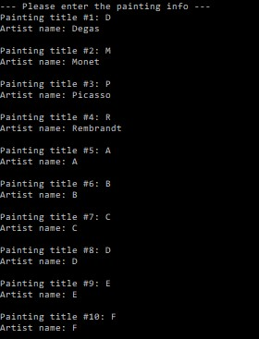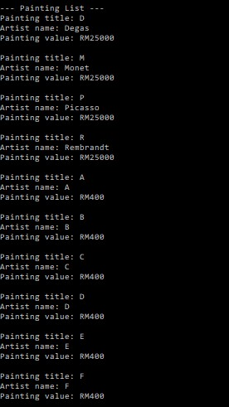
Question 5 page 232
UML Diagram
Shape

+print(): void

-height: double
+Cylinder ()
+surfaceArea(): double
+print(): void
Cylinder

-slant: double
+Cone ()
+surfaceArea(): double
+print(): void
Cone

-width: double
-length: double
+Triangle (double, double)
+calculateArea(): double
+print(): void
Rectangle

-width: double
-length: double
+Rectangle (double, double)
+calculateArea(): double
+print(): void
Rectangle

-radius: double
+Circle (double)
+calculateArea(): double
+print(): void
Circle

Program

class Shape{
public void print(){
System.out.print("The area of the ");}
}

class Circle extends Shape{
public double radius;
Circle (double radius){
this.radius = radius;
}
public double calculateArea(){
return radius * 3.1416;
}
public void print(){
super.print();
System.out.println("circle is: " + calculateArea());}
}

class Cone extends Circle {
double slant;
public Cone() {
super (4.5);
slant = 8;
}
public double surfaceArea() {
return calculateArea() + (calculateArea() * slant);
}
public void print()
{System.out.println("The area of the cone is: " + surfaceArea());}
}

class Cylinder extends Circle {

double height;
public Cylinder() {
super (5.5);
height = 10;
}

public double surfaceArea() {
return (2 * calculateArea()) * height;}
public void print()
{System.out.println("The area of the cylinder is: " +
surfaceArea());}
}

class Rectangle extends Shape{
public double width;
public double length;
Rectangle (double width, double length) {
this.width = width;
this.length = length;
}
public double calculateArea() {
return width * length;
}
public void print(){
super.print();
System.out.println("rectangle is: " + calculateArea());}
}

class Triangle extends Shape{
public double width;
public double length;

Triangle (double width, double length) {
this.width = width;
this.length = length;
}
public double calculateArea() {
return width * length * 0.5;
}
public void print(){
super.print();
System.out.println("triangle is: " + calculateArea());}
}

class TestApplication{
public static void main(String [] args)
{
Circle c = new Circle(10.5);
c.print();
Rectangle r = new Rectangle(2.5, 4.6);
r.print();
Triangle t = new Triangle(3.4, 2.0);
t.print();
Cone cone = new Cone();
cone.print ();
Cylinder cylinder = new Cylinder();
cylinder.print ();}}
Output
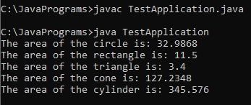

Question 6 page 233
Program
class Address {
private String street;
private String city;
private String state;

public Address() {}

public Address(String ste, String cty, String sta) {
street=ste;
city=cty;
state=sta;
}

public String getFullAddress() {
return street+", "+city+", "+state;
}
}

class Person {
private String name;
private String phone;
private String address;

public Person() {}

public Person(String n, String p, Address a) {
name=n;
phone=p;
address=a.getFullAddress();
}

public void setName(String n) {
name=n;
}

public void setPhone(String p) {
phone=p;
}

public void setAddress(Address a) {
address=a.getFullAddress();
}

public String getName() {
return name;
}

public String getPhone() {
return phone;
}

public String getAddress() {
return address;
}

public void display() {
System.out.println("Name: "+name);
System.out.println("Phone: "+phone);
System.out.println("Address: "+address);
}
}

class BusinessAssociate extends Person {
private String jobtitle;
private String companyName;

public BusinessAssociate() {}

public BusinessAssociate(String n, String p, Address a, String j, String c) {
super.setName(n);
super.setPhone(p);
super.setAddress(a);
jobtitle=j;
companyName=c;
}

public String getJobTitle() {
return jobtitle;
}

public String getCompanyName() {
return companyName;
}

public void display() {
System.out.println("Name: "+super.getName());
System.out.println("Phone: "+super.getPhone());
System.out.println("Job Title: "+jobtitle);
System.out.println("Company: "+companyName);
System.out.println("Address: "+super.getAddress());
}
}

class PersonalFriend extends Person {
private String message;

public PersonalFriend() {}

public PersonalFriend(String n, String p, Address a, String m) {
super.setName(n);
super.setPhone(p);
super.setAddress(a);
message=m;
}

public String getMessage() {
return message;
}

public void display() {
System.out.println("Name: "+super.getName());
System.out.println("Phone: "+super.getPhone());
System.out.println("Address: "+super.getAddress());
System.out.println("Message: "+message);
}
}

class AddressBook {
private Person[] entry;
private int count;
int index=0;

public AddressBook() {}

public AddressBook(int c) {
count=c;
entry=new Person[count];
}

public void addPerson(Person p) {
entry[index]=p;
index++;
count=index;
}

public void displayAddressBook() {
for(int i=0; i<count; i++) {
entry[i].display();
System.out.println();
}
}
}

public class AddressBookApp {
public static void main(String[] args) {
AddressBook book1=new AddressBook(10);
Address ad1=new Address("No 2 Jalan Mawar", "Skudai", "Johor Bahru");
Address ad2=new Address("Block 1-7", "Cheras", "Kuala Lumpur");
Address ad3=new Address("202-2 Jalan Bendahara", "Muar", "Johor Bahru");

Person newfriend1=new Person("Ms. X", "555-1212", ad1);
book1.addPerson(newfriend1);

BusinessAssociate b1;
b1=new BusinessAssociate("Mr. Yeo", "019-2342", ad2, "General Manager", "Motorola");
book1.addPerson(b1);

PersonalFriend f1=new PersonalFriend("Mrs. Zyda", "012-8278", ad3, "My school mate");
book1.addPerson(f1);

book1.displayAddressBook();
}
}

Output
