
2020/2021 – Semester 2

SECJ2154
OBJECT ORIENTED PROGRAMMING

Lecturer Name: Dr Ruhaidah Samsudin
Section 10

ASSIGNMENT 5

GROUP MEMBERS:
NAME | MATRIC NO
Srivani Murugan | A19EC0305
Nurul Aqilah Binti Ahmad | A19EC0203
Nurul Syamira Binti Amat Jifri | A19EC0145

Question 1 and 2 page 183
Program:
import java.util.ArrayList;
class Employee
{
public String name;
public int idNumber;
public String department;
public String position;
public Employee ()
{
name = " ";
idNumber = 0;
department = " ";
position = " ";
}
public Employee (String name, int idNumber, String department, String position)
{
this.name = name;
this.idNumber = idNumber;
this.department = department;
this.position = position;
}
public void setName (String name)
{ this.name = name; }
public void setID (int idNumber)
{ this.idNumber = idNumber; }
public void setDepartment (String department)
{ this.department = department; }
public void setPosition (String position)
{ this.position = position; }

public String getName()
{return name; }
public int getID()
{return idNumber; }
public String getDepartment()
{return department; }
public String getPosition()
{return position; }
}
public class EmployeeTest
{public static void main (String [] args){
Employee emp1 = new Employee ("Dr.Nor Sabrina", 47899, "Accounting", "Vice President");
Employee emp2 = new Employee ("En Ahmad", 39119, "IT", "Programmer");
Employee emp3 = new Employee ("Prof M Izzudin", 66666, "Consultation", "Manager");
Employee emp4 = new Employee ("Dr N Izzati", 34521, "Elect&Etronic", "CEO");
Employee emp5 = new Employee ("Dr A Rahman", 12321, "PR", "Manager");
ArrayList<Employee> empList = new ArrayList<Employee>();
empList.add (emp1);
empList.add (emp2);
empList.add (emp3);
empList.add (emp4);
empList.add (emp5);
for (int i=0; i<empList.size(); i++){
System.out.println(((Employee)empList.get(i)).getName() +", " + ((Employee)empList.get(i)).getID() +", "
+ ((Employee)empList.get(i)).getDepartment() +", " + ((Employee)empList.get(i)).getPosition());}
System.out.println();
System.out.println("Invoke contains() method to check element emp3.");
boolean e = empList.contains(emp3);
if (e)
System.out.println("The list contains information of Prof M Izzudin");
else
System.out.println("The list does not contains information of Prof M Izzudin");
System.out.println();
System.out.println("Invoke isEmpty() method.");
if (empList.isEmpty()){
System.out.println("Employee List is Empty");}
else{
System.out.println("Employee List is Not Empty");}
System.out.println();
System.out.println("Invoke set() method to set element emp5 at index 4.");
Employee emp6 = new Employee ("Srivani", 2202, "Computing", "Manager");
empList.set(4, emp6);
for (int i=0; i<empList.size(); i++){
System.out.println(((Employee)empList.get(i)).getName() +", " + ((Employee)empList.get(i)).getID() +", "
+ ((Employee)empList.get(i)).getDepartment() +", " + ((Employee)empList.get(i)).getPosition());}
System.out.println();
System.out.println("The size of the list is " + empList.size());
System.out.println("Invoke remove() method to remove element at index 3");
empList.remove(3);
for (int i=0; i<empList.size(); i++){
System.out.println(((Employee)empList.get(i)).getName() +", " + ((Employee)empList.get(i)).getID() +", "
+ ((Employee)empList.get(i)).getDepartment() +", " + ((Employee)empList.get(i)).getPosition());}
System.out.println();
}
}

Output:
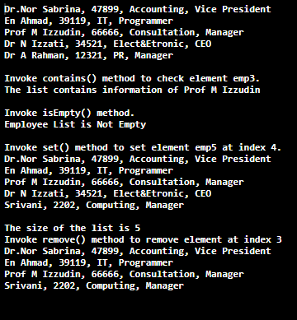

Question 3 and 4 page 184
Program:
import java.util.Vector;
class Student
{
public String name;
public int age;
public String majoring;
public String country;
public Student ()
{
name = " ";
age = 0;
majoring = " ";
country = " ";
}
public Student (String name, int age, String majoring, String country)
{
this.name = name;
this.age = age;
this.majoring = majoring;
this.country = country;
}
public void setName (String name)
{ this.name = name; }
public void setAge (int age)
{ this.age = age; }
public void setMajoring (String majoring)
{ this.majoring = majoring; }
public void setCountry (String country)
{ this.country = country; }
public String getName()
{return name; }
public int getAge()
{return age; }
public String getMajoring()
{return majoring; }
public String getCountry()
{return country; }}
public class StudentTest
{public static void main (String [] args){
Student obj1 = new Student ("Eva", 19, "Accounting", "Poland");
Student obj2 = new Student ("Mahboubeh", 24, "Cryptography", "Iran");
Student obj3 = new Student ("Melvin", 23, "Vision", "Tasmania");
Student obj4 = new Student ("Abdullah", 21, "Usuludin", "Malaysia");
Student obj5 = new Student ("Bella", 22, "Business", "Ireland");
Student obj6 = new Student ("Srivani", 2202, "Computing", "Malaysia");

Vector<Student> objList = new Vector<Student>();
objList.addElement (obj1);
objList.addElement (obj2);
objList.addElement (obj3);
objList.addElement (obj4);
objList.addElement (obj5);
for (int i=0; i<objList.size(); i++){
System.out.println(((Student)objList.get(i)).getName() +", " + ((Student)objList.get(i)).getAge() +", "
+ ((Student)objList.get(i)).getMajoring() +", " + ((Student)objList.get(i)).getCountry());}
System.out.println();
System.out.println("Invoke contains() method to check element obj3.");
boolean s = objList.contains(obj3);
if (s)
System.out.println("The list contains information of Melvin");
else
System.out.println("The list does not contains information of Melvin");
System.out.println();
System.out.println("Invoke insertElement(x) method to add new element at index 1.");
objList.insertElementAt(obj6, 1);
for (int i=0; i<objList.size(); i++){
System.out.println(((Student)objList.get(i)).getName() +", " + ((Student)objList.get(i)).getAge() +", "
+ ((Student)objList.get(i)).getMajoring() +", " + ((Student)objList.get(i)).getCountry());}
System.out.println();
System.out.println("Invoke isEmpty() method.");
if (objList.isEmpty()){
System.out.println("Student List is Empty");
}
else{
System.out.println("Student List is Not Empty");
}
System.out.println();

System.out.println("Invoke set() method to set element obj1 at index 4.");
objList.setElementAt(obj1, 4);
for (int i=0; i<objList.size(); i++){
System.out.println(((Student)objList.get(i)).getName() +", " + ((Student)objList.get(i)).getAge() +", "
+ ((Student)objList.get(i)).getMajoring() +", " + ((Student)objList.get(i)).getCountry());}
System.out.println();
System.out.println("Invoke remove() method to remove element at index 2");
objList.removeElementAt(2);
for (int i=0; i<objList.size(); i++){
System.out.println(((Student)objList.get(i)).getName() +", " + ((Student)objList.get(i)).getAge() +", "
+ ((Student)objList.get(i)).getMajoring() +", " + ((Student)objList.get(i)).getCountry());}
System.out.println();
System.out.println("The capacity is : " + objList.capacity());}}
Output:
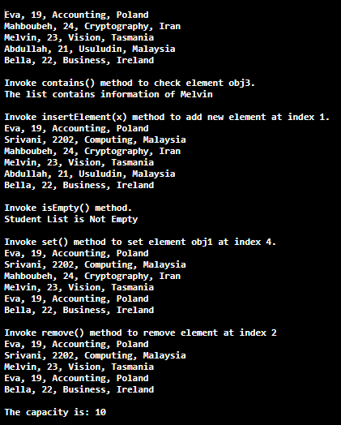

Question 5 page 185
Program:
import java.util.Vector;
import java.util.*;

class SoftwareInfo
{
private String name;
private int serialNum;
private double price;
private String company;

public SoftwareInfo(String name, int serialNum, double price, String company)
{
this.name = name;
this.serialNum = serialNum;
this.price = price;
this.company = company;
}

public String getName()
{
return name;
}

public int getSerialNum()
{
return serialNum;
}

public double getPrice()
{
return price;
}

public String getCompany()
{
return company;
}

public void display()
{
System.out.println("Software Name: " + name);
System.out.println("Serial Number: " + serialNum);
System.out.println("Price: " + price);
System.out.println("Company: " + company);
}
}

public class Software
{
public static void main(String[] args)
{
Scanner input = new Scanner(System.in);
String sold, find;

// i
Vector Perisian_Komputer = new Vector();
Perisian_Komputer.add(new SoftwareInfo("Visual", 110598, 2134.50, "Oracle"));
Perisian_Komputer.add(new SoftwareInfo("Workstation", 110592, 1800.00, "VMware Inc."));
Perisian_Komputer.add(new SoftwareInfo("Creative", 110603, 2050.00, "Adobe"));

// ii
Vector Engineer = new Vector();
Engineer.add("Dov Trietsch");
Engineer.add("Luciano Patrao");
Engineer.add("Jennifer Smith");

System.out.println("Current list and author of software");
for(int i=0; i<Perisian_Komputer.size(); i++)
{
System.out.println();
System.out.println("Software " + (i+1));
((SoftwareInfo)Perisian_Komputer.get(i)).display();
System.out.println("Author: " + Engineer.get(i));
}

// iii
System.out.print("\nName of the software to be sold: ");
sold = input.next();
for(int i=0; i<Perisian_Komputer.size(); i++)
{
if(sold.equals(((SoftwareInfo)Perisian_Komputer.get(i)).getName()))
Perisian_Komputer.removeElement(((Perisian)Perisian_Komputer.get(i)));
}

// iv
System.out.print("\nLocate software from name of the software: ");
find = input.next();

for(int i=0; i<Perisian_Komputer.size(); i++)
{
if(find.equals(((SoftwareInfo)Perisian_Komputer.get(i)).getName()))
System.out.println("The software " + find + " located at index "
+Perisian_Komputer.indexOf(((SoftwareInfo)Perisian_Komputer.get(i))));
}

// v
System.out.println("\nUpdated list and author of software");
for(int i=0; i<Perisian_Komputer.size(); i++)
{
System.out.println();
System.out.println("Software " + (i+1));
((SoftwareInfo)Perisian_Komputer.get(i)).display();
System.out.println("Author: " + Engineer.get(i));
}
}
}

Output:
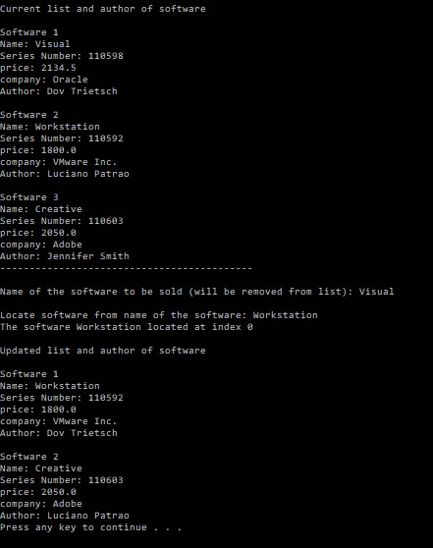

Question 7 page 186
Program:
import java.util.ArrayList;
import java.util.Scanner;
import java.util.*;

public class Occurrence {
public static void main(String[] args) {
ArrayList<Integer> intNumbers=new ArrayList<Integer>();
ArrayList<Integer> occur=new ArrayList<Integer>();
Scanner input=new Scanner(System.in);
int element; // element

System.out.println("Enter any integer values from 1 - 50 as much as you want (separate with space)");
while(input.hasNextInt()) {
element=input.nextInt();
intNumbers.add(element);
}

System.out.print("The inputs are: ");
for(int k=0; k<intNumbers.size(); k++) {
System.out.print(intNumbers.get(k));

if((k>=0)&&(k<=3))
System.out.print(", ");

else
break;
}

System.out.println("\n");

Set<Integer> set=new HashSet<Integer>(intNumbers);
for(Integer i : set) {
System.out.println("Number "+i+" has been input "+Collections.frequency(intNumbers, i)+" times.");
}
}
}
Output:
