
2020/2021 – Semester 2

SECJ2154
OBJECT ORIENTED PROGRAMMING

Lecturer Name: Dr Ruhaidah Samsudin
Section 10

ASSIGNMENT 4

GROUP MEMBERS:
NAME | MATRIC NO
Srivani Murugan | A19EC0305
Nurul Aqilah Binti Ahmad | A19EC0203
Nurul Syamira Binti Amat Jifri | A19EC0145

SUBMISSION DATE: 25 APRIL 2021
Question 2
Program:

import java.util.Scanner;
public class Sales
{
public static void main(String[] args)
{
int pcSold[] = new int[6];

Scanner input = new Scanner(System.in);
System.out.println("Enter the number of computer sold: ");
for (int i = 0; i < pcSold.length; i++)
{
pcSold[i] = input.nextInt();
}

System.out.println("\nMonth" +"\n1 | 2 | 3 | 4 | 5 | 6 |");
System.out.println("Number of computer sold");
for (int p : pcSold)
{
System.out.print(p +" | ");
}
System.out.print("\n");

int total = 0;
System.out.println("\nThe number of computer sold for the whole 6 months: ");
for (int i = 0; i<pcSold.length; i++)
{
total = total + pcSold[i];
}
System.out.println(total);

int temp;
int high = pcSold[0];
for (int i =0; i <pcSold.length; i++)
{
if (pcSold[i] > high)
high = pcSold[i];
}
System.out.println("\nThe highest sell: ");
System.out.println(high);
}
}

Output:
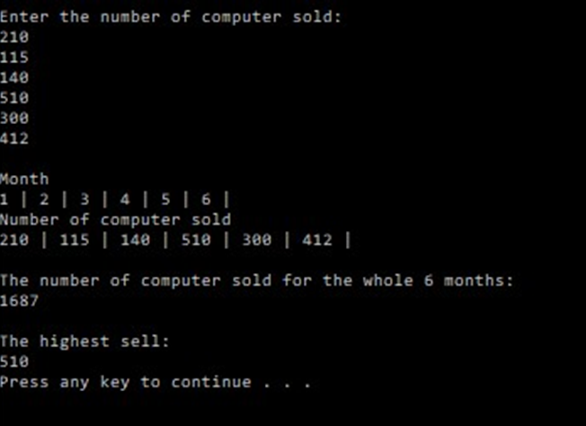

Question 3
Program:

import java.util.Scanner;
public class modifySales
{
public static void main(String[] args)
{
int pcSold[] = new int[6];

readNumSold(pcSold);
displayContent(pcSold);
displayTotal(pcSold);
displayHighestSell(pcSold);
}

public static void readNumSold(int pc[])
{
Scanner input = new Scanner(System.in);
System.out.println("Enter the number of computer sold: ");

for (int i = 0; i < pc.length; i++)
{
pc[i] = input.nextInt();
}
}

public static void displayContent(int pc[])
{
System.out.println("\nMonth" +"\n1 | 2 | 3 | 4 | 5 | 6 |");
System.out.println("Number of computer sold");
for (int p : pc)

{
System.out.print(p +" | ");
}
System.out.print("\n");
}

public static void displayTotal(int pc[])
{
int total = 0;
System.out.println("\nThe number of computer sold for the whole 6 months: ");
for (int i = 0; i<pc.length; i++)
{
total = total + pc[i];
}
System.out.println(total);
}

public static void displayHighestSell(int pc[])
{
int temp;
int high = pc[0];
for (int i =0; i <pc.length; i++)
{ if (pc[i] > high)
high = pc[i];
}
System.out.println("\nThe highest sell: ");
System.out.println(high);
}
}
Output:
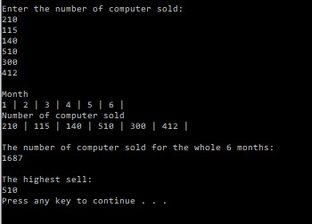

Question 6
Program:

import javax.swing.JOptionPane;
import java.util.Scanner;
import java.lang.*;

class Temperature{
public double degrees;
static int countTemp = 0;

public Temperature() {
degrees = 0;
countTemp += 1; }

public Temperature (double d) {
degrees = d; }

public double getDegrees()
{return degrees; }

public void setDegrees (double d)
{degrees = d; }

public String toString () {
String strMessage = degrees + "celcius";
return strMessage; }

public boolean equals (Temperature deg) {
return (this.getDegrees() == deg.getDegrees()); }

public double convertToCelcius () {
double number1 = (degrees - 32) * (0.56);
System.out.println ("The degree in Celcius is : " + number1 + "oC" );
return number1;
}
public double convertToFahrenheit () {
double number2 = (degrees * (9/5)) + 32;
System.out.println ("The degree in Fahrenheits is : " + number2 + "F" );
return number2;
}
}

public class TestTemperature{

public static void main (String [] args) {
String a;
int b;

Temperature[] temp = new Temperature[10];

Scanner input = new Scanner (System.in);

a = JOptionPane.showInputDialog ("1: Fahrenheit" + "\n2: Celcius" + "\nEnter the option number: ");
b = Integer.parseInt(a);
for (int i=0; i<10; i++)
{temp[i] = new Temperature();
System.out.println ("Please enter the degree number: " + i);
double d = input.nextDouble();
temp[i].setDegrees(d);

if (b == 1)
temp[i].convertToFahrenheit ();
else
temp[i].convertToCelcius ();
}
}
}

Output:
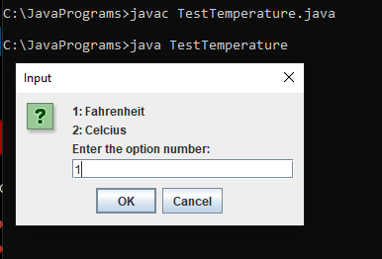
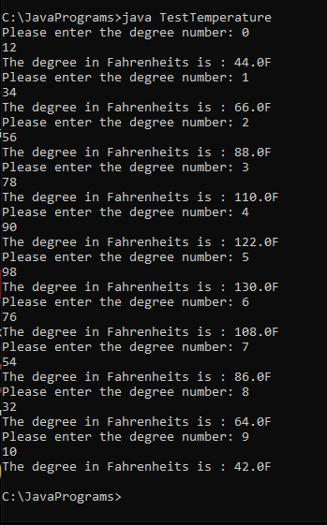
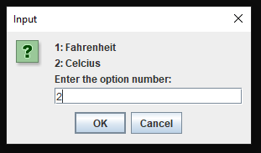
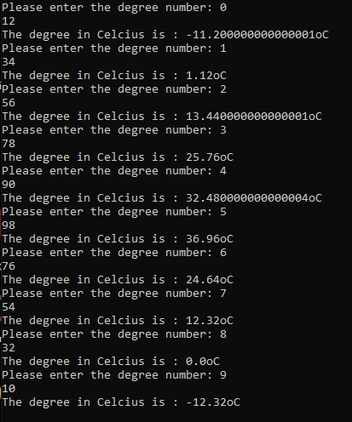

Question 9
Program:
import java.util.Scanner;

public class Assgn4No9 {
public static int[][] buildRagged(int n) {
Scanner input=new Scanner(System.in);
int[][] array=new int[n+1][];
array[0]=new int[1];
array[0][0]=n;
for(int i=1; i<array.length; i++) {
System.out.println("How many elements in Row "+i+": ");
int numElmn=input.nextInt();
array[i]=new int[numElmn+1];
array[i][0]=numElmn;
System.out.println("Enter the elements (separate by 'enter'): ");
for(int j=1; j<numElmn+1; j++) {
array[i][j]=input.nextInt();
}
}
return array;
}

public static void printArray(int x[][]) {
System.out.println();
for(int k=0; k<x.length; k++) {
for(int l=0; l<x[k].length; l++) {
System.out.print(x[k][l]+" ");
}
System.out.println();
}
}

public static void main(String[] args) {
Scanner input=new Scanner(System.in);
System.out.print("Enter data for the array, begin with the number of rows: ");
int rows=input.nextInt();
int[][] array=buildRagged(rows);
printArray(array);
}
}

Output:
