Course code : UICL2072 - 02
Course name : SUSTAINABLE ECONOMY
Group name : ECONOMEME
Students’ name & matric ID :

- SAM YU HONG A18BE0140
- NORA NATASHA BINTI BAKARI A18PP0120
- AQILA NATASHA BINTI ARBANI A18PP0014
- AQILAH HANIM BINTI MOHD TAUFIK B19EC0006
- MUHAMMAD AMIRUDDIN BIN MOHD ZAIRES A18PP0081

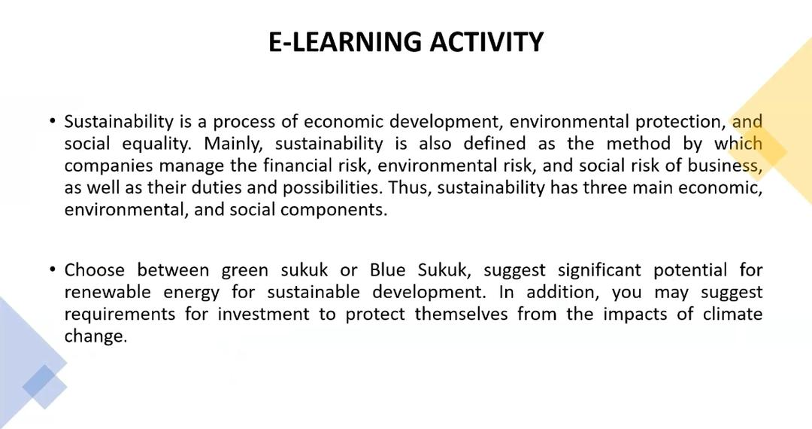

GREEN SUKUK VS BLUE SUKUK
GREEN SUKUK | BLUE SUKUK
Proceeds from green sukuk must be used only for climate-friendly investments | Enhance ocean resilience and investment in the blue economy
Bridge the gap between conventional and islamic financial worlds. It is in line with the objectives of shari’ah to protect the environment | helps to ensure protection and sustainable use of the oceans through investment in the blue economy
A new and innovative financial product that can be used around the world | helping to build ocean resilience
Asia requires $1.7 trillion a year in infrastructure investments, while actual investment pledged each year is closer to $880 billion - far short of the region’s needs. green sukuk can help close the gap | grow and merge with the increasingly popular socially responsible finance and ESG agendas.
 | It will also better align Islamic finance with SDGs, signalling the industry’s commitment to environmental stewardship

- Choose between Green Sukuk or Blue Sukuk.
We chose Blue Sukuk as the method of governing sustainable economic finance. This is because, according to Ahmed (2019), marine economics, often known as the Blue Economy, is a concept for utilising water resources with the goal of increasing economic growth via a variety of innovative and creative activities while assuring both corporate and environmental sustainability. The growing interest in the "blue economy" emphasises the interconnectedness of the seas and climate change prevention. Access to capital and investment, on the other hand, is one of the most significant hurdles to boosting ocean resilience and sustaining the blue economy. Innovative financing is becoming increasingly popular as a means of assisting in the battle against time to safeguard our seas.
Therefore we believe that the ocean and marine life should be given priority as it is equally important for climate change. We believe that Blue Sukuk plays a vital role to Increase ocean resilience and blue economy investment. It aims to assure ocean conservation and sustainable usage through investment in the blue economy, allowing ocean resilience to flourish and blend with the increasingly popular socially responsible finance and environmental sustainability objectives. It would also further integrate Islamic finance with the Sustainable Development Goals, demonstrating the industry's dedication to environmental care.
- Suggest significant potential for renewable energy for sustainable development -

Blue bonds are comparable to green bonds in that both integrate socially responsible investing and environmental, social, and governance (ESG) concepts.
Though the bond is relatively small, it demonstrates a growing interest in blue financing, which is critical for coastal communities who rely significantly on the ocean for food security, tourism, and livelihoods. Numerous coastal and small island developing countries face grave food security threats as a result of climate change and ocean acidification.
While improving ocean resilience and investing in the blue economy are important places to start, moving the Islamic finance industry from green to blue would require more innovative Islamic financial instruments.
Developing Islamic blue finance provides an occasion for the Islamic finance industry to expand and integrate with the growing socially responsible finance and environmental sustainability agendas.
Additionally, it will better integrate Islamic banking with the Sustainable Development Goals, demonstrating the industry's commitment to environmental care.
The marine economy continues to lag behind other sectors in terms of productivity, resource use, technological use, poverty, and environmentally friendly operations.
Furthermore, despite the fact that the rate of return on investment in this area is quite high, medium and large-scale investors have a low level of interest in this industry due to the significant amount of cash required.
In order to optimize the marine economy, which is vital for community welfare, future food sources and energy security, a variety of financial support schemes must be put in place.Thereby, the government should work on developing a financing instrument that can be utilized to spur development of the blue economy.

- May suggest the requirements for investment to protect themselves from the impact of climate change

For instance, establishing an instrument like Blue Sukuk that not only serves to assure ocean protection and sustainable use through blue economy investment, but also facilitates ocean resilience.
One option that can be taken is to invite investors using government-provided instruments such as the State Sukuk (Islamic bond).

If y’all choose blue sukuk (copypaste info)
Q No. 1
- The increase in interest in the ‘blue economy’ highlights the close linkages between the oceans and climate change mitigation.
- However, one of the largest barriers to increasing ocean resilience and supporting the blue economy is access to capital and investment.
- Innovative finance is developing as a popular tool to help in the race against time to protect our oceans.
- Green bonds — debt instruments that fund environmentally-friendly projects — have been going from strength to strength. Although the asset class is only a decade old, the market for green bonds reached a record $163.7 billion (Dh601.2bn) last year, according to the Climate Bonds Initiative.
- Marine economics, or widely known as Blue Economy, is the concept of optimizing water resources that aims to increase economic growth through various innovative and creative activities while ensuring business sustainability as well as environmental sustainability
Q No. 2
- Blue bonds are similar to green bonds in their alignment to the Sustainable Development Goals (SDGs) as both incorporate socially responsible investing and environmental, social and governance (ESG) principles.
- Though a relatively small issue, the bond points to a growing interest in blue financing — much-needed for coastal areas that rely heavily on the ocean for food security, tourism and people’s livelihoods. Many coastal and small island developing nations are extremely vulnerable to food security risks as a result of climate change and ocean acidification.
- A good starting point would be to enhance ocean resilience and investment in the blue economy, but for the Islamic finance industry to move from green to blue would require more innovative Islamic financial instruments.
- Developing Islamic blue finance presents an opportunity for the Islamic finance industry to grow and merge with the increasingly popular socially responsible finance and ESG agendas.
- It will also better align Islamic finance with SDGs, signaling the industry’s commitment to environmental stewardship.
- The marine economy is still a relatively lagging sector when viewed from the low productivity of the level of resource utilization, technology used, poverty, and environmentally friendly activities.
- In addition, the interest of medium and large-scale investment to this sector is relatively less given a large amount of capital needed even though the rate of return is relatively high.
- Hence, optimization of the marine economy, both for community welfare, energy security, and future food sources, requires various scheme of financial supports. In this regard, the government needs to develop a financing instrument that can be used to develop a blue economy

Q No. 3
- For example, creating an instrument such as Blue Sukuk that not only helps to ensure protection and sustainable use of the oceans through investment in the blue economy, but also helping to build ocean resilience.
- One step that can be taken is by inviting investors through instruments provided by the government such as the State Sukuk (Islamic bond).

