
School Computing, Faculty of Engineering
SCSJ3623: Mobile Application Programming
Semester 1, 2021/2022

Group Project Deliverable 2
PROJECT PROPOSAL & REQUIREMENTS

Project Name: UTM Sports Hall Booking System

LECTURER: DR JUMAIL BIN TALIBA
(SECTION 02)

Prepared By:
- Abi Manyu (A17CS3003)
- Nur Hidayah binti Hamri (B19EC0046)
- Nur Hasanah binti Sariddon (B19EC0033)
- Aqilah Hanim binti Mohd Taufik (B19EC0006)

TABLE OF CONTENTS

SECTION A: USER FLOW DIAGRAM ……………………………………………….. 3
1.0 User Flow Diagram ………………………………………………………………… 3
1.1 UF001: Manage Account User Flow Diagram ……………………………….... 3
1.1.1 UF001 -1: Create Account ..…………………………………………….…. 3
1..1.2 UF002 - 2: Login Account ……………...………………………………… 3
1.1.3 UF003 - 3: Update, View Delete Account ……………….……………….. 4
1.2 UF002: Manage Booking User Flow Diagram ……………….………………. 5
1.2.1 UF002 - 1: View availability Sports Facilities …………..…..………….. 5
1.2.2 UF002 - 2: Book Sports Halls ……………………………..…………….. 5
1.2.3 UF002 - 3: Make Payment ……….…………………….……….……….. 5
1.2.4 UF002 - 4: Cancel Booking ………………………………………..…..... 6
SECTION B: WIREFRAMES …………………………………………………………. 7
1.1 UF001: Manage Account User ……………...……………………………….... 7
1.1.1 UF001 -1: Create Account ..…………………………………………….…. 7
1..1.2 UF002 - 2: Login Account ……………...………………………………… 7
1.1.3 UF003 - 3: Update, View Delete Account ……………….……………….. 8
1.2 UF002: Manage Booking User ………………. ……………….………………. 9
1.2.1 UF002 - 1: View availability Sports Facilities …………..…..………….. 9
1.2.2 UF002 - 2: Book Sports Halls ……………………………..…………….. 9
1.2.3 UF002 - 3: Make Payment ……….…………………….……….……….. 11
1.2.4 UF002 - 4: Cancel Booking ………………………………………..…..... 11

SECTION A:
1.0 User Flow Diagram
1.1 UF001: Manage Account User Flow Diagram
This is the flow diagram for Manage Account. The type of user that will perform these activities is UTM students/staff and outsiders. The goal for this flow is to manage the account including creating an account, login account and managing profile.

Flow ID : UF001-1 |  | User Type: Student/Staff UTM and outsider
User stories reference | As a UTM resident or outsider, I want to create an account so that I can access the application.
Goal | The user should be able to register an account for the application
Diagram Flow | 1. Register for a new account for the user who doesn’t have any account yet  2.Enter email  3.Enter matric or staff number  4.Select gender  5.Enter date of birth  6.Prompt register successfully manage

Flow ID : UF001-2 |  | User Type: Student/Staff UTM and outsider
User stories reference | As a UTM resident or outsider, I want to log in to the account so that I can book the sports facilities.
Goal | The user should be able to log into the account for the application.
Diagram Flow | 1. After registering, they are able to login into the account for booking purpose  2.Enter the username  3.Enter password  4.Successfully login into the application

Flow ID : UF001-3 |  | User Type: Student/Staff UTM and outsider
User stories reference | As a UTM resident or outsider, I want to manage the information in my profile account so that I can update, delete and view the information
Goal | The user should be to update, delete and view their profile
Diagram Flow | 1.User will be able to click on update profile  2.Update username  3.Update gender  4.Update date of birth  5.Click on save changes  6.Update successful message will pop up

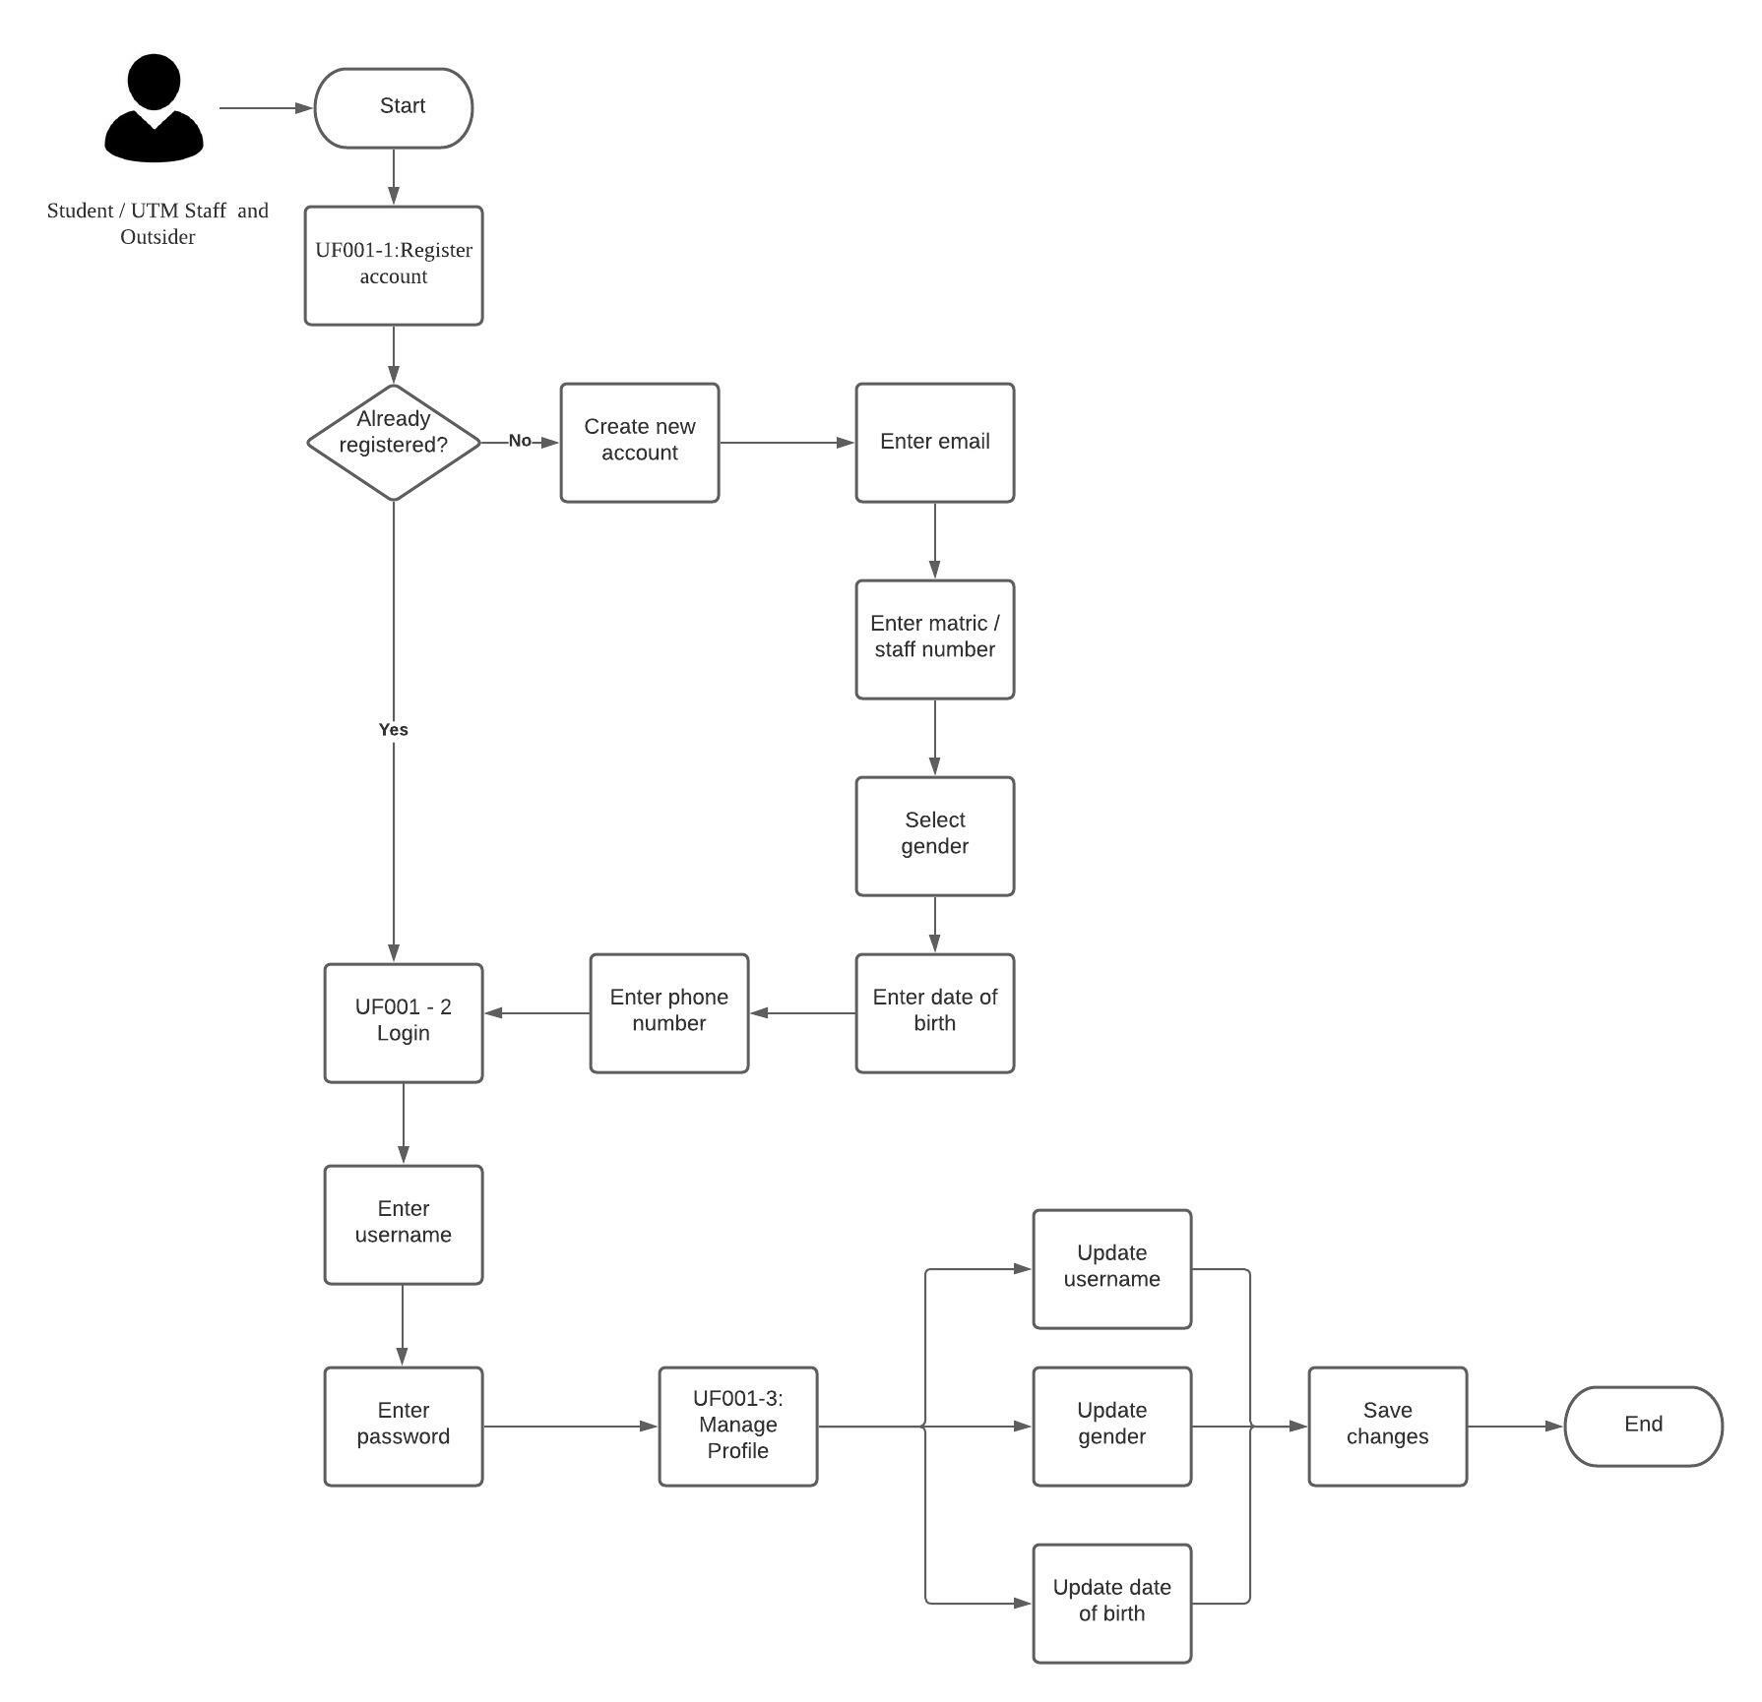
User Flow Diagram for Manage Account

1.2 UF002: Manage Booking User Flow Diagram
This is the flow diagram for Manage Booking. The type of users that will perform these activities are UTM students/staff and outsiders. The goal for this flow is to manage room booking including view available hall, book hall, make payment and cancel the booking.

Flow ID : UF002-1 |  | User Type: Student/Staff UTM and outsider
User stories reference | As a UTM resident or outsider, I want to view the list of available sports halls so that I can book a hall.
Goal | The user should be able to view the list of available halls to book.
Diagram Flow | 1.User able to click and check on the hall availability  2.User can choose the hall and time  3.User able to see the booking list

Flow ID : UF002-2 |  | User Type: Student/Staff UTM and outsider
User stories reference | As a UTM resident or outsider, I want to book a sports hall so that I do not have to go to the office to fill in the form manually
Goal | The user should be able to book a sports hall.
Diagram Flow | 1.User able to click on the book button  2.The pop-up booking box will appear in the application  3.User can click confirm button to confirm the booking

Flow ID : UF002-3 |  | User Type: Student/Staff UTM and outsider
User stories reference | As a UTM resident or outsider, I want to make a payment so that I do not have to make payment manually at the cash deposit machine
Goal | The user should be able to make payment for the hall booking.
Diagram Flow | 1.User upload the payment receipt  2.Click confirm button to proceed

Flow ID : UF002-4 |  | User Type: Student/Staff UTM and outsider
User stories reference | As a UTM resident or outsider, I want to cancel my booking in case I am not able to go
Goal | The user should be able to cancel their booking
Diagram Flow | 1.User able to click on cancel button for cancel the booking  2.Click on confirm button to cancel the booking

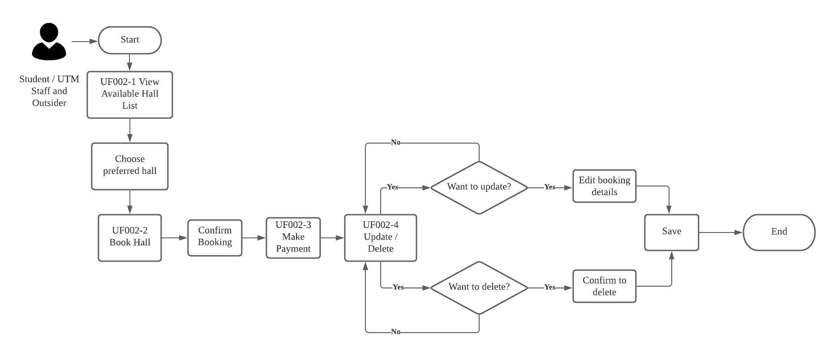
User Flow Diagram for Manage Booking

SECTION B:
Wireframes
- UF001: Manage Account
UF001 -1: Create Account
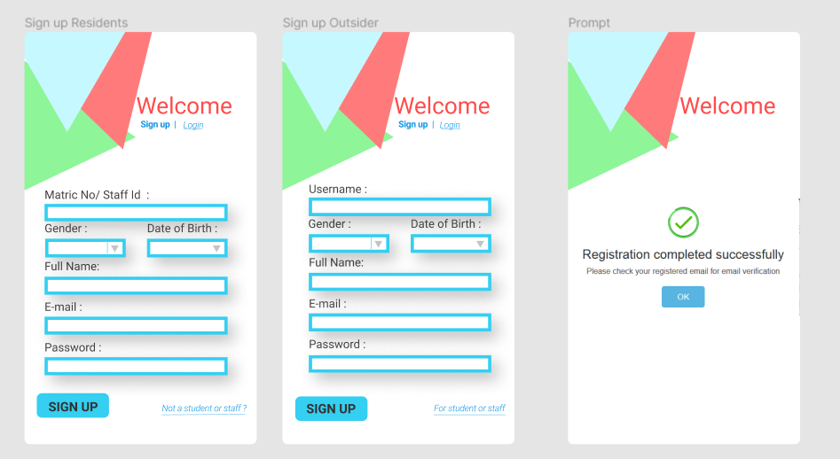
Create an account for two different types of user
UF002 - 2: Login Account
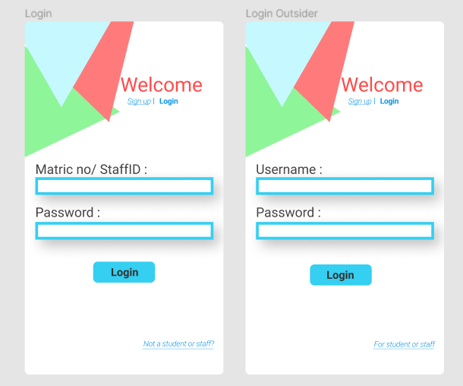
Login using different credentials for different types of user

UF003 - 3: View, Update, Delete Account
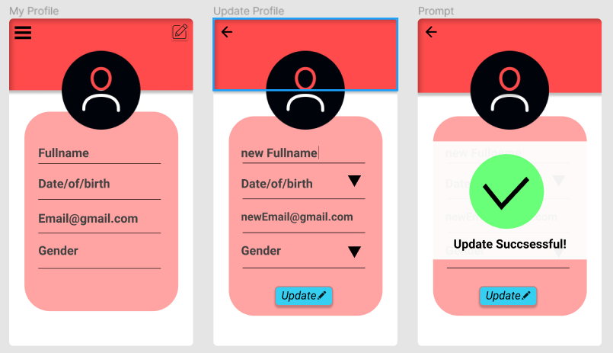
Viewing the user information and updating the process.
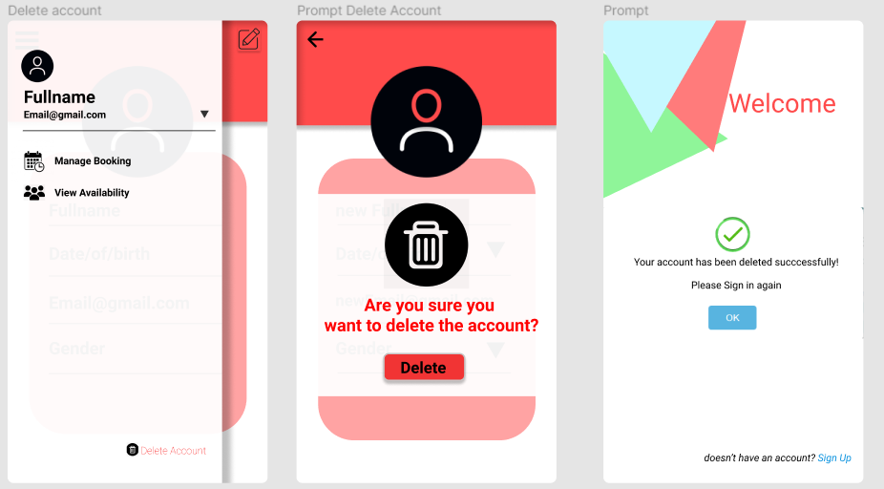
Deleting an accounting process.

- UF002: Manage Booking
UF002 - 1: View availability Sport Facilities
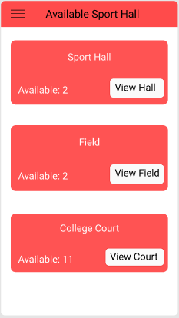
View available Sport Facilities
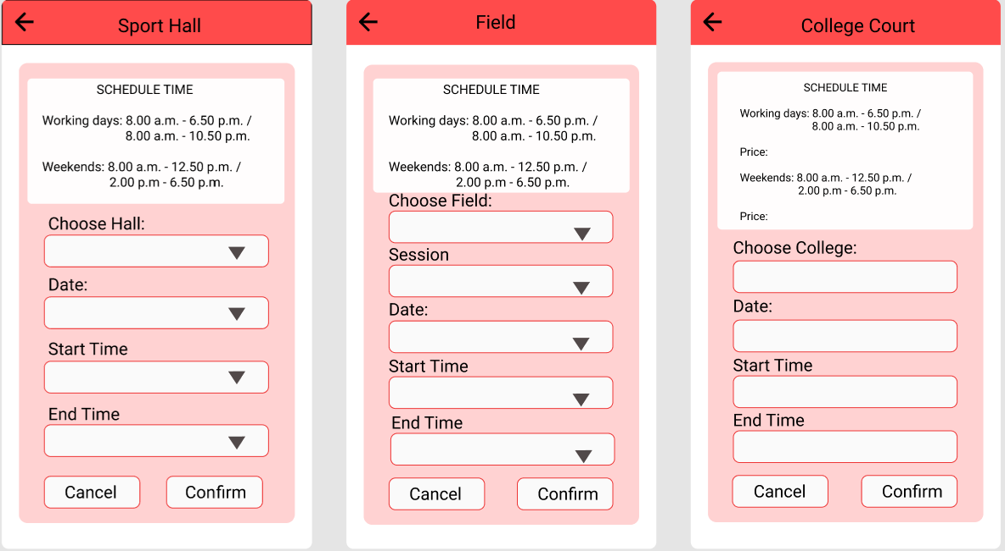
UF002 - 2: Book Sport Halls
Booking for UTM Residents
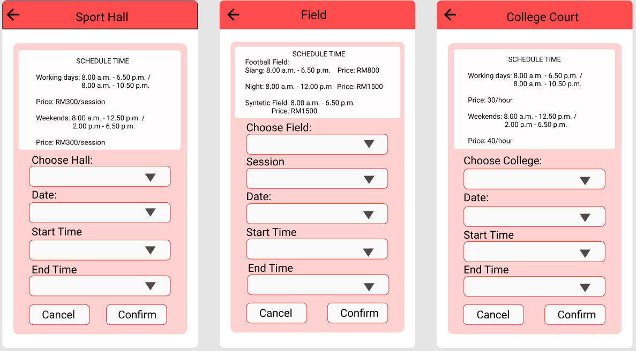
Booking for Outsider

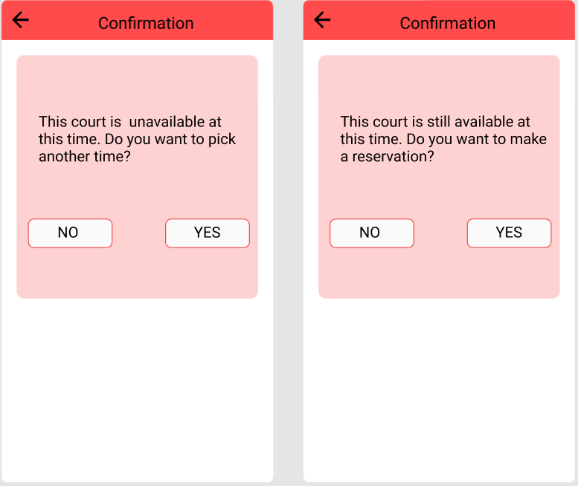
Interface for confirmation booking

UF002 - 3: Make Payment
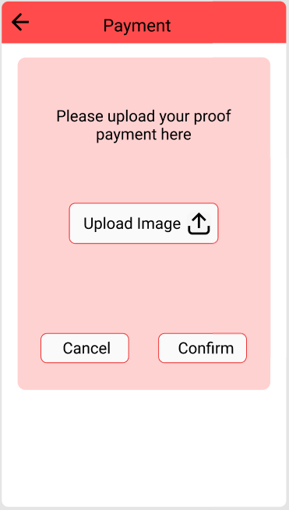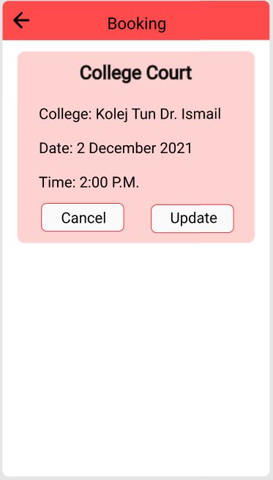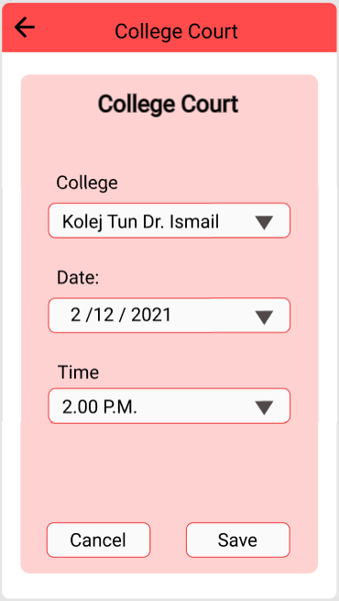
Payment for Outsider View Booking Record Update Booking

UF002 - 4: Cancel Booking

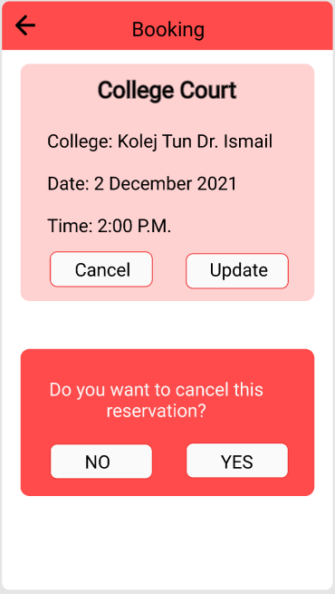
Cancel Booking

