

SECJ/SECV3104: Application Development
PROJECT PROPOSAL & PLANNING

Project Name: HELPSHI (Period Poverty Crowdfund System)
Sustainable Development Goal (SDG):
No. 1-No Poverty and No. 3-Good Health and Well-Being
Software House Name: GIT Group
School of Computing, Faculty of Engineering
Universiti Teknologi Malaysia

Development Team Members:
- Siti Fatimah Az Zahra Binti Mohd Nizam (Team Leader)
- Aqilah Hanim Binti Mohd Taufik (Scrum Master)
- Nur Hidayah Binti Hamri
- Nursyafiqah Binti Abdul Halim

Stakeholders:
Ms Siti Nurashikin (Project Leader of App Development Team)
The She Society (Non-Government Organisation)

INTRODUCTION
Period poverty is defined as the lack of access to sanitary products and it has been acknowledged as a global issue all around the world and Malaysia is not excluded from this. TLFP’s corporate engagement and procurement manager Dianne Too said, “From March last year, we were getting a lot of requests from B40 families for menstrual products” [1]. Period poverty causes school girls to miss school days, and even worse, it leads to health issues. “There are girls in rural areas who do not go to school because they are on their period. They do not have sanitary pads and thus the blood stains their uniforms. They cannot bear the shame, so they skip school” [2]. This information shows the need of a platform to tackle this issue. A non-government organisation (NGO) called The She Society has been actively tackling this issue. Hence, the approach to develop a crowdfunding system that mainly focuses on period poverty called ‘HELPSHI’ came to mind. Other than crowdfunding, this system will be able to provide a platform to reach the targeted community and raise the awareness of period poverty issues in Malaysia. The benefits include to provide a designated platform to tackle period poverty, to raise awareness on this issue in Malaysia, to reach the targeted community easily and to encourage the attitude of helping each other. Although social media has been a great alternative(competition) to achieve the same purposes, it has more cons than pros that will be discussed thoroughly in the next section.
As described earlier, the problems such as lack of awareness of period poverty and unavailability of proper platform to advocate and tackle on this issue have become the main reasons to develop this system. After thorough analysis, this project is believed to be feasible to be developed. The system will be developed as a web-based application and it is estimated to take 12 weeks to be completed starting from November 2021 until the third week of January 2022. The list of objectives of this project are as follows:
- To analyse the requirements from Ms Asyikin from The She Society as the product owner of HELPSHI
- To design the proposed HELPSHI application
- To implement and test HELPSHI application
  - Existing System
As mentioned in the introduction, the existing system is social media as the main platform. The She Society has multiple social media and they have been using these platforms to raise awareness of period poverty, and share the information of donation campaigns. Then donors who are interested in donating can perform the donation through online banking. Figure 1.1 shows the digital poster of the period poverty crowdfund campaign organised by The She Society with collaboration with other NGOs.

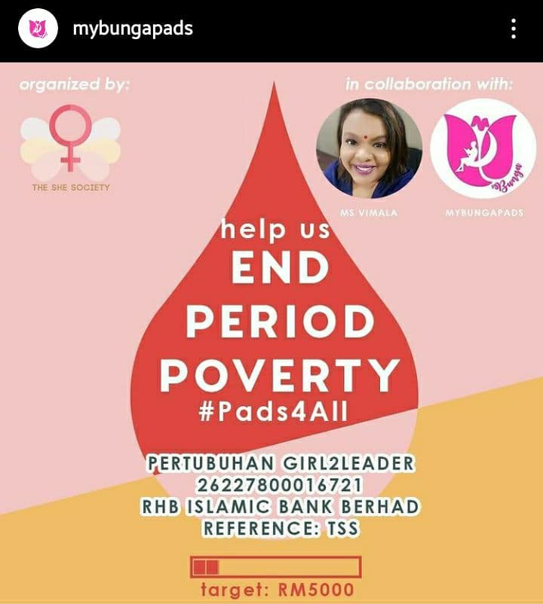
Figure 1.1: Existing system to share crowdfunding campaign

Social media is a great platform to connect with others but the efficiency is debatable especially when generating reports. The collected data from social media are prone to inconsistency making it difficult to generate reports. Although social media is amazing to grow networks, it is also widely used by scammers. This problem has caused the users (donors) to doubt the authenticity of the crowdfund campaign by the real organisation.

Link to The She Society Instagram Page :
https://instagram.com/theshesociety_?utm_medium=copy_link
Link to My Bunga Pads Instagram Page :
https://instagram.com/mybungapads?utm_medium=copy_link
1.2 Proposed System
The primary use case of the proposed system for this project is shown in Figure 1.2. 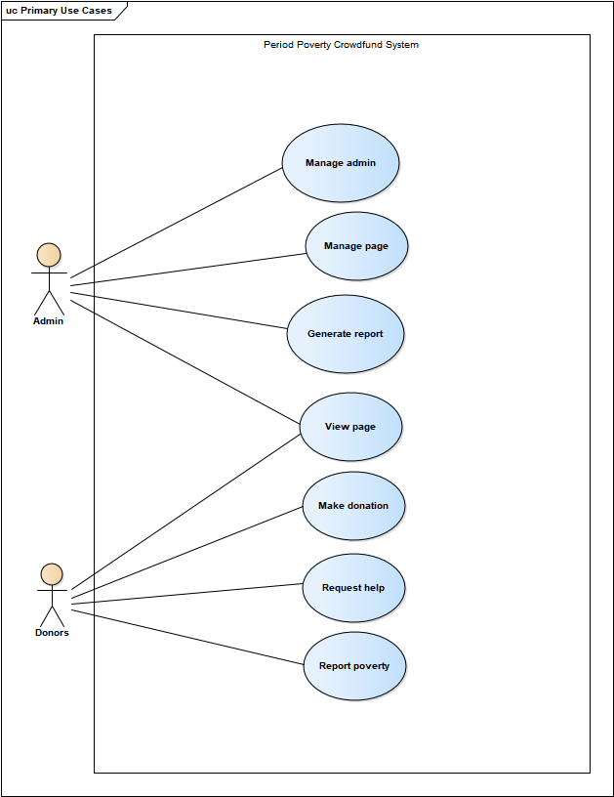
Figure 1.2: Use Case Diagram for HELPSHI System
As shown in Figure 1.2, the system consists of two types of users, the admins who manage the system and can access the database to generate necessary reports. Meanwhile, another type of user is called donors, who are eligible to some main features of the system such as to give donations, to view certain information, to request help and to report help. The functional requirements will be discussed thoroughly in section 1.3 and the non-functional requirements in section 1.4.

1.3 Functional Requirements
- Create account
The admin shall be able to create an account

- Login account
The admin shall be able to login to the account

- Update account
The admin shall be able to update information in the account

- Logout account
The admin shall be able to logout from the account

- Delete account
The admin shall be able to delete the account

- Update crowdfund page
The admin shall be able to update the information in the crowdfund page

- Create blog post
The admin shall be able to create new post in the blog

- Update blog post
The admin shall be able to update the post in the blog

- Delete blog post
The admin shall be able to delete the post in the blog

- Generate donation report
The admin shall be able to generate donation report

- Generate ‘Request Help’ report
The admin shall be able to generate ‘Request Help’ report

- Generate ‘Report Poverty’ report
The admin shall be able to to generate ‘Report Poverty’ report

- View crowdfund page
The visitor shall be able to view the crowdfund page

- View blog page
The visitor shall be able to view the blog page

- Fill in donation form
The donor shall be able to fill in the donation form

- Upload proof
The donor shall be able to upload the proof of donation

- Generate donation appreciation note
The donor shall be able to generate donation appreciation note once the donation is successful

- Report poverty
The donor shall be able to report a period poverty by providing required information in the form

- Request help
The public user shall be able to request help for sanitary products by providing required information in the form

1.4 Non-Functional Requirements

- Security: The system shall protect the user password against unauthorized access and shall not allow the admin to update and delete other account’s information.
- Accuracy: The system should display accurate reports to the user.
- Efficiency: The system should display the pages within milliseconds.
- Usability: The system shall be user-friendly and easy to use for admin and visitors.
- Availability: The admin shall be able to manage the crowdfund page and blog at any time during the day.

USER STORIES

  - Use Case UC001 <Manage admin>
This use case is to manage an admin account.
    - User Story US001
As a new admin, I want to be able to create a new admin account in the system so that I can access the database and other admin’s functionalities.

Acceptance Criteria
- Ability to create available usernames and valid passwords
- Ability to provide personal information such as name and email address
Acceptance Testing
- Username cannot be duplicated with usernames in existing database

    - User Story US002
As an admin, I want to be able to login to the system so that I can access the database and other admin’s functionalities

Acceptance Criteria
- Ability to provide correct username and password

Acceptance Testing
- Correct username and password must be available in the database

    - User Story US003
As an admin, I want to be able to update my personal information in the database

Acceptance Criteria
- Ability to login to the system
- Ability to provide personal information
Acceptance Testing
- Admin must have logged into the system
- Personal information cannot be left empty
- New information must be updated and saved in the database

    - User Story US004
As an admin, I want to be able to log out from the system

Acceptance Criteria
- Ability to login to the system
- Ability to exit from the system

Acceptance Testing
- Admin must have logged into the system before logging out
- After the log out is successful, admin shall not be able to access the system
- Admin must need to login again to access the system

    - User Story US005
As an admin, I want to be able to delete my account and remove my personal information from the database.

Acceptance Criteria
- Ability to login to the system
- Ability to delete account and remove the account’s personal information from the database

Acceptance Testing
- Admin must have logged into the system
- After the delete account is successful, the deleted username cannot be used to login to the system again
  - Use Case UC002 <Manage page>
This use case is to allow the admin to manage the information in the blog and crowdfund page.

    - User Story US006
As an admin, I want to be able to update the information in my crowdfund page

Acceptance Criteria
- Ability to login to the system
- Ability to update the information in crowdfund page

Acceptance Testing
- Admin must have logged into the system
- Admin need to click Edit button to update the crowdfund information
- New information must be updated and saved in the database
- After the admin updates the information in the page, the new information will be displayed in the page and can be viewed by other people

    - User Story US007
As an admin, I want to be able to create new post in the blog

Acceptance Criteria
- Ability to login to the system
- Ability to create the new post in the blog

Acceptance Testing
- Admin must have logged into the system
- Admin need to click New Post before be able to create new post
- Admin need to click Post button to be able to view the new post in the bog

    - User Story US008
As an admin, I want to be able to update the post in my blog

Acceptance Criteria
- Ability to login to the system
- Ability to update the information of the post in the blog

Acceptance Testing
- Admin must have logged into the system
- Admin need to click Edit button to update the posting in blog page
- After the admin updates the post in the blog, the new post will be displayed in the blog and can be viewed by other people

    - User Story US009
As an admin, I want to be able to delete my post at the blog page

Acceptance Criteria
- Ability to login to the system
- Ability to delete the post at blog page

Acceptance Testing
- Admin must have logged into the system
- After the delete post is successful, the deleted post will not be displayed on blog page
  - Use Case UC003 <Generate report>
This use case is to allow admin to generate reports from the database
    - User Story US010
As an admin, I want to generate the donation report so that I can view the total of donation that are donated by the donor
Acceptance Criteria
- Ability to show the current donation report
- Ability to display past donation report
- Ability to provide print / save / share

Acceptance Testing
- Admin able to print out the donation report for them to view the total donation that donated by donors

    - User Story US011
As an admin, I want to generate the ‘Report Poverty’ report so that I can monitor the which problem that need to be solved
Acceptance Criteria
- Ability to show the current ‘Report Poverty’ report
- Ability to display past ‘Report Poverty’ report
- Ability to provide print / save / share

Acceptance Testing
- Admin able to print out the report for them to solve the problem that stated

    - User Story US012
As an admin, I want to generate the ‘Request Help’ report so that I can monitor who is struggling with period poverty or face issue to access sanitary products
Acceptance Criteria
- Ability to show the current ‘Request Help’ report
- Ability to display past ‘Request Help’ report
- Ability to provide print / save / share

Acceptance Testing
- Admin able to print out the report for them to view the help requested from the users
  - Use Case UC004 <View Page>
This use case is to allow admin and donors to view crowdfund page and blog page to make sure all the information shared to the public is correct

    - User Story US013
As an admin, I want to be able to view the information in the crowdfund and blog page

Acceptance Criteria
- Ability to view the information in crowdfund page
- Ability to view the information in blog page

Acceptance Testing
- Admin will be able to view the crowdfund page.
- Admin will be able to view the blog page.

    - User Story US014
As a donor, I want to be able to view the crowdfund page and blog page to keep myself updated about the crowdfunding campaign.

Acceptance Criteria
- Ability to view the information in crowdfund page
- Ability to view the information in blog page

Acceptance Testing
- Donors will be able to view the crowdfund page.
- Donors will be able to view the blog page.

  - Use Case UC005 <Make Donation>
This use case is to allow donors to make the donation
    - User Story US015
As an donors, I want to fill my details before donating so that the organizer will know who is the donor
Acceptance Criteria
- Ability to provide all the required information to the system
  - Name
  - Phone Number
  - Email
  - Donation amount

Acceptance Testing
- The required information must be filled in and submitted
    - User Story US016
As a donor, I want to be able to upload my payment proof to the system so that the organizer will notice the transaction

Acceptance Criteria
- Ability to upload the payment proof

Acceptance Testing
- The required information must be filled in and submitted
  - Use Case UC006 <Request Help>
This use case is to allow donors to request help from the NGO
    - User Story US017
As the donor, I want to be able to ask help from the NGO if I struggle with period poverty or face issue to access sanitary products

Acceptance Criteria
- Ability to provide all the required information to the system
  - name
  - phone number
  - location
  - descriptions
Acceptance Testing
- The required information must be filled in and submitted

  - Use Case UC007 <Report Poverty>
This use case is to allow donors to report poverty to the NGO

    - User Story US018
As the donors, I want to be able to report poverty so this people who struggle with period poverty can be reached by the NGO

Acceptance Criteria
- Ability to provide all the required information to the system such as
  - name
  - phone number
  - location
  - descriptions

Acceptance Testing
- The required information must be filled in and submitted

PRODUCT BACKLOG

Explain briefly: refer to Agile Product Backlog reference. Estimation is by number of days. Assign each task ID to respective team members as listed in Table 3.1. Include the image from Jira as in Figure 3.1 after completing the task assignment to team members.

Table 3.1: Product backlog for XYZ
Task ID | User Story ID | Estimate (Day) | Priority | Team Member
HS-1 | US001 | 3 | 1 | Siti Fatimah
HS-2 | US002 | 3 | 2 | Aqilah Hanim
HS-3 | US003 | 3 | 3 | Nursyafiqah
HS-4 | US004 | 3 | 4 | Nur Hidayah
HS-5 | US005 | 3 | 5 | Siti Fatimah
HS-6 | US006 | 3 | 6 | Aqilah Hanim
HS-7 | US007 | 5 | 7 | Nursyafiqah
HS-8 | US008 | 5 | 8 | Nur Hidayah
HS-9 | US009 | 5 | 9 | Siti Fatimah
HS-10 | US010 | 5 | 10 | Aqilah Hanim
HS-11 | US011 | 5 | 11 | Nursyafiqah
HS-12 | US012 | 5 | 12 | Nur Hidayah
HS-13 | US013 | 4 | 18 | Siti Fatimah
HS-14 | US014 | 4 | 19 | Aqilah Hanim
HS-15 | US015 | 4 | 13 | Nursyafiqah
HS-16 | US016 | 3 | 14 | Nur Hidayah
HS-17 | US017 | 3 | 15 | Siti Fatimah
HS-18 | US018 | 3 | 16 | Aqilah Hanim
HS-19 | US019 | 3 | 17 | Nursyafiqah

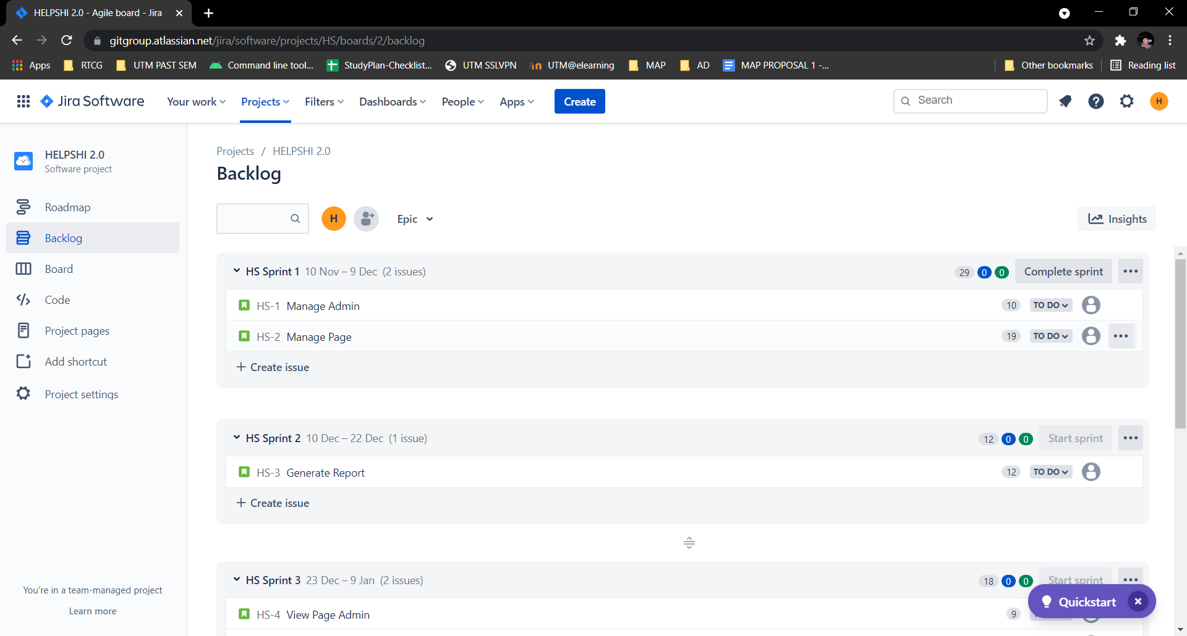Figure 3.1: Backlog for Sprint 1 and 2

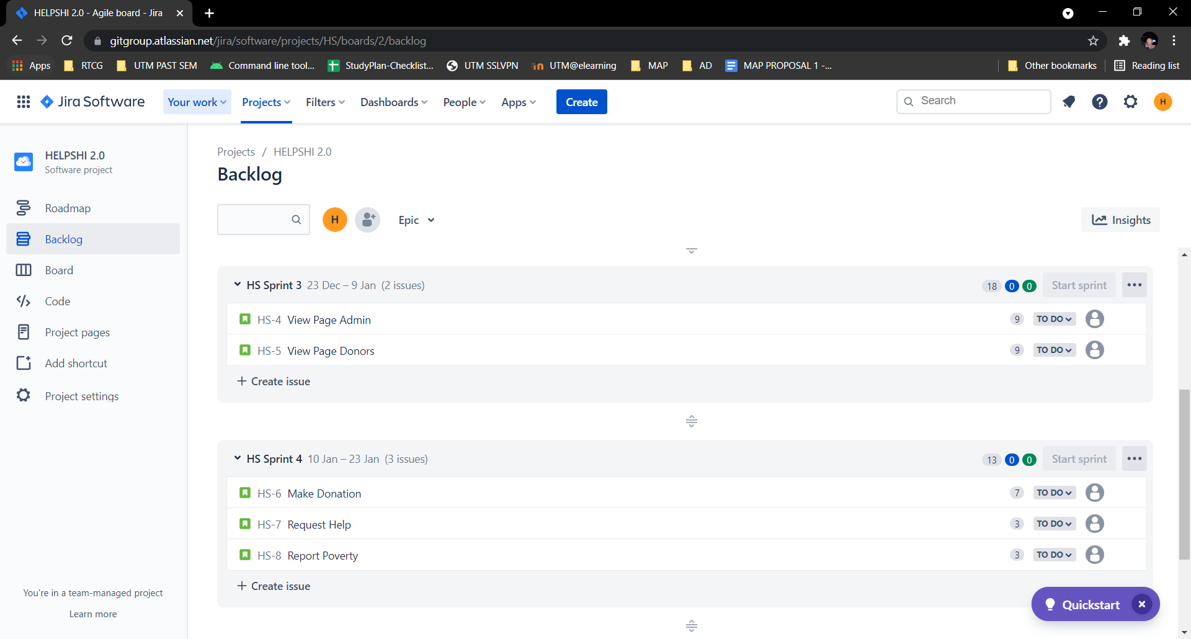
Figure 3.2: Backlog for Sprint 3 and 4

SPRINT

The first sprint consists of features to manage the admin account. This includes features such as create account, log in, update account, log out and delete account. Admin plays an important role in this system because it allows access to the database and this is why it is prioritised in this application development.

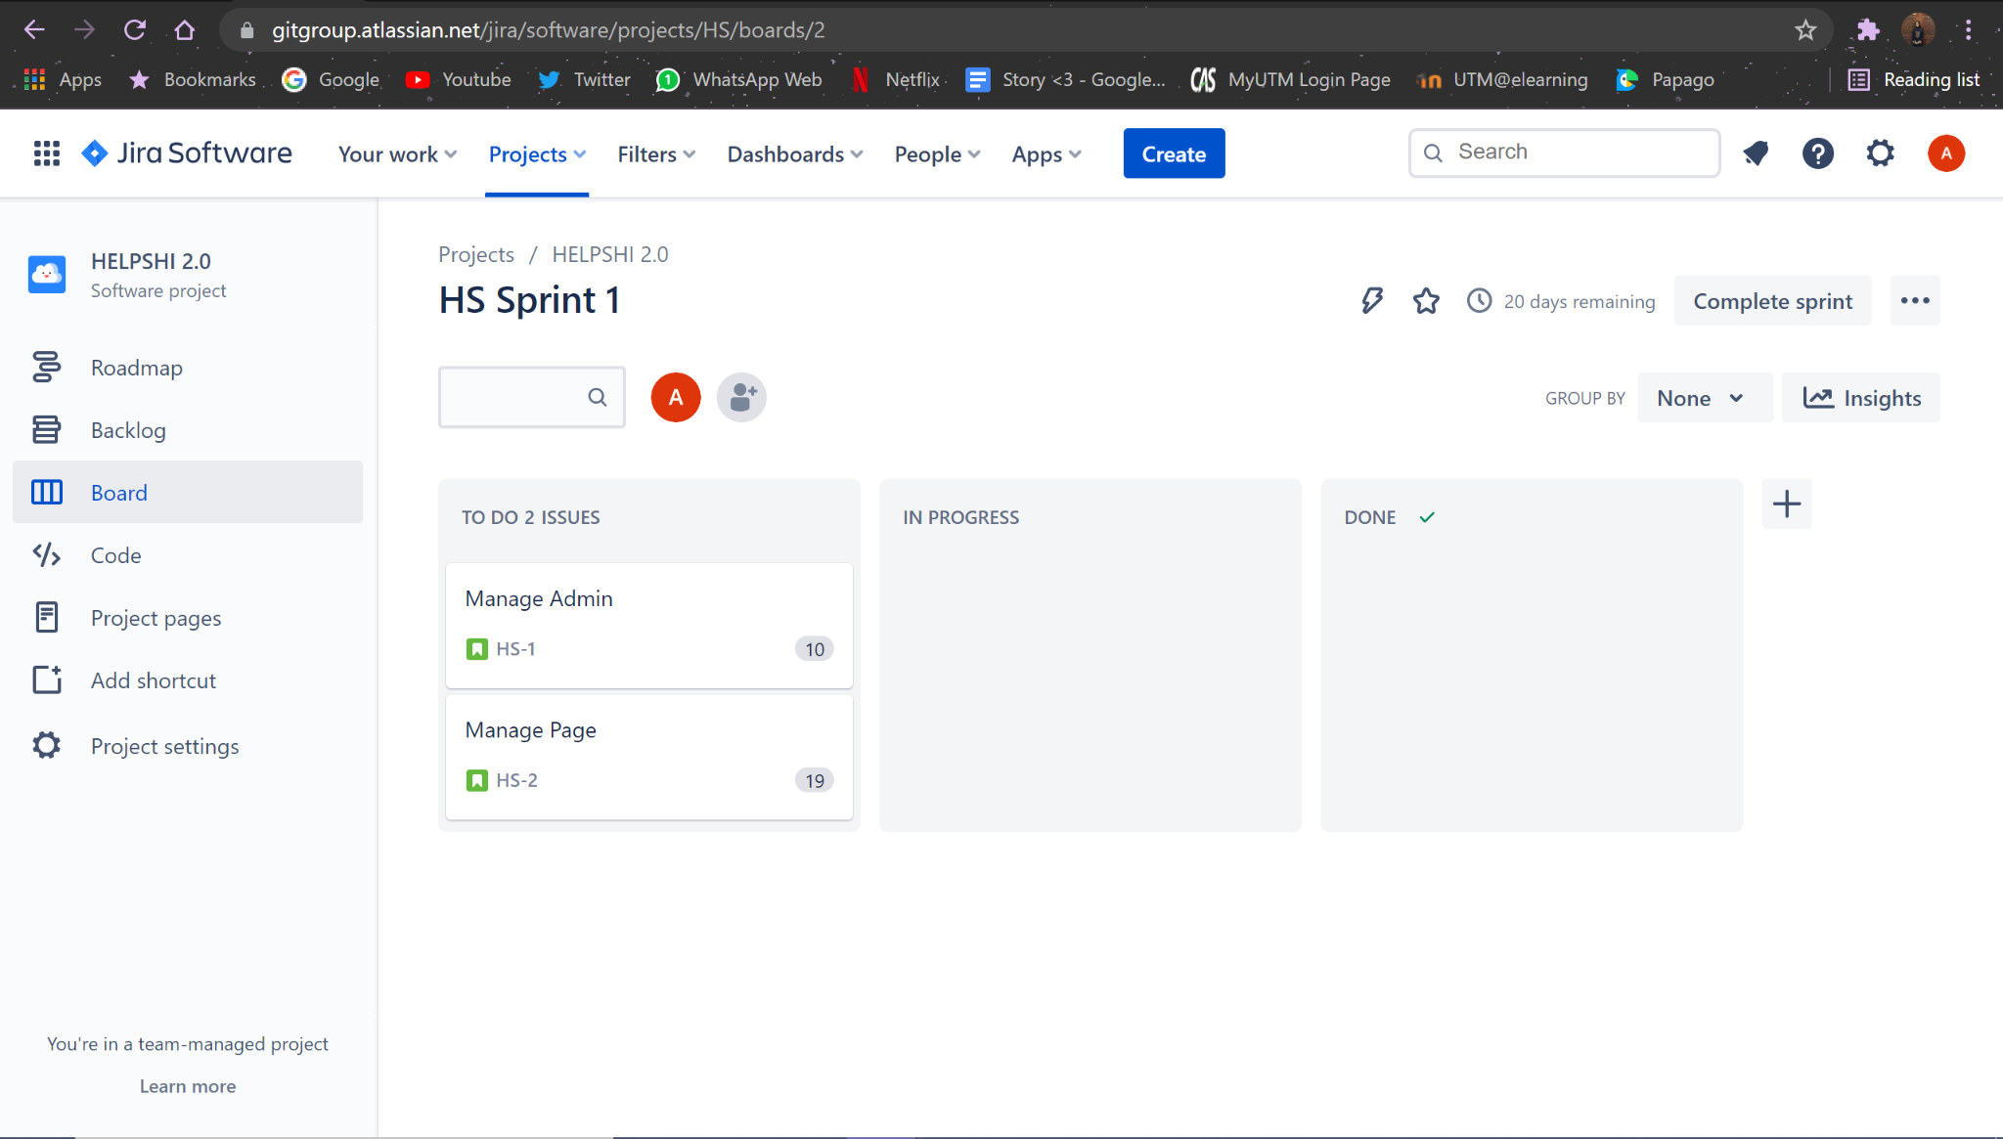
Figure 4.1: Sprint 1 for HELPSHI

The second sprint focuses on handling the crowdfund page and blog page that includes features like create, update, and delete. This sprint also starts the development of features accessible for the second type of user such as view crowdfund page and view blog page. The third sprint primarily works on the second type of user. This sprint focuses on handling the donation or crowdfund process such as filling in forms, submitting donation proof and generating thank you notes for donating. This sprint also works on report poverty and request help features. Lastly, the forth sprint consists of features to generate reports from the system including generate donation report, generate ‘Report Poverty’ report and generate ‘Request Help’ report.

REFERENCES

[1] S. INDRAMALAR, "What is period poverty and why we must end it", The Star, p. 1, 2021.
[2] FAYE KWAN, “The painful reality of period poverty in Malaysia”, Free Malaysia Today, 2020.

