

SECJ/SECV3104: Application Development

SYSTEM DOCUMENTATION


Project Name & Acronym:
HELPSHI (Period Poverty Crowdfund System)
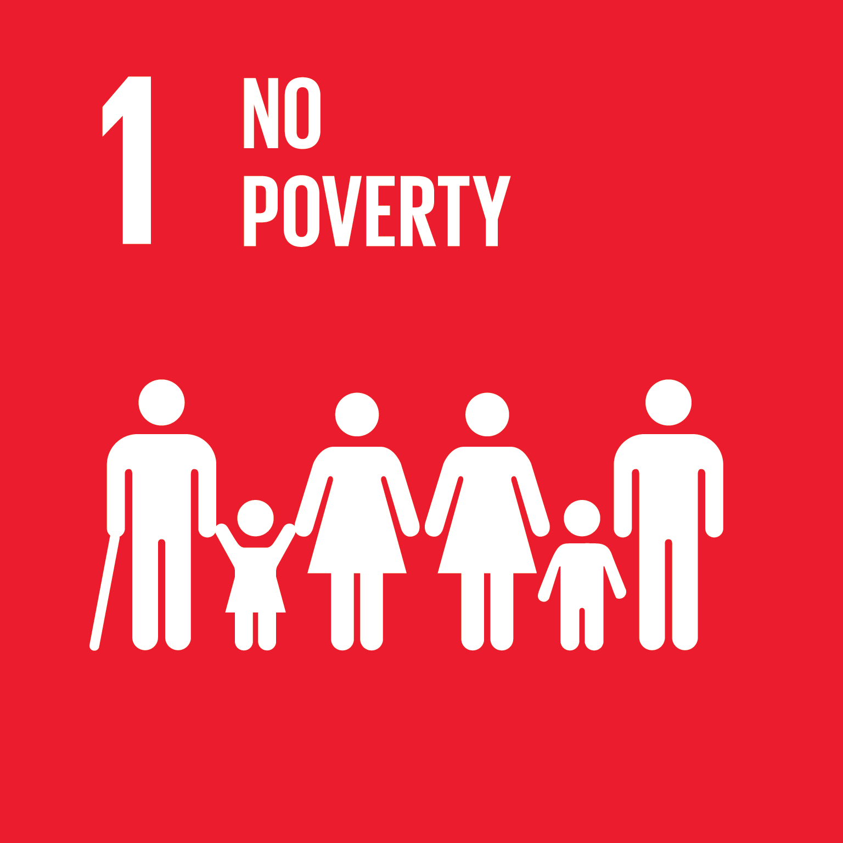
Software House: GIT Group
School of Computing, Faculty of Engineering
Universiti Teknologi Malaysia

Stakeholders:
Ms Siti Nurashikin (Project Leader of App Development Team)
The She Society (Non-Government Organisation)

TABLE OF CONTENTS

1 Introduction 2
1.1 Document Overview 2
1.2 Scope 2
1.3 Abbreviations and Glossary 4
1.4 References 5
2 Project Management 6
2.1 Team/Human Resources 6
2.2 Responsibilities 6
2.3 Customer-User Involvement 7
2.4 Tasks, Planning, and Milestones 7
2.5 Development Environment 9
2.6 Other Resources 9
2.7 Software Life Cycle Model 9
2.8 Reviews 10
2.9 Software Configuration Management 11
2.10 Documentation Management 11
2.11 Verification 12
3 Specifications 13
3.1 System Features 13
3.2 Performance 21
3.3 Other Features 21
3.4 User Interface Layout 22
3.5 System Environment 37
3.6 External Interfaces 37
3.7 Resources 37
3.8 Internal Data 38
3.9 Adaptation 38
3.10 Verification 38
3.11 Personnel and Training 38
3.12 Packaging and Installation 38
4 Architecture 39
4.1 Architecture Overview 39
5 Verification 42
5.1 Test Plan 42
5.2 Tests Description and Test Results 43
6 Requirements Traceability 52

Introduction
System Documentation (SD) comprises six sections. The first section is the introduction that describes the brief idea of the project including the project scope, the purposes, and the objectives. Next, the project management section describes the organisation structure of the HELPSHI project. This section consists of the details of the information of the team members and their roles, project planning, and project reviews. The third section is where the Software Requirement Specification (SRS) documentation is documented purposely to specify the requirements for the system. It explains in detail the purpose and features of the system, the design of interfaces for this system, definitions for the functional and non-functional specifications of the system, behaviour of the system, design constraints or the limitations of the environment to meet each requirement.
This information is collected by interviewing one of the stakeholders of the system and this technique is the most common technique for gathering requirements. The fourth section describes the architecture overview of the system or where the Software Design Document (SDD) is documented. This section includes the general descriptions of the system, the logical architecture, and the physical architecture. Next section involves the documentation of items that should be developed before or during the testing of a system or also known as Software Testing Documentation (STD).
Documentation for software testing helps in estimating the testing effort required, test coverage, requirement tracking, and more. In general, it helps to reduce cost and time in system development. In this testing documentation, it shows the result of the software testing of the system, hence, we can figure out the weakness and improve it. The last section is the requirements traceability and its purpose is to validate that all requirements are fulfilled via test cases such that no functionality is not fulfilled.

Document Overview
This document contains the organization, the specifications, the architecture, and verification or testing of HELPSHI software development projects.

Scope

Identification
This document applies to the Web application developed in the HELPSHI project.

Overview
Period poverty is defined as the lack of access to sanitary products and it has been acknowledged as a global issue all around the world and Malaysia is not excluded from this. TLFP’s corporate engagement and procurement manager Dianne Too said, “From March last year, we were getting a lot of requests from B40 families for menstrual products” [1]. Period poverty causes school girls to miss school days, and even worse, it leads to health issues. “There are girls in rural areas who do not go to school because they are on their period. They do not have sanitary pads and thus the blood stains their uniforms. They cannot bear the shame, so they skip school” [2]. This information shows the need of a platform to tackle this issue.
A non-government organisation (NGO) called The She Society has been actively tackling this issue. Hence, the approach to develop a crowdfunding system that mainly focuses on period poverty called ‘HELPSHI’ came to mind. Other than crowdfunding, this system will be able to provide a platform to reach the targeted community and raise the awareness of period poverty issues in Malaysia. The benefits include to provide a designated platform to tackle period poverty, to raise awareness on this issue in Malaysia, to reach the targeted community easily and to encourage the attitude of helping each other. Although social media has been a great alternative(competition) to achieve the same purposes, it has more cons than pros that will be discussed thoroughly in the next section.
As described earlier, the problems such as lack of awareness of period poverty and unavailability of proper platform to advocate and tackle on this issue have become the main reasons to develop this system. After thorough analysis, this project is believed to be feasible to be developed. The system will be developed as a web-based application and it is estimated to take 12 weeks to be completed starting from November 2021 until the third week of January 2022. The list of objectives of this project are as follows:

- To analyse the requirements from Ms Asyikin from The She Society as the product owner of HELPSHI
- To design the proposed HELPSHI application
- To implement and test HELPSHI application

Abbreviations and Glossary

Abbreviations
No. | Terms/Acronyms/Abbreviation | Definitions
1 | HELPSHI | An acronym for period poverty crowdfund system, HELP comes from the word “help”and SHI comes from the word “she”
2 | TSS | The She Society
3 | SDG | Sustainable Development Goals
4 | HSS | HELPSHI System
5 | SD | System documentation
6 | SRS | Software Requirement Specification
7 | SDD | Software Design Document
8 | STD | Software Testing Documentation
9 | UC | Use Case
10 | US | User story
11 | UML | Unified Modelling Language

Glossary

No | Word | Definition
1 | Domain model | Domain model is a conceptual model to describe and model real world entities and the relationships between them. Domain class objects reflect business concern, policies, and constraints
2 | Sprint | A sprint is a short time-boxed period when a scrum team works to complete a set amount of work
3 | Use Case | The purpose of a use case diagram is to capture the dynamic aspect of a system.
4 | User story | To capture a description of a software feature from a user's perspective
5 | Unified Modelling Language | A standardized modelling language consisting of an integrated set of diagrams

References

Project references

# | Document Identifier | Document Title
[R1] | [1] | S. INDRAMALAR, "What is period poverty and why we must end it", The Star, p. 1, 2021.
[R2] | [2] | FAYE KWAN, “The painful reality of period poverty in Malaysia”, Free Malaysia Today, 2020.

Standard and regulatory references

# | Document Identifier | Document Title

Other references

# | URL | Title
[OTH1] | https://instagram.com/theshesociety_?utm_medium=copy_link | The She Society’s instagram page
[OTH2] | https://instagram.com/mybungapads?utm_medium=copy_link | My Bunga Pads’ instagram page

Project Management
The section describes the organizational structure of the HELPSHI project.

Team/Human Resources
The team is described in the diagram below.

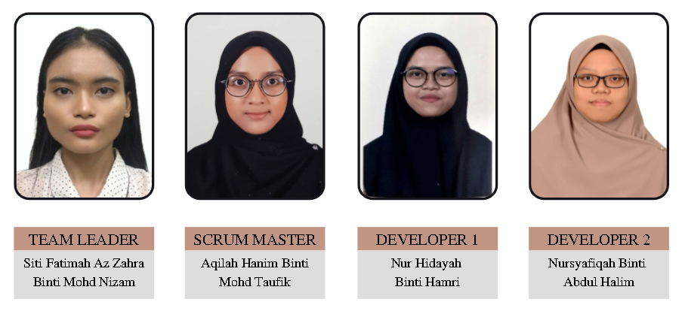

Responsibilities
The team of the project has the following responsibilities :

- Team Leader : Siti Fatimah - US001 : Create Account
- US005 : Delete Account
- US013 : View Page (Donors)
- US014 : View Page (Admin)
- US017 : Fill in Contact Form
- US006 : Update Crowdfund Page

- Scrum Master : Aqilah Hanim - US002 : Login Account
- US009 : Delete Blog Post
- US018 : View Annual Summary of Donation
- US011 : View List of Donation
- US022 : View Blog Post List

- Developer 1 : Nur Hidayah - US004 : Logout Account
- US008 : Update Blog Post
- US016 : Payment Gateway
- US012 : View List of Contact
- US019 : Generate Contact Report
- US020 : View Total Number of Donors
- Developer 2 : Nursyafiqah - US003 : Update Account
- US007 : Create Blog Post
- US015 : Fill in Donation Form
- US010 : Generate Donation Report
- US021 : View Total Donation Amount

Customer-User Involvement

The stakeholders of HELPSHI have attended the initial meeting where the GIT Group proposed the idea of the HELPSHI system. The stakeholders consisted of the founder and also the developers from The She Society. They were happy with the team’s presentation and even gave opinions on how to improve the system and make it look more attractive. They were happy with the team’s initial proposal.

Tasks, Planning, and Milestones

SPRINT | TASK ID | USER STORY ID | USER STORY | ESTIMATE  (DAY) | PRIORITY
Sprint 1 | HSS -1 | US001 | Create Account | 7 | 1
Sprint 1 | HSS -2 | US002 | Login Account | 7 | 2
Sprint 1 | HSS -3 | US003 | Update Account | 7 | 3
Sprint 1 | HSS -4 | US004 | Logout Account | 5 | 4
Sprint 1 | HSS -5 | US005 | Delete Account | 5 | 5
Sprint 2 | HSS -7 | US007 | Create Blog Post | 7 | 6
Sprint 2 | HSS -8 | US008 | Update Blog Post | 7 | 7
Sprint 2 | HSS -9 | US009 | Delete Blog Post | 3 | 8
Sprint 2 | HSS-022 | US022 | View Blog Post List | 3 | 9
Sprint 2 | HSS -13 | US013 | View Page (Donors) | 3 | 10
Sprint 2 | HSS -14 | US014 | View Page (Admins) | 3 | 11
MID SEMESTER BREAK (05/12/2021 - 12/12/2021)
Sprint 3 | HSS -15 | US015 | Fill in Donation Form | 7 | 12
Sprint 3 | HSS -16 | US016 | Payment Gateway | 7 | 13
Sprint 3 | HSS -17 | US017 | Fill in Contact Form | 7 | 14
Sprint 3 | HSS -18 | US018 | View Annual Summary of Donation | 7 | 15
Sprint 3 | HSS -19 | US019 | Generate Contact Report | 7 | 16
Sprint 4 | HSS -6 | US006 | Update Crowdfund Page | 7 | 17
Sprint 4 | HSS -10 | US010 | Generate Donation Report | 7 | 18
Sprint 4 | HSS -11 | US011 | View List of Donation | 7 | 19
Sprint 4 | HSS -12 | US012 | View List of Contact | 7 | 20
Sprint 4 | HSS -20 | US020 | View Total Number of Donors | 7 | 21
Sprint 4 | HSS -21 | US021 | View Total Donation Amount | 7 | 22

SPRINT 1
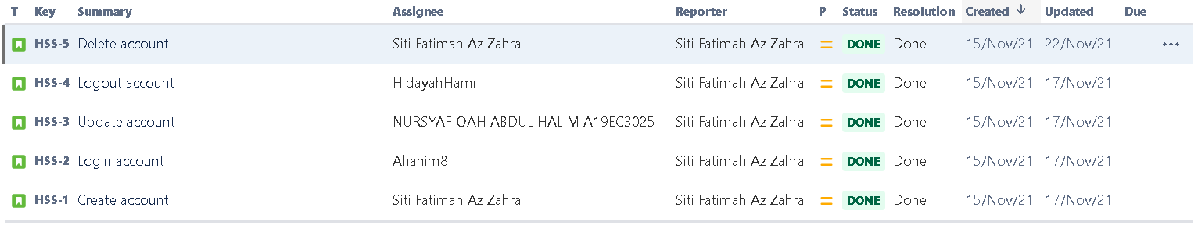
In Sprint 1, the team managed to complete four out of five tasks before the due date. Only one issue, ‘Delete Account’, was completed a day after the due date. All the team members had to create a table in their database named ‘Admin’.

SPRINT 2
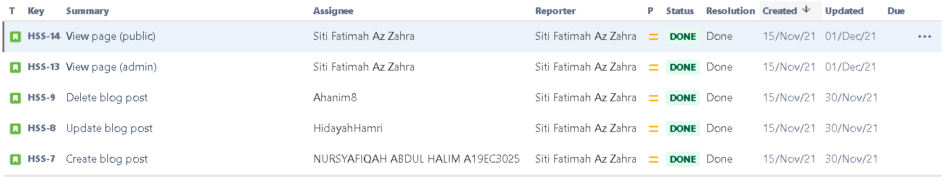
In Sprint 2, all 5 of the tasks were completed on time, before the due date. All the team members had to create another table in their database named ‘Blog’.

SPRINT 3
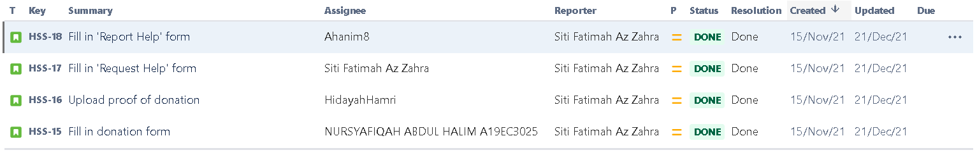
In Sprint 3, all of the tasks were completed on time, before the due date. All the team members had to create tables in their database named ‘ReportHelp’ and ‘RequestHelp’.

SPRINT 4
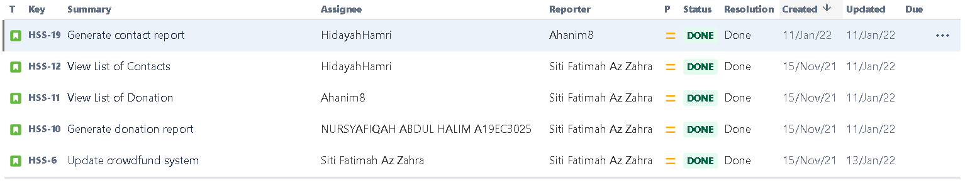
In Sprint 4, all 5 of the tasks were completed on time, before the due date. In fact, there were additional tasks. The team members had to combine tables ‘RequestHelp’ and ‘ReportHelp’. The new table was called ‘Contact’. The system was then successfully deployed with the help of infinityfreeapp.com.

Development Environment

TEAM MEMBER | HARDWARE | SOFTWARE
Siti Fatimah | HP 14-AC160TU  ASUS ROG ZEPHYRUS G14 GA401Q | - VISUAL STUDIO CODE  - ATOM  - HTML  - CSS  - JS  - XAMPP  - PHP  - MYSQL  - JIRA SOFTWARE
Aqilah Hanim | HP 15-AU090TX
Nur Hidayah | ACER NITRO 5 AN515-43-R9B3
Nursyafiqah | HP LAPTOP 14S-DQ2515TU

Other Resources

There is no particular resource needed for the project. Hence, no specific resources are needed for the project.

Software Life Cycle Model

For this project, HELPSHI Web Application uses an Agile Methodology to finish the project. This project uses Agile methodology because it has flexible time and also can reduce the risk. Based on our project we did the task by following the sprint that was already set by the Scrum Master.
Even though using this method has a short time period, the team can always improve the web application every week before the day of the presentation. Besides, for this project to have many tasks before getting the final result, the Scrum Master will prioritize the most important task for each use case and split it into the sprint. Also for each task, the Scrum Master will estimate the time for each task.
Based on the figure below, the Agile methodology always repeats the process if there is something to change against the project and in each sprint there will be tests and reviews that will be done before being presented to the stakeholders. After finishing all the sprint and no changes are being made, this web application will be launched to all users.
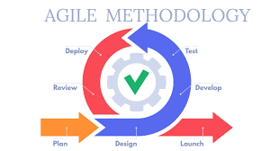
Figure 1 : Agile Methodology

Reviews
Launch Review
This launch review will be focused on the proposal for the web application which needs to identify the source problem, feasibility study and objective of the project. After identifying all the problems and organizing it in a proposal in week 2. Next we need to focus on building the four sprints which in each sprint has some tasks that have been divided according to priority and based on the Agile application development. In this project, our team already divide into four sprints, which Sprint 1 and Sprint 2 have five tasks whie Sprint 3 and Sprint 4 have four tasks that are already assigned to each member of the team. Before proceeding to develop this web application, our team already prepared to propose this idea to the stakeholders on week 3 and they also approved the idea of the proposal. The stakeholders also give an idea and add some requirements for this project to make our web application more usable and user friendly. Lastly, after the proposal gets approved by stakeholder and lecturer, our team starts to make a project plan to develop this web application that is called HELPSHI.
Design Review
For the design review, it is more to the Scrum daily meeting and Sprint review meeting that always focused on the design. This design review will be conducted for 8 weeks before the final product. Our leader will ask us to hold a scrum daily meeting every week or certain days to ensure that each member can do their job well. For scrum daily meetings, the Scrum master will begin dividing the tasks to be performed according to a sprint which has 4 sprints. In these meetings also, the leader will begin to discuss what kind of GUI will be done because for each interface it is necessary to ensure similarity in terms of arrangement, form, buttons and also the fonts that are used in web applications.Next for the Sprint review meeting, each member needs to present their work in front of all members and discuss tasks that have been completed by team members. This meeting will be focusing on checking if all members follow what was planned and follow the similarity for each GUI and need to be done in the second week of the sprint.

Test Review
In this part review also includes the Sprint review meeting in which each member shows and tests the web application in front of other members on the second week of the Sprint . The leader will give comments on existing web applications of each member and what needs to be fixed for the next sprint review meeting. This test review will already be done on week 5, week 7 and will be presented in sprint 3 on week 10 and sprint 4 on week 12.

Final Review
Finally for the final review, this web application will be tested in front of all members, stakeholders and also the end users. In the last test will be displayed and the stakeholder and user will inform whether this project is successful and according to the criteria and requirements set or not. This final review will be done on week 15 which is on showcase day to see the final product of the web application.

Software Configuration Management
The tools that our team used for completing the project is only the laptop for the hardware and mostly use the software while producing this web application. For the software, our team used Visual Studio code software to apply PHP, CSS, and also HTML to make a web Application and PHPMyadmin to save the database of our web application. Besides, the Jiraa software that our team uses is to make this process more organized and always finish on time according to priority.

Documentation Management
For the documentation to keep the progress of all activities and tasks, our teams have used project proposals to save all the source problem, feasibility study and also the objective of the project. By using the Jira tool it can also always update all the tasks that have already been made. Besides that, to always update the code for each of our team and need to compile the code, our team uses google drive to always update the report, slide and also the code so that each member has the same data. All documents and data have been stored in google drive to make it easier for all members to access the data and have the same data system. For code storage, it needs to be stored in an Xampp file to facilitate file opening using localhost because our team uses Xampp for the cross-platform web. Otherwise, all files will not be readable if not saved in that file. Approval for each issue as a whole will be approved by the team leader and also the lecturer, who will evaluate the web application during the sprint review meeting.

Verification
The verification will be managed by meetings that have been done every week which by scrum daily meeting and it will be verified by the team leader. All the documentation will be updated every week according to each issue that has been made. Testing is also done every week to ensure that all buttons and systems run smoothly so that we can continue to the next sprint. For the UAT, it will be done in the final week which is week 15. At that time, all issues must function properly according to the criteria and requirements that have been set

Specifications
This section covers the documentation of Software Requirement Specification (SRS) and it consists of 12 subsections. The subsections are system features, performance, other features, user interface layouts, system environment, external interfaces, resources, internal data, adaptation, verification, personnel and training, and lastly packaging and installation.

System Features

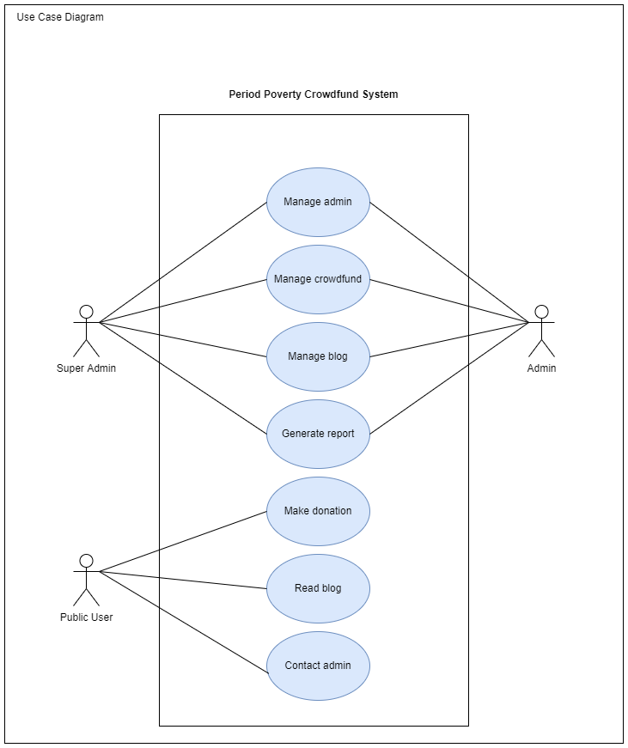
Figure 2 : Use Case Diagram of HELPSHI

As shown in Figure 2, the system consists of two types of users, the admins who manage the system and can access the database to generate necessary reports. Meanwhile, another type of user is called donors, who are eligible to some main features of the system such as to give donations, to view certain information, to request help and to report help. The functional requirements and the non-functional requirements will be discussed thoroughly in the next subsections.

    - Use Case UC001 <Manage admin>
This use case is to manage an admin account.

      - User Story US001
As an admin, I want to be able to create a new admin account in the system so that I can access the database and other admin’s functionalities.

Acceptance Criteria
- Ability to create available usernames and valid passwords
- Ability to provide personal information such as name and email address
Acceptance Testing
- Username cannot be duplicated with usernames in existing databases.

      - User Story US002
As an admin, I want to be able to login to the system so that I can access the database and other admin’s functionalities.

Acceptance Criteria
- Ability to provide correct username and password
Acceptance Testing
- Correct username and password must be available in the database

      - User Story US003
As an admin, I want to be able to update my personal information in the database.

Acceptance Criteria
- Ability to login to the system
- Ability to provide personal information

Acceptance Testing
- Admin must have logged into the system
- Personal information cannot be left empty
- New information must be updated and saved in the database

      - User Story US004
As an admin, I want to be able to log out from the system.

Acceptance Criteria
- Ability to login to the system
- Ability to exit from the system
Acceptance Testing
- Admin must have logged into the system before logging out
- After the log out is successful, admin shall not be able to access the system
- Admin must need to login again to access the system

      - User Story US005
As an admin, I want to be able to delete my account and remove my personal information from the database.

Acceptance Criteria
- Ability to login to the system
- Ability to delete account and remove the account’s personal information from the database
Acceptance Testing
- Admin must have logged into the system
- After the delete account is successful, the deleted username cannot be used to login to the system again

    - Use Case UC002 <Manage Crowdfund>
This use case is to allow the admin to manage the information in the crowdfund page.

      - User Story US006
As an admin, I want to be able to manage payment gateway.

Acceptance Criteria
- Ability to login to the system
- Ability to access the information in crowdfund page
Acceptance Testing
- Admin must have logged into the system
- Admin need to click Manage Payment Gateway button to access the crowdfund information
- Admin need to log into the payment gateway account

      - User Story US018
As an admin, I want to be able to view annual summary of the donation

Acceptance Criteria
- Ability to login to the system
- Ability to click Manage Crowdfund button
Acceptance Testing
- Admin is able to view the annual summary of the donations made

      - User Story US020
As an admin, I want be able to view total donors

Acceptance Criteria
- Ability to login to the system
- Ability to click Manage Crowdfund button
Acceptance Testing
- Admin must have logged into the system
- Admin need to click Manage Crowdfund before being able to view the total number of donors

      - User Story US021
As an admin, I want be able to view total donation

Acceptance Criteria
- Ability to login to the system
- Ability to click Manage Crowdfund button
Acceptance Testing
- Admin must have logged into the system
- Admin need to click Manage Crowdfund before being able to view the total amount of donation

    - Use Case UC003 <Manage Blog>
This use case is to allow admin to manage the blog posts in the system

      - User Story US007
As an admin, I want to be able to create new posts in the blog.

Acceptance Criteria
- Ability to login to the system
- Ability to create the new post in the blog
Acceptance Testing
- Admin must have logged into the system
- Admin need to click New Post before be able to create new post
- Admin need to click Post button to be able to view the new post in the blog

      - User Story US008
As an admin, I want to be able to update the post in my blog.

Acceptance Criteria
- Ability to login to the system
- Ability to update the information of the post in the blog
Acceptance Testing
- Admin must have logged into the system
- Admin need to click Edit button to update the posting in blog page
- After the admin updates the post in the blog, the new post will be displayed in the blog and can be viewed by other people

      - User Story US009
As an admin, I want to be able to delete my post at the blog page.

Acceptance Criteria
- Ability to login to the system
- Ability to delete the post at blog page
Acceptance Testing
- Admin must have logged into the system
- After the delete post is successful, the deleted post will not be displayed on blog page

      - User Story US013
As an admin, I want to be able to view blog pages.

Acceptance Criteria
- Ability to view the information in blog page
Acceptance Testing
- Admin will be able to view the blog page.

      - User Story US022
As an admin, I want to be able to view blog post list

Acceptance Criteria
- Ability to login to the system
- Ability to click Manage Blog button

Acceptance Testing
- Admin able to view the blog posts that are on the public view

    - Use Case UC004 <Generate Report>
This use case is to allow admins to generate the reports of ‘List of Donation’ and also ‘List of Contacts’. Admins could also view both these lists.

      - User Story US010
As an admin, I want to generate the donation report so that I can view the total of donations that are donated by the donor .

Acceptance Criteria
- Ability to login to the system
- Ability to click the Manage Report button
- Ability to show the current donation report
- Ability to display past donation report
- Ability to provide print / save
Acceptance Testing
- Admin able to print out the donation report for them to view the total donation that donated by donors

      - User Story US011
As an admin, I want to view the list of donations that are donated by the donors.

Acceptance Criteria
- Ability to login to the system
- Ability to click the Manage Report button
- Ability to show the current ‘List of Donor’
- Ability to display past ‘List of Donor’
Acceptance Testing
- Admin able to display the whole ‘List of Donor’

      - User Story US012
As an admin, I want to be able to view the list of contacts that are filled by public users.

Acceptance Criteria
- Ability to login to the system
- Ability to click the Manage Report button
- Ability to show the current ‘List of Contacts’
- Ability to display past ‘List of Contacts’
Acceptance Testing
- Admin able to display the whole ‘List of Contacts’

      - User Story US019
As an admin, I want to be able to generate contact report

Acceptance Criteria
- Ability to login to the system
- Ability to click the Manage Report button
- Ability to show the current ‘List of Contacts’
- Ability to display past ‘List of Contacts’
Acceptance Testing
- Admin able to display the whole ‘List of Contacts’

    - Use Case UC005 <Make Donation>
This use case is to allow donors to make the donation

      - User Story US015
As a public user, I want to fill in my details before donating so that the organizer will know who the donor is.

Acceptance Criteria
- Ability to provide all the required information to the system
  - Name
  - Email
  - Donation amount
Acceptance Testing
- The required information must be filled in and submitted

      - User Story US016
As a public user, I want to be able to make a donation payment.

Acceptance Criteria
- Ability to click the Donate button
- Ability to access the online payment gateway
Acceptance Testing
- The required information must be filled in and submitted

    - Use Case UC006 <Read Blog>
This use case is to allow public users to read the blog posts
      - User Story US014
As a public user, I want to be able to view the blog post details.

Acceptance Criteria
- Ability to view to view the blog post details
Acceptance Testing
- Public users will be able to view the blog post details.

    - Use Case UC007 <Contact>
This use case is to allow donors to report poverty to the NGO

      - User Story US017
As a public user, I want to be able to contact the admin by filling in the contact form

Acceptance Criteria
- Ability to provide all the required information to the system
  - Name
  - Email
  - Description
Acceptance Testing
- The required information must be filled in and submitted

Performance
State the non-functional requirement related to performance
- Accuracy: The system should display accurate reports to the user.
- Efficiency: The system should display the pages within milliseconds.
- Usability: The system shall be user-friendly and easy to use for admin and visitors.
- Availability: The admin shall be able to manage the crowdfund page and blog at any time during the day.

Other Features
This section is about non-functional requirements or software features like safety and security as also stated in the project proposal (recap SE course)

- Security: The system shall protect the user password against unauthorized access and shall not allow the admin to update and delete other account’s information.

User Interface Layout

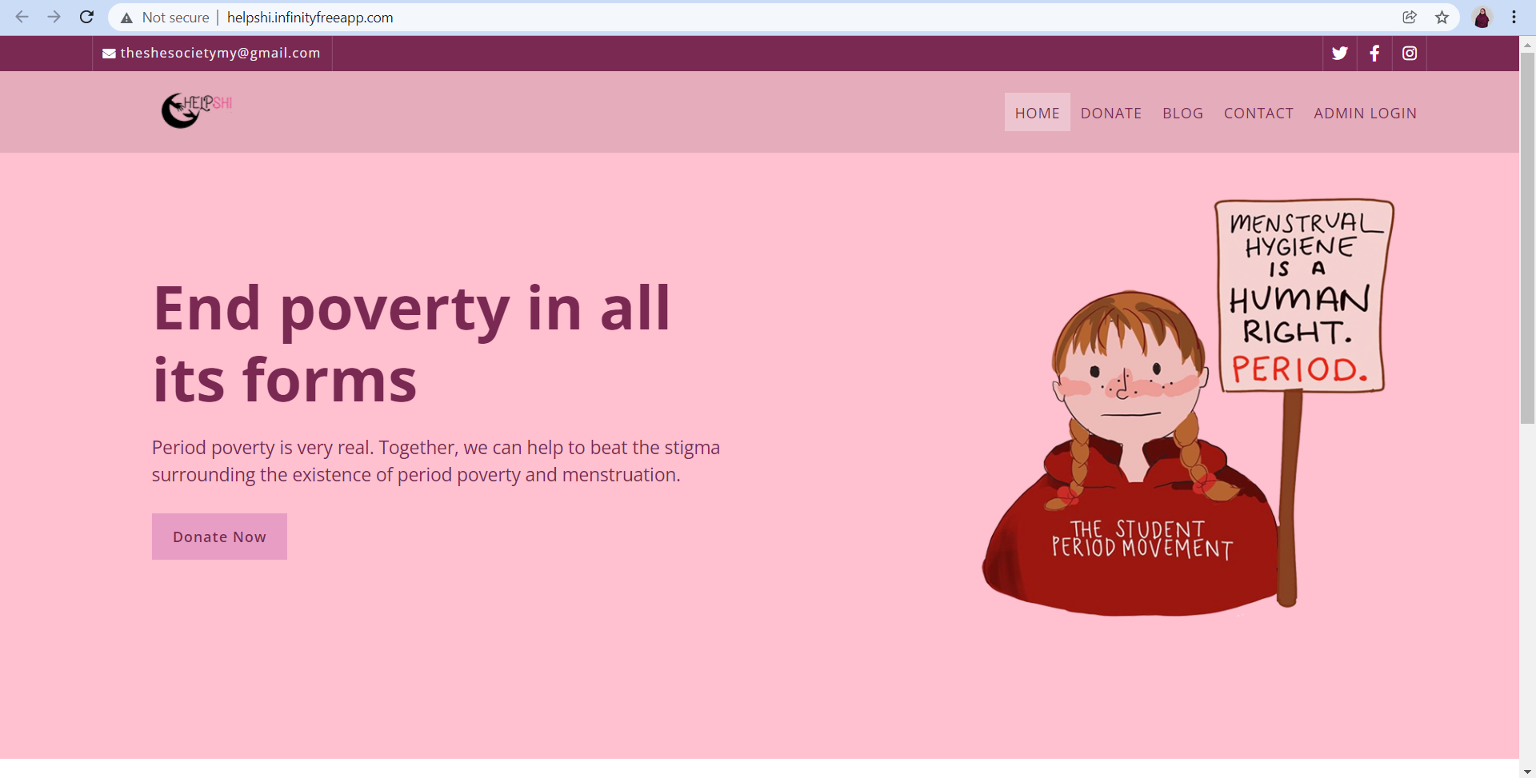

Figure 3

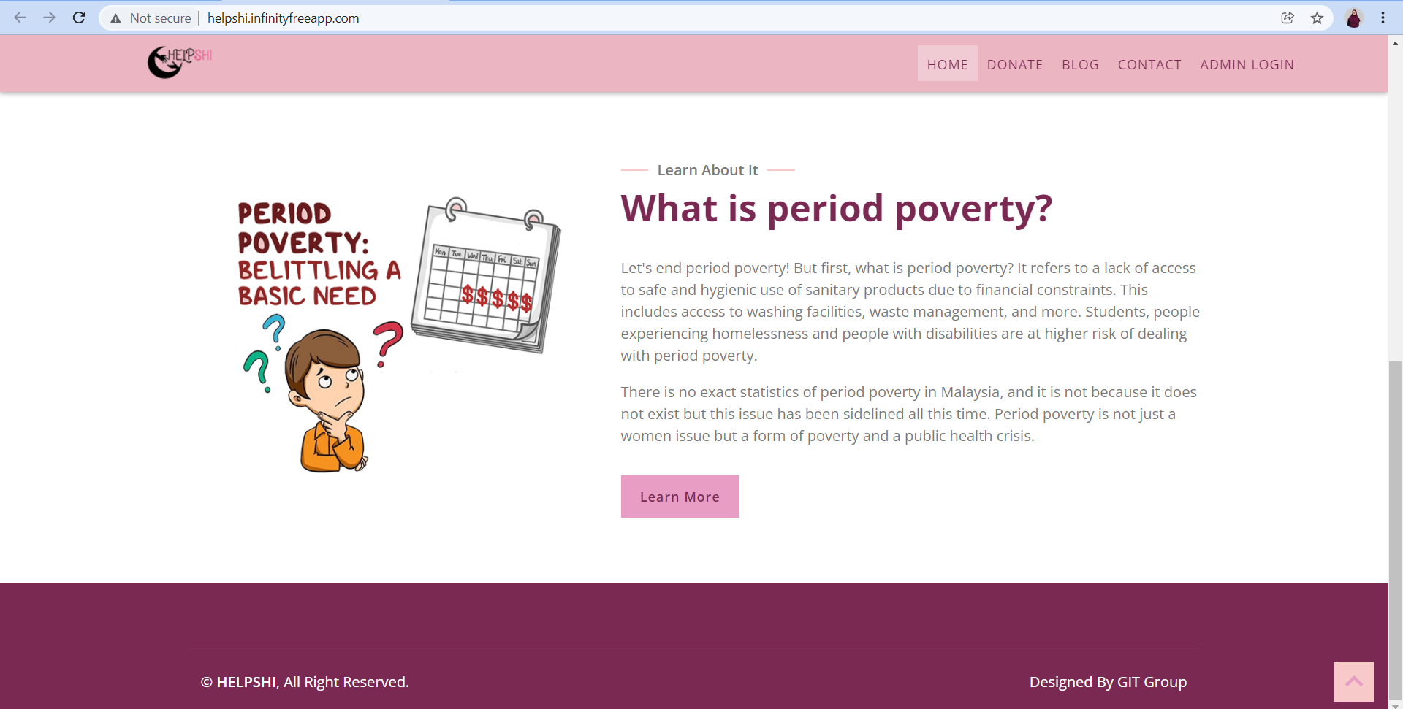

Figure 4 : The home page for public users

This page is the first page that will appear when public users visit to this web application

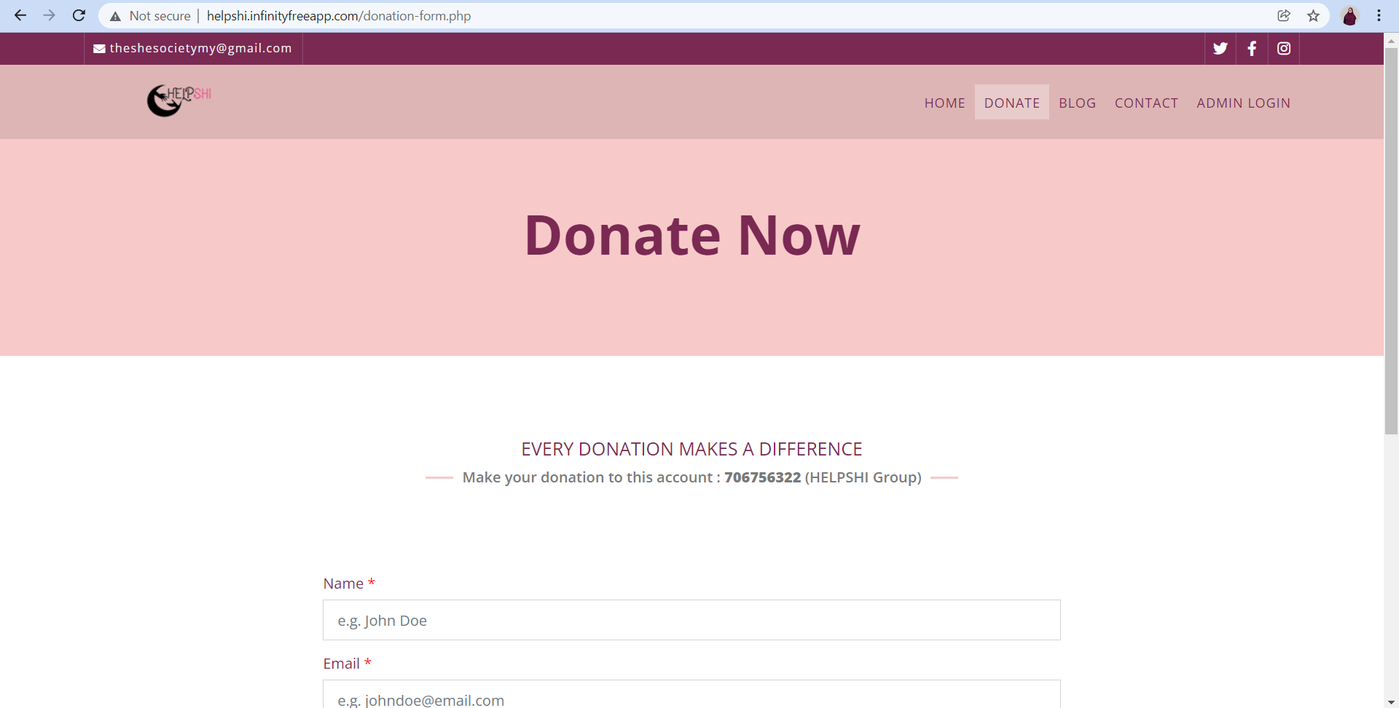

Figure 5

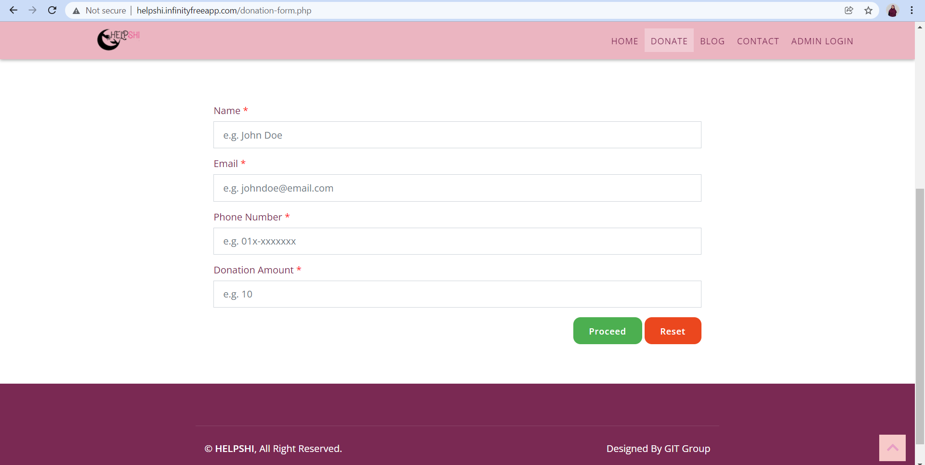

Figure 6 : The donation page where public users can make donation by fill in all the forms given

Public users are allowed to fill the form such as name, email, phone number and also the donation amount before they want to proceed to do donation. .

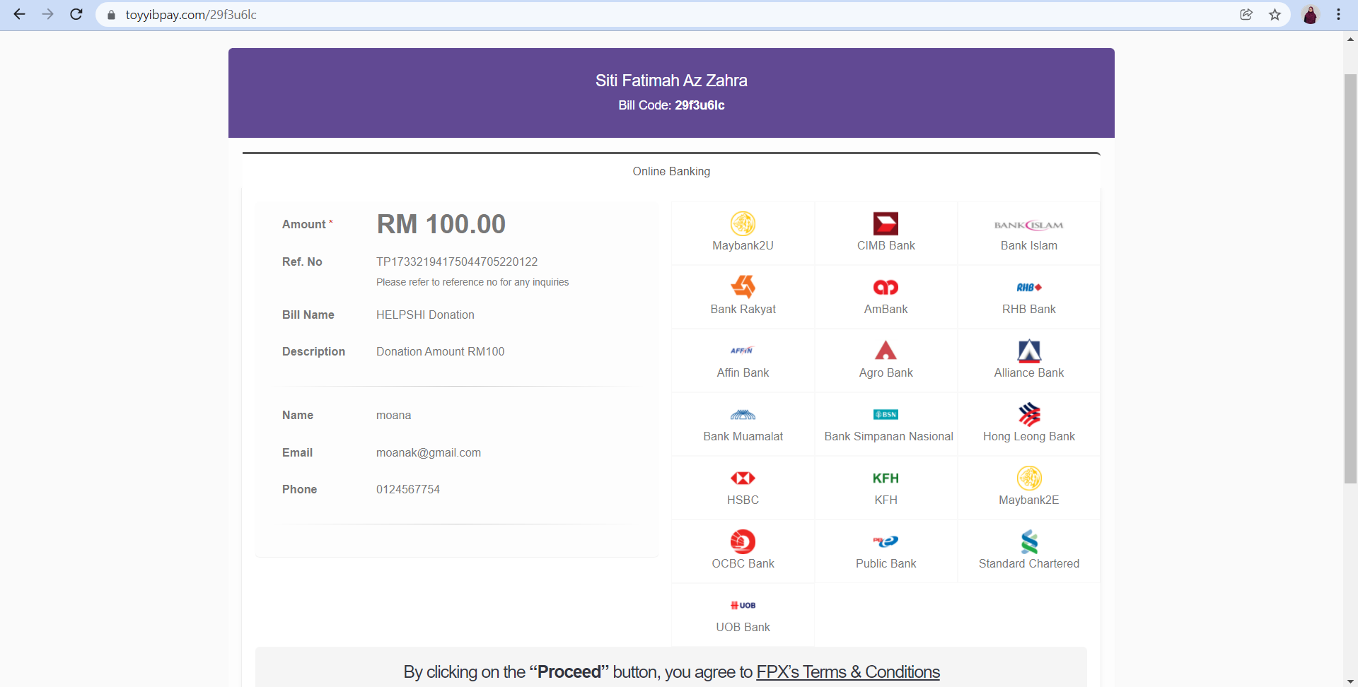

Figure 7 : Payment page when public users proceed their donation

In this page, public users need to choose their preferred bank to proceed with their donation

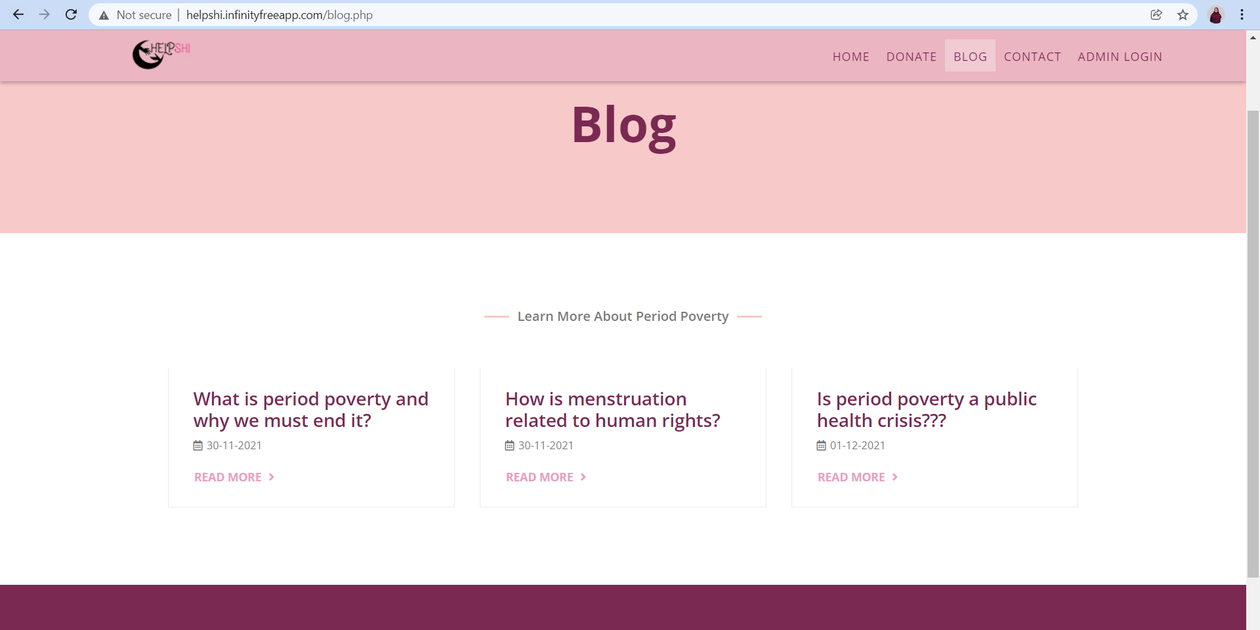

Figure 8 : The blog page where public users can read all the posts

Public users can view the blog posts by clicking to the blog section in the menu tab.
If public users want to read the detailed content of each blog,
they need to click to read more and it will navigate public users to the other page.

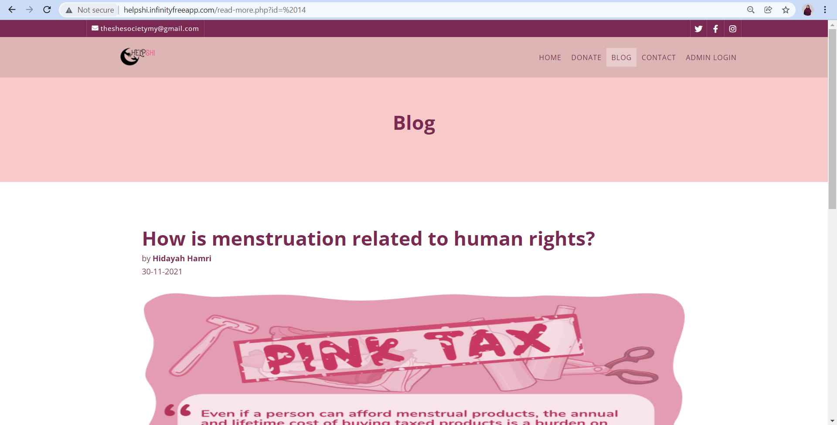

Figure 9

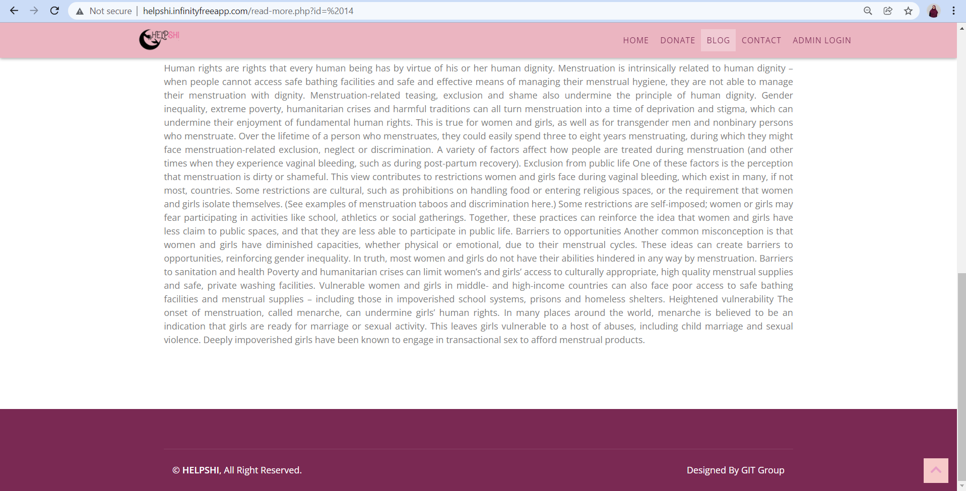

Figure 10 : The detail content of blog post

Public users can read more details about the content of blog posts by clicking on the read more from the previous page

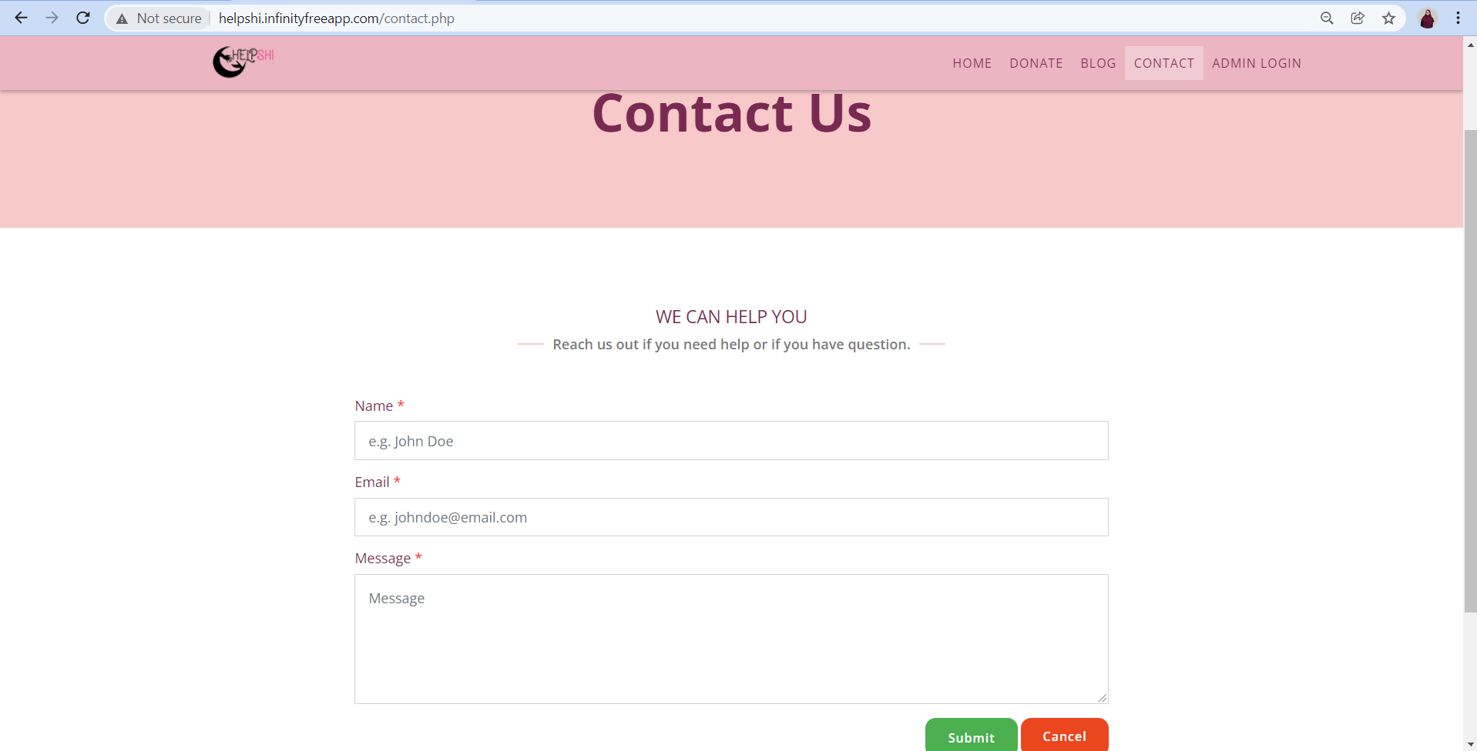

Figure 11 : Contact us page where public users can send message or send help to the admin by filling all the form that provided

Public users can send their message or report any help to the admin by filling all the forms given such as name, email and also the message that need to send

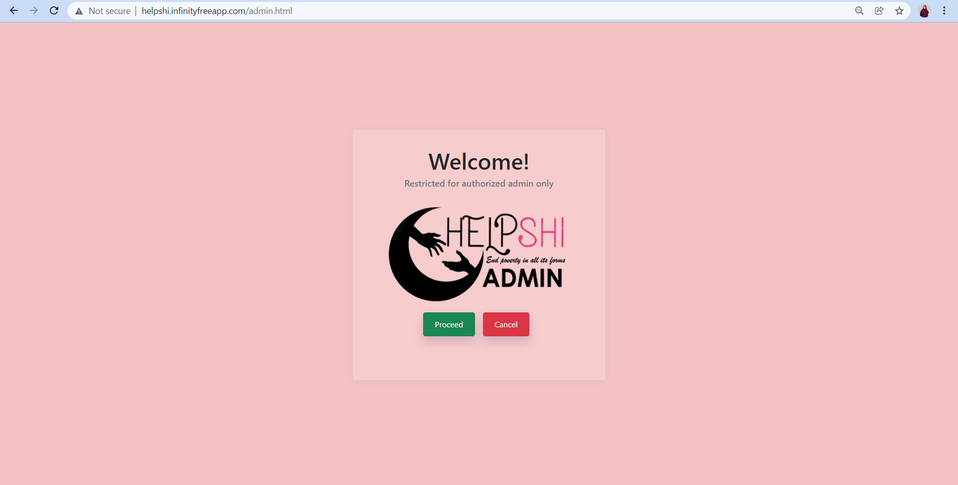

Figure 12 : The main page of admin login

This page will appear when admin click on the admin login section and they need to click to the proceed button to proceed their authentication to access all the admin functionalities

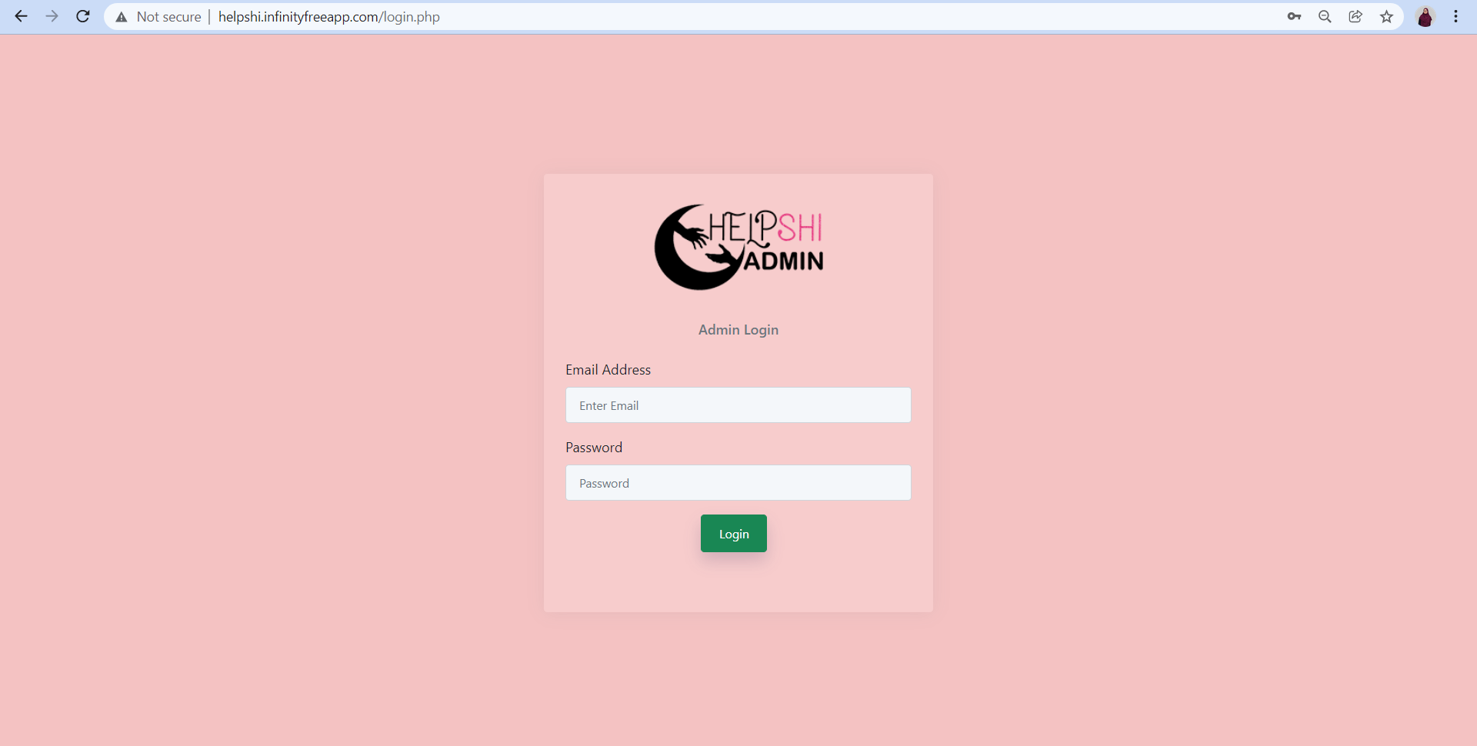

Figure 13 : Login page for admin

Admin need to key in their registered email address and also their password to access admin site

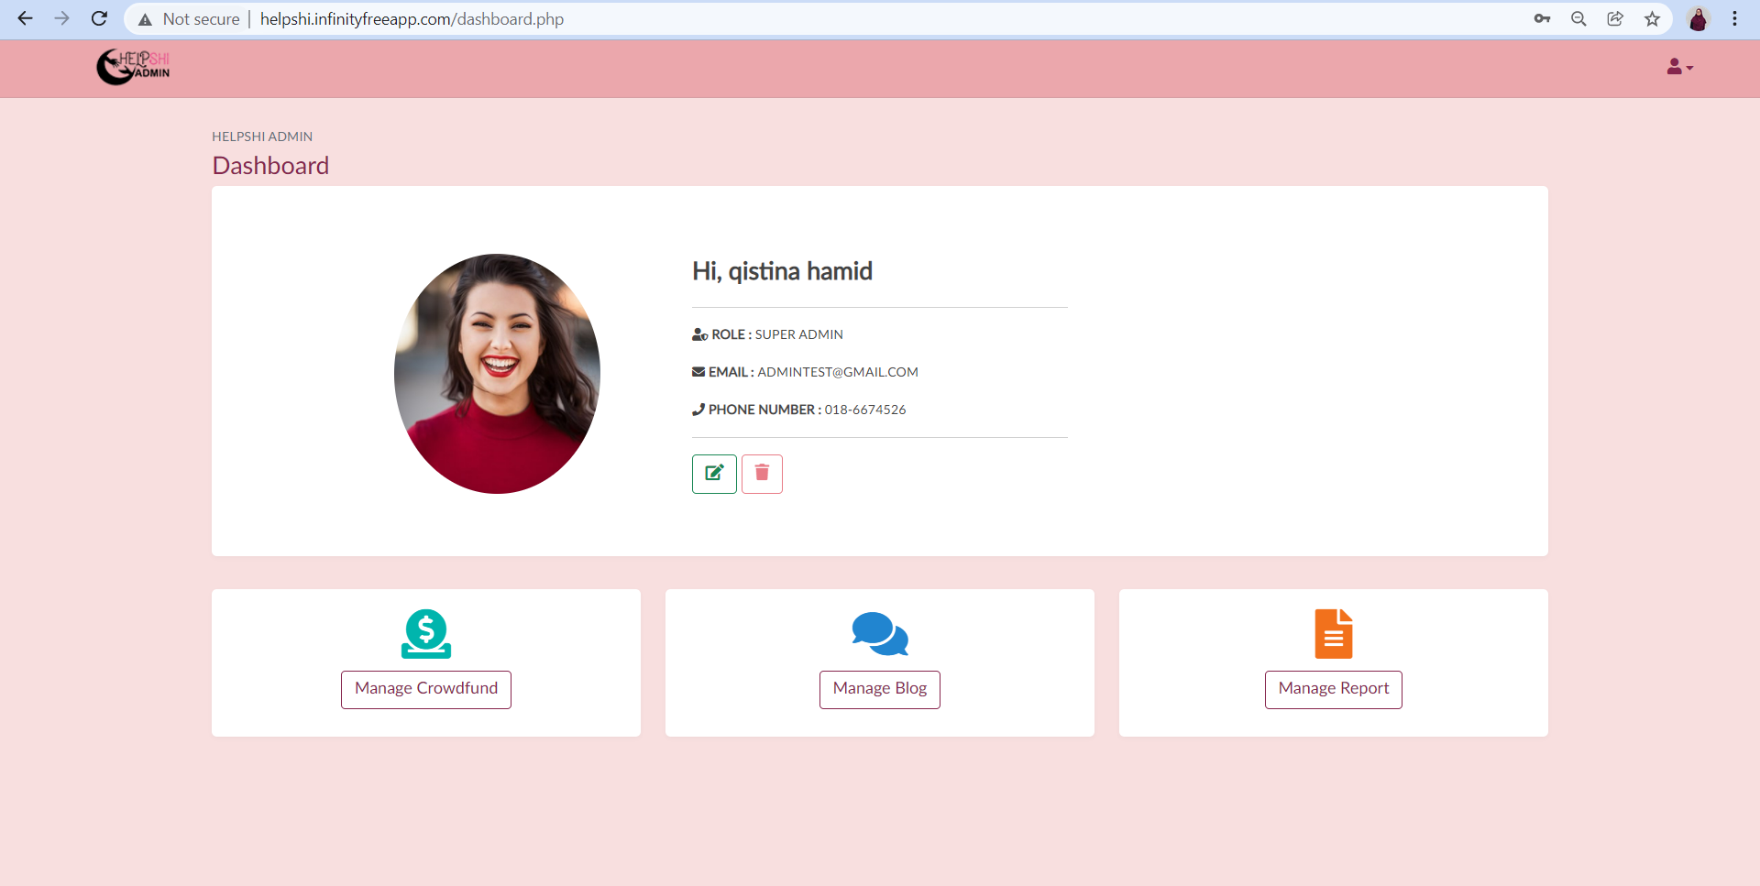

Figure 14 : The main page of admin site

This is the main page that will appear when admin successfully login by using their registered email and password. In this page there are multiple features that can be accessed by admin. The features that can be accessed by the admin are update and delete accounts. There will be two roles of admin which is super admin and also admin. Super admin can delete other admin but ordinary admin cannot delete other admin. Admins also can manage crowdfund, manage all the blog postings and also manage the report

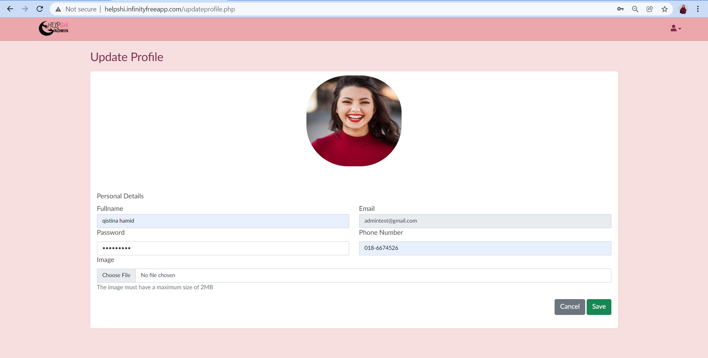

Figure 15 : Update profile page for admin

Admin can update their profile details such as their full name, password, phone number and also profile picture

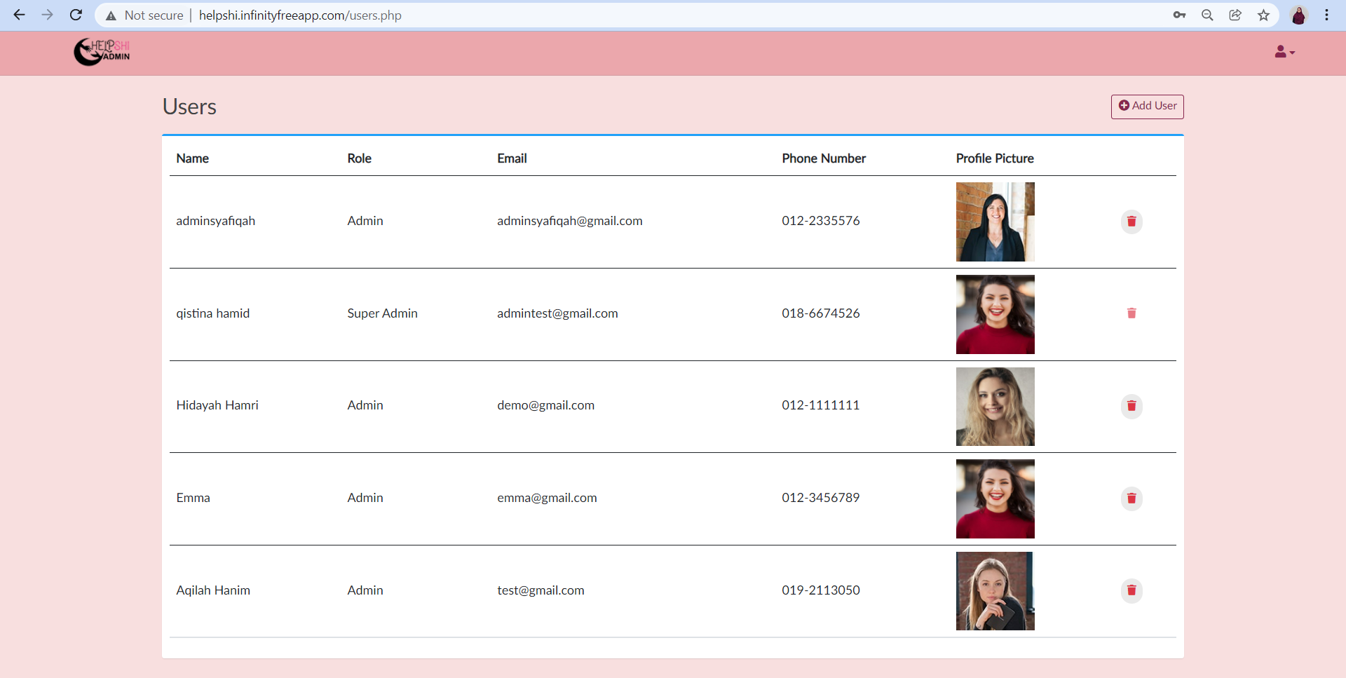

Figure 16 : List of admin page

Admin can view the list of admin by clicking on the users section from the drawer at the right top of the web application. For this part, only super admin can delete other admin.

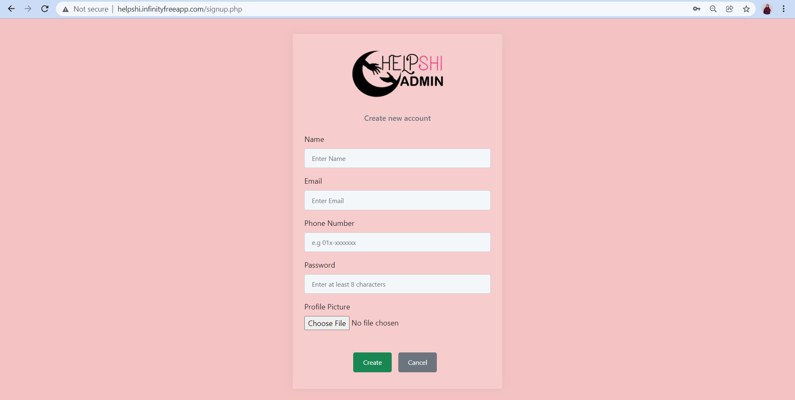

Figure 17 : Create new account page

In this page, both admin (super admin and normal admin) can create a new admin by clicking on add users button from the previous page. Admin need to fill the name, email, phone number, password and also profile picture to create another new admin

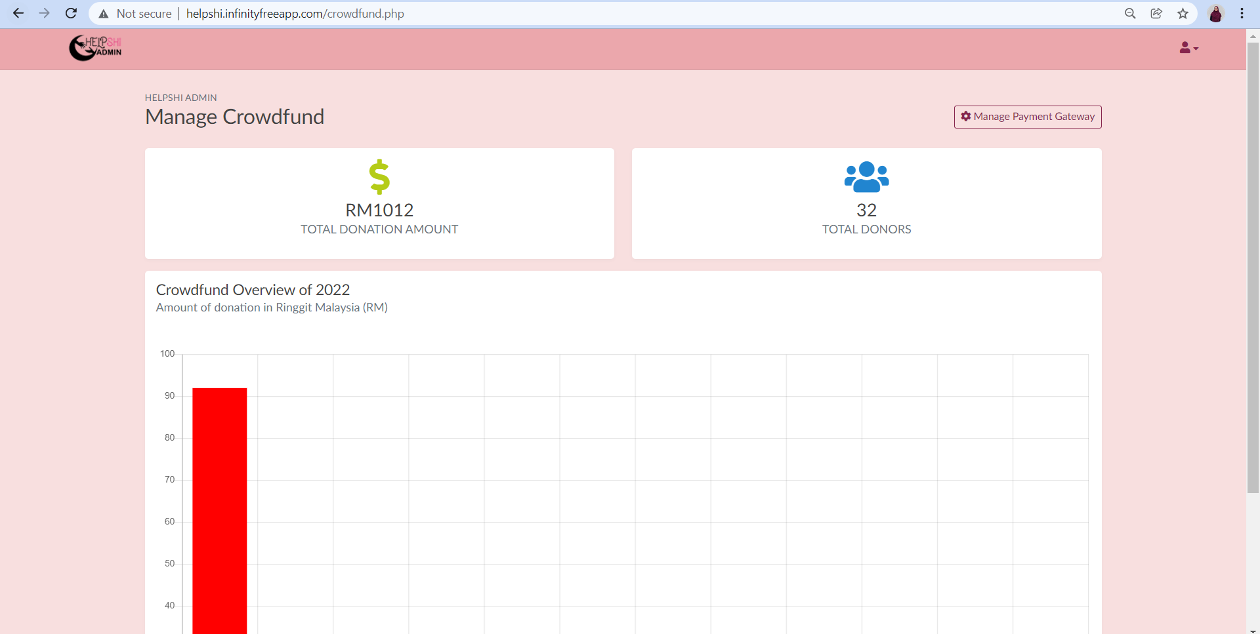

Figure 18 : Manage crowdfund page

Admin can view the total amount of donation, total donors and also the crowdfund overview in this manage crowdfund page

Figure 19 : Manage payment gateway feature

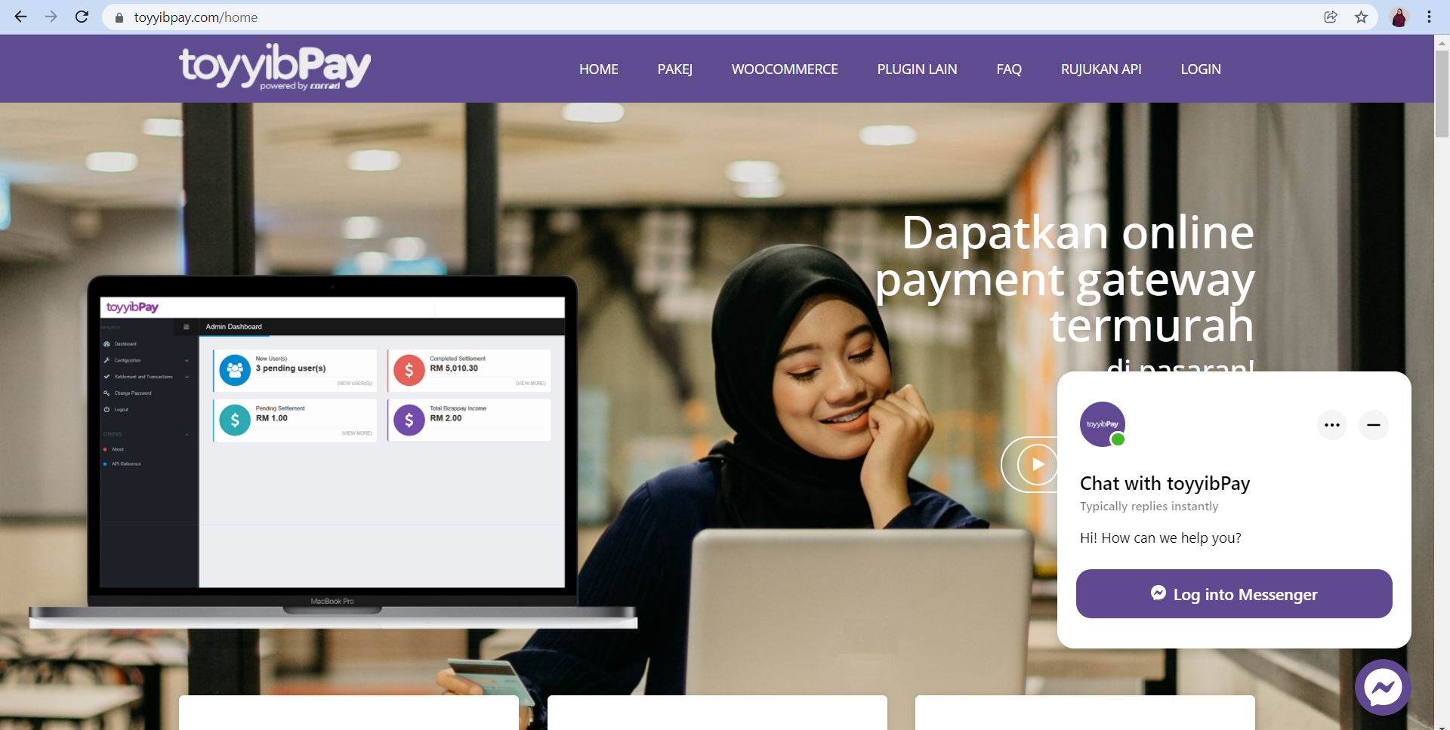

Figure 20 : toyyibPay website

Admin can manage the crowdfund by clicking to manage payment gateway button as shown in figure 19 and it will lead the admin to toyyibPay website

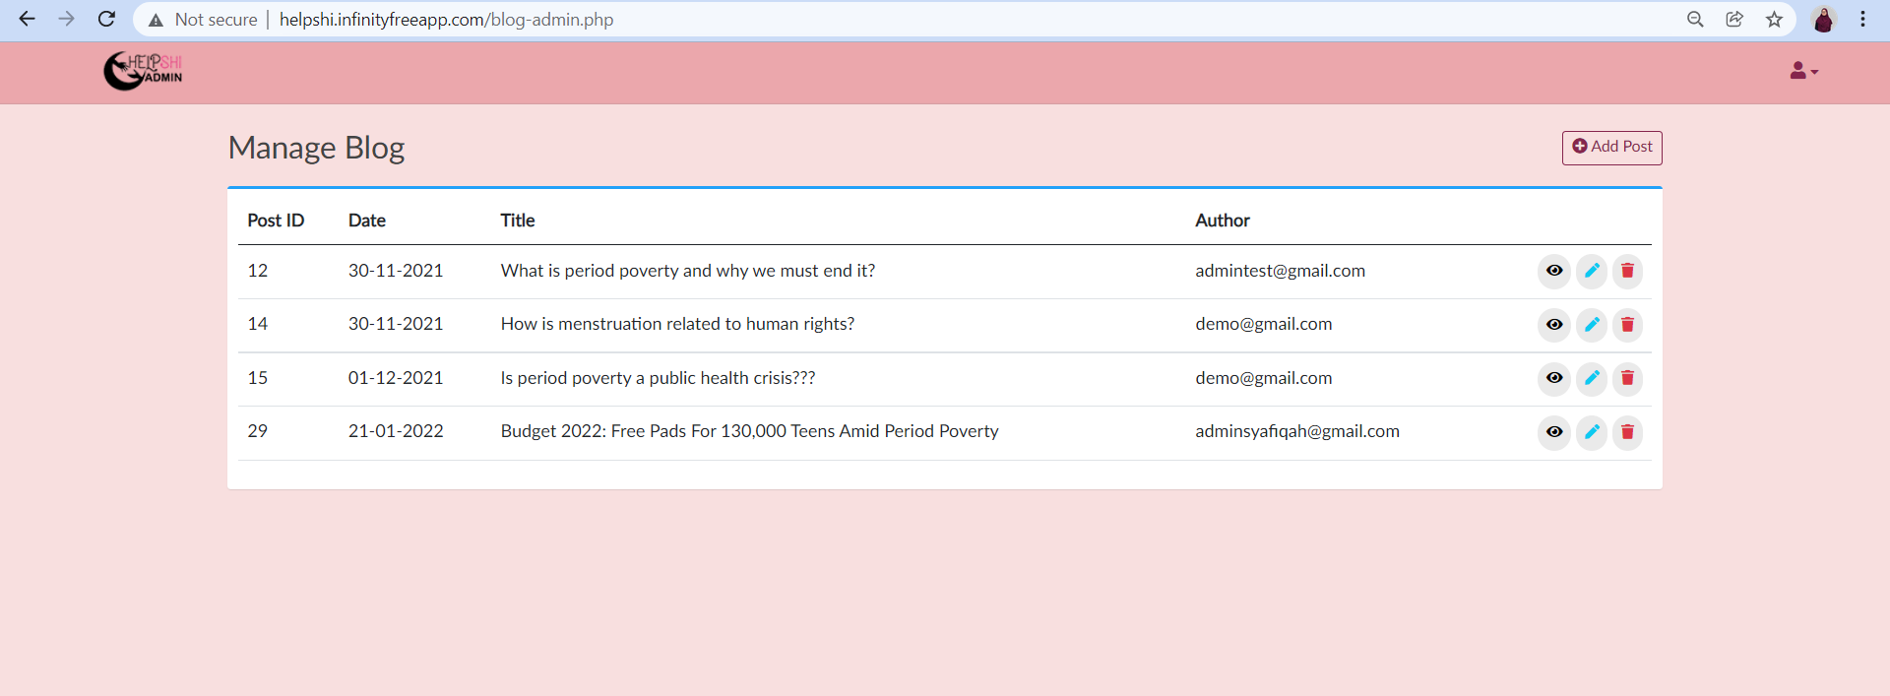

Figure 21 : Manage blog page

Admin can view all the blog posts list. Other than that, admin also can view the details of each blog post by clicking on ‘eye’ icon. Admin also can edit the post by clicking on the ‘pencil’ icon and also delete the posts by clicking on the red dustbin icon. Last but not least, admin can create new blog post by clicking on add post button at the top right manage blog page

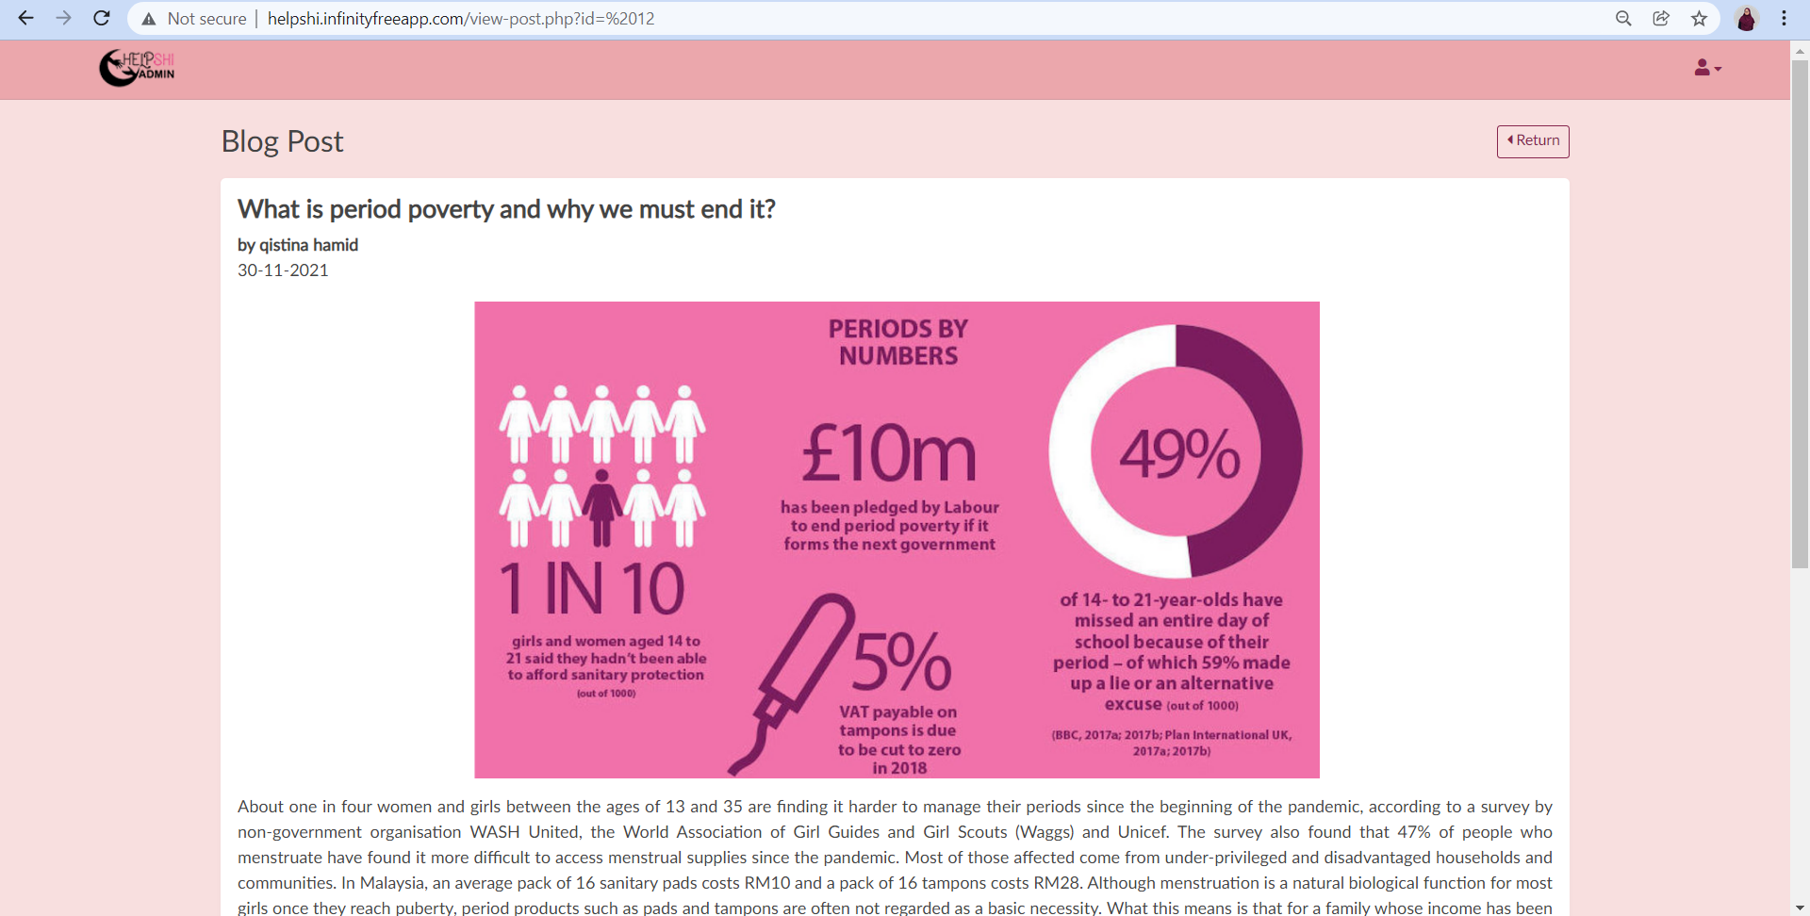

Figure 22 : Blog post page

Admin can view the details of one blog post by clicking on the ‘eye’ icon from the previous page. Admin also can read more the details about one blog post

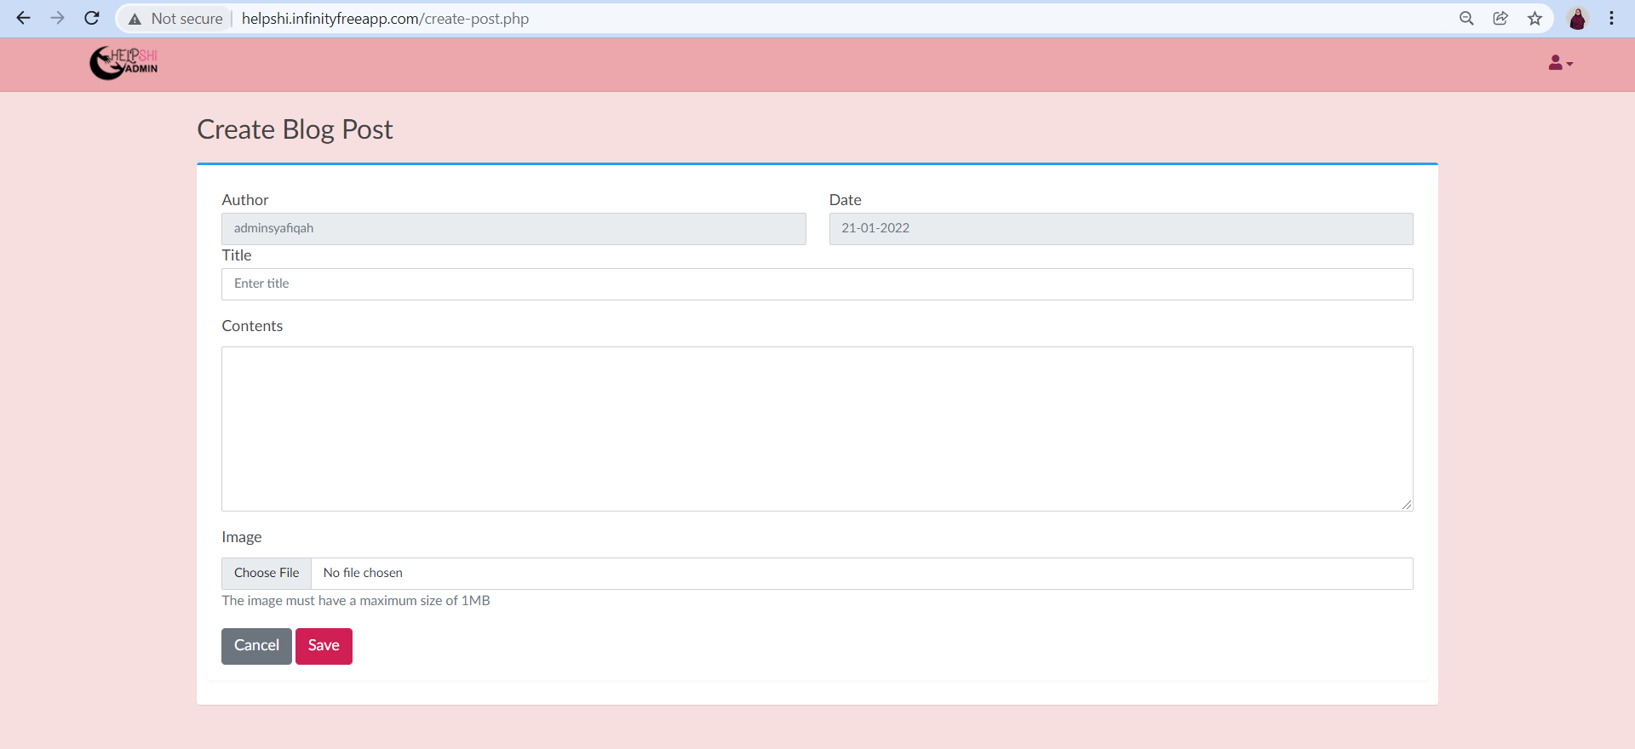

Figure 23 : Create blog post

Admin can create a new blog post by filling all the form given in the page such as title, contents and also image

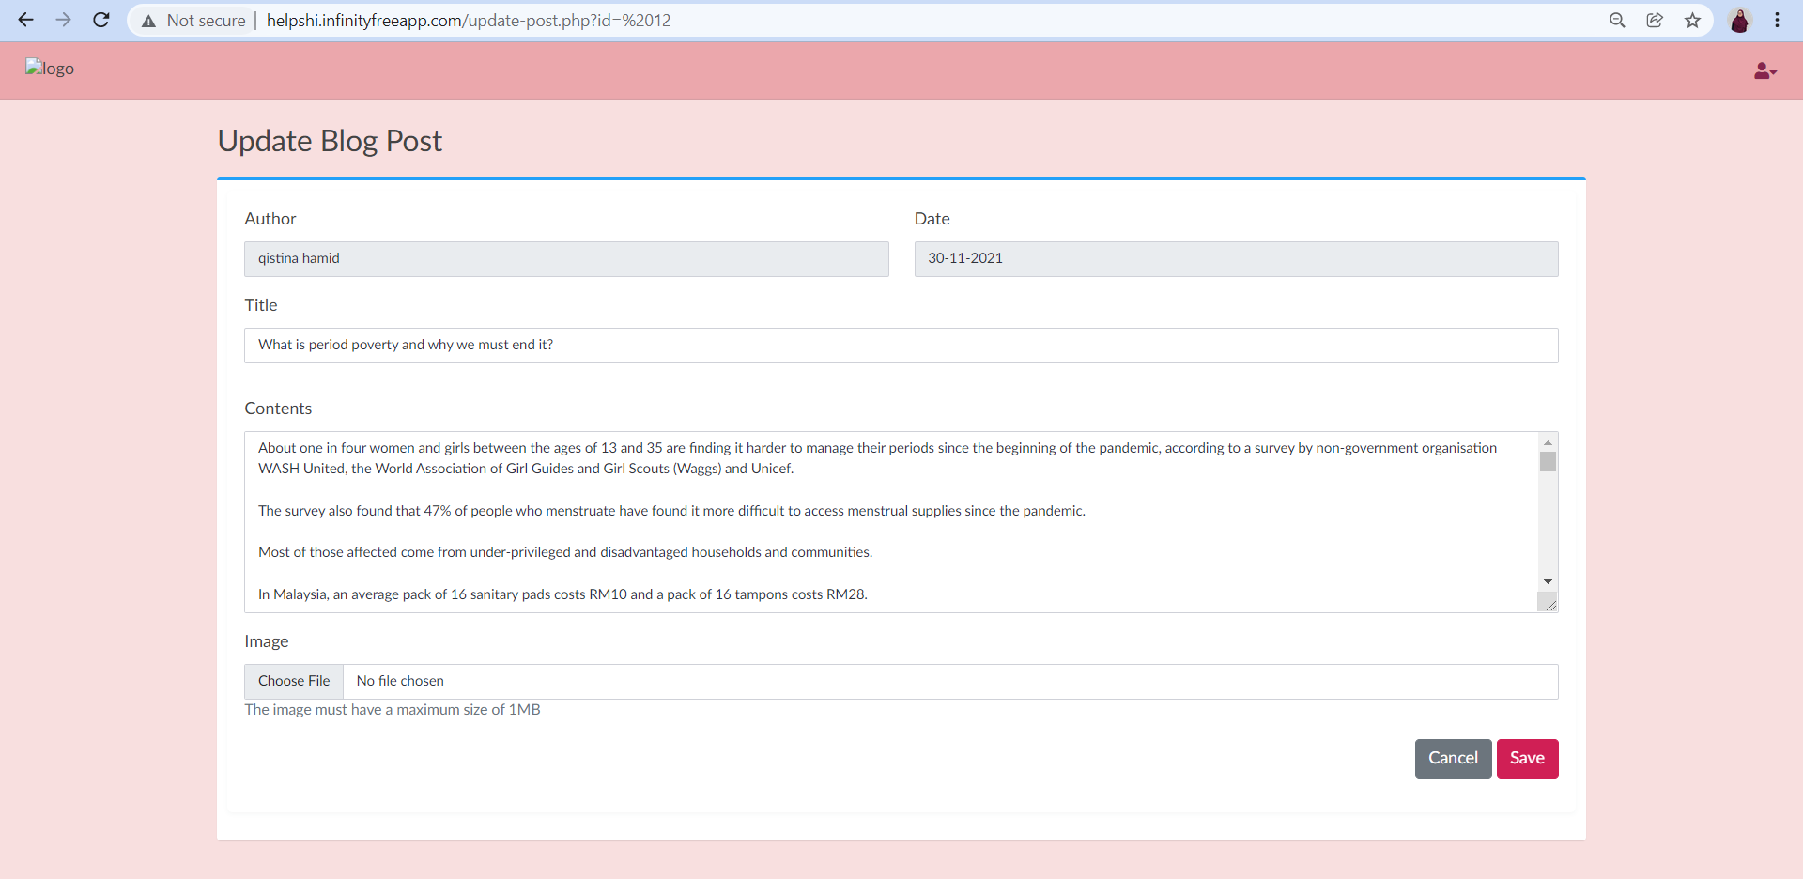

Figure 24 : Update blog post page

Admin can update any blog posts details on this page.

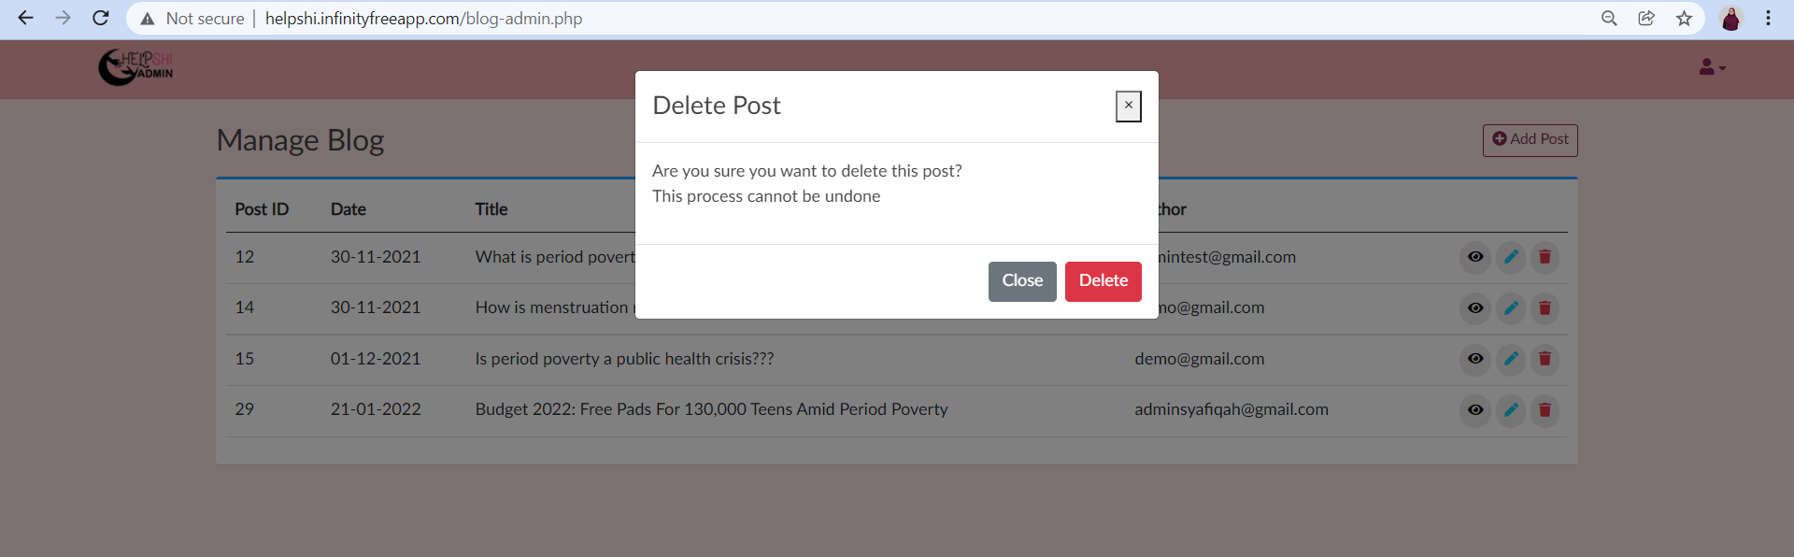

Figure 25 : Delete post pop up message

This pop up message will appear when admin want to delete blog post

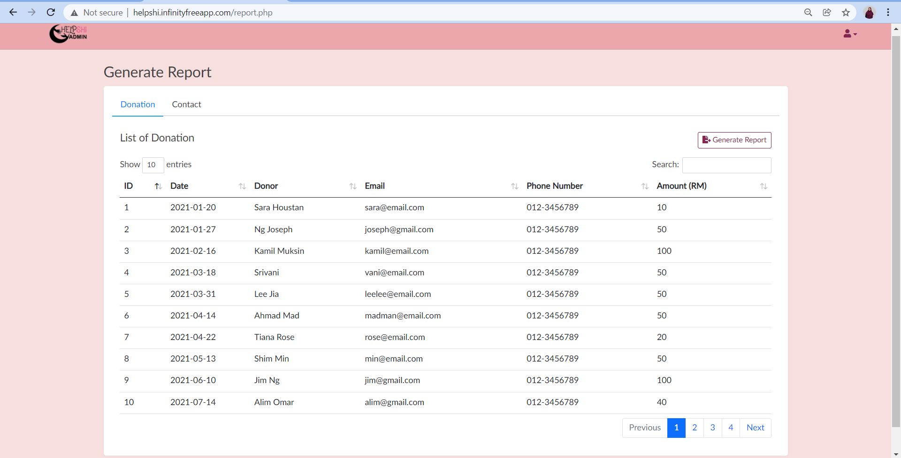

Figure 26 : Donation list page

Admin can view the donors details from generate report features

Figure 27 : Generate donation report button

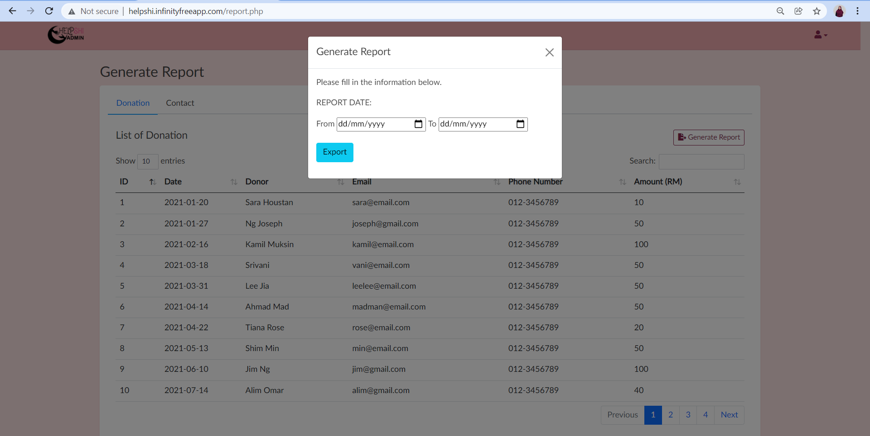

Figure 28 : Generate report pop up windows

Admin can generate a list of donations by clicking on the generate report button. Admin need to choose the date to generate the report

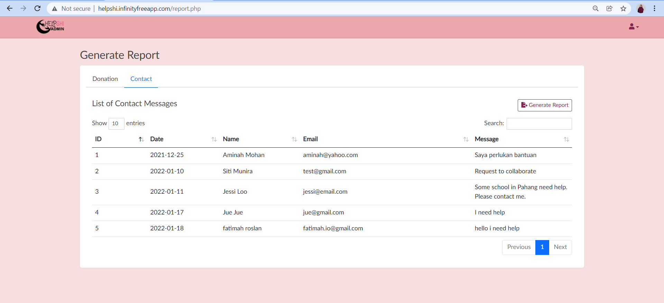

Figure 29 : Contact list page

Admin can view the contact details from generate report features

Figure 30 : Generate contact report button

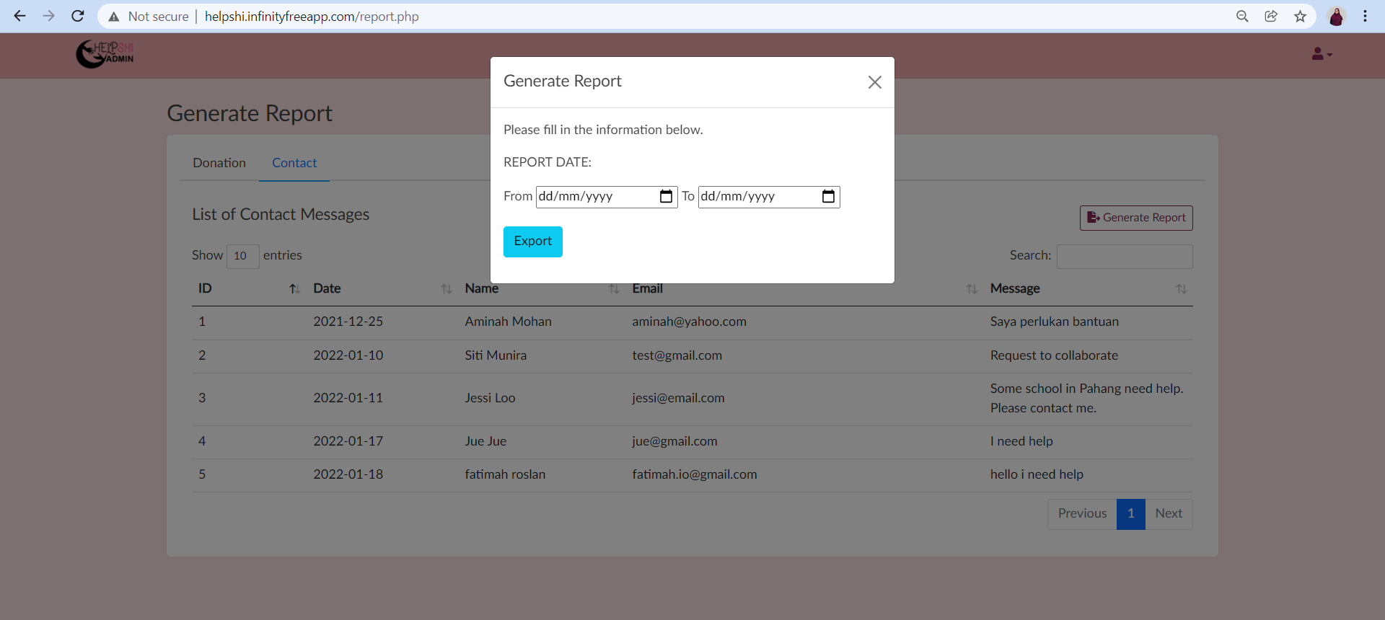

Figure 31 : Generate contact report pop up windows

Admin can generate a list of contacts by clicking on the generate report button. Admin need to choose the date to generate the report

System Environment
This web application is not involved in such integrations.

External Interfaces

Hardware interfaces
This web application is not involved in such integrations.

Network interfaces
Users need to have Internet access in order to access this web application and also it relies on HTTPS and MySQL protocols for communications among its components.

Data exchange
This web application is not involved in such integrations.

Resources
For this project, we use Visual Studio Codes as the IDE that runs the software. This IDE works well in Windows, Linux and macOS. There is built-in support for almost all programming languages including HTML, CSS, Java, PHP, SQL, C++, Ruby and more.

Hardware resources
Hardware requirements

- The devices must at least have at least 1.9 gigahertz (GHz) x86- or x64-bit dual core processor with SSE2 instruction set
- The devices must have at least 2-GB RAM
- The devices must be at least Windows 10 or latest version.
- Must have any web browser such as Google Chrome with current version

Software resources
Software requirements

- Operating system : chosen to use Windows operating system for its best support and user-friendliness.
- Database : MySQL database
- Visual Studio Code : This IDE works well in Windows, Linux and macOS and supports almost all programming languages.

Internal Data
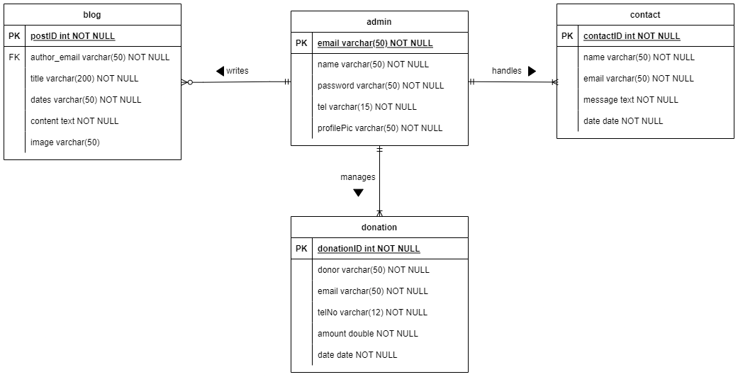
Figure 32: Entity relationship diagram of HELPSHI database

Adaptation
This web application is not involved in such integrations.

Verification
To test this project file which is a file that has been saved in an xampp file, we need to use some verse to bring it up to the web application that has been created. For example, to run the system, you need to call “http://localhost/HELPSHI/login.php” to call the login page for HELPSHI web application. Before that, open the xampp to make sure that the localhost will run smoothly

Personnel and Training
Before starting the web application, our team already has a capability to make a web which each of us knows the PHP, HTML, CSS and Javascript language. Based on what we have proposed to stakeholders, our stakeholders agreed with the development of a web application on crowdfunds and also the dissemination of knowledge about the period of poverty. In this situation, they put more emphasis on the functions that are available in the web application and also the GUI to attract users and donors out there to use this system.

Packaging and Installation
To build this web application, our team needs to install visual studio code software for the backend and also install the bootstrap in the visual studio code to make it easy for us to compile it and present the web application HELPSHI.

Architecture

Architecture Overview
HELPSHI web application is designed to be accessed anywhere, anytime by using any devices such as laptop and smartphone but must be connected to the Internet. It consists of three types of user : super admin, admin and public user. Super admin and admin have the most access to the database and they are responsible to manage the data from the database to get certain outputs. The differences are super admin cannot delete its account, but it can delete other admin, and it has only one super admin account. Meanwhile, public users are the users who can use the system without having to login to the system.
This web application consists of five subsystems called are admin subsystem, donation subsystem, blog subsystem, report subsystem and public subsystem. Each subsystem has a view layer, domain layer and data access layer. View layer is a user interface layer that allows users to interact with the system. Domain layer classes that are related to functions of the system. Meanwhile, a data access layer is a layer that manages the accessing of data from a database.
The public subsystem is the main pages of the HELPSHI web application where all users can access to the page. This subsystem provides an interface for users to access the other functions in application such as make donation (UC005), read blog posts (UC006) and allow public users to contact admin by filling in contact form (UC007). Additionally, this subsystem also includes a third party API which is a payment gateway to allow donations to be made via online banking.
Admin subsystem solely is for admin to manage admin (UC001) and this includes add or create new admin account, update account, delete account and view account details. Although, super admin and admin have slightly different restrictions, the implementation is mostly the same. Next, the blog subsystem is mainly to manage blogs (UC003) includes creating new blog posts, delete blog posts, update, or edit blog posts and view blog posts.
Donation subsystem is to manage donations (UC002). Successful donation will transfer the donation information to the database and allow the data to be processed to determine specific results such as total donation, total donors, and total monthly donation of the current year. Lastly, the report subsystem is basically to generate reports (UC004) based on the input dates. There are two types of reports that can be generated: the first one is a donation report and another one is a contact report. The report is generated in CSV format and can be downloaded.

Logical architecture overview

Top-level software components and their interactions or relationships are shown in the UML Package Diagram below.

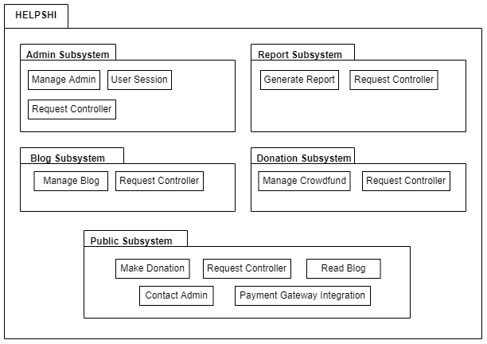
Figure 33: UML package diagram of HELPSHI system

The software can run on Windows operating system. Windows is a graphical operating system developed by Microsoft. It allows users to view and store files, run the software, play games, watch videos, and provides a way to connect to the internet. It was released for both home computing and professional work.

Physical architecture overview

The hardware components on which software runs and their interactions or relationships are described in the UML component diagram below.

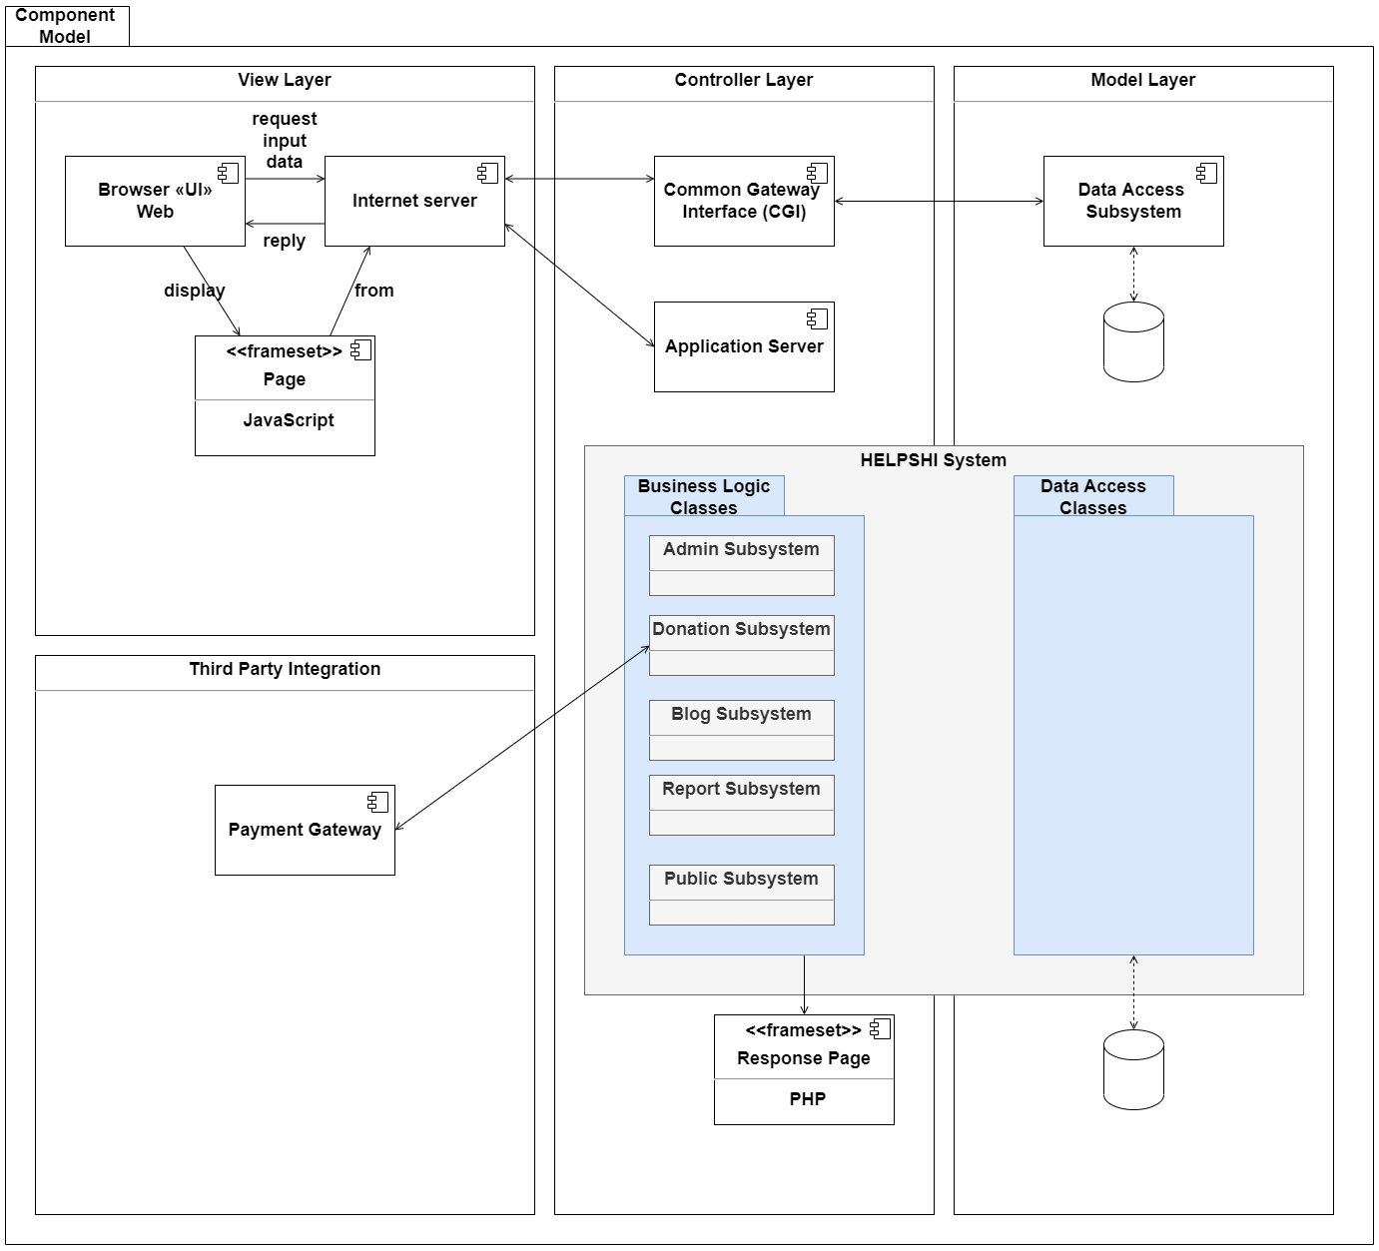
Figure 34: UML component diagram of HELPSHI database

Verification
This section describes the test environment, as well as the test site, the test description and also the test results.

Test Plan

Test environment

The test platform is located in infinityfreeapp.com. The system was deployed using this platform as it was easier to access and free to use. The hardware and software that was used to test the system are as follows :
HARDWARE | SOFTWARE
DELL Latitude 5520 | - OS‘s and service packs  - OS drivers (if specific for you)  - Backup / recovery tools  - Web, blogs, CMS, Databases engines,  - CPU  - Memory  - Disk usage  - Network analyzers  - Test coverage or test management tools  - Simulator, data generator of software or hardware that you don’t have  - Any tiny (or big) software made by you to do the tests | :  :  :  :  :  :  :  :  :  :  : | Windows 10  None  Puran File Recovery  helpshi.infinityfreeapp.com  10%  76%  15%  0%  Unifi  None  None

The data that was used during the tests were firstly listed down in the User Acceptance Testing (UAT) form. The data are identified as US001 to US022. All the user stories are part of seven use cases which are Manage Admin, Manage Crowdfund, Manage Blog, Generate Report, Make Donation, Read Blog and also Contact Admin. The UAT form is stored in a google drive owned by Siti Fatimah where all GIT Group members are allowed access to the form.
- Input files : http://helpshi.infinityfreeapp.com
- Data files : Google Spreadsheet
- Scripts to generate data : MySQL
- Output files, log files : Google Spreadsheet
No type of documentation was delivered for the test. It was fully conducted online through GoogleMeet and a website link.
Customer/ field test site

Our product was tested at the tester’s home, with her own hardware. We provided the deployed link to the system, which the tester successfully opened. The tester was already provided with the data that were initially presented to her but she was not aware of the adjustments that were made.
Test input and output data would be collected by Google spreadsheet, where every team member will be able to access. The test logs will be collected manually as the tests will be conducted with the team members. Bug reports will also be collected personally by the team members.

Tests Description and Test Results

Test Title |  |  | Priority# | Test Case ID | Test Execution Date
Test for UC001: Manage Admin |  |  | HIGH | TC-US001 | 18/1/2022
Test Description |  |  | Test Designed by |  | Test Executed by
Test for US001: Create Account |  |  | Nur Hidayah |  | Miss Asyikin
Step ID | Step Description* | Test Date | Expected Results^ | Actual Results | Pass (P) / Fail (F) | Additional Notes
1 | Go to list of users | 18/1/2022 | Success to view list of users | Success to view list of users | P
2 | Click button ‘Add User’ | 18/1/2022 | Can fill in the new information | Can fill in the new information | P
3 | Fill in the information | 18/1/2022 | Information list has been filled all | Information list has been filled all | P
4 | Save the information by click button ‘Save’ | 18/1/2022 | View updated list after the popup message ‘Account is successfully created’ | View updated list after the popup message ‘Account is successfully created’ | P

Test Title |  |  | Priority# | Test Case ID | Test Execution Date
Test for UC001: Manage Admin |  |  | HIGH | TC-US002 | 18/1/2022
Test Description |  |  | Test Designed by |  | Test Executed by
Test for US002: Login Account |  |  | Nur Hidayah |  | Miss Asyikin
Step ID | Step Description* | Test Date | Expected Results^ | Actual Results | Pass (P) / Fail (F) | Additional Notes
1 | Go to Admin Login | 18/1/2022 | View login page | View login page | P
2 | Fill username and password | 18/1/2022 | Successfully enter admin site | Successfully enter admin site | P | The login needs to be more secure as need verification

Test Title |  |  | Priority# | Test Case ID | Test Execution Date
Test for UC001: Manage Admin |  |  | HIGH | TC-US003 | 18/1/2022
Test Description |  |  | Test Designed by |  | Test Executed by
Test for US003: Update Account |  |  | Nur Hidayah |  | Miss Asyikin
Step ID | Step Description* | Test Date | Expected Results^ | Actual Results | Pass (P) / Fail (F) | Additional Notes
1 | Click edit button | 18/1/2022 | View the update page | View the update page | P
2 | Update the information | 18/1/2022 | New information has been filled | New information has been filled | P
3 | Click button save | 18/1/2022 | The update information display on dashboard | The update information display on dashboard | P

Test Title |  |  | Priority# | Test Case ID | Test Execution Date
Test for UC001: Manage Admin |  |  | MEDIUM | TC-US004 | 18/1/2022
Test Description |  |  | Test Designed by |  | Test Executed by
Test for US004: Logout Account |  |  | Nur Hidayah |  | Miss Asyikin
Step ID | Step Description* | Test Date | Expected Results^ | Actual Results | Pass (P) / Fail (F) | Additional Notes
1 | Click Logout button | 18/1/2022 | View the website page | View the website page | P

Test Title |  |  | Priority# | Test Case ID | Test Execution Date
Test for UC001: Manage Admin |  |  | MEDIUM | TC-US005 | 18/1/2022
Test Description |  |  | Test Designed by |  | Test Executed by
Test for US005: Delete Account |  |  | Nur Hidayah |  | Miss Asyikin
Step ID | Step Description* | Test Date | Expected Results^ | Actual Results | Pass (P) / Fail (F) | Additional Notes
1 | Super Admin cannot delete her account | 18/1/2022 | The button disable for super admin | The button disable for super admin | P
2 | Super Admin go to list of users | 18/1/2022 | View the list of users | View the list of users | P
3 | Super Admin click icon ‘Bin’ | 18/1/2022 | Confirmation message appears | Confirmation message appears | P
4 | Click button ‘Delete’ | 18/1/2022 | View updated list of user after the popup message ‘Account is deleted successfully’ | View updated list of user after the popup message ‘Account is deleted successfully’ | P
5 | Admin cannot delete themselves | 18/1/2022 | There's no button delete at admin site | There's no button delete at admin site | P

Test Title |  |  | Priority# | Test Case ID | Test Execution Date
Test for UC002: Manage Crowdfund |  |  | HIGH | TC-US018 | 18/1/2022
Test Description |  |  | Test Designed by |  | Test Executed by
Test for US006: Manage Payment Gateway |  |  | Nur Hidayah |  | Miss Asyikin
Step ID | Step Description* | Test Date | Expected Results^ | Actual Results | Pass (P) / Fail (F) | Additional Notes
1 | Click the manage crowdfund | 18/1/2022 | View the summary of donation and donors | View the summary of donation and donors | P
2 | Click manage payment gateway button | 18/1/2022 | Direct to toyyibpay website | Direct to toyyibpay website | P

Test Title |  |  | Priority# | Test Case ID | Test Execution Date
Test for UC002: Manage Crowdfund |  |  | LOW | TC-US018 | 18/1/2022
Test Description |  |  | Test Designed by |  | Test Executed by
Test for US018: View annual summary of donation |  |  | Nur Hidayah |  | Miss Asyikin
Step ID | Step Description* | Test Date | Expected Results^ | Actual Results | Pass (P) / Fail (F) | Additional Notes
1 | Click the manage crowdfund | 18/1/2022 | View the summary of donation and donors | View the summary of donation and donors | P

Test Title |  |  | Priority# | Test Case ID | Test Execution Date
Test for UC002: Manage Crowdfund |  |  | LOW | TC-US020 | 18/1/2022
Test Description |  |  | Test Designed by |  | Test Executed by
Test for US020: View total donor |  |  | Nur Hidayah |  | Miss Asyikin
Step ID | Step Description* | Test Date | Expected Results^ | Actual Results | Pass (P) / Fail (F) | Additional Notes
1 | Click the manage crowdfund | 18/1/2022 | View the summary of donation and donors | View the summary of donation and donors | P

Test Title |  |  | Priority# | Test Case ID | Test Execution Date
Test for UC002: Manage Crowdfund |  |  | LOW | TC-US021 | 18/1/2022
Test Description |  |  | Test Designed by |  | Test Executed by
Test for US021: View total donation |  |  | Nur Hidayah |  | Miss Asyikin
Step ID | Step Description* | Test Date | Expected Results^ | Actual Results | Pass (P) / Fail (F) | Additional Notes
1 | Click the manage crowdfund | 18/1/2022 | View total donation | View total donation | P

Test Title |  |  | Priority# | Test Case ID | Test Execution Date
Test for UC003: Manage Blog |  |  | HIGH | TC-US007 | 18/1/2022
Test Description |  |  | Test Designed by |  | Test Executed by
Test for US007: Create Blog Post |  |  | Nur Hidayah |  | Miss Asyikin
Step ID | Step Description* | Test Date | Expected Results^ | Actual Results | Pass (P) / Fail (F) | Additional Notes
1 | Click ‘Manage Blog’ | 18/1/2022 | View the list of blog information | View the list of blog information | P
2 | Click ‘Add Post’ | 18/1/2022 | Can fill in the new information for blog | Can fill in the new information for blog | P
3 | Click ‘Save’ | 18/1/2022 | Popup message appear ‘New Blog Post Is Created Successfully’ and list of new blog appear | Popup message appear ‘New Blog Post Is Created Successfully’ and list of new blog appear | P

Test Title |  |  | Priority# | Test Case ID | Test Execution Date
Test for UC003: Manage Blog |  |  | MEDIUM | TC-US008 | 18/1/2022
Test Description |  |  | Test Designed by |  | Test Executed by
Test for US008: Update Blog Post |  |  | Nur Hidayah |  | Miss Asyikin
Step ID | Step Description* | Test Date | Expected Results^ | Actual Results | Pass (P) / Fail (F) | Additional Notes
1 | Click icon ‘pencil’ to edit | 18/1/2022 | View the information form | View the information form | P
2 | Update new information in the form | 18/1/2022 | New information has been filled | New information has been filled | P
3 | Click ‘Save’ button | 18/1/2022 | Popup message appears ‘Post Updated Successfully!’ and display the list of blog post | Popup message appears ‘Post Updated Successfully!’ and display the list of blog post | P

Test Title |  |  | Priority# | Test Case ID | Test Execution Date
Test for UC003: Manage Blog |  |  | MEDIUM | TC-US009 | 18/1/2022
Test Description |  |  | Test Designed by |  | Test Executed by
Test for US009: Delete Blog Post |  |  | Nur Hidayah |  | Miss Asyikin
Step ID | Step Description* | Test Date | Expected Results^ | Actual Results | Pass (P) / Fail (F) | Additional Notes
1 | Click icon ‘Bin’ | 18/1/2022 | Confirmation message appears | Confirmation message appears | P
2 | Click ‘Delete’ to delete the blog post | 18/1/2022 | view the updated list of blog post after the popup message appears ‘Post is deleted successfully’ | view the updated list of blog post after the popup message appears ‘Post is deleted successfully’ | P

Test Title |  |  | Priority# | Test Case ID | Test Execution Date
Test for UC003: Manage Blog |  |  | MEDIUM | TC-US013 | 18/1/2022
Test Description |  |  | Test Designed by |  | Test Executed by
Test for US013: View Post |  |  | Nur Hidayah |  | Miss Asyikin
Step ID | Step Description* | Test Date | Expected Results^ | Actual Results | Pass (P) / Fail (F) | Additional Notes
1 | Click ‘Manage Blog’ | 18/1/2022 | View the list of blog | View the list of blog | P

Test Title |  |  | Priority# | Test Case ID | Test Execution Date
Test for UC003: Manage Blog |  |  | MEDIUM | TC-US014 | 18/1/2022
Test Description |  |  | Test Designed by |  | Test Executed by
Test for US014: View Blog Post List |  |  | Nur Hidayah |  | Miss Asyikin
Step ID | Step Description* | Test Date | Expected Results^ | Actual Results | Pass (P) / Fail (F) | Additional Notes
1 | Click ‘Manage Blog’ | 18/1/2022 | View the list of blog | View the list of blog | P
2 | Click icon ‘Eye’ | 18/1/2022 | View the detail of the blog post | View the detail of the blog post | P
3 | Click button ‘Return’ | 18/1/2022 | View the list of blog | View the list of blog | P

Test Title |  |  | Priority# | Test Case ID | Test Execution Date
Test for UC004: Generate Report |  |  | HIGH | TC-US010 | 18/1/2022
Test Description |  |  | Test Designed by |  | Test Executed by
Test for US010: Generate donation report |  |  | Nur Hidayah |  | Miss Asyikin
Step ID | Step Description* | Test Date | Expected Results^ | Actual Results | Pass (P) / Fail (F) | Additional Notes
1 | Go to manage report | 18/1/2022 | manage report page | manage report page | P
2 | Generate donation report | 18/1/2022 | donation report generated in xlsx format | donation report generated in xlsx format | P

Test Title |  |  | Priority# | Test Case ID | Test Execution Date
Test for UC004: Generate Report |  |  | MEDIUM | TC-US011 | 18/1/2022
Test Description |  |  | Test Designed by |  | Test Executed by
Test for US011: View list of donation |  |  | Nur Hidayah |  | Miss Asyikin
Step ID | Step Description* | Test Date | Expected Results^ | Actual Results | Pass (P) / Fail (F) | Additional Notes
1 | Do view list of donation | 18/1/2022 | view the donation list | view the donation list | P

Test Title |  |  | Priority# | Test Case ID | Test Execution Date
Test for UC004: Generate Report |  |  | MEDIUM | TC-US012 | 18/1/2022
Test Description |  |  | Test Designed by |  | Test Executed by
Test for US012: View list of contact |  |  | Nur Hidayah |  | Miss Asyikin
Step ID | Step Description* | Test Date | Expected Results^ | Actual Results | Pass (P) / Fail (F) | Additional Notes
1 | Do view list of contact | 18/1/2022 | view the list of contact | view the contact list | P

Test Title |  |  | Priority# | Test Case ID | Test Execution Date
Test for UC004: Generate Report |  |  | HIGH | TC-US019 | 18/1/2022
Test Description |  |  | Test Designed by |  | Test Executed by
Test for US019: Generate contact report |  |  | Nur Hidayah |  | Miss Asyikin
Step ID | Step Description* | Test Date | Expected Results^ | Actual Results | Pass (P) / Fail (F) | Additional Notes
1 | Generate the contact report | 18/1/2022 | contact report generated in xlsx format | contact report generated in xlsx format | P

Test Title |  |  | Priority# | Test Case ID | Test Execution Date
Test for UC005: Make Donation |  |  | HIGH | TC-US015 | 18/1/2022
Test Description |  |  | Test Designed by |  | Test Executed by
Test for US015: Fill in donation form |  |  | Nur Hidayah |  | Miss Asyikin
Step ID | Step Description* | Test Date | Expected Results^ | Actual Results | Pass (P) / Fail (F) | Additional Notes
1 | Enter all form with valid details | 18/1/2022 | can proceed with donation payment | can proceed with donation payment | P
2 | Enter invalid details to the contact form  i.e email form | 18/1/2022 | Error message “Please include @ in the email address” will popup | Error message “Please include @ in the email address” will popup | P
3 | Do not enter the details and click to submit button | 18/1/2022 | Error message “Please fill out this field” will popup | Error message “Please fill out this field” will popup | P

Test Title |  |  | Priority# | Test Case ID | Test Execution Date
Test for UC005: Make Donation |  |  | HIGH | TC-US016 | 18/1/2022
Test Description |  |  | Test Designed by |  | Test Executed by
Test for US016: Make donation payment |  |  | Nur Hidayah |  | Miss Asyikin
Step ID | Step Description* | Test Date | Expected Results^ | Actual Results | Pass (P) / Fail (F) | Additional Notes
1 | Do make donation payment | 18/1/2022 | successfully make donation payment | successfully make donation payment | P

Test Title |  |  | Priority# | Test Case ID | Test Execution Date
Test for UC006: Read Blog |  |  | MEDIUM | TC-US022 | 18/1/2022
Test Description |  |  | Test Designed by |  | Test Executed by
Test for US022: View Blog Post Detail |  |  | Nur Hidayah |  | Miss Asyikin
Step ID | Step Description* | Test Date | Expected Results^ | Actual Results | Pass (P) / Fail (F) | Additional Notes
1 | Public enter to web application Helpshi | 18/1/2022 | View the front page of the website Helpshi | View the front page of the website Helpshi | P
2 | Click ‘Blog’ at the navigation bar | 18/1/2022 | View the list of blog | View the list of blog | P
3 | Click ‘Read More’ at the blog | 18/1/2022 | View the detail of the blog post | View the detail of the blog post | P
4 | Click Logo Helpshi | 18/1/2022 | Return to first ‘Home’ page | Return to first ‘Home’ page | P

Test Title |  |  | Priority# | Test Case ID | Test Execution Date
Test for UC007: Contact Admin |  |  | HIGH | TC-US017 | 18/1/2022
Test Description |  |  | Test Designed by |  | Test Executed by
Test for US017: Fill in contact form |  |  | Nur Hidayah |  | Miss Asyikin
Step ID | Step Description* | Test Date | Expected Results^ | Actual Results | Pass (P) / Fail (F) | Additional Notes
1 | Go to contact | 18/1/2022 | contact page | contact page | P
2 | Enter valid details to the contact form | 18/1/2022 | A pop up message “Your message is sent” will appear | A pop up message “Your message is sent” will appear | P
3 | Enter invalid details to the contact form  i.e email form | 18/1/2022 | Error message “Please include @ in the email address” will popup | Error message “Please include @ in the email address” will popup | P
4 | Do not enter the details and click to submit button | 18/1/2022 | Error message “Please fill out this field” will popup | Error message “Please fill out this field” will popup | P

Requirements Traceability
This table gives the traceability between requirements and tests, and the method of test.

For each requirement, there shall be at least one test. List the use cases identified earlier and respective user stories for each use case for each test case as stated in the respective table in Chapter 5. [Remove these shaded texts after reading the instructions].

Use Case ID,  User Story ID | Use Case Description | Test Case ID | Test Description
UC001, US001 | Manage Admin that can create account | TC-US001 | Super Admin can create new account for admin
UC001, US002 | Manage Admin that can login into the account | TC-US002 | Super Admin and Admin can login into the account
UC001, US003 | Manage Admin that can update the information of the admin | TC-US003 | Super Admin and Admin can update their information
UC001, US004 | Manage Admin that can logout from the account | TC-US004 | Super Admin and Admin can log out from the account
UC001, US005 | Manage Admin that can delete the account | TC-US005 | Super Admin can delete all the admin account but not her account
UC002, US006 | Manage Crowdfund that can manage the payment gateway | TC-US006 | Super Admin and admin can manage the payment gateway at toyyibpay
UC002, US018 | Manage Crowdfund that can view the annual summary of donation | TC-US018 | Super Admin and Admin can view the annual summary of donation
UC002, US020 | Manage Crowdfund that can view the total donor | TC-US020 | Super Admin and Admin can view the total donor
UC002, US021 | Manage Crowdfund that can view the total donation | TC-US021 | Super Admin and Admin can view the total donation
UC003, US007 | Manage Blog that can create new blog post | TC-US007 | Super Admin and Admin can create new blog post
UC003, US008 | Manage Blog that update the information of the blog | TC-US008 | Super Admin and Admin can update the information of the blog post
UC003, US009 | Manage Blog that can delete the blog post | TC-US009 | Super Admin and Admin can delete the blog post
UC003, US013 | Manage Blog that can view the blog post | TC-US010 | Super Admin and Admin can view the blog post
UC003, US014 | Manage Blog that can view the detail of the blog post | TC-US011 | Super Admin and Admin can view the list of the blog post
UC004, US010 | Generate Report that can generate donation report | TC-US010 | Super Admin and Admin can generate the donation report to excel format by choose the date
UC004, US011 | Generate Report that can view list of donation | TC-US011 | Super Admin and Admin can view the list of donation
UC004, US012 | Generate Report that can view list of contact | TC-US012 | Super Admin and Admin can view the list of contact
UC004, US019 | Generate Report that can generate contact report | TC-US019 | Super Admin and Admin can generate the contact report to excel format by choose the date
UC005, US015 | Make Donation that can fill in donation form | TC-US015 | Public User can fill the donation form before make a donation
UC005, US016 | Make Donation that can make donation payment | TC-US016 | Public User can make payment for donation
UC006, US022 | Read Blog that can view the blog post | TC-US016 | Public user can view the detail of the blog post
UC007, US017 | Contact Admin that can fill in contact form | TC-US017 | Public User can fill in the contact form if they need to make report about the poverty or request help

