
UNIVERSITI TEKNOLOGI MALAYSIA
FACULTY OF ENGINEERING, SCHOOL OF COMPUTING
SKUDAI, 81310 JOHOR BAHRU, JOHOR DARUL TAKZIM

SEMESTER II SESSION 2020/2021
SCSJ 3203 - 04: THEORY OF COMPUTER SCIENCE
ASSIGNMENT 1 : THE BARSYS SMART COASTER

LECTURER:
DR. ZALMIYAH ZAKARIA

PREPARED BY :
- Mohd Anas bin Adnan B19EC0043
- Aqilah Hanim Binti Mohd Taufik B19EC0006

DUE DATE :
27th May 2021

TABLE OF CONTENTS

No | Content | Page
1. | Introduction | 3
2. | Formal Definition | 4
3. | State Diagram | 5
4. | Transition Table | 6
5. | Conclusion | 7
6. | Appendix | 8
7. | References | 9

1.0 : INTRODUCTION
The Barsys Smart Coaster is a smart coaster that includes a mini weighing machine with a built-in artificial intelligence (AI) system that guides users through the fine cocktail-mixing process. The coaster is only compatible with the Barsys application that users have to install in their mobile devices, which allows users to choose a recipe, and the coaster remains on a table with an empty glass above it. The application instructs users on how to make their own drink by asking them what to pour into their glass, while the coaster's weight sensor illuminates when it's time to stop pouring. The Barsys Smart Coaster transforms cocktail enthusiasts into professional bartenders in an instant. Users can make a cocktail that's fit for a lounge with their own fresh ingredients. Thousands of cocktails are available in the Barsys Coaster app library, and users can tailor them to their tastes and strength preferences. There are a few options of the Barsys Smart Coaster that users can choose from, including precisely measuring cocktail ingredients as they are poured, as well as lightweight and portable devices.

2.0 : FORMAL DEFINITION
Q: What are the possible states?
q0 - Barsys will be waiting for a connection.
q1 - Putting a glass on Barsys.
q2 - Starting the application and selecting the user's preferred drink.
q3 - The application will display the ingredients that need to be poured step by step.
q4 - The user pours the drink by following the instructions.
q5 - The Barsys Smart Coaster colour indication will turn blue.
q6 - The colour indication will turn green to let user’s know when to stop pouring.
q7 - instruct the user to remove the glass.

Σ: What are the input symbols?
- Signal from the application
- The weight
- Change of colour indicator
δ : How do we move from state to state?

- Barsys will connect with the application successfully.
- Barsys will measure the weight of the glass.
- The application will display the selected drink’s ingredients and the amount to be poured.
- The application will give step-by-step instructions to the user.
- The user continues pouring the drink until Barsys’s light indicator changes color to green.
- The user stops pouring the drink.
- The user finishes making the drink.

q0: Where does the machine start from?

q0 - Barsys waits for the connection

F: What is your final state?

q7 - Instructing the user to pick up the glass

3.0 : STATE DIAGRAM

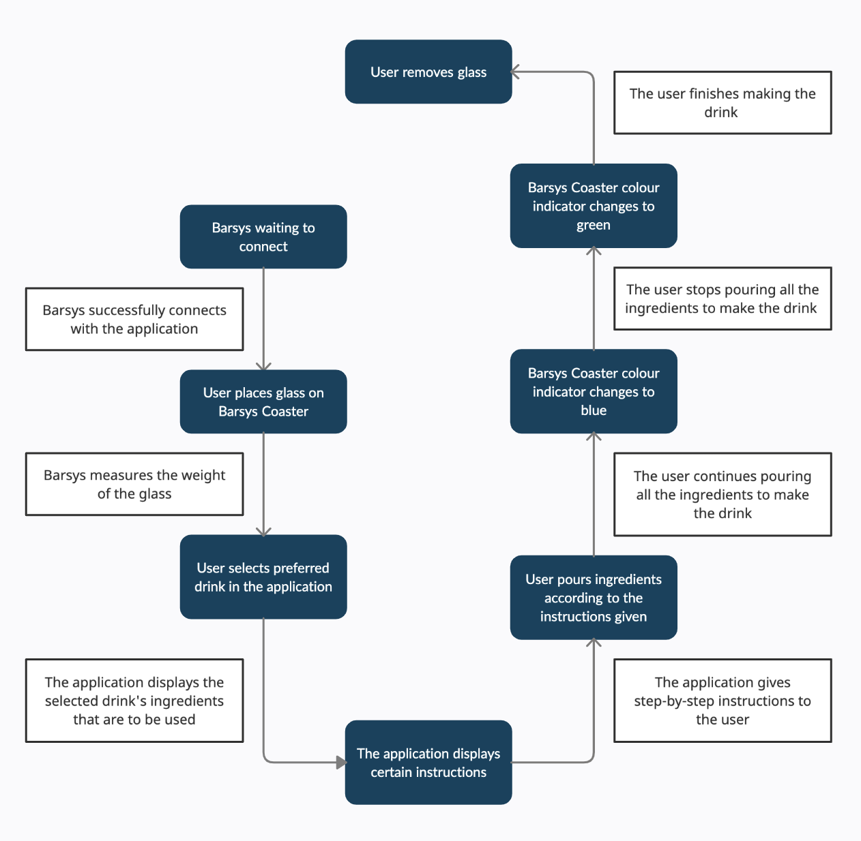
Figure 1 : State diagram of the Barsys Smart Coaster

4.0 : TRANSITION TABLE

δ\Σ | Signal from Application | Weight | Color Changed
q0 | q1 | - | -
q1 | - | q2 | -
q2 | q3 | q3 | -
q3 | q4 | - | -
q4 | q5 | - | q5
q5 | q6 | - | q6
q6 | q7 | - | q7
q7 | - | - | -

5.0 : CONCLUSION

To sum up everything that has been stated, the Barsys Coaster is a smart device that will help users to make a drink at any certain time they want with the precise ingredient without the need to go to a bar or without the presence of a bartender. To use the Barsys Coaster, the user needs to install the Barsys Coaster application into their mobile devices. The application is available on both Android and also IOS platform. The user needs to connect the application to their Barsys Coaster device. In the formal definition of Barsys Coaster, we have defined the states(Q), alphabet(Σ), transition(δ), starting state(q0) and final state(F). For the Barsys Coaster, it consists of a total 8 states which include Barsys waiting for connection as the start state(q0) until instructing the user to pick up the glass as the final state(F). For the alphabet(Σ), we have the signal from the application, weight and the change of colour indicator. In the state diagram, we have explained all transitions between each state. Other than that, in the transition table, we have defined all of the possible alphabets or the data transmitted from the sensor that are in each state.

6.0 : APPENDIX

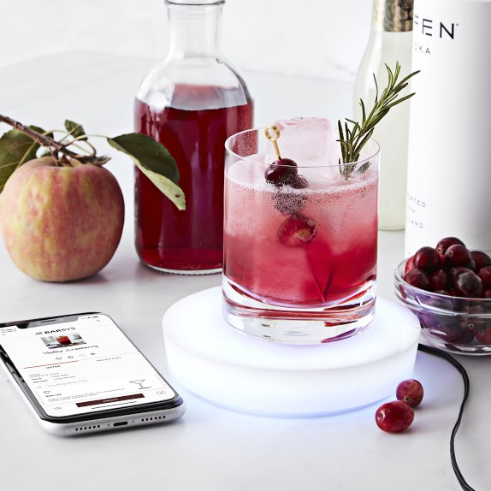
Figure 2 : Image of the Barsys Smart Coaster
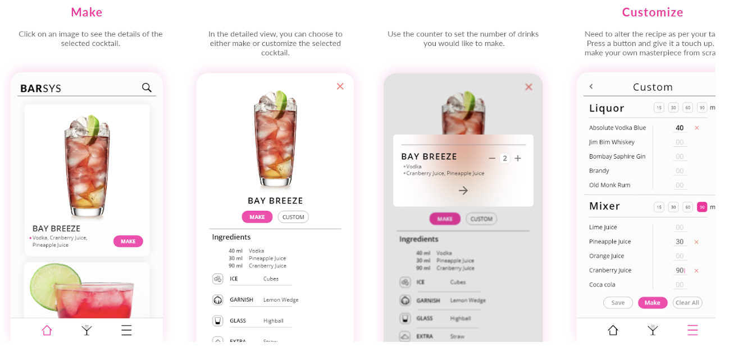
Figure 3 : Image of the Barsys Smart Coaster Application System

7.0 : REFERENCES
- Nelson’s Guide. (2020, September 21). Barsys Smart Coaster - Robot cocktail maker for home. YouTube. https://www.youtube.com/watch?v=D1nxb4LtacE
- In The Know. (2020, January 28). Barsys smart coaster helps you mix over 2,000 different cocktails. YouTube. https://www.youtube.com/watch?v=eBYTDvLcqqQ
- Mashable. (2020, March 3). Can A SMART COASTER Make a Better Drink Than A Bartender? Mashable. YouTube. https://www.youtube.com/watch?v=uXmmvrVHbd4
- Barsys LLC. (2021, May 11). Barsys US | Bring The Bar Home. https://thebarsys.com/

