

UNIVERSITI TEKNOLOGI MALAYSIA
FACULTY OF ENGINEERING
SCHOOL OF COMPUTING
SESSION 2020/2021 SEMESTER 1

SCSJ3553 ARTIFICIAL INTELLIGENCE SECTION 11
PROJECT: FINAL REPORT

THEME: Smart Closet

Group members:
- MUHAMMAD AMIRUL BIN ISMAIL (A18CS0126)
- LEE HUEY MIIN (A18CS0096)
- NURUL NAJIHA BINTI HAMDAN (B19EC0047)
- AQILAH HANIM BINTI MOHD TAUFIK (B19EC0006)

Lecturer: DR AIDA BINTI ALI
Youtube Link: https://youtu.be/m9MCIA22d88

TABLE OF CONTENT

1.0 AI Solution 3
2.0 Goal of AI solution 3
3.0 Process of Empathize in Design Thinking (DT) 4
4.0 Process of Define in Design Thinking (DT) 6
5.0 Knowledge Representation 7
5.1 Problem 7
5.2 Knowledge Representation 10
5.3 Explanation of KR that solved the goals 16
6.0 State Space Search 17
6.1 Details of State and Action 17
6.2 Hypergraph 19
6.3 Problem Formulation by specifying four things: Initial state, Actions, Goal, Path Cost 21
6.4 Sequence of Actions Leading from Initial State to Goal State 23
6.5 Explanation of Formulate Problem to support the Proposed KR 24
7.0 PEAS Model 25
7.1 Formulate The Solution By Using PEAS model 25
7.2 PEAS Model 27
7.2.1 PEAS Model Diagram 28
7.2.2 Property representation in Proof of Concept (POC) 29
7.3 How does the agent in Artificial Intelligence behave and achieve the goal in the proposed product? 30
8.0 POC explanation 31
9.0 Minute Meeting 37

1.0 AI Solution
In this modern era, all things need to be done quickly and efficiently. The presence of software and modern technology affects our daily lifestyle. The improvement of living standards lead to more people being overloaded by their jobs, and at the same time put emphasis on their daily dressing. Sometimes, people are facing problems deciding the outfits they wear today, and use a lot of time on this matter. The shape of the closet as well as too many clothes make it very difficult to find a piece of clothing. Lots of unfolded clothes are also a problem for those who are busy working because they have no time to do that.
Our main target of this application is to provide convenience to the public, especially busy individuals to make it easier for them to manage their closet. "Smart closet" is able to solve all those problems. The main function of this "smart closet" is to help users to fo ld and hang clothes, at the same time arrange the clothes orderly in the closet.

2.0 Goal of AI solution
- To help users who do not have the sufficient time to organize their closet as they are busy with their work or doing other chores.
- To help children who are still too young to learn how to organize their own closets.
- To provide an automatic solution to differentiate types of cloth and arrange it according to cloth types.
- To make sure that users’ closet will always be clean and well-arranged.
- To help users to differentiate cloth type, and handle the particular cloth according to cloth type.

3.0 Process of Empathize in Design Thinking (DT)
Before starting the process of empathize, we had to make a survey through the problem we would like to investigate. We conduct the investigation through fews methods, which are:
- Making a simple survey with friends and family
- Through Internet
- Observe problem in surrounding
The group of our target interviewee is:
- house wife
- children
- adults
We decided to use empathy map as a tool to capture the valuable information from interviewee. We can capture what the user say, think, do, feel.
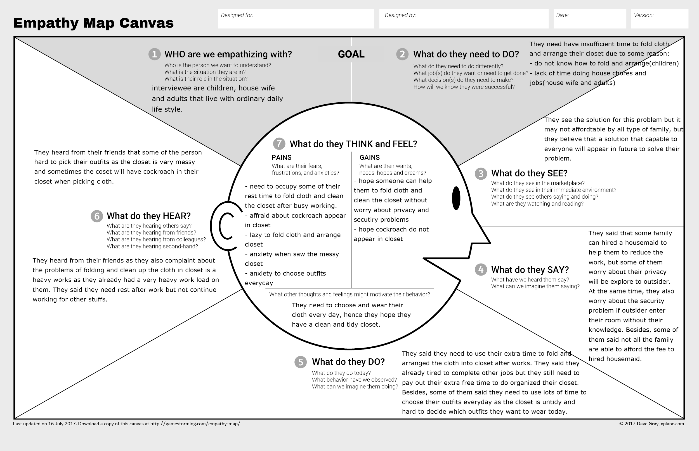

4.0 Process of Define in Design Thinking (DT)
Based on the problem statement that the user responds after conducting observation and simple survey between friends and family members, people who are facing problems about it are housewives, children and working adults. This application would help users to sort out their clothes after washing and drying without folding by their own. They do not have sufficient time to fold clothes and organize their closet. Hence, this application will help our users to simplify their daily workload without worrying much since a lot of house chores are waiting to be done. In addition, users can rest assured that this application will help them live their day in ease without worrying and stressing what to wear everyday.
1. User
- A person who wants to have a clean and well-organized closet.
2. Need
- Require an artificial intelligent solution to help them to determine cloth types, fold or hang the clothes, and arrange the closet.
3. Insight
- The user would like to sort out the suitable clothes for themselves and the system using artificial intelligence.

5.0 Knowledge Representation

5.1 Problem
Current Issue:
When opening the closet, users found that their closet is always scattered with stuff and clothes. All this stuff is not in place. This makes them frustrated when they first view the closet. Since all the clothes and stuff are unorganized, sometimes they cannot find what they want in a short time. Besides, their emotion will be affected when they see the scattered closet.
From the survey, our team found that most of the users do not have sufficient time to arrange their clothes and closet as some of them are busy for work(working adults), doing other house chores(house wife) and do not know how to organize their closet(children).

Introducing Smart Closet:
Smart closet will help the user automatically separate most of the cloth and help them to arrange their closet as well. First of all, users need to put all the cleaned cloth into the container provided outside the closet. Once the user has done putting all the clothes into the container, it will automatically start the process after the cloth is detected by the cloth detector and the closet’s door is closed.
Firstly, a cloth will be taken from the container and a scanner will scan to examine the type of cloth. The first scanner will scan whether the cloth is top or not. If yes, it will fold it and put into the drawer that places the cloth type of tops. If not, it will proceed with another scanner to determine whether it is a bottom or not. If yes, it will fold the bottom and put it into the drawer for the cloth type of bottom. If not, it will proceed to the scanner to determine whether it is a formal shirt (men or ladies) or not. If yes, it will hang the formal shirt with a hanger and hang it in the closet. If not, the particular cloth will be examined as an unrecognized cloth type. This unrecognized cloth type will be put into a container specified for unrecognized cloth type.
If there is no cloth left in the initial container, the process will stop.
Users can arrange the unrecognized cloth type by themselves in a very short time as Smart Closet has arranged for most of the clothes. This can save users time and provide them a cleaner and highly organized closet.
All the knowledge representation of Smart Closet is shown as figure below:
cloth_detector | closet_door_control | cloth_arrange_system
1 | 1 | Activate
1 | 0 | Not activate
0 | 1 | Not activate
0 | 0 | Not activate
criteria to activate the cloth arrange system(fold, hang, arrange operation).

Cloth_arrange _system | is_top | fold_indicator
1 | 1 | 1
1 | 0 | 0
0 | 1 | 0
0 | 0 | 0
Determine the cloth type for top.

Cloth_arrange _system | is_bottom | fold_indicator
1 | 1 | 1
1 | 0 | 0
0 | 1 | 0
0 | 0 | 0
Determine the cloth type for bottom.

Cloth_arrange _system | is_shirt | hang_indicator
1 | 1 | 1
1 | 0 | 0
0 | 1 | 0
0 | 0 | 0
Determine the cloth type for shirt.

5.2 Knowledge Representation
KR1
IF cloth_detector = on AND closet_door_lock = on THEN cloth_arrange_system = on

Explanation
If the cloth detector detects the existence of clothes and the closet door lock is on, then the cloth arrangement system is activated.

First Order Logic(FOL)
∀x ∀y ((cloth_detector(x) ∧ detect_cloth(x)) ∧ (closet(y) ∧ lock(y))) ➝ ∃z (cloth_arrange_system(z) ∧ activate(z))

KR2
IF cloth_detector = on AND closet_door_lock = off THEN cloth_arrange_system = off

Explanation
If the cloth detector detects the existence of clothes but the closet door lock is off, then the cloth arrangement system is deactivated.

First Order Logic(FOL)
∀x ∀y ((cloth_detector(x) ∧ ￢(detect_cloth(x))) ∧ (closet(y) ∧ ￢(lock(y)))) ➝ ∃z (cloth_arrange_system(z) ∧ ￢(activate(z)))

KR3
IF cloth_detector = off AND closet_door_lock = on THEN cloth_arrange_system = off

Explanation
If the cloth detector does not detect the existence of clothes but the closet door is on, then the cloth arrangement system is deactivated.

First Order Logic(FOL)
∀x ∀y ((cloth_detector(x) ∧ ￢(detect_cloth(x))) ∧ (closet(y) ∧ lock(y))) ➝ ∃z (cloth_arrange_system(z) ∧ ￢(activate(z)))
KR4
IF cloth_detector = off AND closet_door_lock = off THEN cloth_arrange_system = off

Explanation
If the cloth detector does not detect the existence of clothes and the closet door is off, then the cloth arrangement system is deactivated.

First Order Logic(FOL)
∀x ∀y ((cloth_detector(x) ∧ ￢(detect_cloth(x))) ∧ (closet(y) ∧ ￢(lock(y))) ➝ ∃z (cloth_arrange_system(z) ∧ ￢(activate(z)))

KR5
IF cloth_arrange_system = on AND is_top = TRUE THEN fold_indicator = TRUE

Explanation
If the cloth arrangement system is activated and the cloth is recognized as top, it will fold the particular cloth in the closet and put the cloth into the drawer label with ‘top’.

First Order Logic(FOL)
∀x ∀y ((cloth_arrange_system(x) ∧ activate(x)) ∧ (cloth(y) ∧ top(y))) ➝ ∃z (top(y) ∧
fold_indicator(z))

KR6
IF cloth_arrange_system = on AND is_top = FALSE THEN fold_indicator = FALSE

Explanation

If the cloth arrangement system is activated and the cloth is not recognized as top, it will not fold the cloth. The cloth will then pass to the next scanner which is used to determine bottom.

First Order Logic(FOL)
∀x ∀y ((cloth_arrange_system(x) ∧ activate(x)) ∧ (cloth(y) ∧ ￢(top(y)))) ➝ ∃z( top(y) ∧
￢(fold_indicator(z)))
KR7
IF cloth_arrange_system = off AND is_top = TRUE THEN fold_indicator = FALSE

Explanation
If the cloth arrangement system is not activated, and it recognizes the cloth as top, it will not fold the cloth. The cloth will then pass to the next scanner which is used to determine bottom.

First Order Logic(FOL)
∀x ∀y ((cloth_arrange_system(x) ∧ ￢(activate(x))) ∧ (cloth(y) ∧ top(y))) ➝ ∃z( top(y) ∧
￢(fold_indicator(z)))

KR8
IF cloth_arrange_system = off AND is_top = FALSE THEN fold_indicator = FALSE

Explanation
If the cloth arrangement system is not activated, and it does not recognize the cloth as top, it will not fold the cloth. The cloth will then pass to the next scanner which is used to determine bottom.

First Order Logic(FOL)
∀x∀y ((cloth_arrange_system (x) ∧ ￢(activate (x))) ∧ (cloth (y) ∧ ￢(top (y))) ➝ ∃z ( top(y) ∧
￢(top_indicator (z)))

KR9
IF cloth_arrange_system = on AND is_bottom = TRUE THEN fold_indicator = TRUE

Explanation
If the cloth arrangement system is activated, and the clothes are recognized as bottom, the clothes will be folded and put into the drawer label with ‘bottom’.

First Order Logic(FOL)
∀x∀y ((cloth_arrange_system (x) ∧ activate (x)) ∧ (cloth (y) ∧ bottom (y))) ➝ ∃z (bottom (y) ∧ fold_indicator (z))

KR10
IF cloth_arrange_system = on AND is_bottom = FALSE THEN fold_indicator = FALSE

Explanation
If the cloth arrangement system is activated, and the clothes are not recognized as bottom, the clothes will not be folded. The cloth will then pass to the next scanner which is used to determine formal shirts.

First Order Logic(FOL)
∀x∀y ((cloth_arrange_system (x) ∧ activate (x)) ∧ (cloth(y) ∧ ￢(bottom(y)))) ➝ ∃z( bottom (y) ∧ ￢(fold_indicator (z)))

KR11
IF cloth_arrange_system = off AND is_bottom = TRUE THEN fold_indicator = FALSE

Explanation
If the cloth arrangement system is not activated, and the clothes are recognized as bottom, the clothes will not be folded. The cloth will then pass to the next scanner which is used to determine formal shirts.

First Order Logic(FOL)
∀x ∀y ((cloth_arrange_system (x) ∧ ￢ (activate (x))) ∧ (cloth (y) ∧ ￢(bottom (y))) ➝ ∃z( bottom (y) ∧ ￢(bottom_indicator (z)))

KR12
IF cloth_arrange_system = off AND is_bottom = FALSE THEN fold_indicator = FALSE

Explanation
If the cloth arrangement system is not activated, and the clothes are not recognized as bottom, the clothes will not be folded. The cloth will then pass to the next scanner which is used to determine formal shirts.

First Order Logic(FOL)
∀x∀y ((cloth_arrange_system (x) ∧ ￢(activate (x))) ∧ (cloth (y) ∧ ￢(bottom (y)))) ➝ ∃z( bottom (y) ∧ ￢(bottom_indicator (z)))

KR13
IF cloth_arrange_system = on AND is_shirt = TRUE THEN hang_indicator = TRUE

Explanation
If the cloth arrangement system is activated and the cloth is recognized as men or ladies shirts, it will hang the particular cloth in the closet since the cloth will not be put back to the container which the cloth cannot be determined.

First Order Logic(FOL)
∀x ∀y ((cloth_arrange_system(x) ∧ activate(x)) ∧ (cloth(y) ∧ shirt(y))) ➝ ∃z( shirt(y) ∧
hang_indicator(z))

KR14
IF cloth_arrange_system = on AND is_shirt = FALSE THEN hang_indicator = FALSE
Explanation
If the cloth arrangement system is activated and the cloth is not recognized as men or ladies shirts, it will not hang the cloth. The cloth will be put in a container with unrecognized cloth.

First Order Logic(FOL)
∀x ∀y ((cloth_arrange_system(x) ∧ activate(x)) ∧ (cloth(y) ∧ ￢(shirt(y)))) ➝ ∃z( shirt(y) ∧
￢(hang_indicator(z)))

KR15
IF cloth_arrange_system = off AND is_shirt = TRUE THEN hang_indicator = FALSE

Explanation
If the cloth arrangement system is not activated, and it recognizes the cloth as men or ladies shirts, it will not hang the cloth. The cloth will be put in a container with unrecognized cloth.

First Order Logic(FOL)
∀x ∀y ((cloth_arrange_system(x) ∧ ￢(activate(x))) ∧ (cloth(y) ∧ shirt(y))) ➝ ∃z (shirt(y) ∧
￢(hang_indicator(z)))

KR16
IF cloth_arrange_system = off AND is_shirt = FALSE THEN hang_indicator = FALSE

Explanation
If the cloth arrangement system is not activated, and it recognizes the cloth as men or ladies shirts, it will hang the cloth. The cloth will be put in a container with unrecognized cloth.

First Order Logic(FOL)
∀x ∀y ((cloth_arrange_system(x) ∧ ￢(activate(x))) ∧ (cloth(y) ∧ ￢(shirt(y)))) ➝ ∃z( shirt(y) ∧
￢(hang_indicator(z)))

5.3 Explanation of KR that solved the goals
- The goal of this smart closet is to create an AI that is able to fold or hang the cloth into a closet and at the same time arrange it into the closet. In order to start the folding and hanging process, the smart closet will detect the existence of cloth by using a cloth detector. Another criteria to activate the folding and hanging process is the door of the closet must be closed during the operation. When cloth is detected by a cloth detector and the closet’s door is closed, the closet will start to fold or hang the cloth and arrange it in the closet. The knowledge representation for this function is KR1, KR2, KR3, and KR4.
- The smart closet needs to determine the type of cloth first before deciding to fold or hang it. To examine the type of cloth, a few clothes scanners are used in this AI. Each scanner has its own work to determine each type of cloth, which are top, bottom and formal shirt. When the cloth is examined as top, it will fold the cloth and put the cloth to the top’s drawer. If the cloth is not a top, it will pass it to the next scanner(bottom’s scanner) to examine it. The knowledge representation for this function is KR5, KR6, KR7, and KR8.
- If the cloth is examined as a bottom, it will fold the cloth and put it into the bottom’s drawer. If the cloth is not a bottom, it will pass to the next scanner(shirt’s scanner) to examine it. The knowledge representation for this function is KR9, KR10, KR11, and KR12.
- If the cloth is examined as a formal shirt, it will hang the cloth in the closet. If the cloth is not a shirt, it will place the cloth into a container, which is specified for all the unrecognized cloth types. Users may arrange into the closet by their own since the closet had arranged most of the cloth into the closet. The knowledge representation for this function is KR13, KR14, KR15, and KR16.

6.0 State Space Search

6.1 Details of State and Action
1st State: Cloth detector will detect the existence of clothes. If no cloth is detected, the cloth arrangement system will remain inactive.

2nd State: Cloth arrangement system will activate the scanner to recognize the cloth whether it is a top or not. It will fold the cloth if the particular cloth is recognized as a top. If cloth is not recognized as top, it will pass to the scanner for cloth type bottom.

3rd State: Cloth arrangement system will activate the scanner to recognize the cloth whether it is a bottom or not. It will fold the cloth if the particular cloth is recognized as a bottom. If cloth is not recognized as bottom, it will pass to the scanner for cloth type formal shirts.

4th State: Cloth arrangement system will activate the scanner to recognize the cloth whether it is a formal shirt or not. It will hang the cloth if the particular cloth is recognized as a formal shirt. If cloth is not recognized as formal shirts, it will be recognized as unrecognized clothes and will be placed in a special container in the closet.

- The cloth arrangement option will be activated when both cloth detector and closet door control are recognized and functioning in the system.

Overview Action Graph
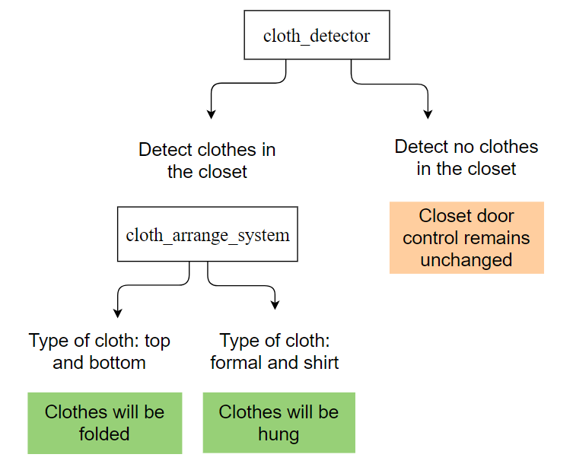

6.2 Hypergraph
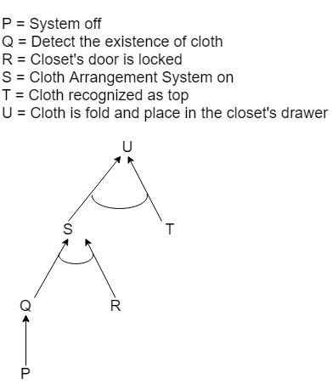

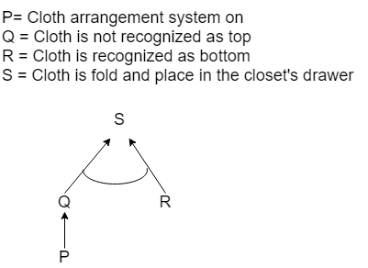
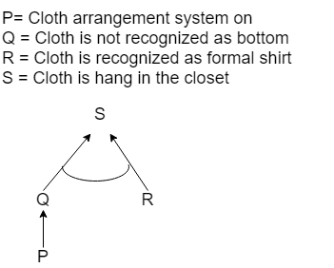

6.3 Problem Formulation by specifying four things: Initial state, Actions, Goal, Path Cost
- Initial State: No cloth detected
- Action: Hung/Fold
- Goal: A cloth is fold/hung in a closet
- Path Cost: 1 unit per action

Table of problem formulation:
 | Clothes Detector | Door control | Cloth Scanner | Action
1 |  |   open/lock | No Clothes Detected | No Action
2 | Detect | open | 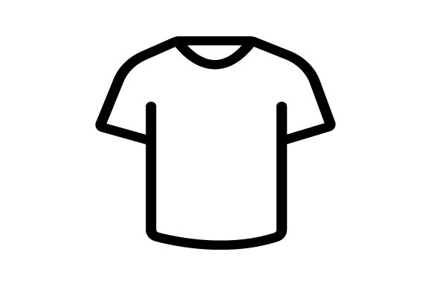  Top Bottom Formal  Shirt | No Action
3 | Detect | lock | Top |   Fold
4 | Detect | lock | Bottom | Fold
5 | Detect | lock | Formal Shirt |   Hung
6 | Detect | lock | Not a top | Move to scanner for cloth type ‘bottom’
7 | Detect | lock | Not a bottom | Move to scanner for cloth type ‘formal shirts’
8 | Detect | lock | Not a formal shirt | Place cloth to a special container
9 | Detect | lock | Top, bottom or shirts | Fold  Hung

6.4 Sequence of Actions Leading from Initial State to Goal State

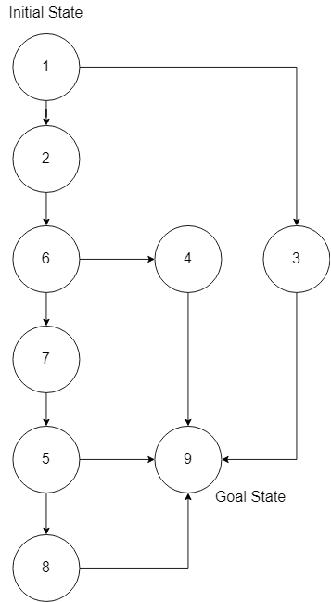

6.5 Explanation of Formulate Problem to support the Proposed KR
Based on the table of problem formulation:
- If no existence of clothes is detected, and the closet’s door is either opened or locked, no action will be taken by the closet since the cloth arrangement system is not activated. This is shown in KR3 and KR 4. The closet will remain the current state, which is an inactive state.
- If the existence of clothes is detected, and the closet’s door is opened, no action will be taken by the closet since the cloth arrangement system is not activated. This is shown in KR2, KR7, KR8, KR11, KR12, KR15 and KR16. The closet will remain the current state, which is an inactive state.
- If the existence of cloth is detected, and the cloth is recognized as a top, it will fold the particular cloth. This is shown in KR1 and KR5 and the cloth will be folded.
- If the existence of cloth is detected, and the cloth is recognized as a bottom, it will fold the particular cloth. This is shown in KR1 and KR9 and the cloth will be folded.
- If the existence of cloth is detected and the cloth is recognized as a formal shirt, it will hang the particular cloth in the closet. This is shown in KR1 and KR13 and the cloth will be hung.
- If the existence of clothes is detected, and the particular cloth is not recognized as a top, it will activate the scanner for bottom to do recognition. This is shown in KR1 and KR6 and the cloth will pass to the bottom scanner state.
- If the existence of clothes is detected, and the particular cloth is not recognized as a bottom, it will activate the scanner for formal shirts to do recognition. This is shown in KR1 and KR10 and the cloth will pass to the formal shirts scanner state.
- If the existence of clothes is detected, and the particular cloth is not recognized as a formal shirt, it will shift the clothes to the special container, which are labelled for unrecognized clothes. This is shown in KR1 and KR14.
- If the existence of clothes is detected, and the clothes are top or bottom or formal shirt, it will fold or hang the cloth in the closet. This is shown in KR1, KR5, KR9 and KR13.

7.0 PEAS Model

7.1 Formulate The Solution By Using PEAS model
 | Before Applying Smart Closet | After Applying Smart Closet
P:  Performance Measure | - Closet is not well arranged and always accumulates with a lot of stuff.  - Clothes are not folded or hung. | - Closet will be arranged orderly by the system.  - Smart Closet will help them to fold or hang the clothes in the closet according to the cloth type (top, bottom, formal shirt).
E:  Environment | - Users need to spend some of their precious time to fold and arrange the closet cause users do not have time to do other things.  - Messy closets make users difficult to find their stuff, sometimes will cause bad emotion when they see the messy condition in the closet. | - Save users time to fold, hang or arrange the closet.  - Closet always appears clean and tidy promotes good emotion.  - All the stuff in the closet is clearly labelled hence not difficult when finding stuff.
A:  Actuators  /  Effectors | - Users need to fold, hang, and arrange clothes into the closet manually. | - Users just need to collect washed clothes and place it into a container that is connected to the Smart closet as Smart Closet will help them to differentiate, fold and hang the clothes into the closet.
S:  Sensor | - No sensor is used to detect type of cloth. | - Cloth detector to detect the existence of cloth.  - Cloth type detector to differentiate top, bottom and formal shirt.  - If it is a top or a bottom, the Smart closet will fold and put them into their respective drawer.  - If it is a formal shirt, the Smart closet will hang it in the drawer.  - If it is not recognized as above cloth type, the Smart closet will place it into another drawer to let the user to arrange it.

7.2 PEAS Model
Agent: Smart Closet
Performance measure: time, tidy, accurate cloth recognition, safety
- The Smart Closet helps users to save their time spending on fold and arrange the cloth into the closet since the machine will automatically help them to fold and arrange clothes.
- All the cloth will be arranged according to the cloth type, making the closet appear clean and tidy.
- Smart closet can recognize the cloth type accurately as it is assisted by a high tech sensor which is able to analyse the common characteristic of clothes and compare to the knowledge base towards cloth type. For any unrecognized cloth, a Smart closet will place it into another container to avoid mixing with recognized clothes.

Environment: Cloth, closet, closet owner
- The environment is basically inside the closet.
- Clothes are required to recognize and arrange according to their cloth types.
- Closet owners oftenly use the closet to pick or keep their clothes.

Actuators: Fold cloth machine, hang cloth machine, placing machine
- Fold cloth machine is to fold tops and bottoms.
- Hang cloth machine is to hang formal shirts.
- Placing machine will place tops and bottoms to respective drawers. Besides, placing machines will place unrecognized clothes into a container for unrecognized cloth.

Sensors: Cloth detector, cloth type detector
- Cloth detectors will detect the existence of cloth in the initial container.
- Cloth type detector will detect the cloth type according to the characteristic of each cloth type.

7.2.1 PEAS Model Diagram
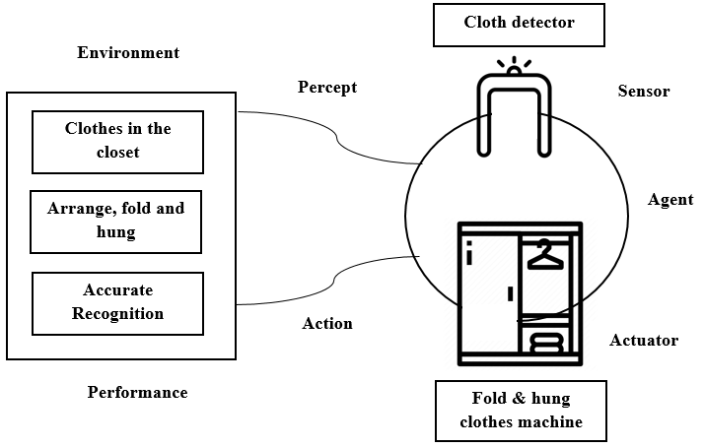

7.2.2 Property representation in Proof of Concept (POC)

How will every element be present in POC?
- Performance
- The goal is to make sure that all the cloth is arranged in a designated place. After implementing Artificial Intelligence, it is expected to reduce the user's time to fold clothes and arrange them in the closet. Clothes also expected to be recognized and arranged accurately.

- Environment
- The clothes will be used to show how the clothes are folded or hung by a smart closet. It is also to show how users can save time by placing unfolded clothes in the closet.

- Actuator
- The action that will be shown is Smart Closet will identify and differentiate the type of clothing and then choose whether to hang or fold the clothes based on its type. Smart Closet will pick up the cloth that had been placed inside the container.

- Sensors
- The cloth detector and a cloth type detector will be used as input data so that the cloth will be arranged at designated places. A simulation will be used to show the situation when data input was received.

7.3 How does the agent in Artificial Intelligence behave and achieve the goal in the proposed product?
The agent behaves as a simple reflex agent because it takes an action based on only the current environmental situation. It maps the current percept into the proper action ignoring the history of it. This system is in an infinite loop, each percept contains a state of the current location which is [the system is on when clothes detected] or [the system is off when no clothes detected] and the system will decide whether to [fold clothes] or [hang clothes] depending on the type of clothes.

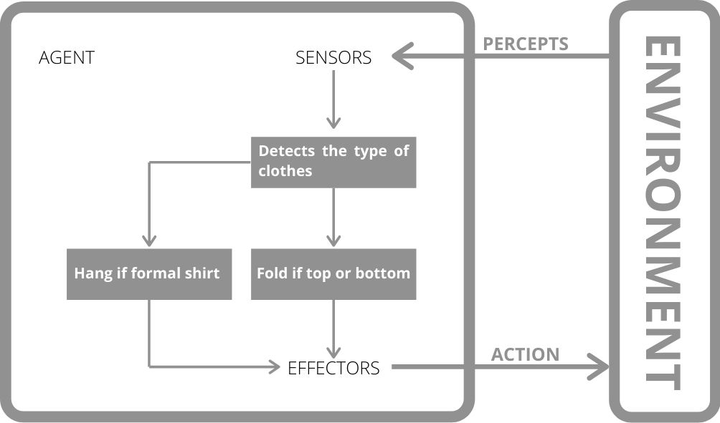

8.0 POC explanation
From the survey, we had found some of the problems of users according to the closet. They wish to have a tidy closet, in fact they have no time to arrange their stuff orderly in the closet making it appear messy. Besides, some of the users like children unable to arrange the closet by themselves as they only will put everything into any place in the closet. Another problem is that the user who is busy for work also has less time to arrange the washed cloth into the closet. Due to these problems, we had decided to design ‘Smart Closet’ to help them in closet management. This Smart Closet will work when detecting the cloth and it will automatically help the user to arrange the cloth. Users just need to take their washed clothes to the closet, and just wait for the closet to differentiate and arrange the cloth for them.
For our POC design, as we were staying at home and far away from each other, we are unable to do our own prototype for the closet. As replacement, we are designing an application prototype to represent the logic and function of our projects.
The initial state of the closet is no cloth is detected by the cloth detector. The closet will change its state according to the existence of cloth and the cloth type, eventually will reach the goal state, in which the cloth is folded or hung in the closet. When a user is placing a lot of cloth into the closet, the cloth detector will detect and activate the cloth arrangement system. From these clothes, the closet will pick a cloth and try to identify the type of cloth. According to the cloth type, the closet will decide how they handle the selected cloth.

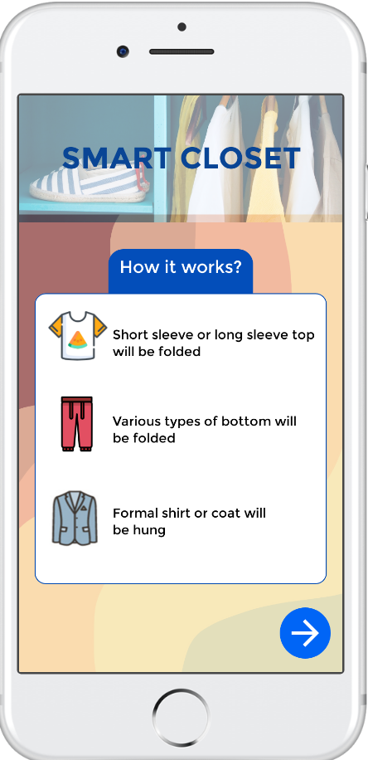

In this prototype, we had selected various clothes to demo our closet.

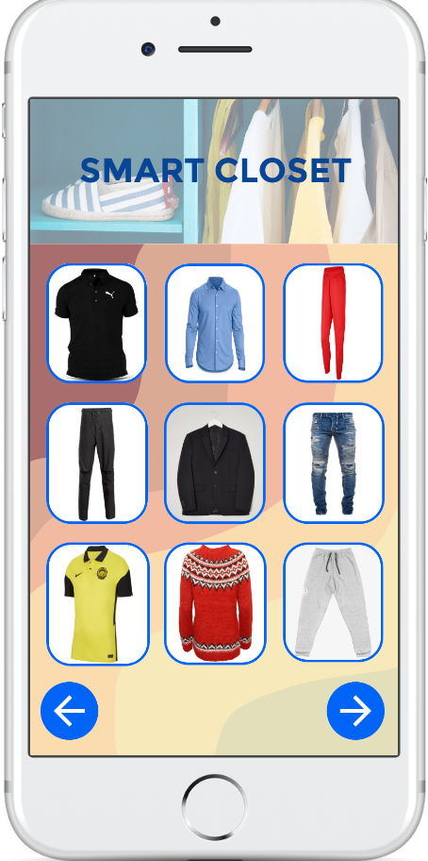
Closet will differentiate the type of cloth according to the feature and characteristic of cloth. For example, tops commonly will have a short sleeve. Closet will have a detector to collect the characteristics of the selected cloth and compare with the data in the knowledge base.
If the cloth is detected as top, the closet will fold the cloth. This implements KR1 and KR5.

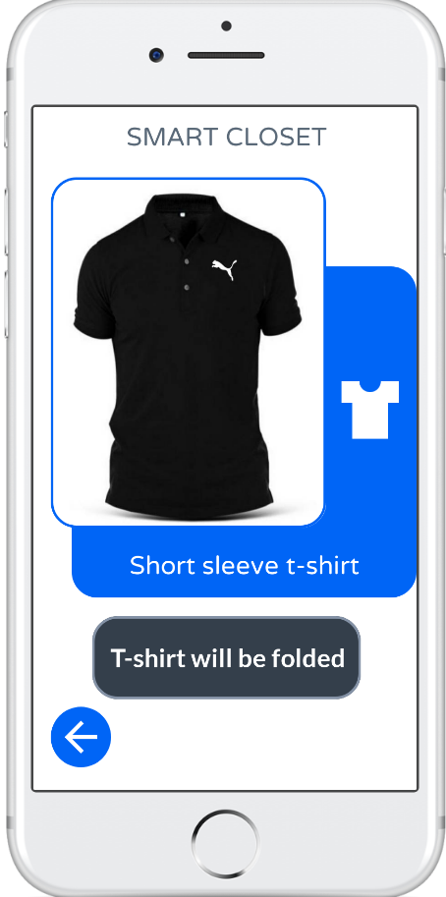

For the bottom, it usually had the characteristic of trousers. If the cloth is detected as a bottom, it will fold it. This implements KR1 and KR9.
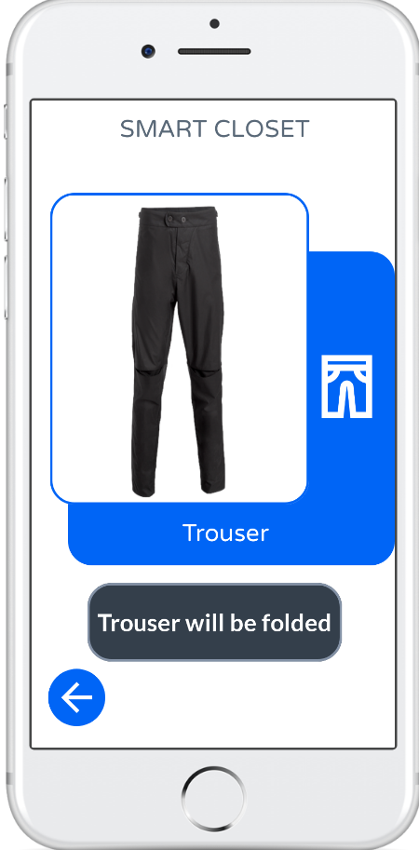

For the formal shirt, it usually had a long sleeve and a row of buttons at the front of the cloth. If the cloth is detected as a shirt, it will hang the shirt. This implements KR1 and KR14.

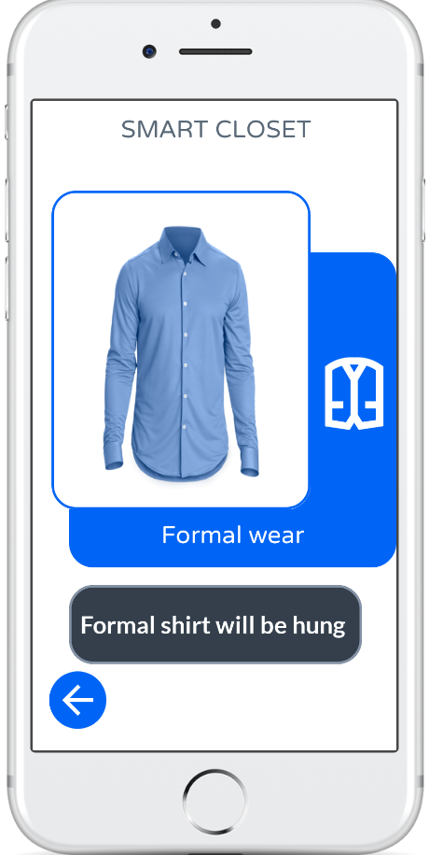
To view our application demo, please go to link below:
Youtube Link: https://youtu.be/m9MCIA22d88

9.0 Minute Meeting
1ST MEETING

Purpose : Project Proposal
Date : 11 November 2020
Time : 5.00 P.M
Venue : Google Meet

Attendance :
NO | NAME | ATTENDANCE
1 | LEE HUEY MIIN | PRESENT
2 | NURUL NAJIHA BINTI HAMDAN | PRESENT
3 | MUHAMMAD AMIRUL BIN ISMAIL | PRESENT
4 | AQILAH HANIM BINTI MOHD TAUFIK | PRESENT

Discussion :
- Propose idea on a project for Artificial Intelligence.
- Vote on Project (Decided on Smart Closet).
- Distribution of Task for Project Proposal.

Group Member | Task
Muhammad Amirul | AI Solution
Aqilah Hanim | The goal of AI Solution
Lee Huey Miin | Describe the process of Empathize in Design Thinking
Nurul Najiha | Describe the process of Define in Design Thinking

2ND MEETING

Purpose : Project Progress 2
Date : 30 November 2020
Time : 3.00 P.M
Venue : Google Meet

Attendance :
NO | NAME | ATTENDANCE
1 | LEE HUEY MIIN | PRESENT
2 | NURUL NAJIHA BINTI HAMDAN | PRESENT
3 | MUHAMMAD AMIRUL BIN ISMAIL | PRESENT
4 | AQILAH HANIM BINTI MOHD TAUFIK | PRESENT

Discussion :
- List down the Knowledge Representations found in the project.
- Distribution of Task for Project Progress 2.

Group Member | Task
Muhammad Amirul | - Knowledge Representation 5  - Knowledge Representation 6  - Knowledge Representation 7  - Knowledge Representation 8
Aqilah Hanim | - Knowledge Representation 9  - Knowledge Representation 10  - Knowledge Representation 11  - Knowledge Representation 12
Lee Huey Miin | - Knowledge Representation 13  - Knowledge Representation 14  - Knowledge Representation 15  - Knowledge Representation 16
Nurul Najiha | - Knowledge Representation 1  - Knowledge Representation 2  - Knowledge Representation 3  - Knowledge Representation 4

3RD MEETING

Purpose : Project Progress 3
Date : 17 December 2020
Time : 11.30 A.M
Venue : Whatsapp

Attendance :
NO | NAME | ATTENDANCE
1 | LEE HUEY MIIN | PRESENT
2 | NURUL NAJIHA BINTI HAMDAN | PRESENT
3 | MUHAMMAD AMIRUL BIN ISMAIL | PRESENT
4 | AQILAH HANIM BINTI MOHD TAUFIK | PRESENT

Discussion :
- Distribution of Task for Project Progress 3.

Group Member | Task
Muhammad Amirul | Solution : Sequence of actions leading Initial State to Goal State
Aqilah Hanim | Formulate problem by specifying Initial State, Actions, Goal and Path Cost
Lee Huey Miin | Drawing the Graph and Explanation
Nurul Najiha | Details of State and Action

4TH MEETING

Purpose : Project Progress 4
Date : 9 January 2021
Time : 2.00 P.M
Venue : Whatsapp

Attendance :
NO | NAME | ATTENDANCE
1 | LEE HUEY MIIN | PRESENT
2 | NURUL NAJIHA BINTI HAMDAN | PRESENT
3 | MUHAMMAD AMIRUL BIN ISMAIL | PRESENT
4 | AQILAH HANIM BINTI MOHD TAUFIK | PRESENT

Discussion :
Distribution of Task for Project Progress 4.

Group Member | Task
Muhammad Amirul | Property Representation in Proof of Concept (POC)
Aqilah Hanim | How agent in AI behave & achieve goal in the proposed product
Lee Huey Miin | PEAS Model
Nurul Najiha | PEAS Model Diagram

5TH MEETING

Purpose : Final Report
Date : 29 January 2021
Time : 2.30 P.M
Venue : Google Meet

Attendance :
NO | NAME | ATTENDANCE
1 | LEE HUEY MIIN | PRESENT
2 | NURUL NAJIHA BINTI HAMDAN | PRESENT
3 | MUHAMMAD AMIRUL BIN ISMAIL | PRESENT
4 | AQILAH HANIM BINTI MOHD TAUFIK | PRESENT

Discussion :
- Prototype Sketching
- Distribution of Task for Final Report.

Group Member | Task
Muhammad Amirul | Prototype and Documentation
Aqilah Hanim | Prototype and Documentation
Lee Huey Miin | Prototype and Documentation
Nurul Najiha | Prototype and Documentation

6TH MEETING

Purpose : Final Report & Video
Date : 4 February 2021
Time : 9.00 P.M
Venue : Google Meet

Attendance :
NO | NAME | ATTENDANCE
1 | LEE HUEY MIIN | PRESENT
2 | NURUL NAJIHA BINTI HAMDAN | PRESENT
3 | MUHAMMAD AMIRUL BIN ISMAIL | PRESENT
4 | AQILAH HANIM BINTI MOHD TAUFIK | PRESENT

Discussion :
- Discuss about video and report.

Group Member | Task
Muhammad Amirul | Video
Aqilah Hanim | Video
Lee Huey Miin | Documentation
Nurul Najiha | Documentation

