

UNIVERSITI TEKNOLOGI MALAYSIA
FACULTY OF ENGINEERING
SCHOOL OF COMPUTING
SESSION 2020/2021 SEMESTER 1

SCSJ3553 ARTIFICIAL INTELLIGENCE SECTION 11
PROJECT: DESIGN THINKING PROJECT PROPOSAL

THEME: Smart Closet

Group members:
- MUHAMMAD AMIRUL BIN ISMAIL (A18CS0126)
- LEE HUEY MIIN (A18CS0096)
- NURUL NAJIHA BINTI HAMDAN (B19EC0047)
- AQILAH HANIM BINTI MOHD TAUFIK (B19EC0006)

Lecturer: DR AIDA BINTI ALI
AI Solution
In this modern era, all things need to be done quickly and efficiently. The presence of software and modern technology affects our daily lifestyle. The improvement of living standards lead to more people being overloaded by their jobs, and at the same time put emphasis on their daily dressing. Sometimes, people are facing problems deciding the outfits they wear today, and use a lot of time on this matter. The shape of the closet as well as too many clothes make it very difficult to find a piece of clothing. Lots of unfolded clothes are also a problem for those who are busy working because they have no time to do that.
Our main target of this application is to provide convenience to the public, especially busy individuals to make it easier for them to manage their closet. "Smart closet" is able to solve all those problems. The main function of this "smart closet" is to give users suggestions on what clothes are suitable to wear on the day. Users are also able to match their clothes through the system in this "smart closet" system. In addition, this "smart closet" is capable of folding clothes and arranging the clothes according to the best method or taste of the user.

Goal of AI solution
- To create an AI that will make it easier for users to choose and arrange their daily wear effortlessly.
- Help users to pick out their daily wear without them needing to find the clothes themselves.
- To provide an AI that will specify the best option of clothes for the users to wear throughout the day.
- To update which clothes are available, and which are not in the closet.
- To organize the clothes that the user owns by colour code and type of clothing.
- To help users who do not have the sufficient time to organize their closet as they are busy with their work or doing other chores.
- To help children who are still too young to learn how to organize their own closets.
Process of Empathize in Design Thinking (DT)
Before starting the process of empathize, we had to make a survey through the problem we would like to investigate. We conduct the investigation through fews methods, which are:
- Making a simple survey with friends and family
- Through Internet
- Observe problem in surrounding
The group of our target interviewee is:
- house wife
- children
- adults
We decided to use empathy map as a tool to capture the valuable information from interviewee. We can capture what the user say, think, do, feel.
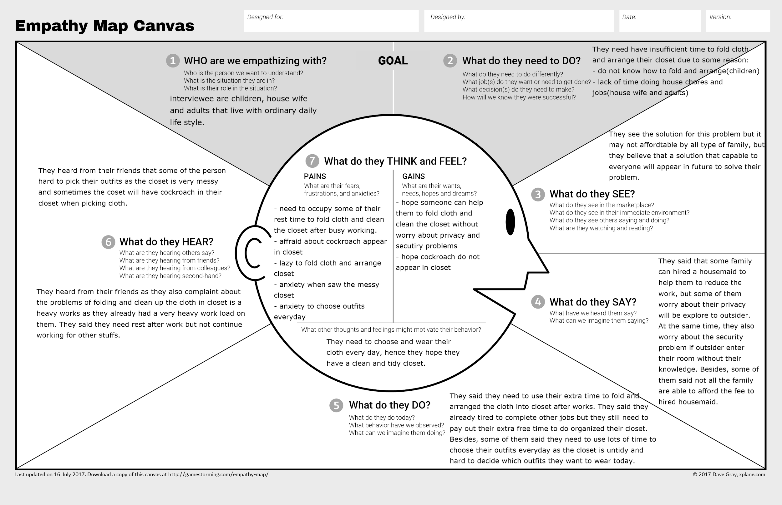
Process of Define in Design Thinking (DT)
Based on the problem statement that the user responds after conducting observation and simple survey between friends and family members, people who are facing problems about it are housewives, children and working adults. They are dealing with the problem of sorting out clothes after using and washing along with choosing their own clothes for outfit of the day during working days and free time. From the observation, there are problems but the solutions and alternatives to that problem are not easy to execute. But in the future, this problem can be solved by finding another way that could help the users using artificial intelligence technology.
The target users for this application are housewives, children, and working adults. This application would help users to sort out their clothes after washing and drying without folding by their own. They do not have sufficient time to fold clothes and organize their closet. Hence, this application will help our users to simplify their daily workload without worrying much since a lot of house chores are waiting to be done. In addition, users can rest assured that this application will help them live their day in ease without worrying and stressing what to wear everyday.
1. User
- A person who wants to choose their clothes from the closet to wear for outfit of the day using artificial intelligence help.
2. Need
- To pick suitable outfits of the day from head to toes and the system is arranged together with sorting the clothes in the closet.
3. Insight
- The user would like to sort out the suitable clothes for themselves and the system using artificial intelligence.

