

UNIVERSITI TEKNOLOGI MALAYSIA
FACULTY OF ENGINEERING
SCHOOL OF COMPUTING
SESSION 2020/2021 SEMESTER 1

SCSJ3553 ARTIFICIAL INTELLIGENCE SECTION 11
PROJECT: Smart Closet
Progress 3
State Space Search

Group members:
- MUHAMMAD AMIRUL BIN ISMAIL (A18CS0126)
- LEE HUEY MIIN (A18CS0096)
- NURUL NAJIHA BINTI HAMDAN (B19EC0047)
- AQILAH HANIM BINTI MOHD TAUFIK (B19EC0006)

Lecturer: DR AIDA BINTI ALI

State Space Search
Details of State and Action
1st State: Cloth detector will detect the existence of clothes. If no cloth is detected, the cloth arrangement system will remain inactive.

2nd State: Cloth arrangement system will activate the scanner to recognize the cloth whether it is a top or not. It will fold the cloth if the particular cloth is recognized as a top. If cloth is not recognized as top, it will pass to the scanner for cloth type bottom.

3rd State: Cloth arrangement system will activate the scanner to recognize the cloth whether it is a bottom or not. It will fold the cloth if the particular cloth is recognized as a bottom. If cloth is not recognized as bottom, it will pass to the scanner for cloth type formal shirts.

4th State: Cloth arrangement system will activate the scanner to recognize the cloth whether it is a formal shirt or not. It will hang the cloth if the particular cloth is recognized as a formal shirt. If cloth is not recognized as formal shirts, it will be recognized as unrecognized clothes and will be placed in a special container in the closet.

- The cloth arrangement option will be activated when both cloth detector and closet door control are recognized and functioning in the system.

Overview Action Graph
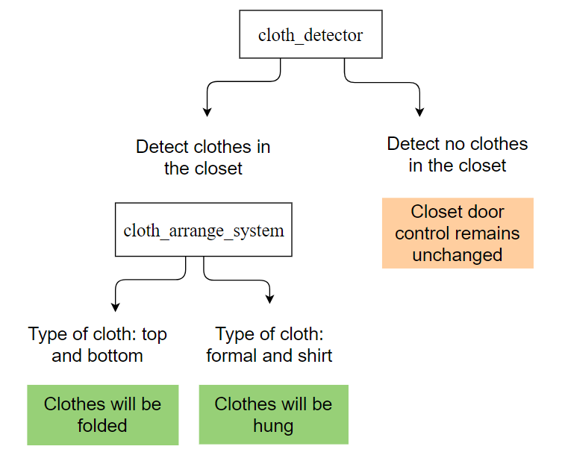

Hypergraph
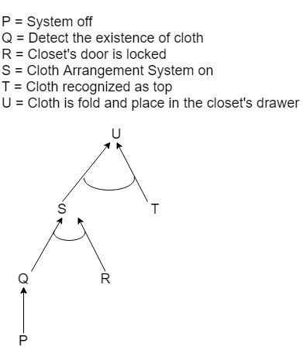

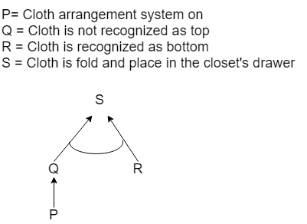
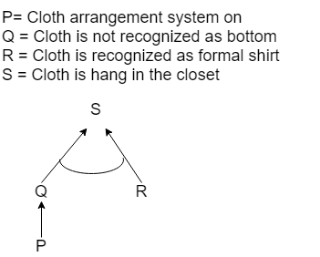

Problem Formulation by specifying four things: Initial state, Actions, Goal, Path Cost
- Initial State: No cloth detected
- Action: Hung/Fold
- Goal: A cloth is fold/hung in a closet
- Path Cost: 1 unit per action

Table of problem formulation:
 | Clothes Detector | Door control | Cloth Scanner | Action
1 |  |   open/lock | No Clothes Detected | No Action
2 | Detect | open | 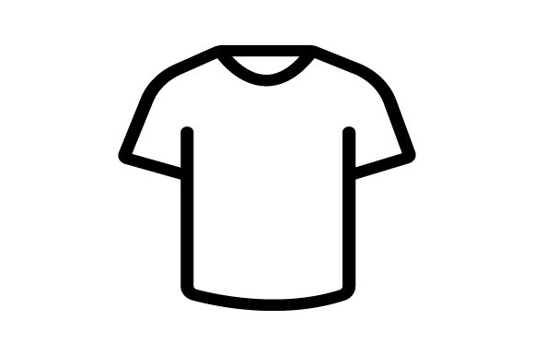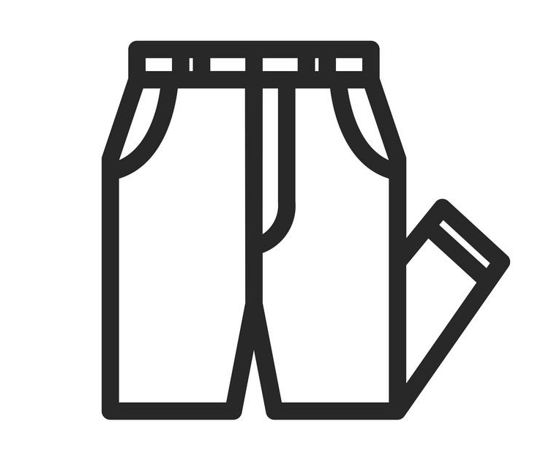  Top Bottom Formal  Shirt | No Action
3 | Detect | lock | Top |   Fold
4 | Detect | lock | Bottom | Fold
5 | Detect | lock | Formal Shirt |   Hung
6 | Detect | lock | Not a top | Move to scanner for cloth type ‘bottom’
7 | Detect | lock | Not a bottom | Move to scanner for cloth type ‘formal shirts’
8 | Detect | lock | Not a formal shirt | Place cloth to a special container
9 | Detect | lock | Top, bottom or shirts | Fold  Hung

Sequence of Actions Leading from Initial State to Goal State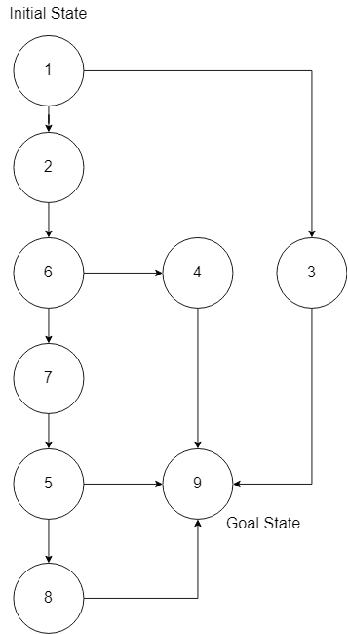

Explanation of Formulate Problem to support the Proposed KR
Based on the table of problem formulation:
- If no existence of clothes is detected, and the closet’s door is either opened or locked, no action will be taken by the closet since the cloth arrangement system is not activated. This is shown in KR3 and KR 4. The closet will remain the current state, which is an inactive state.
- If the existence of clothes is detected, and the closet’s door is opened, no action will be taken by the closet since the cloth arrangement system is not activated. This is shown in KR2, KR7, KR8, KR11, KR12, KR15 and KR16. The closet will remain the current state, which is an inactive state.
- If the existence of cloth is detected, and the cloth is recognized as a top, it will fold the particular cloth. This is shown in KR1 and KR5 and the cloth will be folded.
- If the existence of cloth is detected, and the cloth is recognized as a bottom, it will fold the particular cloth. This is shown in KR1 and KR9 and the cloth will be folded.
- If the existence of cloth is detected and the cloth is recognized as a formal shirt, it will hang the particular cloth in the closet. This is shown in KR1 and KR13 and the cloth will be hung.
- If the existence of clothes is detected, and the particular cloth is not recognized as a top, it will activate the scanner for bottom to do recognition. This is shown in KR1 and KR6 and the cloth will pass to the bottom scanner state.
- If the existence of clothes is detected, and the particular cloth is not recognized as a bottom, it will activate the scanner for formal shirts to do recognition. This is shown in KR1 and KR10 and the cloth will pass to the formal shirts scanner state.
- If the existence of clothes is detected, and the particular cloth is not recognized as a formal shirt, it will shift the clothes to the special container, which are labelled for unrecognized clothes. This is shown in KR1 and KR14.
- If the existence of clothes is detected, and the clothes are top or bottom or formal shirt, it will fold or hang the cloth in the closet. This is shown in KR1, KR5, KR9 and KR13.

