

UNIVERSITI TEKNOLOGI MALAYSIA
FACULTY OF ENGINEERING
SCHOOL OF COMPUTING
SESSION 2020/2021 SEMESTER 1

SCSJ3553 ARTIFICIAL INTELLIGENCE SECTION 11
PROJECT: Smart Closet
Progress 4
Intelligent Agent

Group members:
- MUHAMMAD AMIRUL BIN ISMAIL (A18CS0126)
- LEE HUEY MIIN (A18CS0096)
- NURUL NAJIHA BINTI HAMDAN (B19EC0047)
- AQILAH HANIM BINTI MOHD TAUFIK (B19EC0006)

Lecturer: DR AIDA BINTI ALI

PEAS Model
Formulate The Solution By Using PEAS model
 | Before Applying Smart Closet | After Applying Smart Closet
P:  Performance Measure | - Closet is not well arranged and always accumulates with a lot of stuff.  - Clothes are not folded or hung. | - Closet will be arranged orderly by the system.  - Smart Closet will help them to fold or hang the clothes in the closet according to the cloth type (top, bottom, formal shirt).
E:  Environment | - Users need to spend some of their precious time to fold and arrange the closet cause users do not have time to do other things.  - Messy closets make users difficult to find their stuff, sometimes will cause bad emotion when they see the messy condition in the closet. | - Save users time to fold, hang or arrange the closet.  - Closet always appears clean and tidy promotes good emotion.  - All the stuff in the closet is clearly labelled hence not difficult when finding stuff.
A:  Actuators  /  Effectors | - Users need to fold, hang, and arrange clothes into the closet manually. | - Users just need to collect washed clothes and place it into a container that is connected to the Smart closet as Smart Closet will help them to differentiate, fold and hang the clothes into the closet.
S:  Sensor | - No sensor is used to detect type of cloth. | - Cloth detector to detect the existence of cloth.  - Cloth type detector to differentiate top, bottom and formal shirt.  - If it is a top or a bottom, the Smart closet will fold and put them into their respective drawer.  - If it is a formal shirt, the Smart closet will hang it in the drawer.  - If it is not recognized as above cloth type, the Smart closet will place it into another drawer to let the user to arrange it.

PEAS Model
Agent: Smart Closet
Performance measure: time, tidy, accurate cloth recognition, safety
- The Smart Closet helps users to save their time spending on fold and arrange the cloth into the closet since the machine will automatically help them to fold and arrange clothes.
- All the cloth will be arranged according to the cloth type, making the closet appear clean and tidy.
- Smart closet can recognize the cloth type accurately as it is assisted by a high tech sensor which is able to analyse the common characteristic of clothes and compare to the knowledge base towards cloth type. For any unrecognized cloth, a Smart closet will place it into another container to avoid mixing with recognized clothes.

Environment: Cloth, closet, closet owner
- The environment is basically inside the closet.
- Clothes are required to recognize and arrange according to their cloth types.
- Closet owners oftenly use the closet to pick or keep their clothes.

Actuators: Fold cloth machine, hang cloth machine, placing machine
- Fold cloth machine is to fold tops and bottoms.
- Hang cloth machine is to hang formal shirts.
- Placing machine will place tops and bottoms to respective drawers. Besides, placing machines will place unrecognized clothes into a container for unrecognized cloth.

Sensors: Cloth detector, cloth type detector
- Cloth detectors will detect the existence of cloth in the initial container.
- Cloth type detector will detect the cloth type according to the characteristic of each cloth type.

PEAS Model Diagram
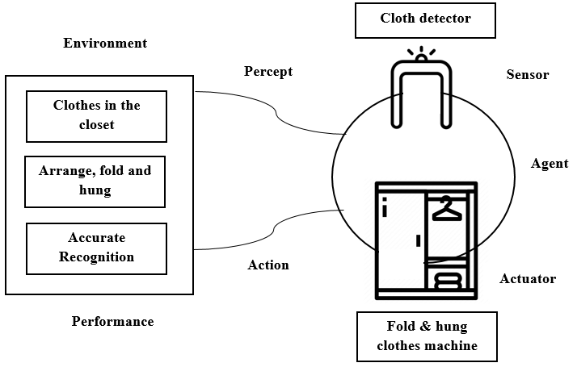

Property representation in Proof of Concept (POC)

How will every element be present in POC?

- Performance
- The goal is to make sure that all the cloth is arranged in a designated place. After implementing Artificial Intelligence, it is expected to reduce the user's time to fold clothes and arrange them in the closet. Clothes also expected to be recognized and arranged accurately.

- Environment
- The clothes will be used to show how the clothes are folded or hung by a smart closet. It is also to show how users can save time by placing unfolded clothes in the closet.

- Actuator
- The action that will be shown is Smart Closet will identify and differentiate the type of clothing and then choose whether to hang or fold the clothes based on its type. Smart Closet will pick up the cloth that had been placed inside the container.

- Sensors
- The cloth detector and a cloth type detector will be used as input data so that the cloth will be arranged at designated places. A simulation will be used to show the situation when data input was received.
How does the agent in Artificial Intelligence behave and achieve the goal in the proposed product?
The agent behaves as a simple reflex agent because it takes an action based on only the current environmental situation. It maps the current percept into the proper action ignoring the history of it. This system is in an infinite loop, each percept contains a state of the current location which is [the system is on when clothes detected] or [the system is off when no clothes detected] and the system will decide whether to [fold clothes] or [hang clothes] depending on the type of clothes.

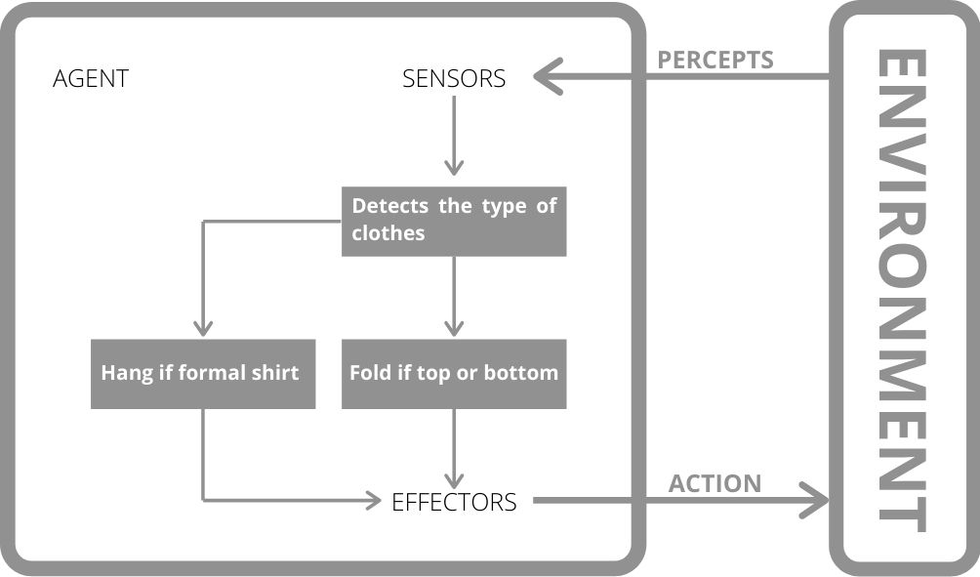

Self Reflection
Aqilah Hanim Binti Mohd Taufik (B19EC0006) :
After working with the team for almost a semester, I am relieved to say that this team Team Impostor is the best team I have worked with all semester. Each team member does their part of the tasks flawlessly. Even if one of us does not know how to complete a task, the others would lend a helping hand and help each other out. Huey Miin, Amirul and Najiha always help me out whenever I need them. I am thankful I got extremely great team members especially since we are all facing a great difficulty this semester.

Lee Huey Miin (A18CS0096) :
All the team members were able to complete all the jobs that were distributed. If anybody in the team is facing difficulties, all of the team members are willing to help and solve the problems. We will discuss it together to find the solutions for our project. Team atmosphere is also good enough as we can discuss all the problems and solutions peacefully, in other words, good communications among us. In this difficult situation (attend online class), all of them are able to complete their roles and jobs. I very much appreciate their cooperation and contribution in order to complete the project.

Muhammad Amirul Bin Ismail (A18CS0126)
Team members are all able to carry out the assigned work well. Huey Miin which incharge parts formulate the solution using PEAS model can do her job well. Najiha, who was assigned to make a PEAS model diagram can also prepare it well. While Aqilah was able to complete her work at the right time. Overall, all team members can complete their assignments on time. Communication between us is also good and everyone knows what to do.

Nurul Najiha binti Hamdan (B19EC0047):
For Team Working Value, I would say that each team member in Team Impostor clearly knows their role and responsibilities in order to complete each task starting from project proposal until progress 4. If any of the team members did not understand the instructions of the project, everyone is glad to help because it is important to guide each other out especially during a pandemic period that required us to study and complete every task online.

