
UNIVERSITI TEKNOLOGI MALAYSIA
FACULTY OF ENGINEERING, SCHOOL OF COMPUTING
SKUDAI, 81310 JOHOR BAHRU, JOHOR DARUL TAKZIM
SCSV3213 - 01: FUNDAMENTAL OF IMAGE PROCESSING

FINAL PROJECT FIP

LECTURER:
MD. SAH BIN HJ. SALAM

PREPARED BY:
Muhammad Amirul Fahmi Bin Noor Anim (B19EC0018)
Nur Hasanah Binti Sariddon (B19EC0033)
Mohd Anas Bin Adnan (B19EC0043)

Table of Content

Content | Page
1.0 Work Distribution | 3
2.0 Introduction | 4
3.0 Process Chart | 5
4.0 User Manual | 5 - 8
5.0 Experimental Procedure  5.1 Coding Structure | 9 - 14
6.0 Result  6.1 Sample of Image and Output | 15 - 20
7.0 Discussion | 21
8.0 Conclusion | 21

Work Distribution

Task | Person In Charge
Design Interface | Anas, Fahmi& Hasanah
Develop Interface | Anas & Fahmi
Develop Application | Anas & Fahmi
Documentation | Anas, Fahmi & Hasanah

2.0 Introduction
The task given for the group project under the subject Fundamental of Image Processing is to develop a simple to be used application using Matlab Script to process an input images of a written text or signature or even picture with not clear white background into a black or coloured text with a white background.
The application is very useful for today's situation where we are needed to implement Open and Distance Learning (ODL) due to Covid-19 pandemic. We have a hard time getting our physical supervisor signature due to the Movement Control Order (MCO) that requires the supervisor to give the signature via digital documents. However, some of them do not have a scanner at their home which needs to capture the signature only by using the camera's phone which is sometimes not clear and not looking formal, especially in a formal document.
For this project, we use a pre-built application maker in Matlab. The GUI was saved in Matlab figure (.fig file). Then, the callbacks function in the Matlab code i.e.: .m file (which was automatically created by creating the interface using the application maker that has been mentioned earlier) are edited. Figure 1.1 and 1.2 shows a sample input image that we use to process it into a scanned document image.
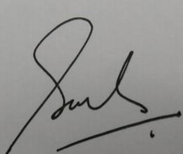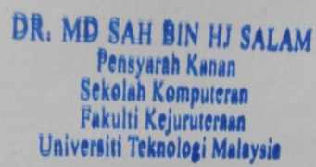
Figure 1.1 Figure 1.2
3.0 Process Chart
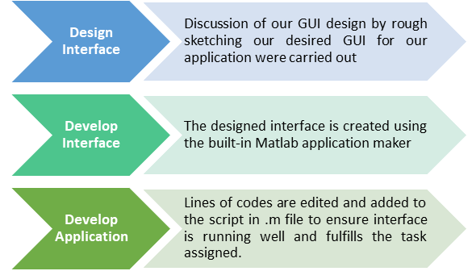
4.0 User Manual
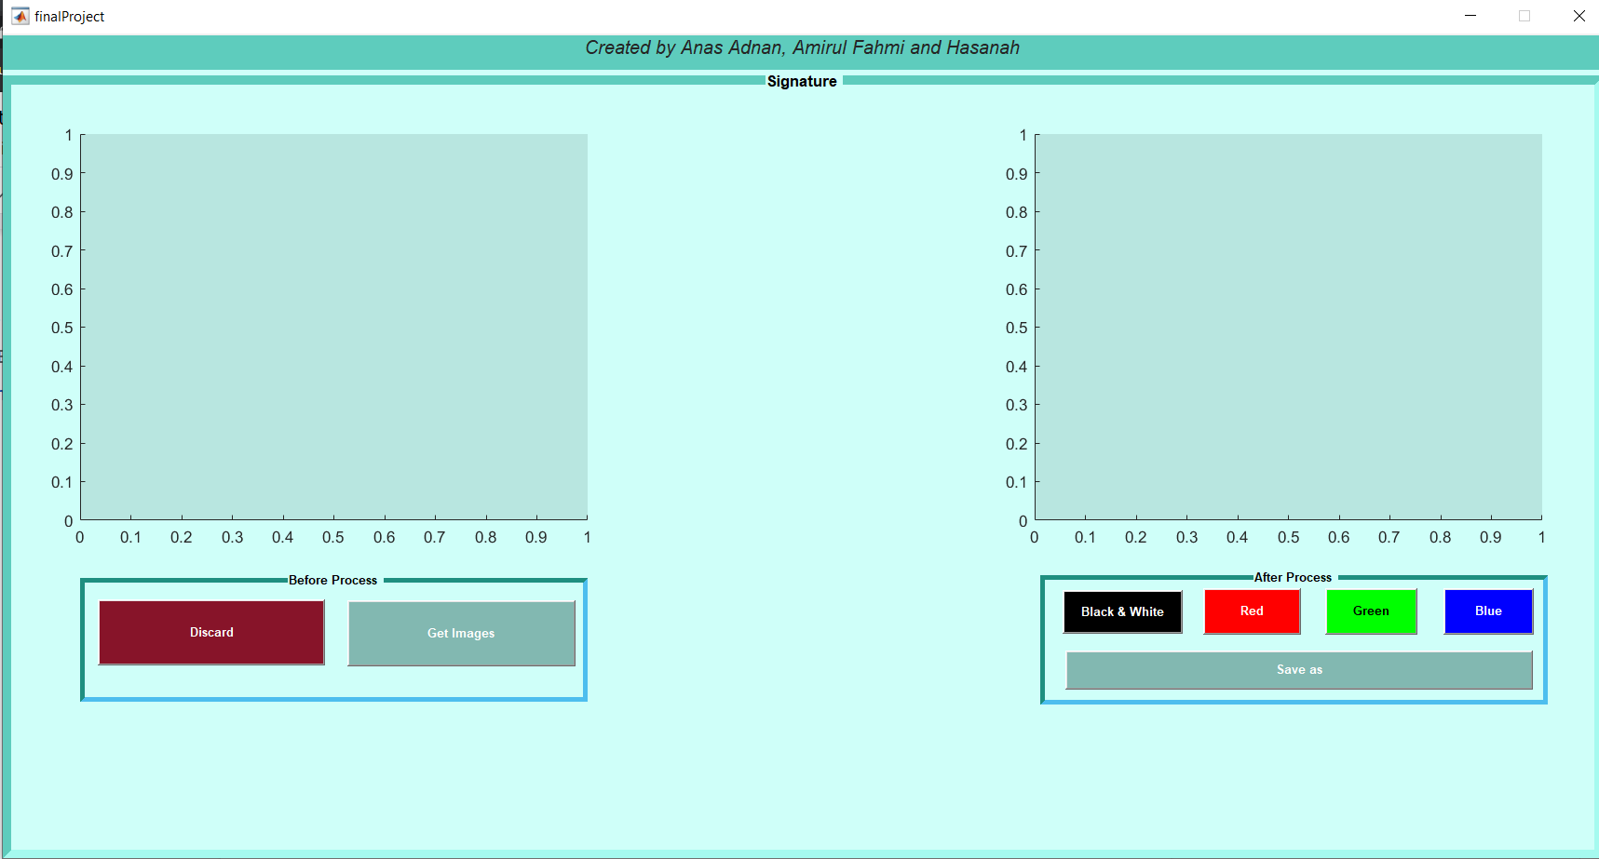
- Gui Design
Gui is designed by our team to make sure that the user will be able to use our application. This application really focuses on the user friendly design which we have designed the button based on the function process.
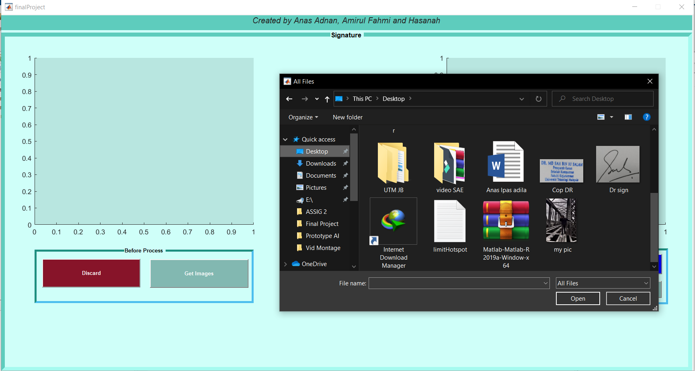
- Insert Image
The user needs to select the image that the user wants to go through the process. The image that has been selected can be in any format. Image will be shown in the rectangle area which will be the original image.
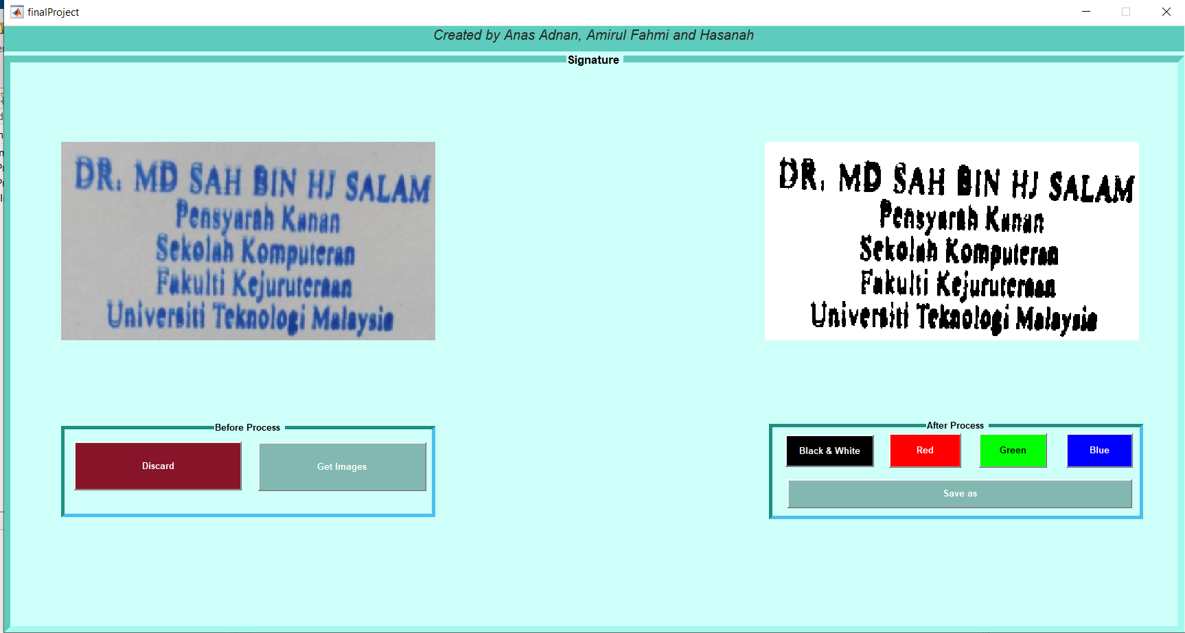
- Create Black&White
Users need to push black & white button if the user needs to have an image in black and white. Image will be shown on the rectangle above the after process box.
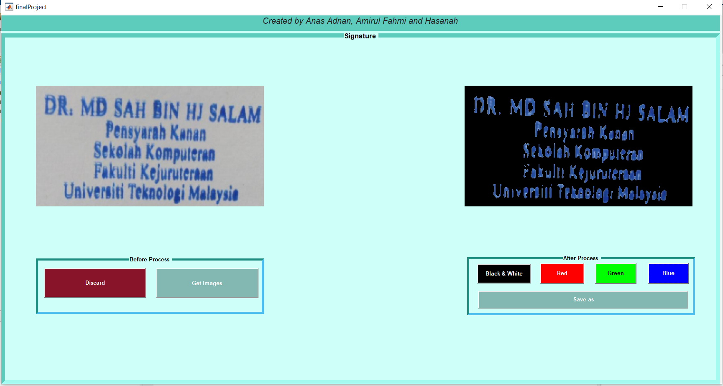
- Select Colour
Users need to either push the red, green or blue button. This button is to make the application to select the specific colour for the users used. Image will be shown on the rectangle above the after process box.

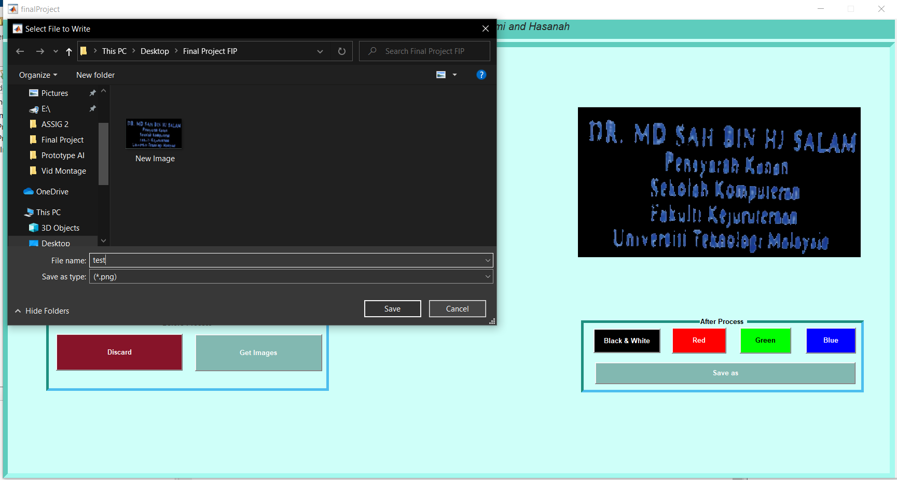
- Save New Image
After the process has been done the user needs to save a new image. New images can be saved in the PNG format. Users need to push the save button.
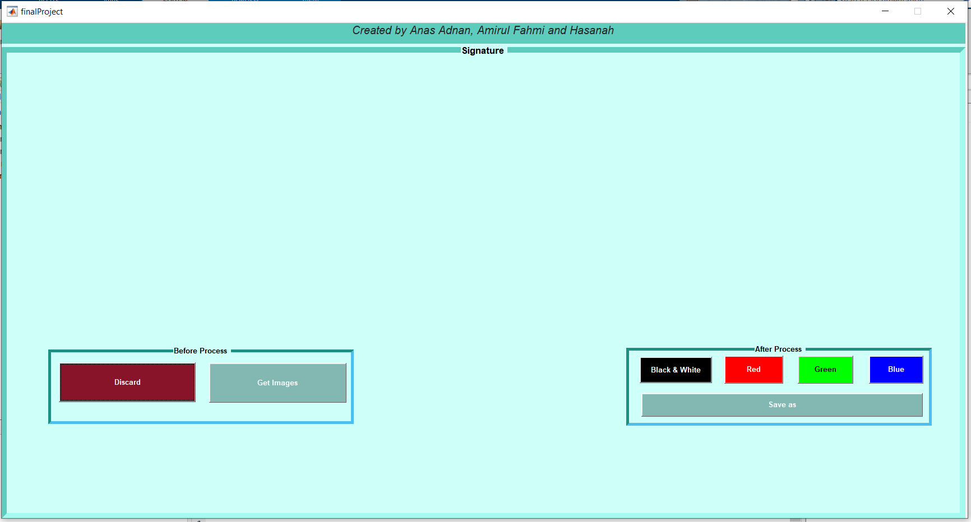
- Cancel The Process
Users can push the discard button to cancel the process. This will remove the image that has been shown in the rectangle above before process and after process.

5.0 Experimental Procedure
5.1 Coding Structure
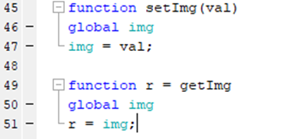
Figure 5.1: Shows the definitions of 2 vital functions.
A mutator function (setImg) and an accessor (getImg) function. setImg is called to set a called value(val) into a declared a global img variable that will be used in the next few functions will be explained later. getImg is called to access any value of img currently exist and will be used in the next few functions.

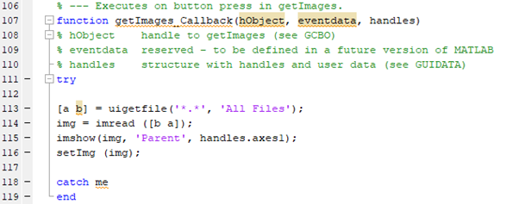
Figure 5.2: Involves “Get Image” button in the GUI created.
This function will allow the user to select a file from the computer by clicking the button. Line 113 is the line to execute the get file. Line 114 is to insert the file retrieved into a local variable named img. Then the image will be displayed on axes1 through line 115. setImg is used to set the global img variable with the retrieved img value.

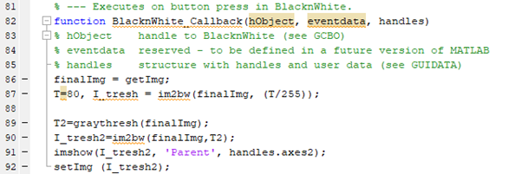
Figure 5.3: Function to process image into black & white
This function is to convert the original image into a black and white document. To make the image into a clear black and white document, im2bw function will be used twice to get a clear image. In line 91, the image will be displayed in axes2 as the processed image.

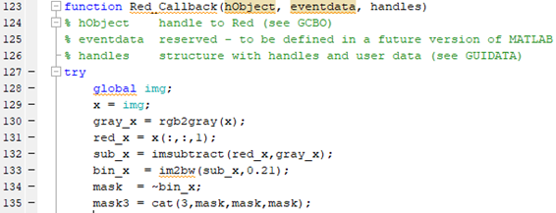
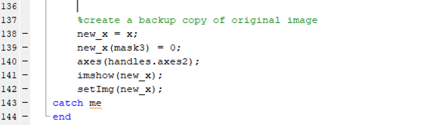
Figure 5.4: Function to process image into red with transparent background
This function is to convert an image with a red coloured text into a red with transparent background document. The global image will be retrieved and declared as x. In line 130 until 139, the process of detecting the red text in the original image was done. The processed image is shown at axes2 in line 140 and 141 using imshow function. Then, the new processed image is set into a global image using setImage.

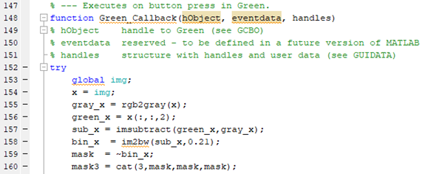
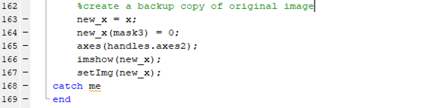
Figure 5.5: Function to process image into green with transparent background
This function is to convert an image with a green coloured text into a green with transparent background document. The global image will be retrieved and declared as x. In line 155 until 164, the process of detecting the blue text in the original image was done. The processed image is shown at axes2 in line 166 and 167 using imshow function. Then, the new processed image is set into a global image using setImage.

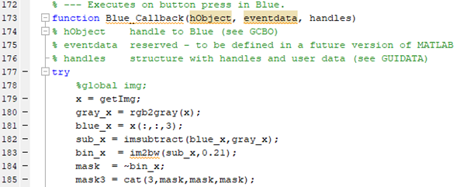
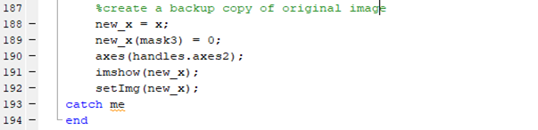
Figure 5.6: Function to process image into blue with transparent background
This function is to convert an image with a blue coloured text into a blue with transparent background document. The global image will be retrieved and declared as x. In line 180 until 189, the process of detecting the blue text in the original image was done. The processed image is shown at axes2 in line 191 and 192 using imshow function. Then, the new processed image is set into a global image using setImage.

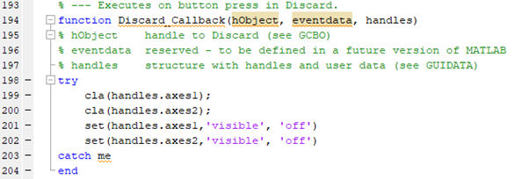
Figure 5.7: Programme to discard image
In this function, the user can discard the original and the processed image to create a new process. Functions in line 199 and 198 is to discard the original image and axes1 while functions in line 200 and 202 are used to discard the processed image in axes2.
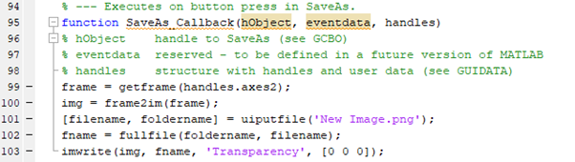
Figure 5.8: Programme to save edited image
To save the edited image, the user may click the “Save as” button to save the image. So, lines of coding starting from line 95 to 103 are responsible for that functionality. In line 99, the frame from axes2 will be retrieved and declared as frame. Then, the frame will be converted to image using frame2im function. The rest of the code is for saving the image. “New Image” is the pre-set name of the image file with the file type of png. Users can change the file name on the application.
6.0 Result
6.1 Sample of Image and Output
There are ten screenshots of the input and output image. On the left is the input and on the right is the output image which is an edited image. (a) it shows the initial interface of the application which is untouched by the user. (b) refers to the Get Image button to read the image that the user wanted. (c) It refers to displaying the image after the user has selected the image that they want. (d) It refers to the Black&White button which can change the image to be in the black and white. (e) It refers to the Red button which will select just the color of red in the image. (f) It refers to the Green button which will select just the color of green in the image. (g) It refers to the Green button which will select just the color of green in the image. (j) It refers to the Discard button which will cancel the process that the users have done.
When clicking the button "Save as, a popup of save location settings will show up and the user can select the destination of the folder location. (a) may he refer for reference. After saving, the user will be able to find the image file in the folder that was selected by the user in the previous popup. Users may find the file as in the screenshot in (h).
- 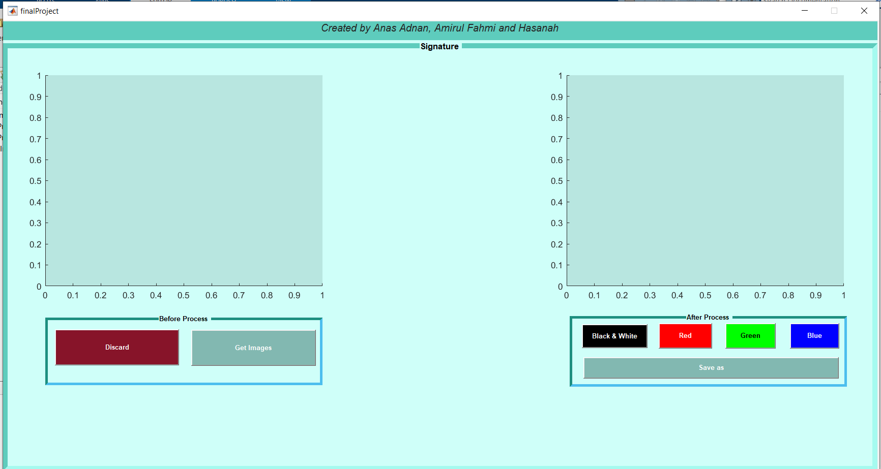

- 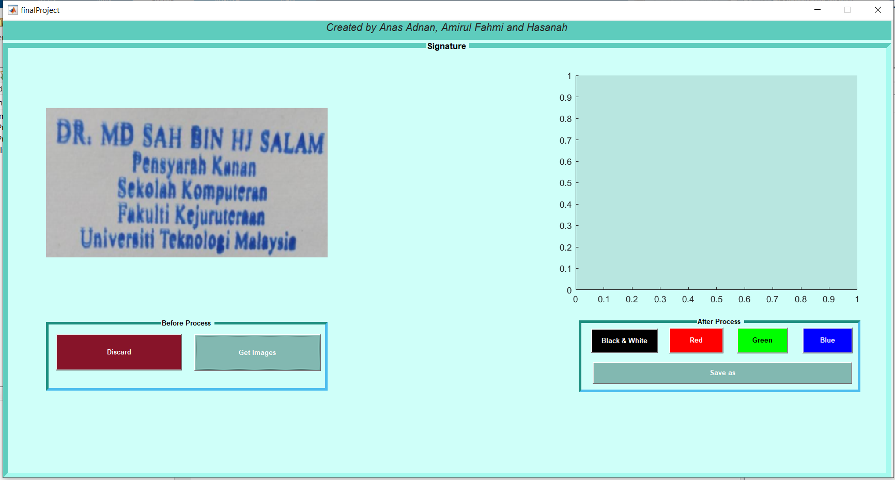

- 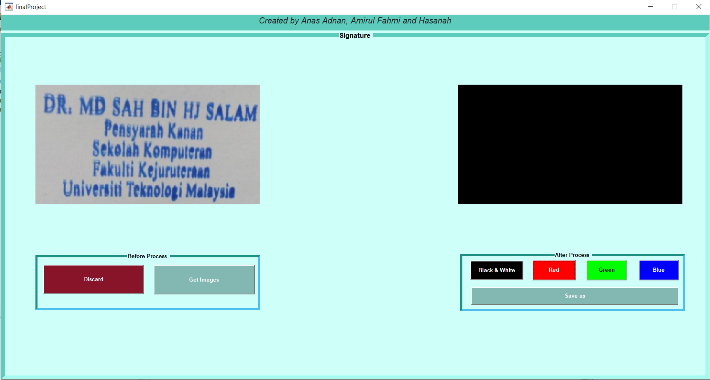

- 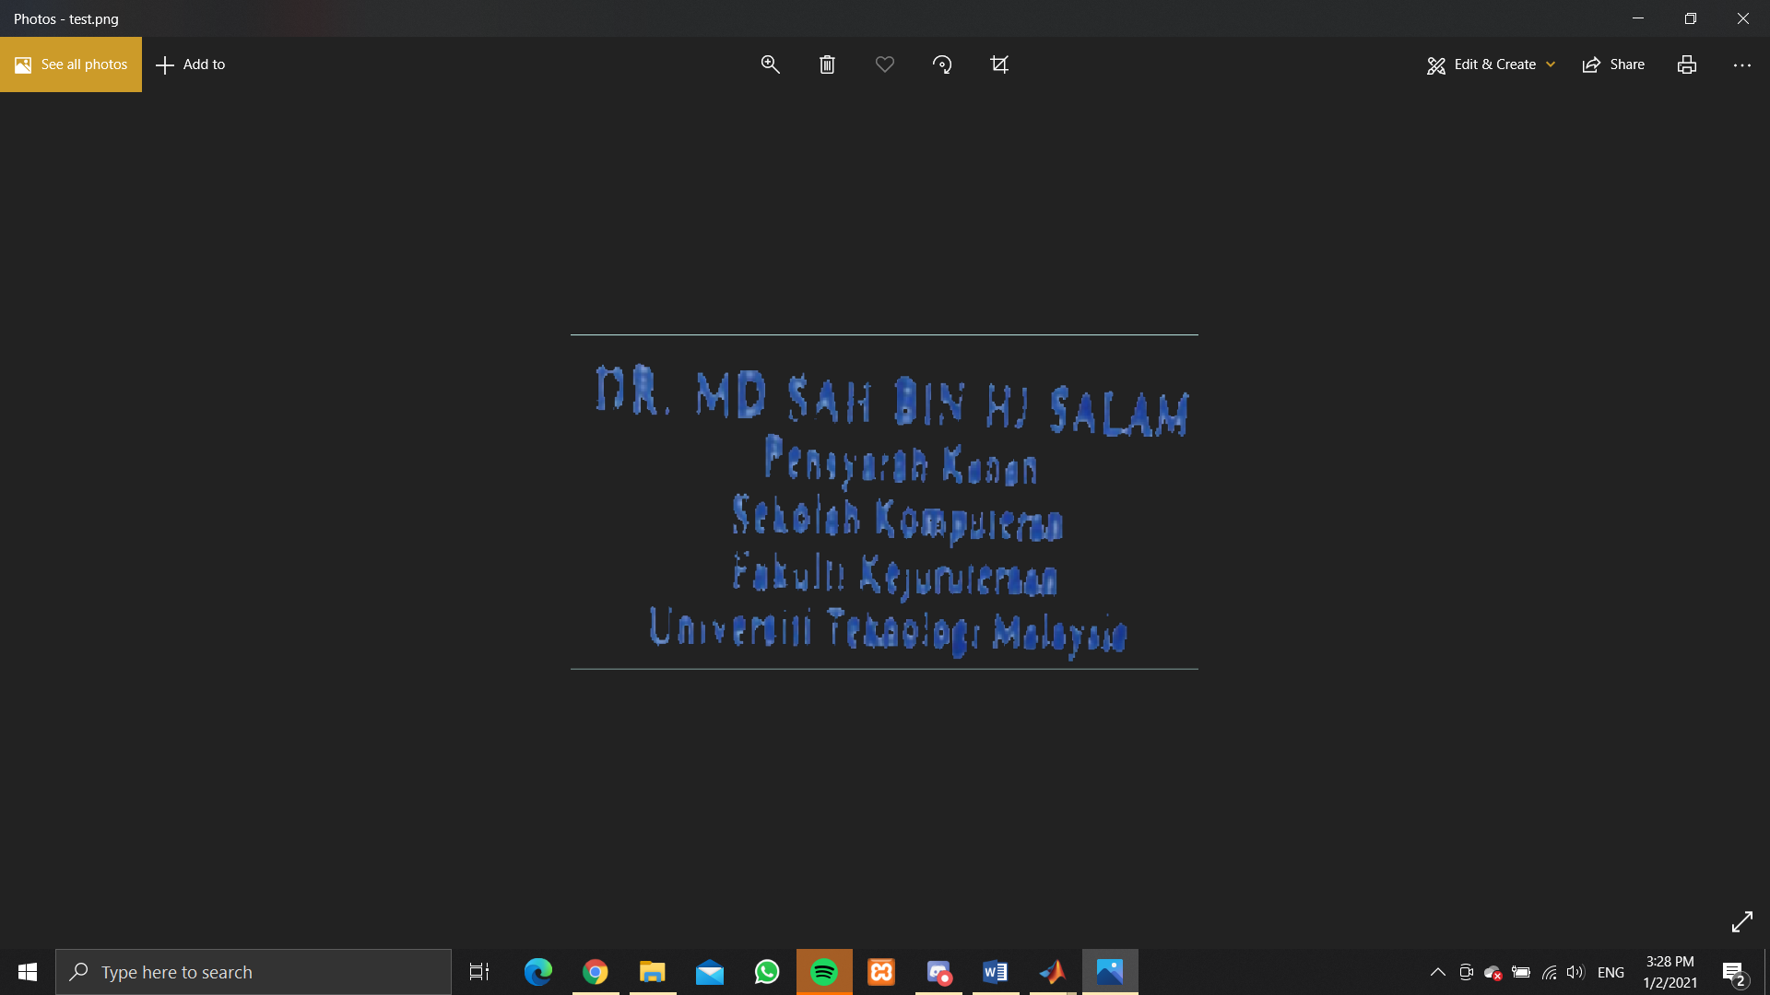
7.0 Discussion
For the discussion, actually in this Matlab assignment that requires us to develop an image processor application it is very challenging because there's so many things that we must explore and find out for ourselves. For example we must do the research on the internet, youtube and so on. The coding, terms, format in this Matlab is very different compared to the others software because Matlab actually is software that is used for wide purpose, including deep learning and machine learning, signal processing and communications, control systems, test and measurement, computational finance, and computational biology. Matlab is a software that uses high-level language the same as Python, it is interpreted, has an interactive prompt, allows dynamic typing and provides automatic memory management. In this task, for the beginning we have got so many errors and there's so many things that are very important to take serious action because to produce the image processor application even a tiny problem will affect the programme from being running clearly as we want. At the end, after so must error has been fixed and a lots of troubleshooting, finally we has successfully develop an image processor application that purpose is to process the blur and darken image to be more clearly to see and the objective of this assignment which is to develop a simple and friendly applications for the user is finally achieve.
8.0 Conclusion
In conclusion, this assignment which is using Matlab is to develop a platform that can do image processing is really helping for those who are learning the topic “Image Processing”. This Matlab software is quite challenging because this assignment is 100% using a Matlab script to process any kind of written text, signature, and picture which is not very clear to be more clear. The application that has been developed by using the Matlab programme is very simple to use because the user just only inserts the picture, chooses the image processor and lastly the user can save it directly into the computer. This image processor is very helpful for those who are gonna use the image to submit to the other people, for example lecturer or academic use. Lastly, this Matlab is actually a very great platform to polish the skill in developing something using programming because it has so many functions that users can use to create something based in their purpose and interest.

