

INTRODUCTION TO ENTREPRENEURSHIP
UHAK1032

THE BUSINESS PLAN REPORT
AQUANTAE

Lecturer : Mr. Hairudin Bin Abdul Majid
Due Date : 28th January 2021 (Thursday)

LAUNDRY SERVICE: AQUANTAE ENTERPRISE

1490, JALAN BSS 2/3B, BANDAR SEREMBAN SELATAN, 71450 SEREMBAN, NEGERI SEMBILAN, MALAYSIA

SHAHRUL ASYRAF BIN MUHAMMAD HISHAM SEGARAN
AQILAH HANIM BINTI MOHD TAUFIQ
NUR HIDAYAH BINTI HAMRI
NURUL NAJIHA BINTI HAMDAN
MOHHAMAD ARIF ISTIAQ

28 JANUARY 2021

Table of Content

1.0 Introduction
1.1 Name of the business
1.2 Type of business
1.3 Industry overview
1.4 Location of the business
1.5 Date of commencement
1.6 Factors influencing choice of business
1.7 Business potential
2.0 Purpose
3.0 Background of the Business
3.1 Information of the Business
3.1.1Name of the business
3.1.2 Business address
3.1.3 Correspondence address
3.1.4 Telephone number
3.2 Form of business
3.3 Main activity
3.4 Registration, Bank Information
3.4.1 Date of commencement of business
3.4.2 Date of business registration
3.4.3 Business registration number
3.4.4 Name of bank
3.4.5 Bank account number
3.5 Equity contribution
4.0 Background of Partners/Shareholders
4.1 Information of Share Partners/Shareholders
4.1.1 Name in full
4.1.2 Identity card number
4.1.3 Permanent address
4.1.4 Correspondence address
4.1.5 Telephone number
4.1.6 Date of birth
4.1.7 Age
4.1.8 Marital status
4.2 Academic qualification
4.3 Courses attended
4.4 Skills
4.5 Experiences
4.6 Current job/position
4.7 Other/Previous business experiences
5.0 Location of Project
5.1 Physical location
5.2 Building
5.3 Infrastructure
6.0 The Organization Plan
6.1 General business description
6.2 Organizational chart
6.3 Table of job designation and number of workers
6.4 Job description
6.5 Remuneration table
6.6 List of office furniture, fixtures and fittings
6.7 The administrative budget
7.0 The Marketing Plan
7.1 Introduction to the product/service
7.2 Target market
7.3 Market size
7.4 Competition
7.5 Market share
7.6 Sales forecast
7.7 Marketing strategies
7.8 Promotion strategy
7.9 Business card
7.10 The marketing budget
8.0 The Production/ Operation Plan
8.1 Process Flow Chart
8.2 Unit Output/Hours of Operation
8.3 Material Requirement
8.4 List of Direct Workers
8.4.1 designation
8.4.2 remuneration
8.5 List of Machines and Equipment
8.6 Plant/Office Layout
8.7 Operation Overhead
9.0 The Financial Plan
9.1 Project Implementation Cost
9.2 Sources of Financing
9.3 Table of Depreciation
9.4 Loan Amortization Schedule
9.5 Hire Purchase Repayment Scheme
9.6 Cash Flow Proforma
9.7 Profit and Loss Proforma
9.8 Balance Sheet Proforma
10.0 Justification
Appendices

Executive Summary

The Aquantae is a full-service laundry located in Bandar Seremban Selatan. The Aquantae features a full service of moderately priced ‘comfort’ services influenced by high demand in that area. The Aquantae is owned and operated by Aquantae Ltd and is 100% owned by Mr. Shahrul Asyraf and his 4 partners. The plan covers sections on companies, products and services, markets focus, action plans and forecasts, management team, and financial plans. This shop plans to get a loan from Xcite Bank of RM50000 to set up their business in Bandar Seremban Selatan. At the same time we have created a mobile application that can make it easier for our customers to make order management with Aquantae.

The purpose of the business is to grow in the short and medium term. The business plans focus on this planned expansion and how to further expand this business to the public and if have the opportunity to open a franchise in a new area. This Aquantae was built based on the results of ideas and discussions between Mr Shahrul and his partner. Aquantae provides affordable high quality services based on natural resources products and application facilities to customers who want to visit or who live near the area

So what do we mean by Aquantae, which when people see it and mention it continues to know that it is related to water and also makes it easier for users to remember this unique name. Aquantae allows customers to order only through the app without having to move to the store. After making the reservation, Aquantae staff will take the clothes to be washed at the customer's house. The purpose of Aquantae is to facilitate customers; this is to provide quality service and treatment to all customers who use our services

1.0 Introduction

1.1 Name of the business
The Aquantae is owned and owned by Aquantae Enterpriseand is 100% owned by Mr Shahrul Asyraf and his partner. They have 4 partners which helps in running this business. The name of Aquantae was chosen as the business name because of its unique and catchy name. This aquantae is a combination of the names Aqua and Quantae. Aqua in Latin means water or rain and Quantae means fine mind and like to talk which means it refers to our friendly staff. The name aquantae is also easy to get attention for the first time when people see it. When they see Aquantae, they already guess that this business is related to water

1.2 Type of business
Aquantae is included in the type of business that is laundry service. Based on our observations, the majority of the population living in the area are people with jobs and if you look at the Covid-19 pandemic season, they are still working as usual and some of them have to work in the workplace. Based on the survey we did as well, most of them came home late and had no time to wash clothes especially during this rainy season. There is no difference with those who work from home where they are too busy managing work and family at one time so they do not have time to wash and fold clothes.

1.3 Industry overview
Aquantae is a cleaning company that will provide services such as washing, ironing, folding, dry cleaning. We offer pickup and delivery of clothes. What makes our business different is that we will have our own application. The application will allow customers to create orders, view progress of their order and make payment through the application. We have two packages offered which are normal and express. A normal order will take from 2 to 5 days to complete an order based on the amount of clothes. While express orders will be delivered on the same day.

1.4 Location of the business
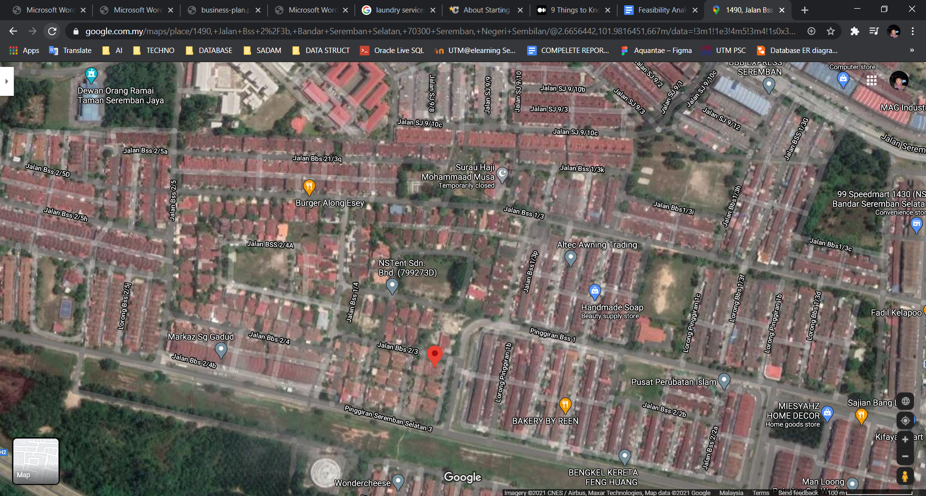
The Aquantae is located in the marked area, adjacent to the housing development on average all residents have jobs. This is an excellent position as there are no competitors nearby. It is also a short distance from the public hall where most of the big ceremonies are held in the hall.

1.5 Date of commencement
Commencement Date: 6 November 2020

1.6 Factors influencing choice of business
Factors to create the Aquantae due to high demand during this season especially during the rainy season and the pandemic. Quite difficult to build at first but we believe at this time cleanliness is very important and very high demand especially working class individuals who require laundry services to be done. The second factor for developing Aquantae is also because most of the laundry services are only in the middle of the city, we change location by locating Aquantae in a developing area with a large population.

1.7 Business potential
Potential for the Aquantae is it has reasonable prices, fast delivery, provides services pickup and delivery of clothes, have multiple payment methods, wash various types of clothes, use high quality detergent. The most important thing in developing this business is that we want the best for our customers by making it easy for them to make reservations. Throughout our observation in these laundry services is that most laundry services do not provide booking services through the application. For Aquantae, we decided to develop an application that is easy to use by all ages which is user-friendly and understandable.

2.0 Purpose
This business plan is prepared by Aquantae Enterprise to obtain a term loan for the amount of RM52,000 from the XCITE Bank.

3.0 Background of the Business

3.1 Information of the Business
Business Name : AQUANTAE ENTERPRISE
Business address : 1490, Jalan BSS 2/3B, Bandar Seremban Selatan, 71450
Seremban, Negeri Sembilan, Malaysia
Correspondence : 1490, Jalan BSS 2/3B, Bandar Seremban Selatan, 71450
Address Seremban, Negeri Sembilan, Malaysia
Telephone number : 07-9262355

3.2 Form of business

Type of business : Services
Type of legal entity : Enterprise
Business was established on : 6 November 2020
Business located at : 1490, Jalan BSS 2/3B, Bandar Seremban Selatan, 71450
Seremban, Negeri Sembilan, Malaysia
Type of facilities needed : Washing machine, dryer machine , steam iron, iron table
The number of employee : 5 staff members
The operation information : Operation Day : Monday - Saturday (8 a.m. - 8 p.m.)
Close : Sunday

3.3 Main activity
The main activities for this business are related to daily wear and also prioritize cleanliness and tidiness. There are some special main activities from Aquantae which is it provide:
1) Wash variety of clothes
2) Drying clothes
3) Iron and fold clothes
4) Pickup and Delivery of clothes

3.4 Registration and Bank Information

Commencement Date of Business : 6 November 2020
Date of business registration : 1 Januari 2021
Business Registration Number : XCITE-20202551
Name of bank : XCITE Bank
Bank account number : 601263540954

4.0 Background of Partners/Shareholders
Aquantae business has one main supplier which is TLC(Truly Loving Company) that supplies all of their consumables. With the addition of another application, there will be economies of scale and the Aquantae will be able to negotiate better trading terms.

4.1 Name in full : Julia Chong
4.2 Identity card number : 680427-01-5064
4.3 Permanent Address : A-28-12, Menara UOA Bangsar, No. 5, Jalan Bangsar
Utama 1,59000 Kuala Lumpur, Malaysia
4.4 Correspondence Address : A-28-12, Menara UOA Bangsar, No. 5, Jalan Bangsar
Utama 1,59000 Kuala Lumpur, Malaysia
4.5 Telephone number : 013-7564560
4.6 Date of birth : -
4.7 Age : 53
4.8 Marital status : Married
4.9 Academic qualification : B.A. (Hons) Accounting and Finance from Middlesex
University, London and a M.Sc. Administrative
Sciences from City University, London
4.10 Courses attended : -
4.11 Skills : Experienced in running a large business
4.12 Experiences :
- Her 30-year career in the fast-moving consumer goods (FMCG) industry
- Managing Director of Reckitt Benckiser Malaysia /Singapore /Thailand /IndoChina
- General Manager of UNZA Malaysia
- Executive Director of HEXZA Mather
- Marketing Director of Warner Lambert Malaysia
- Brand Management at Fraser & Neave (Malaysia)
4.13 Current job/position : Chief Executive Officer and Founder TCL
4.14 Other/Previous : Managing Director for one of the world's largest
household, health
Business Experiences : Personal care manufacturers

5.0 Location of Project

5.1 Physical location
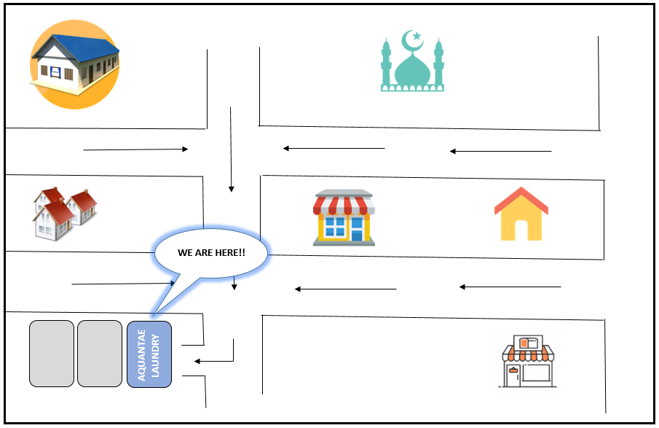
5.2 Building
For our commercial structure we use shop office as a place to start this laundry business
5.3 Infrastructure
The shop area has many buildings that many people visit such as mosques, bakeries and also grocery stores. There also has a multi-purpose hall where many residents use it for a specific purpose such as the placement of flood victims or covid.

6.0 The Organization Plan

6.1 General business description
A cleaning company that will provide washing, ironing, folding and dry cleaning services. We also offer pickup and delivery of clothes. An application on the business will be developed. The application will allow customers to create orders, view progress of their order and make payment through the application.

6.2 Organizational chart
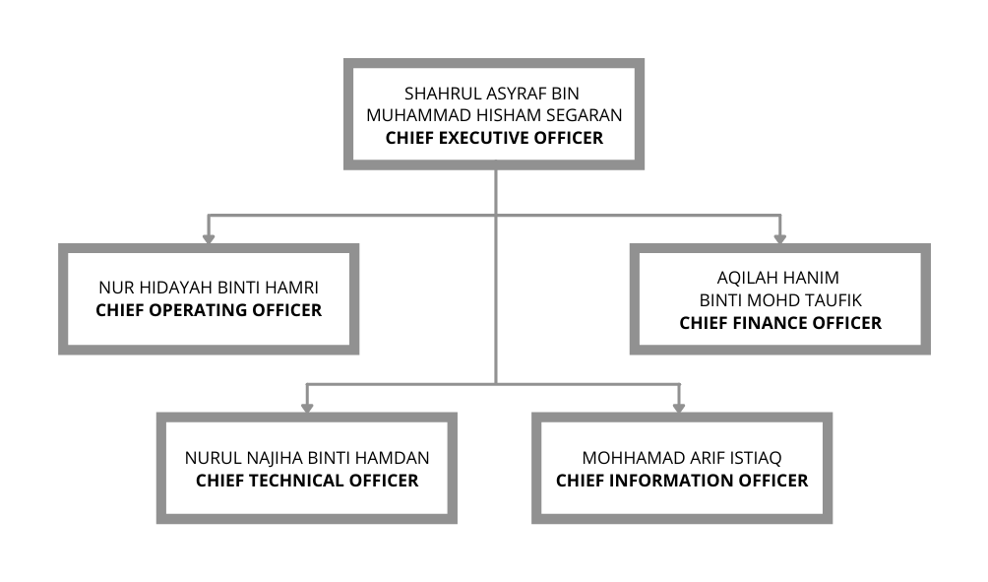

6.3 Table of job designation and number of workers
POSITION | NUMBER OF WORKERS
Chief Executive Officer | 1
Chief Operating Officer | 1
Chief Finance Officer | 1
Chief Technical Officer | 1
Chief Information Officer | 1

6.4 Job description
POSITION | JOB DESCRIPTION
Chief Executive Officer | - Creating, communicating, and implementing the organization's vision, mission, and overall direction  - Leading the development and implementation of the overall organization's strategy  - Soliciting advice and guidance, when appropriate, from the Board of Directors  - Formulating and implementing the strategic plan that guides the direction of the business or organization.  - Overseeing the complete operation of an organization in accordance with the direction established in the strategic plans  - Evaluating the success of the organization in reaching its goals.  - Also a worker at the establishment that is in charge of pick up, deliveries and checking orders.
Chief Operating Officer | - Oversees the daily administrative and operational functions of a business.  - Reports directly to the chief executive officer (CEO) and is considered to be second in the chain of command.  - Handles a company's internal affairs, while the CEO functions as the public face of the company, and thereby handles all outward-facing communication.  - Also a worker at the establishment that is in charge of washing and drying the clothes and also checking orders.
Chief Finance Officer | - The top-level financial controller, handling everything relating to cash flow and financial planning.  - Oversee the taxation issues for the companies.  - Plays a vital role in the company's strategic initiatives.  - Worker at the establishment that is in charge of cleaning and drying the clothes, and also keeping up with payment.
Chief Technical Officer | - Responsible for the management of an organization's research and development (R&D)  - Responsible for the organization’s technological needs.  - Worker at the establishment that is in charge of ironing and folding the clothes.
Chief Information Officer | - Responsible for managing and successfully implementing the information and computer technology systems of a company.  - Worker at the establishment that is in charge of pick up, deliveries, ironing and folding the clothes.

6.5 Remuneration table
POSITION | MONTHLY SALARY  (RM) | EPF 13%  (RM) | SOCSO 2%  (RM) | TOTAL AMOUNT  (RM)
Chief Executive Officer | 1200.00 | 156.00 | 24.00 | 1380.00
Chief Operating Officer | 1200.00 | 156.00 | 24.00 | 1380.00
Chief Finance Officer | 1200.00 | 156.00 | 24.00 | 1380.00
Chief Technical Officer | 1200.00 | 156.00 | 24.00 | 1380.00
Chief Information Officer | 1200.00 | 156.00 | 24.00 | 1380.00
TOTAL | RM 6900.00

6.6 List of office furniture, fixtures and fittings
ITEMS | PRICE / UNIT  (RM) | QUANTITY | TOTAL AMOUNT  (RM)
File Cabinet | 200.00 | 3 | 600.00
Table | 300.00 | 5 | 1500.00
Chair | 60.00 | 10 | 600.00
Computer | 1100.00 | 3 | 3300.00
Air Conditioner | 700.00 | 2 | 1400.00
Printer / Fax | 300.00 | 2 | 600.00
Telephone | 150.00 | 3 | 450.00
TOTAL | RM 8450.00

6.7 The administrative budget
ITEMS | FIXED ASSETS  (RM) | MONTHLY EXPENSES  (RM) | OTHER EXPENSES  (RM)
Land and Building
Furniture, Fixtures and Fittings | 8450.00
Salary
(EPF & SOCSO)
Rent |  | 2000.00
Business License and Registration |  |  | 760.00
Phone and Wifi |  | 200.00
Water |  | 500.00
Electricity |  | 500.00
TOTAL | 8450.00 | 10100.00 | 760.00

7.0 The Marketing Plan
7.1 Introduction to the product/service
Aquantae is a laundry service which is owned by Mr Shahrul Asyraf and his partners. There are various services it provides. Some of them are- Laundry service that provides pick-up and delivery services, Pickup and delivery services can be chosen by customers, customers can book slots, make payments and track the progress of their orders through the online application provided by Aquantae. This is a laundry service provided by 24/7.
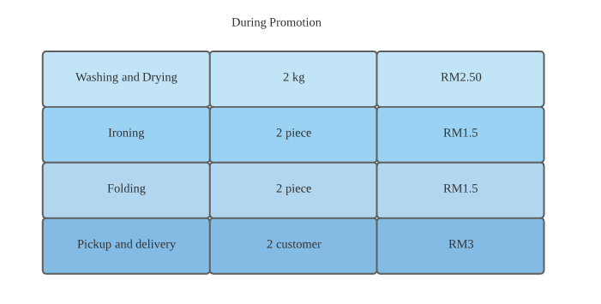

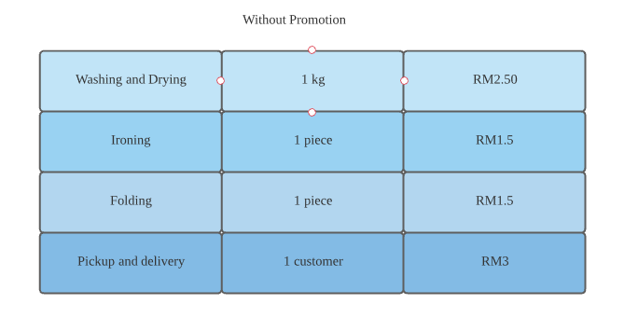
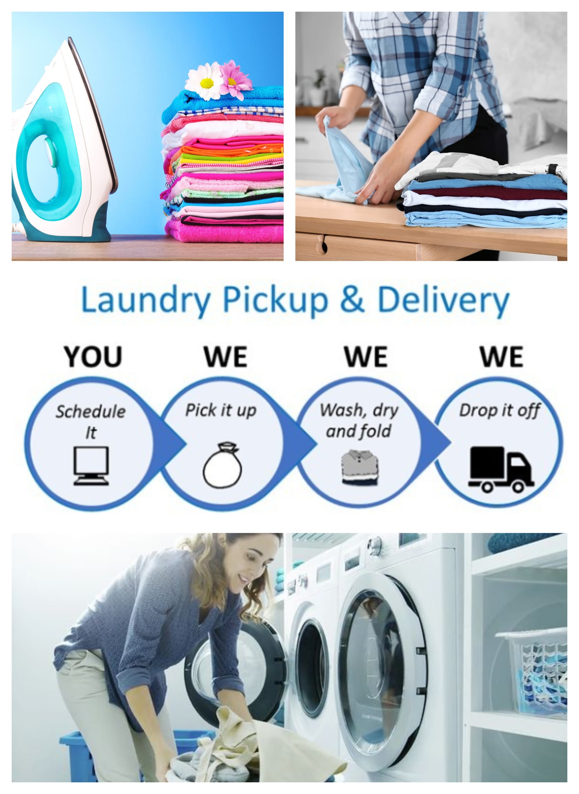

7.2 Target market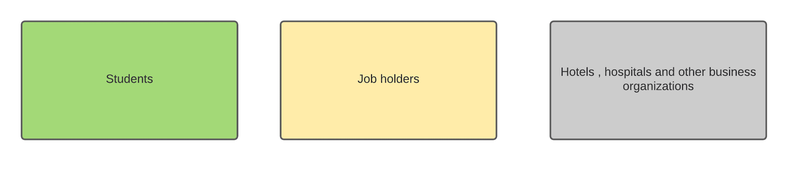
7.3 Market size
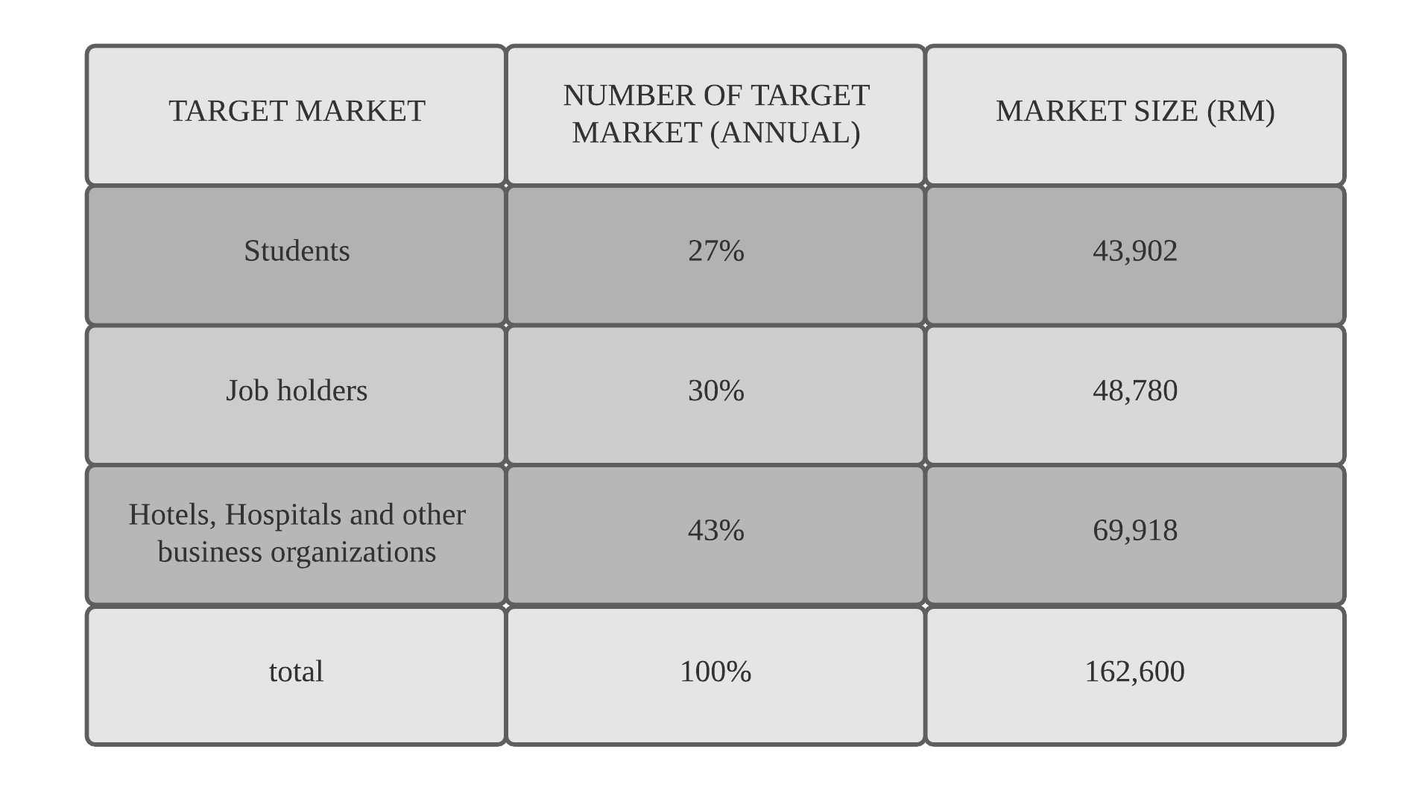
7.4 Competition
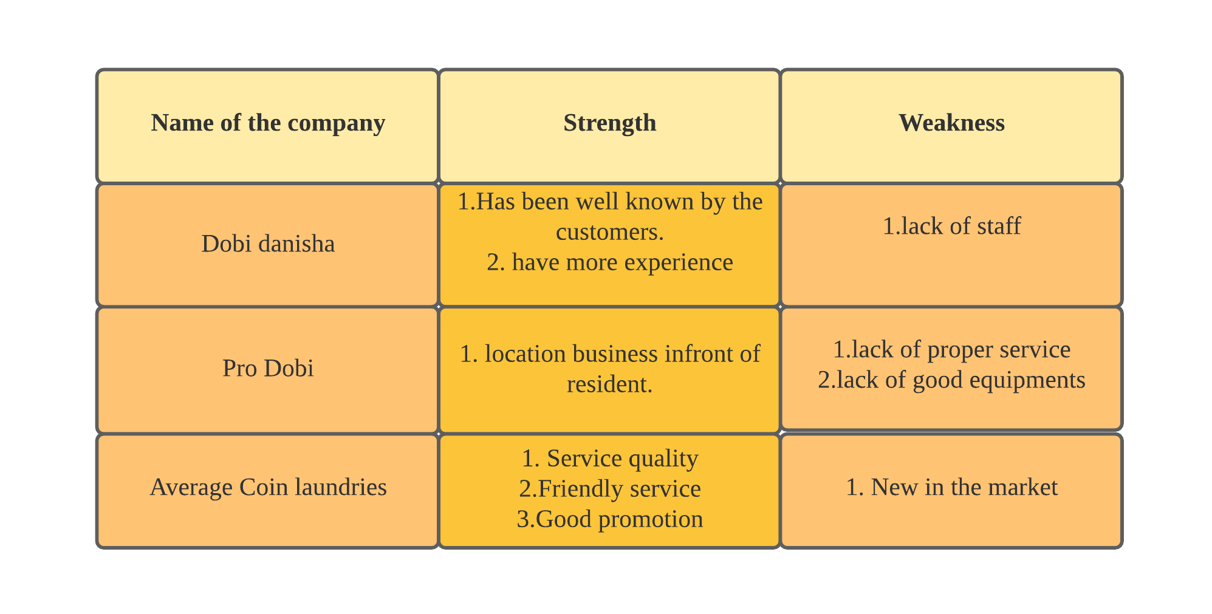
7.5 Market share
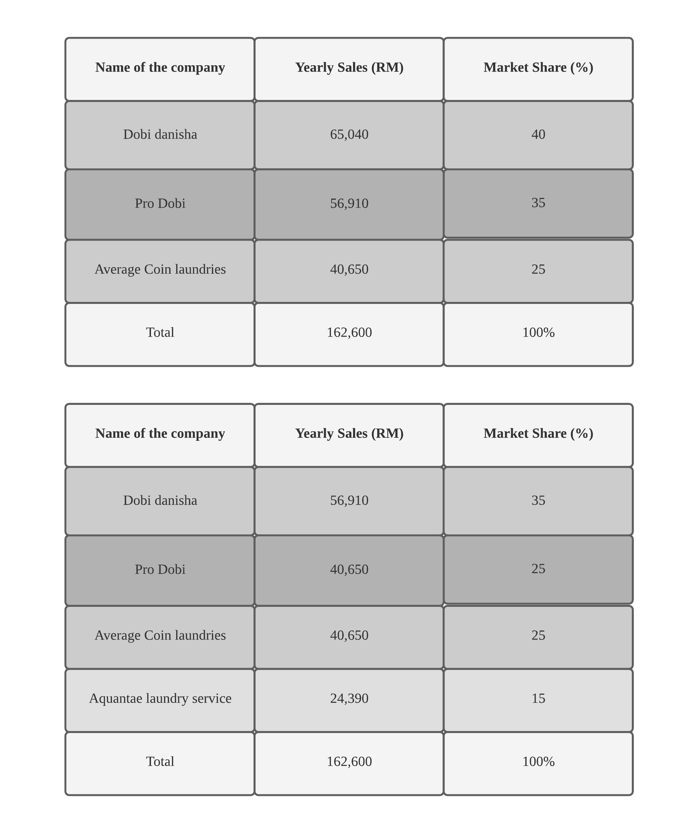

7.6 Sales forecast
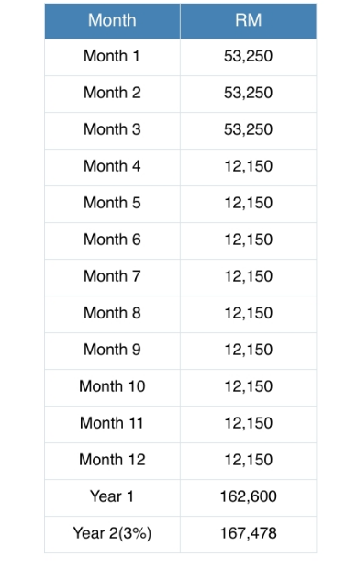

7.7 Marketing strategies
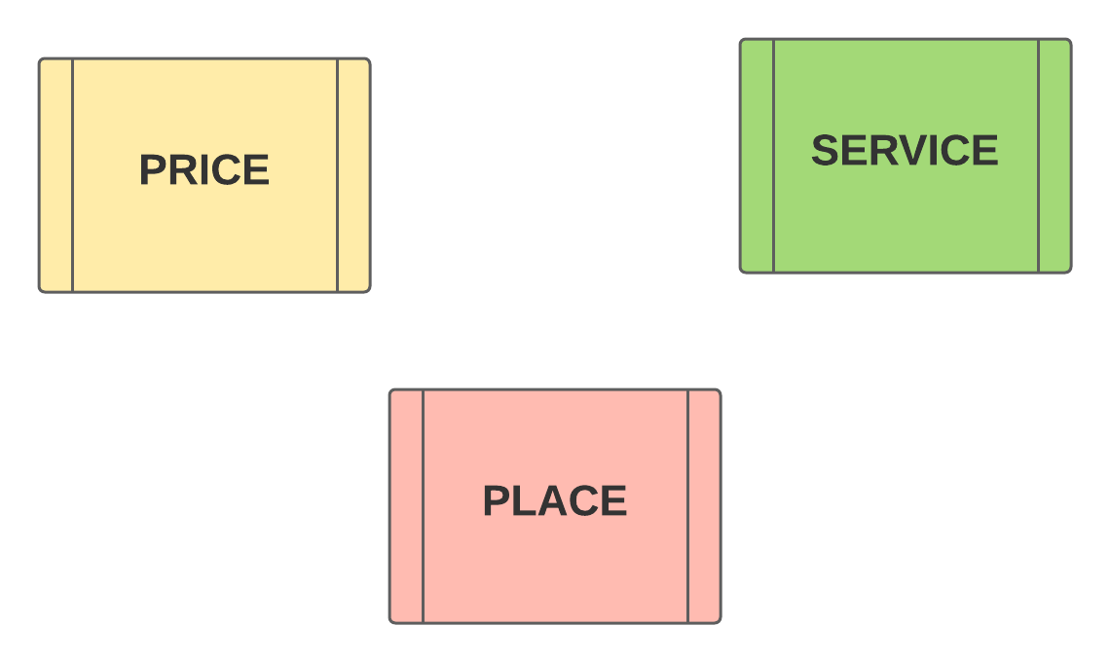

7.8 Promotion strategy
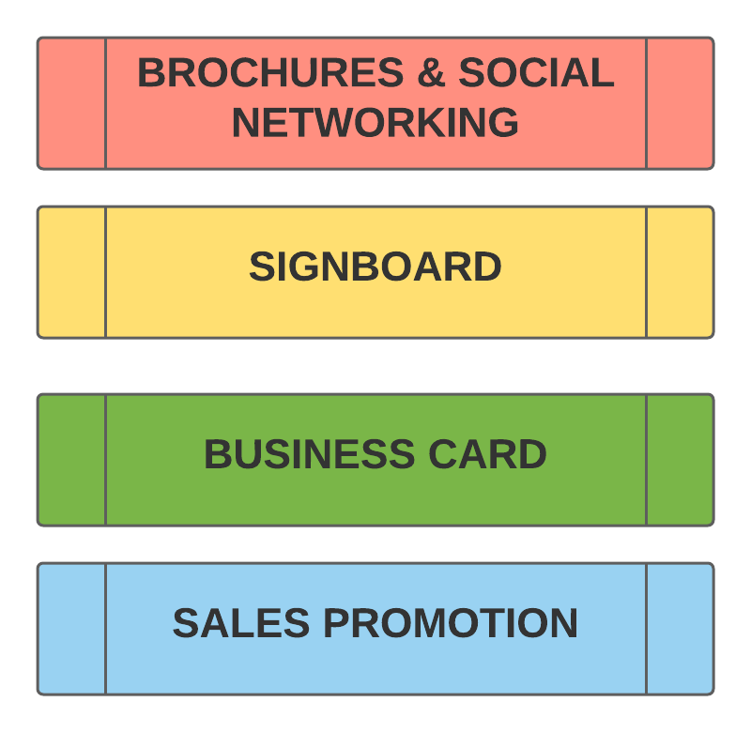

7.9 Business card


7.10 The marketing budget
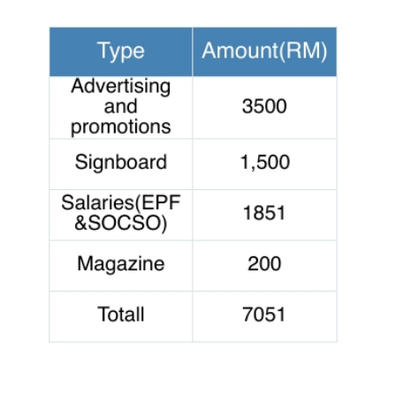

8.0 The Production/ Operation Plan
8.1 Process Flow Chart
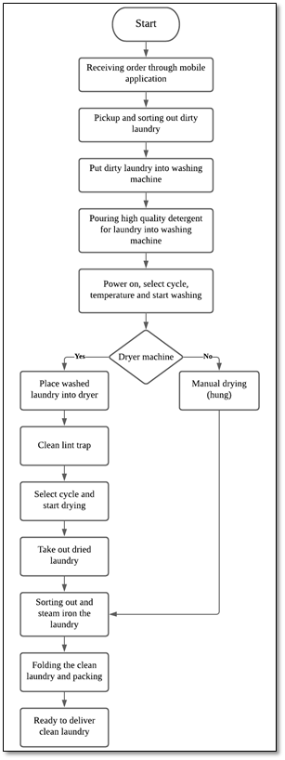
Laundry Process Flowchart

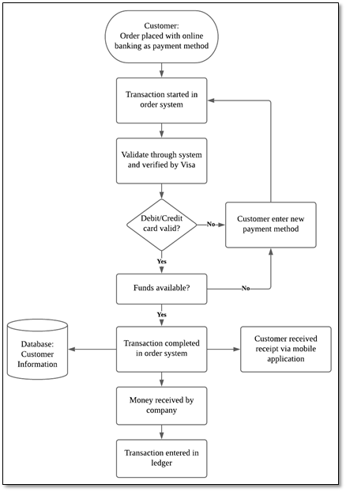
Payment Process Flowchart

8.2 Unit Output/Hours of Operation
The day to day operations of our laundry service business include a focus on providing the best customer service as well as a fun and professional work atmosphere. We as the part of Aquantae Enterprise understand that the purpose of a laundry service business is to provide laundry cleaning services such as washing, ironing, folding and dry cleaning. We are focusing on targeting people to use our online and delivery services which is easier for customers as they did not need to trouble themselves by going to the laundry especially during this pandemic. To this end, a big part of our operations plan is to continue attracting the best in local and regional services to our various stages as our target market is working class individuals who are located in the centre of a busy city.
Capacity planning refers to the process of deciding the production capacity needed by one organization to meet the demands for its products. The tools and supplies that we used for our laundry service business are Samsung 10.5kg Front Load Washer, MayTag 10.5kg Front Load Dryer, 20kg of laundry detergent, ironing board, Philips PowerLife steam iron, weighing scale, clothes hanger and basket. For the first 3 months of daily production, we are required to produce 200kg units of washing and drying, 120 clothing pieces of both ironing and folding followed by 10 customers for pickup and delivery services. This daily production takes about one day to complete the orders as the daily earning can reach RM710. The potential challenge that probably deals with is how to complete customer’s order if they are in a rush. We will try our best to complete their order first than other customers. Aquantae Enterprise is open on Monday until Saturday and will be closed every Sunday. Our laundry business will be operating from 9.00AM until 11.00PM because we want to prepare and clean the whole premise for tomorrow's services.

8.3 Raw Material Requirement
Material requirements planning (MRP) is a control and planning system for inventory, production and also scheduling. It converts the master schedule of production into a clear and detailed schedule therefore we can purchase raw materials and components. MRP synchronizes the flow of components and materials in an order system based on the production schedule. Table below material requirements of Aquantae Enterprise.
Items | Price/unit (RM) | Quantity | Total Cost (RM)
20kg of Laundry Detergent | 50 | 100 | 5000
5kg of 5liter Laundry Softener | 23 | 100 | 2300
5liter of Clorox Bleach | 15 | 100 | 1500
TOTAL |  |  | 8800

8.4 List of Direct Workers
Managers and employees are playing important roles in carrying out the company’s operating plan. Each position in the company has their responsibilities and duties that need to be fulfilled in order to make service business go well. Table below is the list of operation personnel.
Position | No. of personnel
Operation manager | 1
Worker | 4

8.4.1 Designation
Table below is the daily roster or schedule that shows turns of duty or leave for the operation manager and workers.
Staff | MON | TUE | WED | THUR | FRI | SAT | SUN
Operation manager | ✔️ | ✔️ | ✔️ | ✔️ | ✔️ | ✔️ | ❌
Worker | ✔️ | ✔️ | ✔️ | ✔️ | ✔️ | ✔️ | ❌
Courier | ✔️ | ✔️ | ✔️ | ✔️ | ✔️ | ✔️ | ❌

8.4.2 Remuneration
Remuneration is a payment or compensation received for services, works or employment performed by individuals or employees.
Position | Monthly salary (RM) | EPF (13%) (RM) | SOCSO (2%) (RM) | Total (RM)
Chief Executive Officer | 1200 | 156 | 24 | 1380
Chief Operating Officer | 1200 | 156 | 24 | 1380
Chief Finance Officer | 1200 | 156 | 24 | 1380
Chief Technical Officer | 1200 | 156 | 24 | 1380
Chief Information Officer | 1200 | 156 | 24 | 1380
TOTAL |  |  |  | 6900
8.5 List of Machines and Equipment
Machines and equipment are important and necessary in our service business. Table below shows the equipment used for our laundry business including the worth and its cost.
Item | Price/Unit (RM) | Quantity | Total Cost (RM)
Samsung 10.5kg Front Load Washing Machine | 2800 | 3 | 8400
MayTag 10.5kg Front Load Dryer | 3000 | 3 | 9000
Computer Equipment  - Monitor  - Keyboard  - Mouse  - PC | 300  20  20  2500 | 1  1  1  1 | 2840
Large Ironing Board | 195 | 3 | 585
Philips PowerLife Steam Iron | 145 | 3 | 435
Weighing Scale | 120 | 1 | 120
Clothing hanger | 2 | 500 | 1000
Basket | 20 | 10 | 200
TOTAL |  |  | 22,580

8.6 Plant/Office Layout
Layout below is the floor plan layout of our laundry service business. The laundry shop will be at the centre of the city to attract more working class individuals who are focusily busy with their work and career. At the front shop, there will be one door for customers to go in and out while at their left and right view, there will be chairs and desks for them to wait if they are self-pickup the clean laundry. At the reception space, there will be a complete set of computer equipment for workers to track and check the orders requested. In addition, there will be packed laundries on the long table at the front house for courier to deliver. The square shaped labelled ‘W’ is the washing machine while ‘D’ is the dryer machine complete with baskets to put the laundry inside it. The folding/hanging and ironing space are provided in the floor plan layout including a small pantry space and restroom exclusively for staff only.
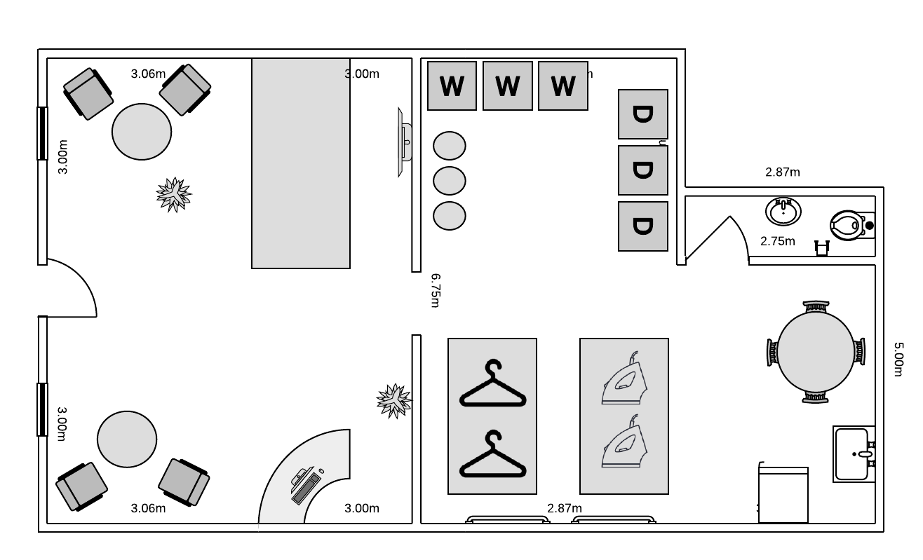

8.7 Operation Overhead
Operational overhead is the cost of running the company’s daily business. The amount is fixed and did not change as the company’s production level uphills or downfalls.
Type | Fixed Asset Cost (RM) | Monthly Expenses (RM)
Operational Equipment | 22,580.00 | -
Raw Material | 8800.00 | -
Salary | - | 6000.00
TOTAL | 31,380.00 | 6000.00

9.0 The Financial Plan
9.1 Project Implementation Cost
9.2 Sources of Financing
9.3 Table of Depreciation
9.4 Loan Amortization Schedule
9.5 Hire Purchase Repayment Scheme
9.6 Cash Flow Proforma
9.7 Profit and Loss Proforma
9.8 Balance Sheet Proforma

10.0 Justification
Appendices

NABC Template

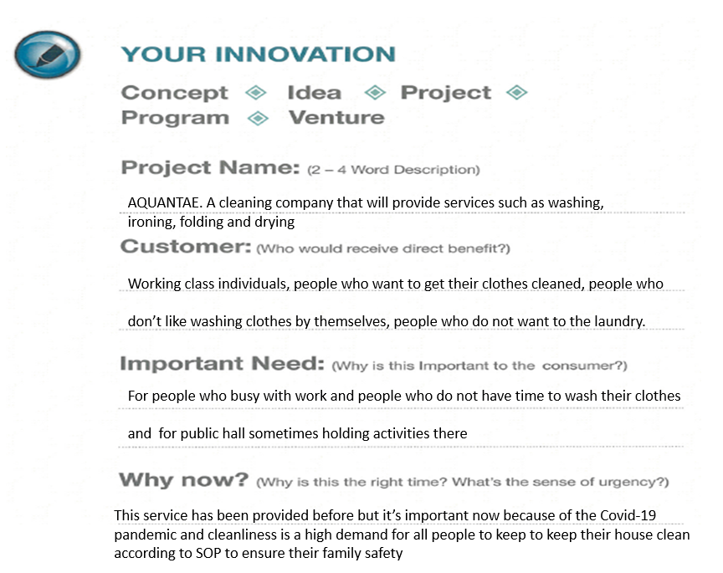
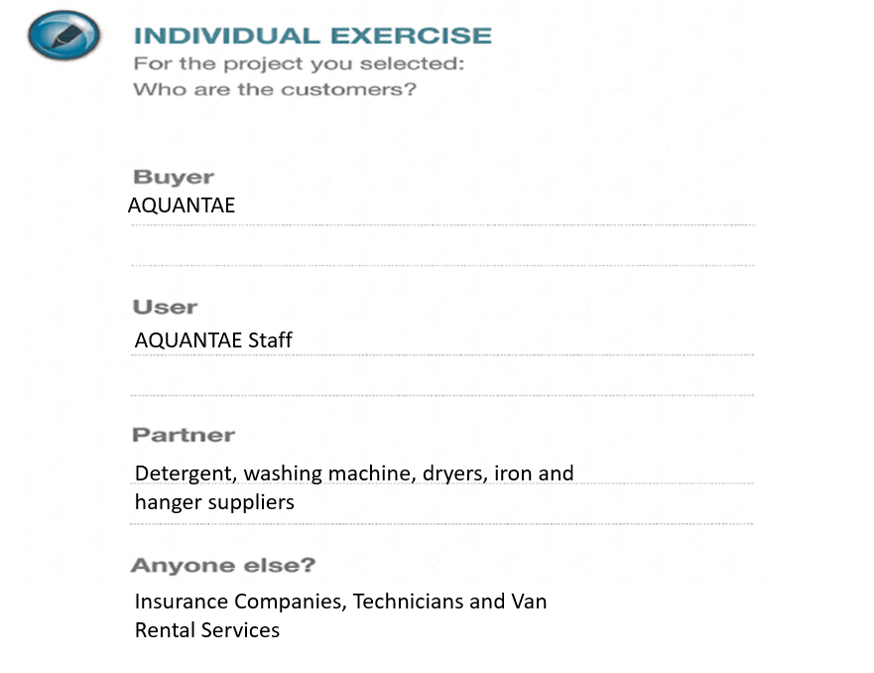

Business Model Canvas
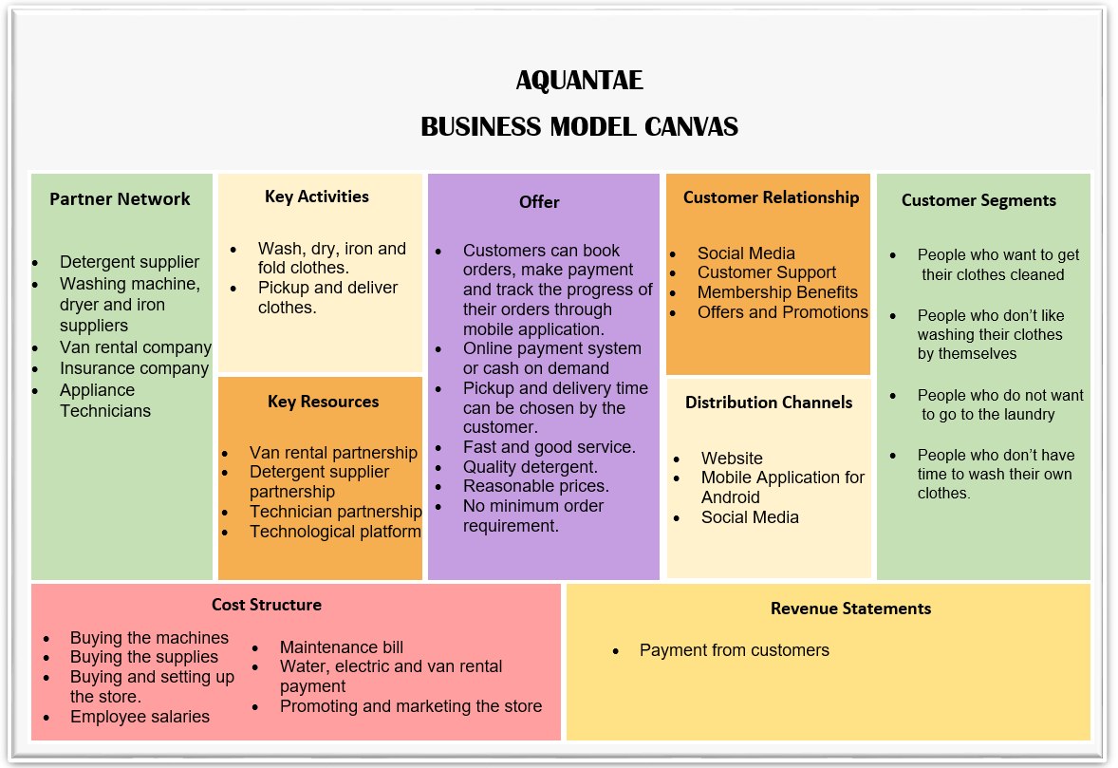
Blue Ocean Strategy + EERC
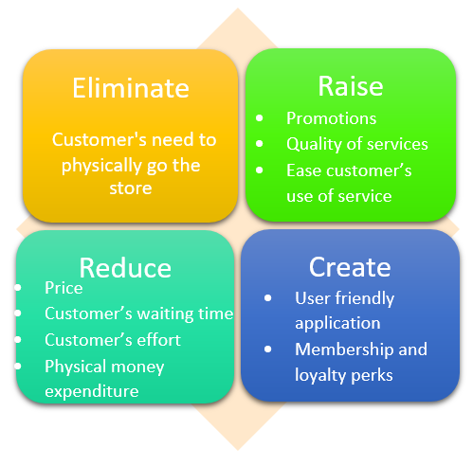

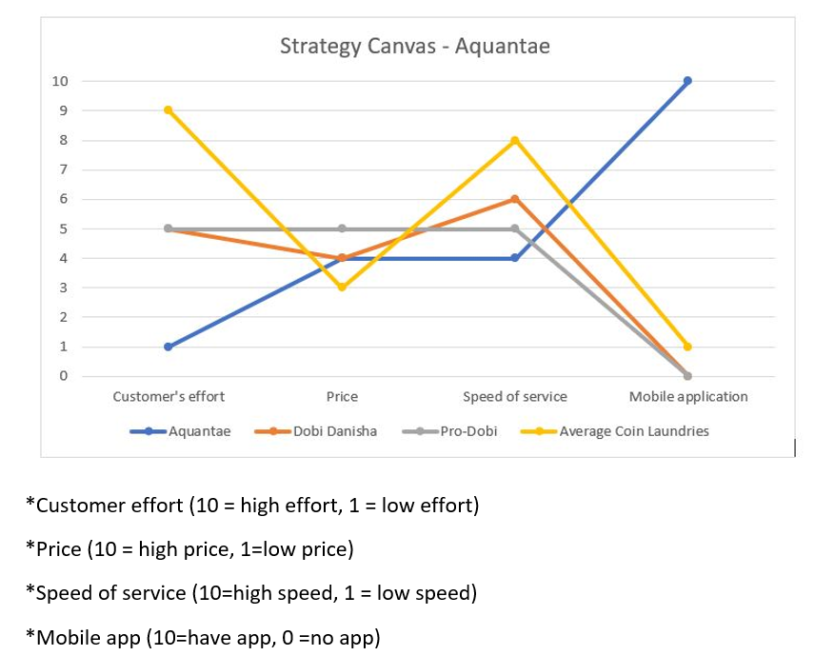

Product Profile

